**Experiment 8- Programmable Digital Data Display System**

**Circuit Diagram:**

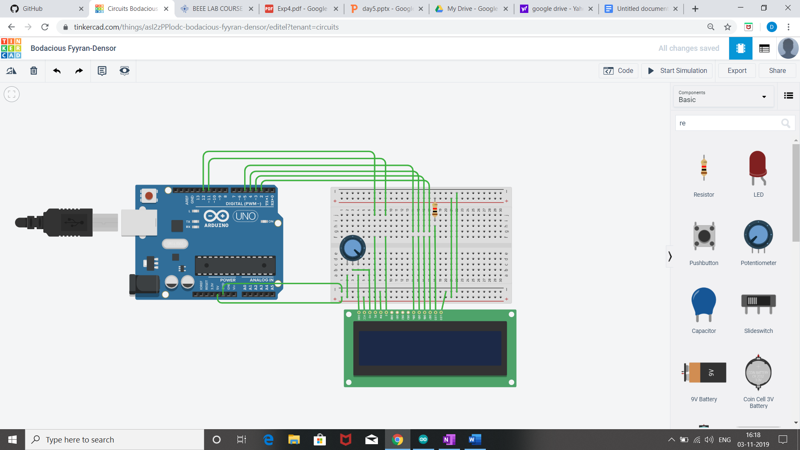

Theory:-

Concept used:

* We have used the concept of LCD(liquid crystal display).
* A **register select (RS) pin** that controls where in the LCD's memory you're writing data to. You can select either the data register, which holds what goes on the screen, or an instruction register, which is where the LCD's controller looks for instructions on what to do next.
* A **Read/Write (R/W) pin** that selects reading mode or writing mode
* An **Enable pin** that enables writing to the registers
* 8 **data pins (D0 -D7)**. The states of these pins (high or low) are the bits that you're writing to a register when you write, or the values you're reading when you read.
* There's also a **display constrast pin (Vo)**, **power supply pins (+5V and Gnd)** and **LED Backlight**  pins that you can use to power the LCD, control the display contrast, and turn on and off the LED backlight, respectively
* We have used the potentiometer for variable resistance.

Learning and observation:

* The Liquid Crystal library works with all LCD displays that are compatible with the driver.
* Potentiometer keeps voltage difference constant.
* A digital data display of hello world can be seen when you turn on the circuit.
* A in-built library #include <LiquidCrystal.h> is used to reduce the code which already contain the details of connections.

**Problem and Troubleshooting:**

* Correct Port should be selected.
* End wires of potentiometer should be connected 0 and 5 volt connecting middle wire change the voltage difference.
* Connection should not be loose.

**Precautions:**

* Arduino Board should be kept at dry place.
* Correct Board/Port is to be selected.
* All connections should be tight.
* Avoid dropping or applying mechanical impact on Lcd as it can damage display surface.

**Learning outcome:**

* I have learnt the use of input library function(<liquidcrystal.h>) for lcd .
* I have learnt how to change the movement of cursor at different location of on display screen.