**HOME CHALLENGE**

**Objective : To make a circuit for output as**

**-FIRST LED BLINKS ONCE**

**-FIRST TWO LEDs BLINK TWICE**

**-FIRST THREE LEDs BLINK THRICE**

**-ALL FOUR LEDs BLINK FOUR TIMES**

**CIRCUIT DIAGRAM:**

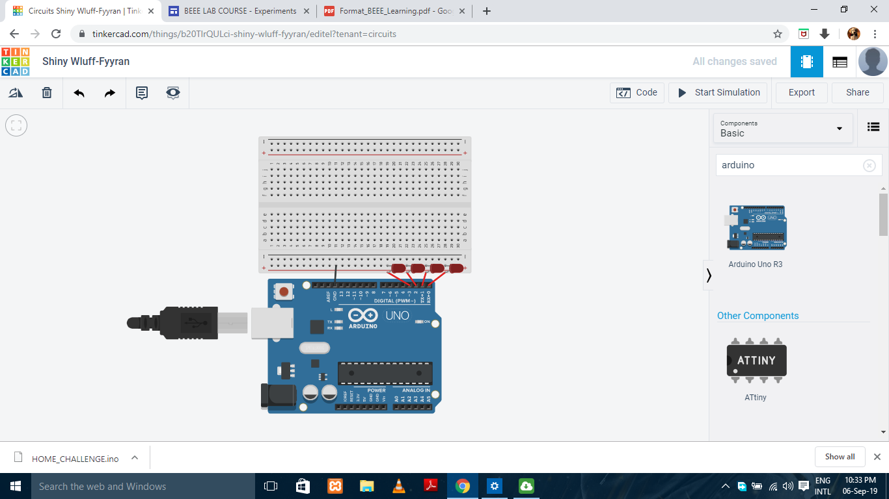

**CODE:**

void setup()

{

for(int i=0;i<4;i++)

pinMode(i, OUTPUT);

}

void loop()

{

for(int i=0;i<=3;i++)

{

for(int o=0;o<=i;o++)

{for(int u=0;u<=i;u++)

{

digitalWrite(u,HIGH);

}

delay(300);

for(int u=0;u<=i;u++)

{ digitalWrite(u,LOW);

}

delay(300);

}

}

}