Software Security API

Milestone 2

9-25-09

Eric Crockett

_________________

Josh Dash

_________________

David Pick

_________________

Table of Contents
1. Executive Summary 3
2. Introduction 3
3. Use Cases 4
3.1 Login 4
3.2 Initial Scan 5
3.3 Re-scan 6
3.4 View Logs 7
4. Functional Requirements 8
5. Data Flow Diagram 8
5.1 Legend 8
5.2 Context Diagram 9
5.3 Level 0 Diagram – Monitoring 9
5.4 Level 0 Diagram – Logging 9
5.5 Level 1 Diagram – Scan Executable 10
5.6 Level 1 Diagram – System Scan 10
6. References 10
None 11
8. Index 11
9. Glossary 11

- Executive Summary
This document provides an initial look at user interaction with our system. It gives a brief overview of the current system and its background. Additionally, it identifies the key features of the system and the specific user needs which they satisfy. User interaction is depicted through use cases, and additional functional requirements which do not require user interaction are described. Finally, a series of data flow diagrams graphically illustrates the flow of data within the system and to external actors.

- Introduction
Tempus Technologies [1] is looking to enhance the security of their payment gateways while lowering cost. They need a custom designed system to ensure their data remains secure everywhere, from their central servers to computers running card scanners at retail stores. This document is the second in a set of milestones which will fully describe the requirements for the proposed solution. In this milestone, the system's functional requirements are identified and the flow of data through the system is shown. The next milestone will include supplementary specifications, interface requirements, system constraints, and other non-functional system requirements. Milestones completed this quarter will completely describe the system requirements and user interaction with the system. In the winter quarter, our team will focus on the software architecture of the system, and some development will begin. The final product will be developed and delivered in the spring quarter.

- Use Cases

3.1 Login
Name: Login to management console
Description: The user will open the application and enter their username and password to gain access to file integrity settings and scan results.
Actors: User
Basic Flow:
- User open application
- User enters username in form
- User enters password in form
- User clicks submit button
Alternate Flow:

1.1. Application does not start up - User contacts Tempus [1] for support
4.1. User enters incorrect username or password - System does not allow them to login, and informs them of the issue.
4.2. System cannot contact database of usernames and passwords - System reports error
Preconditions:
- The application is installed and running
- The user is registered with the application by the Tempus employee when they set up the system
Post Conditions:
- The system consoles is shown to the user or an error is reported
Special Requirements:
- None

3.2 Initial Scan
Name: Initial System Scan
Description: When the system is first set up, the user configuring the system will be able to run an initial system scan.
Actors: User
Preconditions:
- User is logged in to the system
- User is presented with a button to scan the system
Basic Flow:
- User clicks the button
- The scanned files are added to the database
Alternate Flow:
1.1. The system is not able to perform the scan - The user is presented with an error message
Postconditions:
- The application continues to run in the background without user interaction
Special Requirements:
- The scan cannot be paused because this could allow an attacker access to the system.

3.3 Re-scan
Name: System Re-Scan
Description: After applications are added to the system, the user can select which ones are allowed to run
Actors: User
Preconditions:
- User is logged into the system
- User has the application open
Basic Flow:
- User clicks the re-scan button
- User is shown a list of new applications on the system
- User selects applications to be whitelisted
Alternate Flow:
1.1. System is not able to perform the scan - User is shown an error message
2.1. No new applications are found - system returns to monitoring state
2.2. System cannot read from the database to retrieve new applications - User is shown an error message
3.1. User doesn't select any applications - No applications are whitelisted, system returns to monitoring state
3.2. System cannot write which applications are whitelisted to the database - User is shown an error message
Postconditions:
- System returns to monitoring state
Special Requirements:
- None

3.4 View Logs
Name: View Logs
Description: Tempus [1] is shown a list of all new applications that are found, as well as when the applications last attempted execution.
Actors: Tempus Technologies [1], Log Reviewer
Preconditions:
- Tempus employee is logged into the system
Basic Flow:
- Tempus employee searches for the client they would like to review
- Tempus employee selects the client from a list presented to them
- Tempus employee is shown a list of events that have occurred on the system, in the form of a spreadsheet
Alternate Flow:
1.1. Employee enters an invalid search term - An error message is shown and they are asked to enter a new search term
2.1. The query used returns no results - Nothing is returned and the employee can revise their search
3.1. No events have been logged so far - The employee is shown a message saying nothing has been logged yet
Postconditions:
- The employee returns to the search form
Special Requirements:
- None

Functional Requirements
Tempus Technologies [1] currently uses SolidCore [3] in order to implement file integrity on payment card processing systems. Our solution must duplicate the functionality of SolidCore [3] by providing system scans to create a whitelist of executables. Our solution must also prevent unauthorized (non-whitelisted) files from executing. In addition to the basic SolidCore [3] functionality, Tempus needs a solution that allows greater control and monitoring of payment card processing systems. This will be accomplished by a logging system that will alert Tempus of any unauthorized execution attempts. Our solution will be almost entirely automated except for the option to perform an initial scan or an on-demand scan. As a result, there will be very little user interaction apart from a basic graphical user interface. In addition to the requirements described in the use cases, these non-interactive functional requirements completely describe the system’s behavior.
  - The system must be able to scan the entire file system and store the hashes of all executables in an embedded database.
  - The system must hook the Windows API on file executions in order to prevent unauthorized executables from running.
  - The hash of intercepted executables must be compared to the database hash. If no match is found in the database whitelist, the executable must not be allowed to run.
  - When an unauthorized executable tries to run, a Syslog [2] message must be sent to an external Tempus server indicating the name and location of the executable, as well as the time the execution was prevented.
  - The system must support on-demand system-wide rescans. Rescans must allow new executables to be entered into the database.

Data Flow Diagram

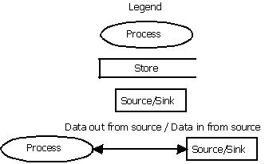
5.1 Legend

5.2 Context Diagram
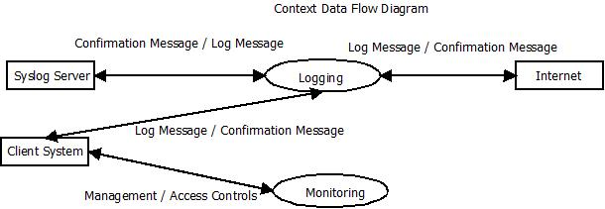
This context data flow diagram shows how our system (“client system”) interacts with external actors such as the internet and an off-site Syslog server [2].

5.3 Level 0 Diagram – Monitoring
This level 0 data flow diagram expands the contextual “monitoring” process. This process involves scanning the system on demand for new executables, performing real-time system scanning, and logging into the management console to view monitoring results.
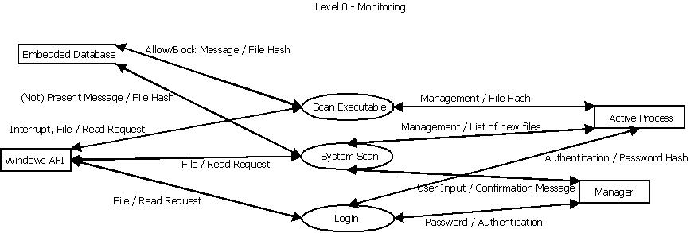

5.4 Level 0 Diagram – Logging
The level 0 diagram for the contextual “logging” process is the same as the context diagram.

5.5 Level 1 Diagram – Scan Executable
This level 1 diagram shows the details of the “scan executable” process in the “monitoring” data flow diagram. Scanning executables consists of talking to the embedded database, computing file hashes, and granting or denying access based on the executable’s hash.
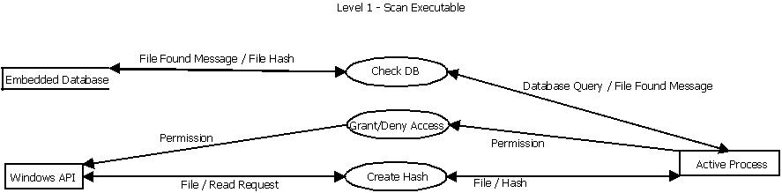

5.6 Level 1 Diagram – System Scan
This level 1 diagram shows the details of the “system scan” process in the “monitoring” data flow diagram. A system scan involves searching the file system directory tree for files, creating a hash for those files, and checking the database to see if the hash is present.
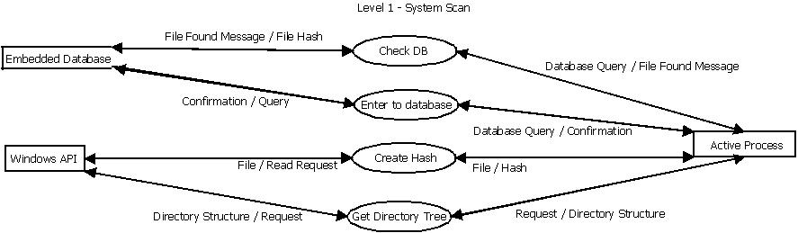

6. References
[1] Tempus Technologies, Inc., Payment Mate. http://www.tempuspayment.com/
[2] Syslog, Syslog Wiki. http://www.syslog.org/
[3] SolidCore, SolidCore. http://www.solidcore.com/

7. Appendix

None

8. Index

data flow diagrams 3
SolidCore 8, 10
Syslog 8, 9, 10
Tempus Technologies 3, 7, 8, 10
whitelist 8

9. Glossary
Payment gateway: moves transactions from a magnetic card reader to a company which processes the payment
Whitelist: List of applications allowed to run on the system

