Software Security API

Milestone 3

10-20-09

Eric Crockett

_________________

Josh Dash

_________________

David Pick

_________________

Table of Contents
1. Executive Summary 3
2. Introduction 3
3. Usability Requirements 3
4. Performance Requirements 3
5. Reliability Requirements 4
6. Supportability Requirements 4
7. Hardware and Software Interfaces 4
8. Documentation Requirements 4
9. Installation 4
10. Licensing Requirements 4
11. Design Constraints 5
12. Feature Mapping 5
12.1. Functional Requirements Mapping 5
12.2. Non-functional Requirements Mapping 5
13. State Machine 6
14. Decision Tree 6
15. User Interfaces 7
15.1. Main Management Console 7
15.2. Scan Results 7
15.3. View Log 7
16. References 8
17. Appendix 8
18. Index 8
19. Glossary 8
- Executive Summary
This document describes the supplementary specifications for our system. Additional considerations relating to the system design include usability, performance, reliability, supportability, and installation requirements. This document also contains specifications unrelated to the system design such as documentation, licensing, and installation requirements. In addition to supplementary requirements, this document includes system design constraints and a state machine describing the system's operation.

- Introduction
Tempus Technologies is looking to enhance the security of their payment gateways while lowering cost. They need a custom designed system to ensure their data remains secure everywhere, from their central servers to computers running card scanners at retail stores. This document is the third in a set of milestones which will fully describe the requirements for the proposed solution. Previous milestones have identified the system's functional requirements, provided use cases, and explored the problem's background. In this milestone, the system's supplementary requirements and design constraints are specified. The requirements in this document will be traced to features and use cases identified in the previous milestones. The system is also described using a state machine. The next milestone will provide system test cases, coding standards, and change control protocols. Other milestones completed this quarter will completely describe the system requirements and user interaction with the system. In the winter quarter, our team will focus on the software architecture of the system, and some development will begin. The final product will be developed and delivered in the spring quarter.

- Usability Requirements
- Tempus employees should be able to perform an initial scan of the client system after 10 minutes of training from our development team. After no more than an hour of training, a Tempus employee should be able to understand all of the user interaction with the system.
- System-wide scans should take no more than 5 minutes to setup.
- Tempus will be provided with a detailed user manual for the system.
- The system should have a user interface similar to SolidCore so that the new system is easy to use.

- Performance Requirements
- System-wide scans should be able to process one gigabyte of files in no more than 5 minutes.
- The real-time scanner must not delay the execution of any white-listed program by more than 250 milliseconds when a single executable tries to run.
- If multiple executables attempt to run within 250 milliseconds, executables will be tested in the order in which they were started, and each individual executable may not be delayed more than 250 milliseconds.
- A log should be sent to Tempus no more than 30 seconds after an executable is blocked or a system scan completes.

- Reliability Requirements
- The system must protect against unauthorized executions 99% of the time the client computer is on. The file integrity system is not required to be operational while the operating system initializes.
- The system should fail less than once a week on average under continuous operation.
- The system should become operational after a failure by restarting the computer.
- The system must never allow an unauthorized execution, and should incorrectly prevent the execution of no more than 1 in 1000 whitelisted programs.
- The system may not contain any critical bugs which would compromise the security of the system. It should have no more than 2 non-critical bugs/KLOC which affect functionality or user interaction.

- Supportability Requirements
- Tempus software engineers should be able to define a new log message type with less than 1 hour of work.
- Tempus software engineers should be able to convert the local management console to a remote console within two weeks.
- Tempus software engineers should be able to increase the flexibility of the scanner with file type restrictions and similar modifications in less than 1 week.

- Hardware and Software Interfaces
- The system must hook the Windows API to intercept files on execution.
- The system must work on Microsoft Windows XP and newer versions of Windows.
- The system must be capable of sending remote log messages to a SysLog server.
- The system must utilize an embedded database to store file hashes.

- Documentation Requirements
Documentation for the product will be provided in the form of training manuals and a document containing a detailed description of the products features.

- Installation
The product will be delivered to the client via the Internet, as well as a mailed CD. The software will be installed using a generic Microsoft install wizard. This will consist of the installer choosing where the files should be stored, and how often the software will scan the system. Once the software is installed it should run on system startup, and not be accessible by the system's everyday user.

- Licensing Requirements
As part of the project we will be using several commercial projects. Tempus Technologies has mandated that the project be developed using Embarcadero's version of Delphi. Tempus already has a license for Delphi, and ases for Delphi. The team will also use the madCodeHook library as part of the project. madCodeHook is a Delphi library for hooking into the Microsoft Windows API. There is a one-time fee associated with madCodeHook, which will allow for full and unlimited use of the library in our project. Tempus is also requiring the use of the Accuracer embedded database. Tempus already owns the license to the database, so no additional licenses need to be purchased.
- Design Constraints
  - The software must be written in Delphi.
  - The software should use the Accuracer embedded database.
  - The system must send log messages using SysLog.
  - The user must not be able to tamper with the application once it was been run.
  - The system must be completed within the 2009-2010 school year.

- Feature Mapping

Functional Requirements Mapping
Feature | Use Cases | Functional Requirements
Management Console | User logs into management console
Logging System | View Logs | F.4, F.5
Real-time scanning of executables upon run |  | F.2
Scheduled System Scans | System Re-Scan, Initial System Scan | F.1, F.5
Program Whitelist |  | F.3

Non-functional Requirements Mapping
Feature | Use Cases | Non-functional Requirements
Scheduled System Scans | System Re-Scan, Initial System scan | 3.1, 3.2, 4.1, 5.5, 6.3, 7.4
Logging System | View Logs | 4.4, 6.1, 7.3
Real-time scanning of executables upon run |  | 4.2, 4.3, 5.1, 5.2, 5.3, 5.4, 5.5, 6.3, 7.1
Management Console | User logs into management console | 3.4, 6.2, 7.2
Program Whitelist |  | 3.1, 3.4, 5.4, 7.4

- State Machine
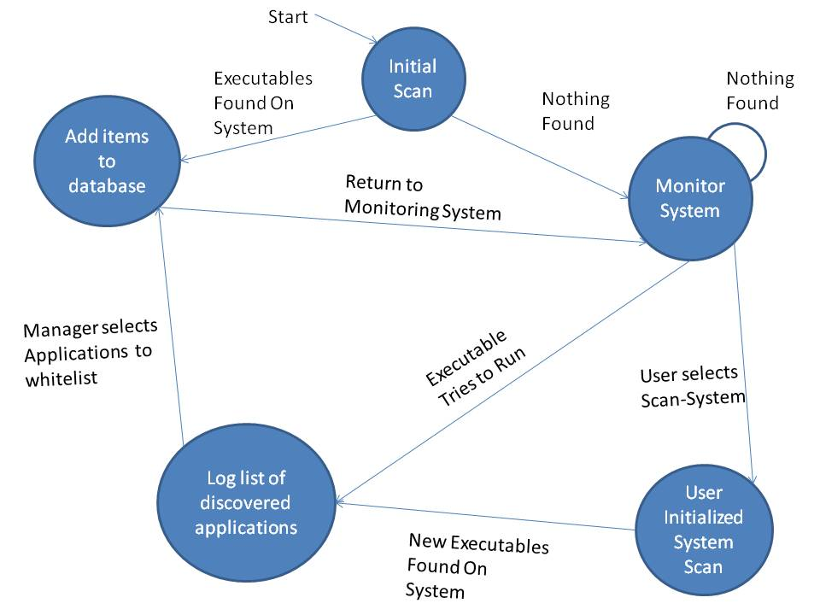

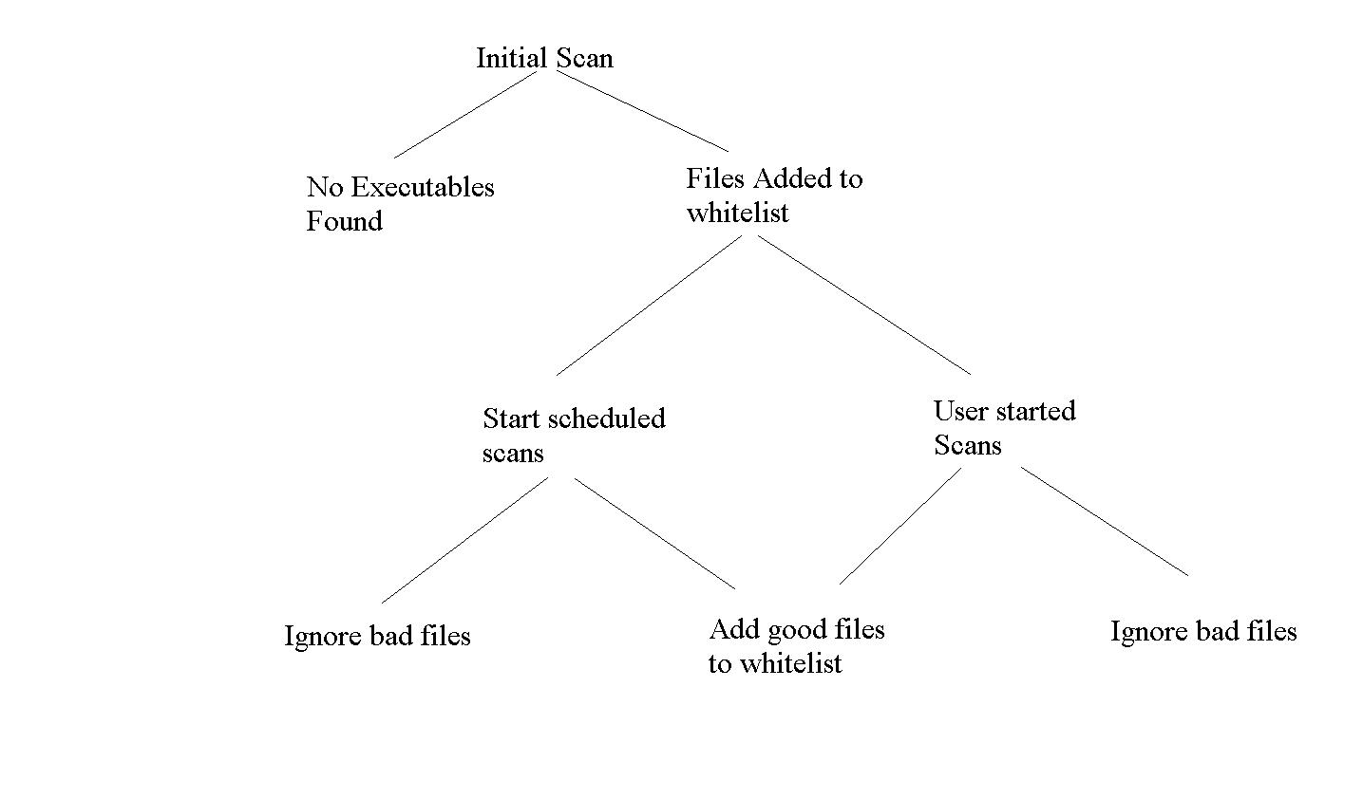
- Decision Tree

- User Interfaces

Main Management Console
This is the main user interface. It allows a Tempus employee to view the system log or to perform a system scan.
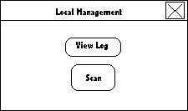

Scan Results
This screen appears during a manual system scan. It shows the progress of the scan and a list of files not currently in the database. A Tempus employee can choose which files to whitelist.

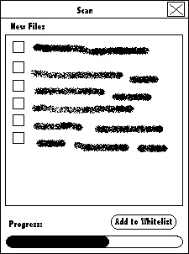

View Log
This screen contains all of the system log messages. It is accessed from the main management console screen. Each log message has a brief description of the event and the time when the event was logged.
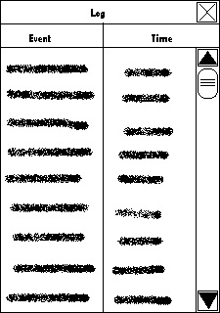

- References
[1] Tempus Technologies, Inc., Payment Mate. http://www.tempuspayment.com/
[2] Syslog, Syslog Wiki. http://www.syslog.org/
[3] SolidCore, SolidCore. http://www.solidcore.com/
- Appendix

- Index

- Glossary

