|  |  |
| --- | --- |
|  |  |
| **YASH GARG** | |

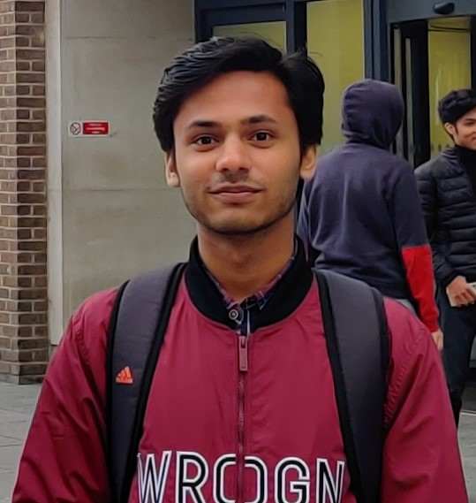

**Career Objective:** Team player with strong research skills and proactive problem solver aiming to obtain a Data Science position to expand my knowledge and skills.

**Educational Details:**

* **B.Tech** – Computer Science and Engineering, Amity School of Engineering and Technology, Amity University, **80.7%**
* **Class XII** – G.D Goenka Public School, Sec-22, Rohini, New Delhi, CBSE, **87.35%**
* **Class X** – G.D Goenka Public School, Sec-22, Rohini, New Delhi, CBSE, **90%**

**Academic Achievements:**

* **DataCamp**, Data Scientist with Python. [(Certificate)](https://www.datacamp.com/statement-of-accomplishment/track/b4dacff05e660f9ac23324b6ca7f7063dcdcdf56)
* **Coursera (Macquarie University)**, Excel Skills for Business. [(Certificate)](https://drive.google.com/file/d/1XQb4c_FtsCutK4IhJuKw969Ov1L0fIRN/view)
* **LinkedIn Learning**, Tableau Essential Training. [(Certificate)](https://drive.google.com/file/d/1MpSbsaG4Wv6n7TOIern0qT7p9cD2H2A0/view)

**Key Projects & Presentations:**

* **Title:** Predicting Bridge Damage During Earthquake Using Machine Learning Algorithms.  
  **Details:** Published and presented in the proceedings of Confluence 2021, [IEEE Xplore](https://ieeexplore.ieee.org/document/9377100)
* **Title:** International Debt Statistics.  
  **Details:** DataCamp Project based on Analysis using SQL, [Github Pages](https://ygarg704.github.io/international-debt-stats/)
* **Title:** Predicting Credit Card Approval.  
  **Details:** DataCamp Project based on Analysis and Classification using Machine Learning Algorithms, [Github Pages](https://ygarg704.github.io/Predicting-credit-card-approvals/)
* **Title:** John Snow Ghost Map.  
  **Details:** DataCamp Project based on Analysis and Visualization using bokeh and folium library in python, [Github Pages](https://ygarg704.github.io/JohnSnow-ghost-map/)

**Work Experience:**

* **The Sparks Foundation**, Data Science and Business Analytics Intern, April 2021 [(Offer Letter)](https://drive.google.com/file/d/13NL1SBOP52schsLz-Q3VACTuoKhRPGUf/view)

**Technical Skills:**

* Machine Learning
* Python
* SQL
* Microsoft Office, Tableau
* C, C++
* Java
* HTML, CSS, Bootstrap
* Version Control – Git / GitHub

**Extra Curricular Achievements:**

* First place at **McKesson Corporation** and **Girls in Tech Virtual Hackathon 2020** with **Pink+**, a comprehensive aid for Breast Cancer patients. [(Certificate)](https://drive.google.com/file/d/1oOLheE0avu-iII8B_VXxHPrDAHr_gUnH/view)
* Finalists in **Weavy Collaboration Hacks 2020**. [(Certificate)](https://drive.google.com/file/d/1EFH-ndUtyYdyydBJsmvZJeYaiQGHrniE/view)

**Personal Details:**

* **Permanent Address:** 2nd Floor, 118, Deepali Enclave, Pitampura, New Delhi, 110034
* **Contact Numbers:** 9582082241**,** 01140195562
* **Email id:** [ygarg704@gmail.com](mailto:ygarg704@gmail.com)
* **Website:** [ygarg704.github.io](https://ygarg704.github.io/)
* **Date of Birth:** November 27, 2000

**SIGNATURE**

**Name:** Yash Garg

**Date:** 24-04-2021