**Android: How to configure Host manager Nuc and Pixel phone device**

Now we can connect between the Nuc and the Pixel Android phone device without any cable.

1. Install Linux/Windows Host manager (as described in: **/setup/Linux** or **/setup/Windows ..How_To_Install..**).
2. Install adb (for windows refer to : <https://developer.android.com/studio/releases/platform-tools.html>)
3. Update the environment variable:
   * **Windows**: REALSENSE_DRIVER= **ANDROID**
   * **Linux:**

* **Location:** /etc/environment
* **REALSENSE_DRIVER=ANDROID**

1. Refer to Nuc device with Internet connection and turn on the **Mobile hotspot** option (**Figures 1 and 2**).
2. Connect between the Pixel phone device and the Nuc by using USB type-C cable.
3. Refer to the Pixel Android phone-> settings->Wi-Fi and select the Nuc name (enter the required user/password as configured in the Nuc – **Figure 2.1**).
4. Then refer in the Nuc to the command line, type: **adb devices**, make sure that a serial number appears (**Figure 3**).
5. Type **adb shell**
6. Type: ifconfig in order to get the Pixel phone IP address (**Figure 4**).
7. Disconnect the type-C cable.
8. Now there is TCP/IP connection between the Nuc and the Pixel Android phone without using the type-C cable connection.

**Figure 1.**

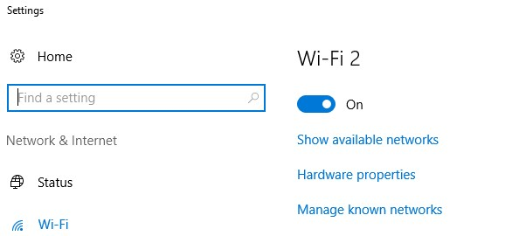

**Figure 2.**

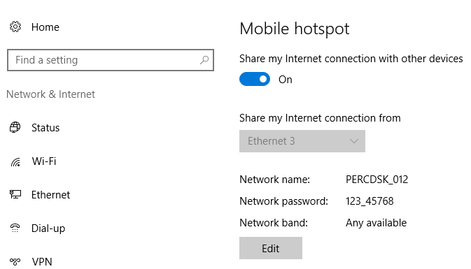

**Figure 2.1**

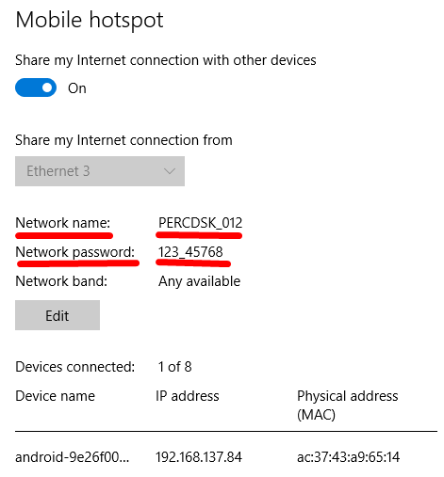

**Figure 3.**

cid:image007.png@01D357BA.2D008A20

**Figure 4.** (Getting the Pixel Android phone IP address)

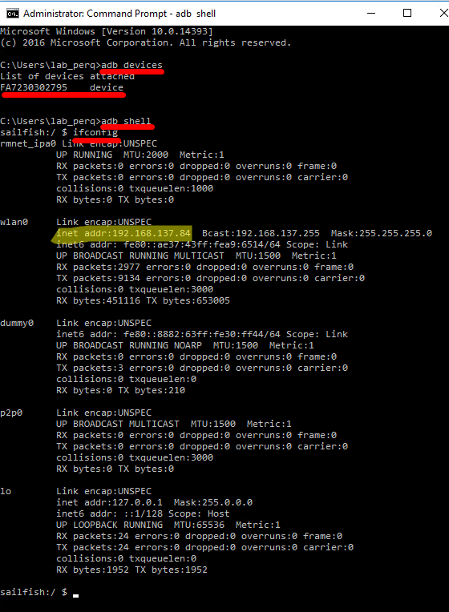

**How to run image quality (IQ) android test on the Festo lab:**

1. The Host manager machine should be located in the Festo lab:
2. Refer to the Host Manager machine.
3. Refer to: /Host/HostManager/Dispacher.py

* Mark the ‘mock’ value and set ‘Festo’ (or any other value instead) as follows:
  + self.__local_env_conf['robot'] = 'Festo72' #'mock'

1. Refer to: /Environment/Labsdata.py

* Change the lab72-> RPC server and IP address as follows:
* *# FESTO LAB 7.2 Description*{  
   **'id'**: **'Festo72'**,  
   **'robot'**:  
   {  
   **'id'**: **'101'**,  
   **'rpc_server'**: **'http://192.168.2.3:9053'**, *# using it in to connect to rpc server* **'ip_address'**: **'192.168.0.3'**, *# using it in robot.connect()* **'x_zero_pos'**: **'10.0'**, *# not in use* **'z_zero_pos'**: **'10.0'** *# not in use* },

1. Refer to the Main Engine machine
2. Configure in the MainEngine.py->Edit configuration->Script Parameters the following parameter:

* -s IQDS5uNightlyConf

1. Refer to the Pixel device and make sure that the DS5u camera connected to the type-C device.
2. Restart the device
3. Refer to Settings (Slide down twice the upper screen) and press the **Hotspot** option.
4. Press the Realsense icon and then start, make sure that the camera shows frames.
5. Close the application
6. Refer to the Host manager machine->Network and select the **AndroidAP2** option.

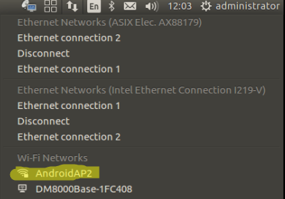

1. Refer to Terminal then type: adb devices

Make sure that there is S/N and not Null value.

1. In case of getting Null value refer to Terminal, then type:

$sudo adb kill-server

$sudo adb start-server

$adb devices

* Another option to check the connection:

1. Open CMD (terminal in Linux), and check what is the device IP by typing **ipconfig** (**ifconfig** in linux)
2. See the default-Gateway (it’s the device IP) in-general the IP is **192.168.43.1**
3. connect the adb over wifi by typing: adb connect 192.168.43.1:5555
4. that’s it, you should see the following massage which’s informing you that you are connected:

**Connected to 192.168.43.1:5555**

**_______________________**

**Best Regards,**

***Pinhas Yaacov***

***PerC|System Validation***

cid:image001.jpg@01D08B2F.E4EDD520