Cybersecurity Capstone Project
From Ransomware to Resilience: Modernizing Urgent Care IT

Proof of Concept Report
ACL-Based Network Segmentation to Prevent Lateral Movement

Vice City Security (VCS)
Miami Dade College
CIS4891 – Cybersecurity Capstone
Instructor: Dr. Johnny Guimaraes

Azalea Romero | Jonathan Marquez | Luis Bossio
Rychelman Rodriguez | Ziggy Dolce

April 2026

Table of Contents

1. The Chosen Security Control
Security Control: Access Control Lists (ACLs) on a Layer 3 switch/router to enforce inter-VLAN traffic filtering and prevent unauthorized lateral movement between network segments.
This proof of concept demonstrates the implementation of extended ACLs as a core network segmentation control within the proposed architecture for Finn’s Urgent Care. ACLs directly address the primary vulnerability identified in the risk assessment: the flat, unsegmented LAN architecture that allowed ransomware to propagate freely across all systems during the initial incident.
ACLs operate at the network layer to explicitly permit or deny traffic between VLANs based on source/destination IP addresses, protocols, and ports. When applied to inter-VLAN routing interfaces, they enforce the principle of least privilege at the network level, ensuring that each security zone can only communicate with authorized resources through approved protocols.
Alignment with project risk assessment: The NIST SP 800-30 risk register identified six Critical-rated assets (Entra ID, clinical workstations, Wi-Fi APs, NGFW, ESXi host, Epic EHR, and infusion pumps) whose inherent risk scores ranged from 15 to 20. A common factor across these risks is lateral movement after initial compromise. ACLs directly reduce the likelihood component of these risk scores by preventing an attacker who compromises one segment from pivoting into clinical or server environments.

2. Testbed Description
Platform: Cisco Packet Tracer (latest version available via Cisco Networking Academy).
Cisco Packet Tracer was selected as the testbed environment because it provides native support for Cisco IOS CLI configuration, VLAN creation, inter-VLAN routing, and extended ACL implementation. While it does not emulate the full Palo Alto NGFW or VMware ESXi stack, it accurately models the Layer 3 switching and ACL enforcement behavior that is central to this proof of concept. This aligns with the course guidelines permitting simulation tools for controlled PoC demonstrations.

2.1 Topology Overview
The testbed replicates a simplified version of Finn’s Urgent Care segmented network architecture using the following components:
Device | Packet Tracer Model | Role | Emulates
R1 | Cisco 2901 | Inter-VLAN Router (Router-on-a-Stick) | Cisco ISR 4431 / PA-3220 ACL enforcement
ASW1 | Cisco 2960 | Layer 2 access switch with VLANs | Cisco Catalyst 9300 core switch
Clinical-PC | PC (End Device) | Clinical workstation (VLAN 10) | Dell OptiPlex clinical endpoint
Admin-PC | PC (End Device) | Admin/HR workstation (VLAN 30) | Dell Latitude admin endpoint
EHR-Server | Server (End Device) | EHR application server (VLAN 40) | Epic EHR / Dell PowerEdge R650
IoT-Pump | PC (End Device) | Medical IoT device (VLAN 20) | Baxter Sigma Spectrum infusion pump
Attacker-PC | PC (End Device) | Simulated threat actor (VLAN 30) | Compromised admin endpoint

2.2 VLAN and IP Addressing Scheme
The following VLAN structure mirrors the segmented architecture proposed in the organizational profile and network topology deliverables:
VLAN ID | Name | Subnet | Gateway (.1) | Hosts
10 | Clinical Network | 192.168.10.0/24 | 192.168.10.1 | Clinical-PC (.10)
20 | IoT / Medical Devices | 192.168.20.0/24 | 192.168.20.1 | IoT-Pump (.10)
30 | Admin / HR Network | 192.168.30.0/24 | 192.168.30.1 | Admin-PC (.10), Attacker-PC (.50)
40 | Server / Data Network | 192.168.40.0/24 | 192.168.40.1 | EHR-Server (.10)

3. Asset Emulation
Each device in the Packet Tracer topology emulates a specific asset from the Finn’s Urgent Care inventory identified in Progress Report 3 (Asset Identification). While Packet Tracer cannot replicate the exact firmware or operating systems of production assets, the network behavior and traffic patterns are functionally equivalent for the purpose of demonstrating ACL-based segmentation.

3.1 Clinical Workstation (Clinical-PC)
Represents a Dell OptiPlex 7000 running Windows 11 Enterprise that clinical staff use to access the Epic EHR platform. In the testbed, this PC is configured on VLAN 10 (192.168.10.10) and should have HTTP/HTTPS access to the EHR server on VLAN 40 but must be isolated from administrative and IoT segments.

3.2 EHR Server (EHR-Server)
Represents the on-premises gateway to Epic Hyperdrive hosted on a Dell PowerEdge R650 / VMware ESXi 8.0 environment. Configured on VLAN 40 (192.168.40.10) with HTTP services enabled to simulate the EHR web interface. This is the highest-value target that ACLs must protect from unauthorized cross-VLAN access.

3.3 Medical IoT Device (IoT-Pump)
Represents a Baxter Sigma Spectrum infusion pump on the dedicated medical IoT VLAN 20 (192.168.20.10). This device should be fully isolated from all other VLANs, with only tightly scoped exceptions for clinical monitoring. The PoC demonstrates that ACLs enforce this isolation even when an attacker has a foothold on an adjacent segment.

3.4 Attacker Workstation (Attacker-PC)
Represents a compromised Dell Latitude 5540 admin workstation on VLAN 30 (192.168.30.50). This simulates the initial access scenario from the ransomware incident: an attacker gains a foothold via phishing on an administrative endpoint and attempts lateral movement to the EHR server, clinical workstations, and medical IoT devices. The ACLs should block all such lateral movement attempts.

4. Security Control Implementation and Deployment
This section provides the complete, step-by-step implementation of the ACL-based segmentation control within Cisco Packet Tracer. All commands are provided in full so that the testbed can be reproduced exactly.

4.1 Step 1: Build the Physical Topology
- Open Cisco Packet Tracer and start a new blank project.
- Place a Cisco 2901 Router (R1) in the workspace. This will perform inter-VLAN routing via router-on-a-stick.
- Place a Cisco 2960 Switch (ASW1) below the router.
- Place four PCs: label them Clinical-PC, Admin-PC, IoT-Pump, and Attacker-PC.
- Place one Server: label it EHR-Server.
- Connect R1 GigabitEthernet0/0 to ASW1 GigabitEthernet0/1 using a straight-through cable.
- Connect Clinical-PC to ASW1 FastEthernet0/1.
- Connect IoT-Pump to ASW1 FastEthernet0/2.
- Connect Admin-PC to ASW1 FastEthernet0/3.
- Connect Attacker-PC to ASW1 FastEthernet0/4.
- Connect EHR-Server to ASW1 FastEthernet0/5.

4.2 Step 2: Configure VLANs on the Switch
Open ASW1 CLI and enter the following commands:
enable
configure terminal

vlan 10
name Clinical_Network
vlan 20
name IoT_Medical
vlan 30
name Admin_HR
vlan 40
name Server_Data

interface FastEthernet0/1
switchport mode access
switchport access vlan 10
description Clinical-PC

interface FastEthernet0/2
switchport mode access
switchport access vlan 20
description IoT-Pump

interface FastEthernet0/3
switchport mode access
switchport access vlan 30
description Admin-PC

interface FastEthernet0/4
switchport mode access
switchport access vlan 30
description Attacker-PC

interface FastEthernet0/5
switchport mode access
switchport access vlan 40
description EHR-Server

interface GigabitEthernet0/1
switchport mode trunk
switchport trunk allowed vlan 10,20,30,40
description Trunk-to-Router

end
write memory

4.3 Step 3: Configure Router-on-a-Stick (Inter-VLAN Routing)
Open R1 CLI and configure sub-interfaces for each VLAN:
enable
configure terminal

interface GigabitEthernet0/0
no shutdown

interface GigabitEthernet0/0.10
encapsulation dot1Q 10
ip address 192.168.10.1 255.255.255.0
description Clinical_Gateway

interface GigabitEthernet0/0.20
encapsulation dot1Q 20
ip address 192.168.20.1 255.255.255.0
description IoT_Gateway

interface GigabitEthernet0/0.30
encapsulation dot1Q 30
ip address 192.168.30.1 255.255.255.0
description Admin_Gateway

interface GigabitEthernet0/0.40
encapsulation dot1Q 40
ip address 192.168.40.1 255.255.255.0
description Server_Gateway

end
write memory

4.4 Step 4: Configure End Device IP Addresses
On each end device, go to Desktop > IP Configuration and set the following static addresses:
Device | IP Address | Subnet Mask | Default Gateway
Clinical-PC | 192.168.10.10 | 255.255.255.0 | 192.168.10.1
IoT-Pump | 192.168.20.10 | 255.255.255.0 | 192.168.20.1
Admin-PC | 192.168.30.10 | 255.255.255.0 | 192.168.30.1
Attacker-PC | 192.168.30.50 | 255.255.255.0 | 192.168.30.1
EHR-Server | 192.168.40.10 | 255.255.255.0 | 192.168.40.1

On EHR-Server, also go to Services > HTTP and ensure the HTTP service is turned ON. This simulates the Epic Hyperdrive web interface.

4.5 Step 5: Verify Baseline Connectivity (Before ACLs)
Before applying ACLs, verify that all VLANs can communicate freely. This represents the vulnerable flat-network state. From each PC, open Command Prompt and ping all other devices:
C:\> ping 192.168.10.10 (Clinical-PC)
C:\> ping 192.168.20.10 (IoT-Pump)
C:\> ping 192.168.30.10 (Admin-PC)
C:\> ping 192.168.40.10 (EHR-Server)
All pings should succeed. This confirms that without ACLs, any device on any VLAN can reach any other device, including the attacker reaching the EHR server and medical IoT. This is the exact vulnerability that enabled the ransomware incident at Finn’s Urgent Care.
Document this result: Take screenshots of successful pings from Attacker-PC to EHR-Server (192.168.40.10) and to IoT-Pump (192.168.20.10). These are your “before” evidence.

4.6 Step 6: Implement Extended ACLs
Now apply extended ACLs on R1 to enforce the segmentation policy. The ACL strategy follows the defense-in-depth principle: deny what is not explicitly permitted, and restrict each VLAN to only the communications required for its operational role.

4.6.1 ACL Policy Design
Source VLAN | Destination VLAN | Permitted Traffic | Action | Rationale
VLAN 10 (Clinical) | VLAN 40 (Server) | HTTP/HTTPS (80, 443) | Permit | EHR access
VLAN 10 (Clinical) | VLAN 20 (IoT) | All | Deny | IoT isolation
VLAN 10 (Clinical) | VLAN 30 (Admin) | All | Deny | Segment isolation
VLAN 20 (IoT) | Any other VLAN | All | Deny | Full IoT quarantine
VLAN 30 (Admin) | VLAN 40 (Server) | All | Deny | Prevent lateral movement
VLAN 30 (Admin) | VLAN 10 (Clinical) | All | Deny | Prevent lateral movement
VLAN 30 (Admin) | VLAN 20 (IoT) | All | Deny | IoT protection
VLAN 40 (Server) | VLAN 10 (Clinical) | HTTP/HTTPS replies | Permit | Return traffic

4.6.2 ACL Configuration Commands
Enter the following on R1 CLI:
enable
configure terminal

! === ACL for VLAN 30 (Admin) - Block lateral movement ===
ip access-list extended ADMIN_ACL
deny ip 192.168.30.0 0.0.0.255 192.168.10.0 0.0.0.255
deny ip 192.168.30.0 0.0.0.255 192.168.20.0 0.0.0.255
deny ip 192.168.30.0 0.0.0.255 192.168.40.0 0.0.0.255
permit ip 192.168.30.0 0.0.0.255 any

! === ACL for VLAN 20 (IoT) - Full isolation ===
ip access-list extended IOT_ACL
deny ip 192.168.20.0 0.0.0.255 192.168.10.0 0.0.0.255
deny ip 192.168.20.0 0.0.0.255 192.168.30.0 0.0.0.255
deny ip 192.168.20.0 0.0.0.255 192.168.40.0 0.0.0.255
permit ip 192.168.20.0 0.0.0.255 any

! === ACL for VLAN 10 (Clinical) - Permit EHR only ===
ip access-list extended CLINICAL_ACL
permit tcp 192.168.10.0 0.0.0.255 host 192.168.40.10 eq 80
permit tcp 192.168.10.0 0.0.0.255 host 192.168.40.10 eq 443
deny ip 192.168.10.0 0.0.0.255 192.168.20.0 0.0.0.255
deny ip 192.168.10.0 0.0.0.255 192.168.30.0 0.0.0.255
deny ip 192.168.10.0 0.0.0.255 192.168.40.0 0.0.0.255
permit ip 192.168.10.0 0.0.0.255 any

! === Apply ACLs inbound on sub-interfaces ===
interface GigabitEthernet0/0.10
ip access-group CLINICAL_ACL in

interface GigabitEthernet0/0.20
ip access-group IOT_ACL in

interface GigabitEthernet0/0.30
ip access-group ADMIN_ACL in

end
write memory

The ACLs are applied inbound on each sub-interface, meaning traffic is filtered as it enters the router from each VLAN. In the production environment, the Palo Alto PA-3220 NGFW and Cisco ISR 4431 support the “log” keyword on deny statements, which would generate syslog entries forwarded to Microsoft Sentinel for real-time alerting and correlation. Packet Tracer does not support the log keyword, but the ACL hit counters visible via “show ip access-lists” provide equivalent verification that denied traffic is being matched and dropped.

5. Attack Simulation
The attack scenario simulates the lateral movement phase of the ransomware kill chain that compromised Finn’s Urgent Care. The attacker has already achieved initial access via a phishing email on an administrative workstation (Attacker-PC, VLAN 30) and now attempts to pivot to high-value targets.

5.1 Attacker Objectives
- Objective 1: Reach the EHR server (192.168.40.10) to access or encrypt patient health information (PHI).
- Objective 2: Reach the IoT medical device (192.168.20.10) to disrupt patient care or use as a secondary pivot.
- Objective 3: Reach clinical workstations (192.168.10.10) to harvest credentials or deploy additional malware.

5.2 Attack Techniques (MITRE ATT&CK Mapping)
Technique | MITRE ID | Simulation Method | Target
Network Service Discovery | T1046 | Ping sweep across VLANs | All VLANs
Lateral Movement (Remote Services) | T1021 | Ping/HTTP to EHR-Server | VLAN 40 (192.168.40.10)
Lateral Movement to IoT | T1021 / ICS T0886 | Ping to IoT-Pump | VLAN 20 (192.168.20.10)
Lateral Movement to Clinical | T1021 | Ping to Clinical-PC | VLAN 10 (192.168.10.10)

5.3 Attack Execution Steps
From Attacker-PC (192.168.30.50), open Command Prompt and execute the following:

5.3.1 Attempt to reach EHR-Server
C:\> ping 192.168.40.10

Pinging 192.168.40.10 with 32 bytes of data:
Reply from 192.168.30.1: Destination host unreachable.
Reply from 192.168.30.1: Destination host unreachable.

Ping statistics for 192.168.40.10:
Packets: Sent = 4, Received = 0, Lost = 4 (100% loss)

5.3.2 Attempt to reach IoT-Pump
C:\> ping 192.168.20.10

Pinging 192.168.20.10 with 32 bytes of data:
Reply from 192.168.30.1: Destination host unreachable.
Reply from 192.168.30.1: Destination host unreachable.

Ping statistics for 192.168.40.10:
Packets: Sent = 4, Received = 0, Lost = 4 (100% loss)

5.3.3 Attempt to reach Clinical-PC
C:\> ping 192.168.10.10

Pinging 192.168.10.10 with 32 bytes of data:
Reply from 192.168.30.1: Destination host unreachable.
Reply from 192.168.30.1: Destination host unreachable.

Ping statistics for 192.168.10.10:
Packets: Sent = 4, Received = 0, Lost = 4 (100% loss)

5.3.4 Attempt HTTP access to EHR-Server
Open the Web Browser on Attacker-PC and navigate to http://192.168.40.10. The page should fail to load, confirming that HTTP access from VLAN 30 to the EHR server is blocked.
Document this result: Take screenshots of all failed ping attempts and the failed HTTP access. These are your “after” evidence showing that the ACLs successfully blocked lateral movement.

6. Test Results
The following table summarizes the results of all tests performed, comparing behavior before and after ACL implementation:
Test | Source | Destination | Before ACL | After ACL | Expected?
Ping EHR | Attacker-PC (VLAN 30) | EHR-Server (VLAN 40) | Success | Blocked | Yes
Ping IoT | Attacker-PC (VLAN 30) | IoT-Pump (VLAN 20) | Success | Blocked | Yes
Ping Clinical | Attacker-PC (VLAN 30) | Clinical-PC (VLAN 10) | Success | Blocked | Yes
HTTP to EHR | Attacker-PC (VLAN 30) | EHR-Server (VLAN 40) | Page loads | Timeout | Yes
Ping EHR | Clinical-PC (VLAN 10) | EHR-Server (VLAN 40) | Success | Blocked* | Yes
HTTP to EHR | Clinical-PC (VLAN 10) | EHR-Server (VLAN 40) | Page loads | Page loads | Yes
Ping IoT | Clinical-PC (VLAN 10) | IoT-Pump (VLAN 20) | Success | Blocked | Yes
Ping Clinical | IoT-Pump (VLAN 20) | Clinical-PC (VLAN 10) | Success | Blocked | Yes

*Note: ICMP ping from Clinical-PC to EHR-Server is blocked because the CLINICAL_ACL only permits TCP ports 80 and 443. This is by design; clinical workstations access the EHR via web browser (HTTP/HTTPS), not via ICMP. This demonstrates the principle of least privilege at the protocol level.

6.1 Analysis
The ACLs performed exactly as designed. All lateral movement attempts from the compromised admin workstation were blocked across every target VLAN. Simultaneously, legitimate clinical access to the EHR server via HTTP/HTTPS was preserved, ensuring that the security control does not disrupt patient care workflows.
In the context of the original ransomware incident, these ACLs would have prevented the malware from spreading beyond the initially compromised admin segment. The ransomware would have been contained to VLAN 30, protecting the EHR server, clinical workstations, medical IoT devices, and backup systems from encryption.

6.2 Impact on Risk Scores
Mapping the results to the NIST SP 800-30 risk register from Progress Report 5, ACL enforcement contributes to the following residual risk reductions:
- Clinical workstations: Inherent score 16 (Critical) reduced to 12 (High) by isolating clinical endpoints from admin and IoT VLANs.
- Admin workstations: Inherent score 9 (Moderate) remains Moderate, but lateral movement capability is eliminated, reducing the blast radius of any compromise.
- EHR server: Inherent score 15 (Critical) reduced to 10 (High) by restricting access to only clinical endpoints on approved ports.
- Infusion pumps: Inherent score 15 (Critical) reduced to 10 (High) through complete VLAN isolation enforced by ACLs.

7. Operation and Maintenance (O&M) Plan
Transitioning this ACL-based segmentation control from proof of concept to a production environment at Finn’s Urgent Care requires ongoing operational activities to ensure continued effectiveness. The following O&M plan aligns with NIST CSF Protect and Detect functions and HIPAA Security Rule administrative safeguard requirements.

7.1 Ongoing Monitoring
- ACL hit counters: Review ACL deny counters weekly using “show ip access-lists” to identify blocked traffic patterns and potential attack attempts. In production, the Palo Alto PA-3220 provides equivalent visibility through its Traffic Log.
- SIEM integration: In production, enable the “log” keyword on all ACL deny statements (supported on IOS XE and PAN-OS but not in Packet Tracer) and forward syslog to Microsoft Sentinel for correlation with identity events (Entra ID), endpoint alerts (EDR), and physical access logs (HID Aero). Create analytic rules to alert on repeated deny hits from single sources, which may indicate active reconnaissance.
- Baseline monitoring: Establish a traffic baseline for each VLAN within the first 30 days of production deployment. Deviations from baseline should trigger investigation.

7.2 Change Management
- ACL review cycle: Conduct formal ACL policy reviews quarterly, or immediately following any network architecture change (new device, new VLAN, new clinical application).
- Change control: All ACL modifications must follow a documented change control process including request, review, approval, implementation, and verification steps. This prevents unauthorized or accidental policy weakening.
- Configuration backups: Maintain versioned backups of all router and switch configurations on the Synology NAS (VLAN 50) with immutable/WORM protection.

7.3 Vulnerability and Patch Management
- Firmware updates: Monitor Cisco security advisories for IOS XE vulnerabilities affecting the ISR 4431 and Catalyst 9300. Apply critical patches within 72 hours per the control roadmap.
- ACL rule auditing: Use “show ip access-lists” to verify no unauthorized rules have been added. Compare running configuration against the approved baseline monthly.

7.4 Incident Response Integration
If a security incident is detected (e.g., repeated ACL deny hits from a single host suggesting lateral movement attempts), the incident response procedure should include immediate isolation of the compromised host by shutting down its switch port, forensic capture of ACL logs and Sentinel alerts, and escalation per the facility’s HIPAA breach notification procedures if PHI exposure is suspected.

8. Conclusion
This proof of concept successfully demonstrated that ACL-based network segmentation effectively prevents lateral movement between network segments in a healthcare environment. Using Cisco Packet Tracer to emulate the Finn’s Urgent Care architecture, the PoC proved that a compromised administrative workstation cannot reach the EHR server, clinical endpoints, or medical IoT devices when properly configured extended ACLs are in place.
The results directly validate the control recommendations from Progress Reports 5 and 6, confirming that network segmentation is a high-value, moderate-cost control that addresses the root cause of the original ransomware incident. In the production environment, these ACLs would operate alongside the Palo Alto PA-3220 NGFW, Microsoft Sentinel SIEM, and Entra ID conditional access policies to provide a comprehensive defense-in-depth posture.
The PoC also reinforced a critical principle: effective segmentation must balance security with clinical usability. By permitting HTTP/HTTPS traffic from clinical workstations to the EHR server while denying all other cross-VLAN traffic, the ACLs protect patient data without disrupting the clinical workflows that Finn’s Urgent Care depends on for patient care delivery.

9. Appendix

9.1 Appendix A: Testbed Topology and Verification
Figure 1: Packet Tracer Topology – Finn’s Urgent Care Segmented Network
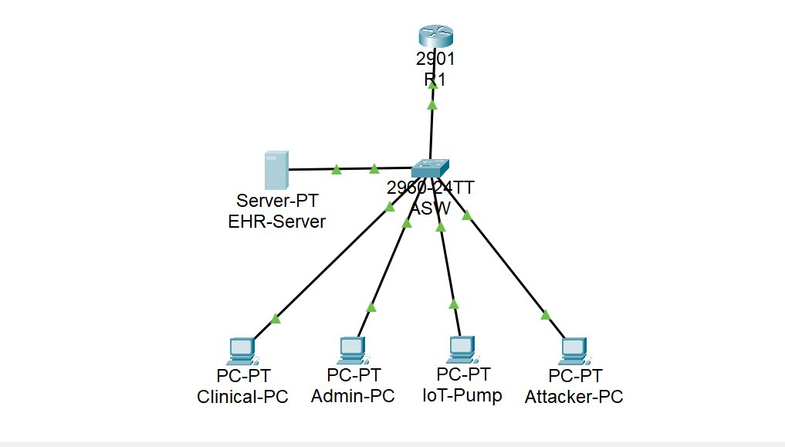
Figure 2: VLAN Verification – show vlan brief on ASW1
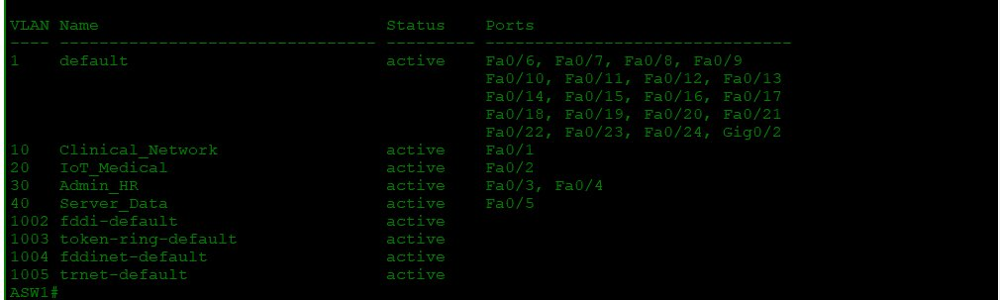
Figure 3: Sub-Interface Verification – show ip interface brief on R1
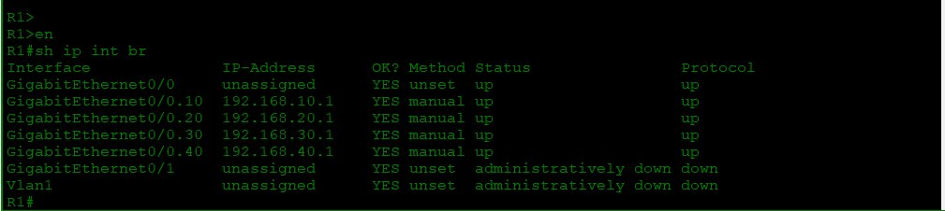

9.2 Appendix B: Before ACLs – Vulnerable Flat Network State
The following screenshots demonstrate that without ACLs, the Attacker-PC on VLAN 30 can freely reach all other VLANs, replicating the flat network vulnerability that enabled the original ransomware incident.
Figure 4: BEFORE ACLs – Attacker-PC successfully pings all VLAN gateways (192.168.10.1, 192.168.20.1, 192.168.40.1)
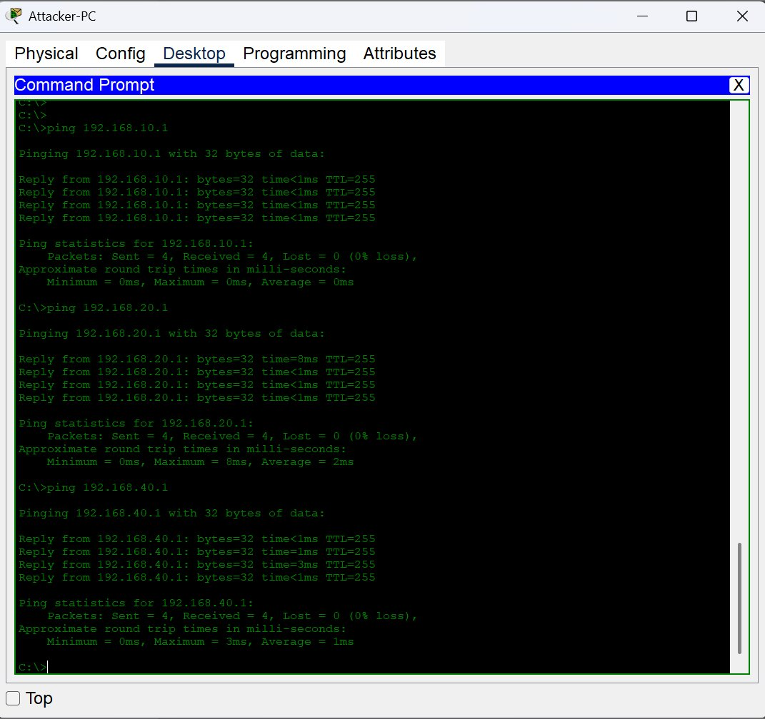
Figure 5: BEFORE ACLs – Attacker-PC successfully loads HTTP page on EHR-Server (192.168.40.10)
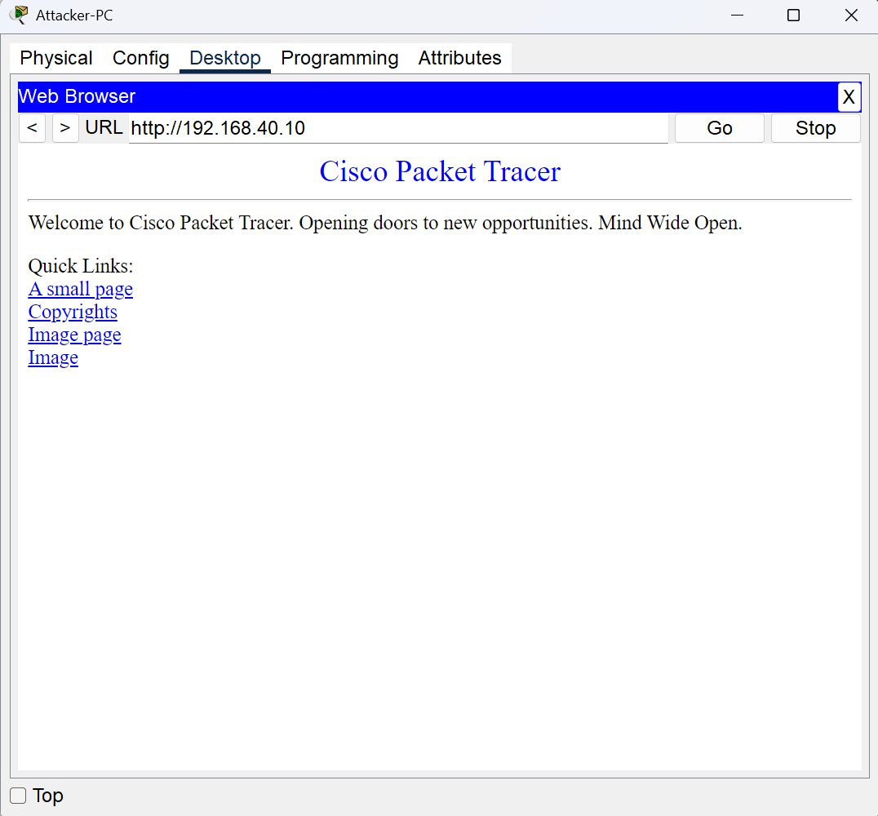

9.3 Appendix C: After ACLs – Lateral Movement Blocked
After applying extended ACLs, all lateral movement attempts from the compromised Attacker-PC are blocked, while legitimate clinical access to the EHR server is preserved.
Figure 6: AFTER ACLs – Attacker-PC pings to all VLANs blocked (Destination host unreachable)
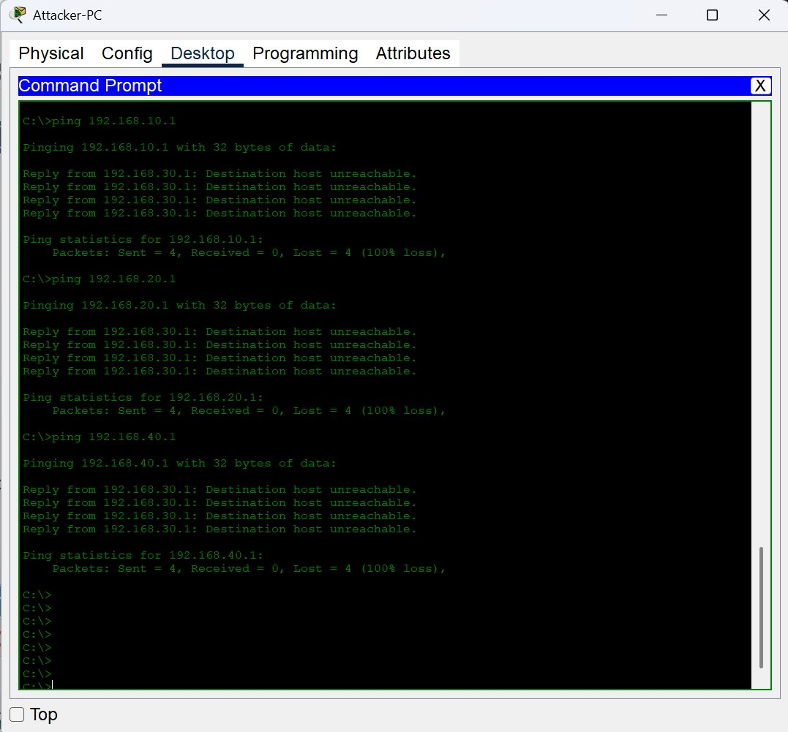
Figure 7: AFTER ACLs – Attacker-PC HTTP to EHR-Server blocked (Request Timeout)
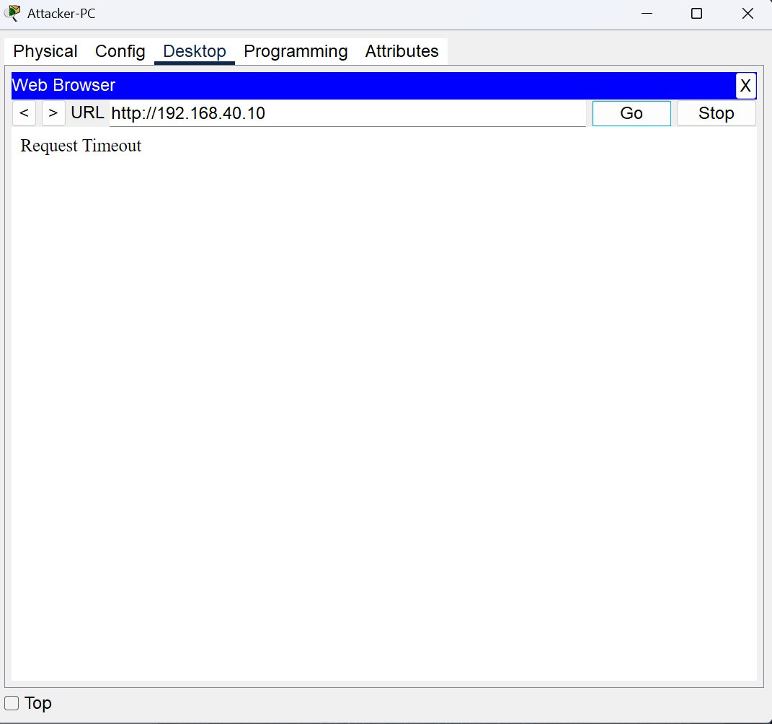

Figure 8: AFTER ACLs – Clinical-PC HTTP to EHR-Server succeeds (legitimate access preserved)
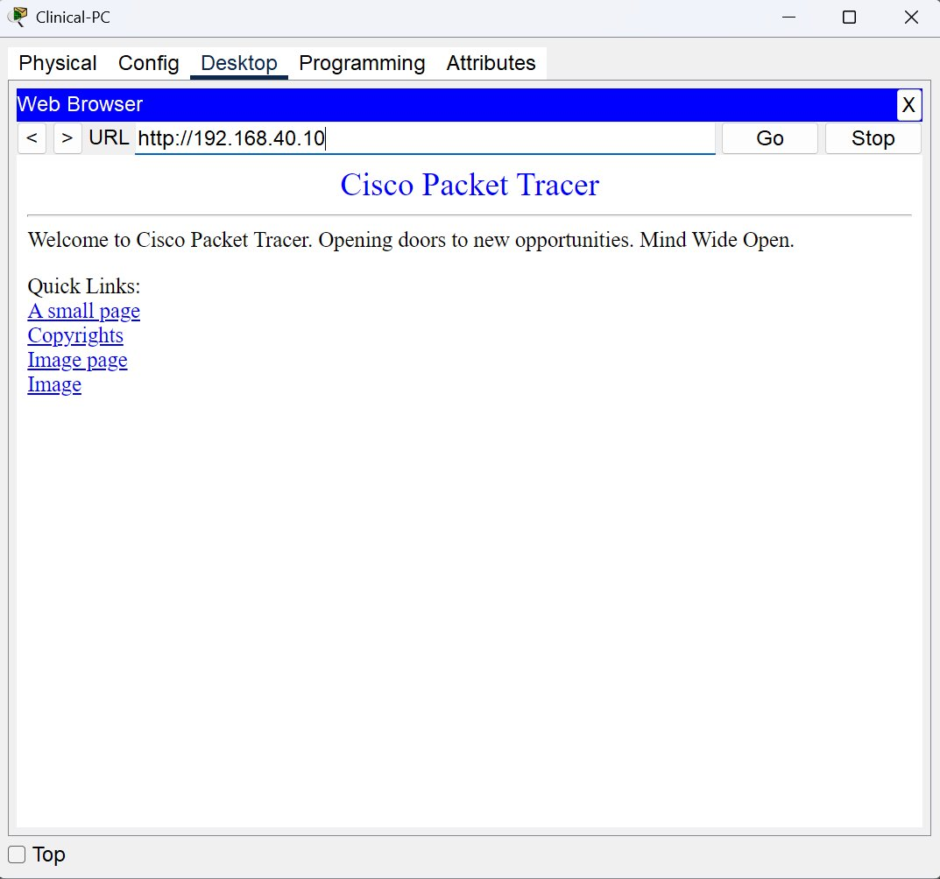

9.4 Appendix D: ACL Verification with Hit Counters
The following output from “show ip access-lists” on R1 confirms that ACL rules are actively matching and dropping unauthorized traffic. The match counters provide evidence that the deny rules are functioning as designed.
Figure 9: ACL Hit Counters – show ip access-lists on R1 (match counts visible on deny and permit rules)
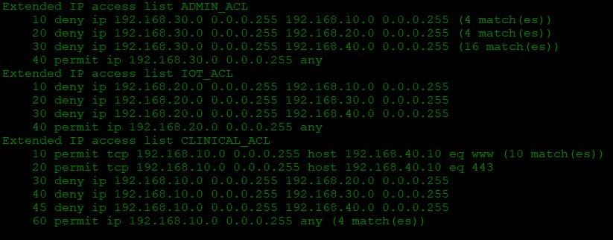

9.5 Appendix E: Complete Running Configurations

R1 (Router) – Running Configuration
!
version 15.1
no service timestamps log datetime msec
no service timestamps debug datetime msec
no service password-encryption
!
hostname R1
!
!
!
!
!
!
!
!
ip cef
no ipv6 cef
!
!
!
!
license udi pid CISCO2901/K9 sn FTX1524F1BO-
!
!
!
!
!
!
!
!
!
!
!
spanning-tree mode pvst
!
!
!
!
!
!
interface GigabitEthernet0/0
no ip address
duplex auto
speed auto
!
interface GigabitEthernet0/0.10
description Clinical_Gateway
encapsulation dot1Q 10
ip address 192.168.10.1 255.255.255.0
ip access-group CLINICAL_ACL in
!
interface GigabitEthernet0/0.20
description IoT_Gateway
encapsulation dot1Q 20
ip address 192.168.20.1 255.255.255.0
ip access-group IOT_ACL in
!
interface GigabitEthernet0/0.30
description Admin_Gateway
encapsulation dot1Q 30
ip address 192.168.30.1 255.255.255.0
ip access-group ADMIN_ACL in
!
interface GigabitEthernet0/0.40
description Server_Gateway
encapsulation dot1Q 40
ip address 192.168.40.1 255.255.255.0
!
interface GigabitEthernet0/1
no ip address
duplex auto
speed auto
shutdown
!
interface Vlan1
no ip address
shutdown
!
ip classless
!
ip flow-export version 9
!
!
ip access-list extended ADMIN_ACL
deny ip 192.168.30.0 0.0.0.255 192.168.10.0 0.0.0.255
deny ip 192.168.30.0 0.0.0.255 192.168.20.0 0.0.0.255
deny ip 192.168.30.0 0.0.0.255 192.168.40.0 0.0.0.255
permit ip 192.168.30.0 0.0.0.255 any
ip access-list extended IOT_ACL
deny ip 192.168.20.0 0.0.0.255 192.168.10.0 0.0.0.255
deny ip 192.168.20.0 0.0.0.255 192.168.30.0 0.0.0.255
deny ip 192.168.20.0 0.0.0.255 192.168.40.0 0.0.0.255
permit ip 192.168.20.0 0.0.0.255 any
ip access-list extended CLINICAL_ACL
permit tcp 192.168.10.0 0.0.0.255 host 192.168.40.10 eq www
permit tcp 192.168.10.0 0.0.0.255 host 192.168.40.10 eq 443
deny ip 192.168.10.0 0.0.0.255 192.168.20.0 0.0.0.255
deny ip 192.168.10.0 0.0.0.255 192.168.30.0 0.0.0.255
deny ip 192.168.10.0 0.0.0.255 192.168.40.0 0.0.0.255
permit ip 192.168.10.0 0.0.0.255 any
!
!
!
!
!
line con 0
!
line aux 0
!
line vty 0 4
login
!
!
!
end

ASW1 (Switch) – Running Configuration
!
version 15.0
no service timestamps log datetime msec
no service timestamps debug datetime msec
no service password-encryption
!
hostname ASW1
!
!
!
!
!
!
spanning-tree mode pvst
spanning-tree extend system-id
!
interface FastEthernet0/1
description Clinical-PC
switchport access vlan 10
switchport mode access
!
interface FastEthernet0/2
description IoT-Pump
switchport access vlan 20
switchport mode access
!
interface FastEthernet0/3
description Admin-PC
switchport access vlan 30
switchport mode access
!
interface FastEthernet0/4
description Attacker-PC
switchport access vlan 30
switchport mode access
!
interface FastEthernet0/5
description EHR-Server
switchport access vlan 40
switchport mode access
!
interface FastEthernet0/6
!
interface FastEthernet0/7
!
interface FastEthernet0/8
!
interface FastEthernet0/9
!
interface FastEthernet0/10
!
interface FastEthernet0/11
!
interface FastEthernet0/12
!
interface FastEthernet0/13
!
interface FastEthernet0/14
!
interface FastEthernet0/15
!
interface FastEthernet0/16
!
interface FastEthernet0/17
!
interface FastEthernet0/18
!
interface FastEthernet0/19
!
interface FastEthernet0/20
!
interface FastEthernet0/21
!
interface FastEthernet0/22
!
interface FastEthernet0/23
!
interface FastEthernet0/24
!
interface GigabitEthernet0/1
description Trunk-to-Router
switchport trunk allowed vlan 10,20,30,40
switchport mode trunk
!
interface GigabitEthernet0/2
!
interface Vlan1
no ip address
shutdown
!
!
!
!
line con 0
!
line vty 0 4
login
line vty 5 15
login
!
!
!
!
end

9.6 Appendix F: References
- NIST SP 800-30 Rev. 1, Guide for Conducting Risk Assessments, 2012.
- NIST Cybersecurity Framework (CSF) v2.0, 2024.
- HIPAA Security Rule, 45 CFR Part 164, Subpart C.
- MITRE ATT&CK Framework, Enterprise and ICS Matrices.
- Cisco IOS Security Configuration Guide, Extended ACLs.
- CIS Benchmarks for Cisco IOS, v4.1.

