**W1D5 – LESSON2, Part 3 ASSIGNMENT – Writing SQL DML queries and statements:**

**In this assignment, you will make use of the Hotel database schema you implemented in**

**Assignment 2. You are required to do the following:**

1. **Populate your Hotel database tables with the data, as given below:**

**Note: It is recommended that you populate the tables with the given data by writing and executing appropriate SQL INSERT statement, in code (i.e. DO NOT DO IT INTERACTIVELY USING the MySQL Workbench tool).**

|  |  |  |  |
| --- | --- | --- | --- |
| **Hotel** |  |  |  |
| **hotelNo** | **hotelName** |  | **City** |
| **101** | **Marriott** |  | **Fairfield** |
| **102** | **Radisson** |  | **Chicago** |
| **103** | **Hilton** |  | **London** |
| **100** | **Marriott** |  | **Chicago** |
| **Room** |  |  |  |
| **roomNo** | **hotelNo** | **Type** | **Price** |
| **1** | **101** | **Executive** | **120** |
| **2** | **101** | **Standard** | **100** |
| **1** | **102** | **Standard** | **100** |
| **1** | **100** | **Executive** | **150** |
| **3** | **103** | **Standard** | **125** |
| **2** | **100** | **Standard** | **115** |
| **Guest** |  |  |  |
| **guestNo** | **guestName** |  | **guestAddress** |
| **1** | **Ana** |  | **12, John st** |
| **2** | **Bob** |  | **Null** |
| **3** | **Carlos** |  | **1000 N Court st** |

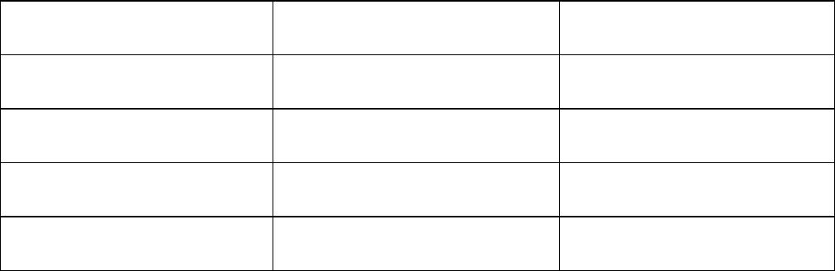



|  |  |  |  |  |
| --- | --- | --- | --- | --- |
|  | **4** | **David** | **6 S Circle Dr** | |
|  | **5** | **Elaine** | **19 Western Blvd** | |
|  | **6** | **Filmon** | **90 Addis Way** | |
| **Booking** |  |  |  |  |
| **hotelNo** | **guestNo** | **dateFrom** | **dateTo** | **roomNo** |
| **100** | **3** | **2021-1-16** | **2021-2-4** | **2** |
| **101** | **2** | **2021-1-13** | **2021-1-16** | **1** |
| **103** | **1** | **2021-2-9** | **2021-3-25** | **3** |
| **101** | **2** | **2021-2-10** | **2021-2-15** | **1** |
| **102** | **4** | **2021-3-4** | **2021-3-9** | **1** |

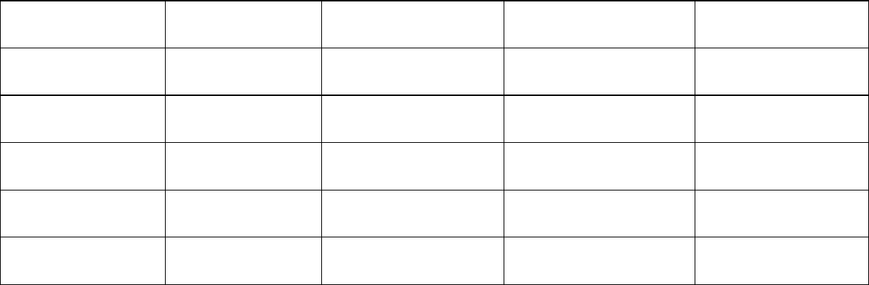

1. **Using the Hotel database, which you have now populated with the above data, write SQL DML code for the following:**
   1. **List full details of all hotels.**
   2. **List full details of all hotels in Chicago.**
   3. **…**
   4. **…**
2. **…**

insert into `hotel`.`hotel`(`hotelNo`,`hotelName`,`city`) values (101,'Marriot','Fairfield');

insert into `hotel`.`hotel`(`hotelNo`,`hotelName`,`city`) values (102,'Radisson','Chicago');

insert into `hotel`.`hotel`(`hotelNo`,`hotelName`,`city`) values (103,'Hilton','London');

insert into `hotel`.`hotel`(`hotelNo`,`hotelName`,`city`) values (100,'Marriot','Chicago');

insert into `hotel`.`room`(`roomNo`,`hotelNo`,`type`,`price`) values (1,101,'Executive',120);

insert into `hotel`.`room`(`roomNo`,`hotelNo`,`type`,`price`) values (2,101,'Standard',100);

insert into `hotel`.`room`(`roomNo`,`hotelNo`,`type`,`price`) values (1,102,'Standard',100);

insert into `hotel`.`room`(`roomNo`,`hotelNo`,`type`,`price`) values (1,100,'Executive',150);

insert into `hotel`.`room`(`roomNo`,`hotelNo`,`type`,`price`) values (3,103,'Standard',125);

insert into `hotel`.`room`(`roomNo`,`hotelNo`,`type`,`price`) values (2,100,'Standard',115);

insert into `hotel`.`guest`(`guestNo`,`guestName`,`guestAddress`) values (1,'Ana','12, John st');

insert into `hotel`.`guest`(`guestNo`,`guestName`,`guestAddress`) values (2,'Bob','12, John st');

insert into `hotel`.`guest`(`guestNo`,`guestName`,`guestAddress`) values (3,'Carlos','12, John st');

insert into `hotel`.`guest`(`guestNo`,`guestName`,`guestAddress`) values (4,'David','12, John st');

insert into `hotel`.`guest`(`guestNo`,`guestName`,`guestAddress`) values (5,'Elaine','12, John st');

insert into `hotel`.`guest`(`guestNo`,`guestName`,`guestAddress`) values (6,'Filmon', '90 Addis Way');

insert into `hotel`.`booking`(`hotelNo`,`guestNo`,`dateFrom`,`dateTo`,`roomNo`) values (100,3,'2021-01-16','2021-02-04', 2);

insert into `hotel`.`booking`(`hotelNo`,`guestNo`,`dateFrom`,`dateTo`,`roomNo`) values (101, 2, '2021-1-13','2021-1-16', 1);

insert into `hotel`.`booking`(`hotelNo`,`guestNo`,`dateFrom`,`dateTo`,`roomNo`) values (103, 1, '2021-2-9', '2021-3-25', 3);

insert into `hotel`.`booking`(`hotelNo`,`guestNo`,`dateFrom`,`dateTo`,`roomNo`) values (101, 2, '2021-2-10','2021-2-15', 1);

insert into `hotel`.`booking`(`hotelNo`,`guestNo`,`dateFrom`,`dateTo`,`roomNo`) values (102, 4, '2021-3-4', '2021-3-9', 1);

select *

from `hotel`.`hotel`;

select *

from `hotel`.`hotel`

where city = 'chicago';