**Assignment5 - W1D6 – LESSON2, Part 3 – Writing SQL DML queries and statements continues:**

**In this assignment, you will continue making use of the Hotel database schema you implemented in Assignments 2 and 4. You are required to do the following:**

1. **If you have not already done it, Populate your Hotel database tables with the data, as given below:**

**Note: It is recommended that you populate the tables with the given data by writing and executing appropriate SQL INSERT statement, in code (i.e. DO NOT DO IT INTERACTIVELY USING the MySQL Workbench tool).**

|  |  |  |  |
| --- | --- | --- | --- |
| **Hotel** |  |  |  |
| **hotelNo** | **hotelName** |  | **City** |
| **101** | **Marriott** |  | **Fairfield** |
| **102** | **Radisson** |  | **Chicago** |
| **103** | **Hilton** |  | **London** |
| **100** | **Marriott** |  | **Chicago** |
| **Room** |  |  |  |
| **roomNo** | **hotelNo** | **Type** | **Price** |
| **1** | **101** | **Executive** | **120** |
| **2** | **101** | **Standard** | **100** |
| **1** | **102** | **Standard** | **100** |
| **1** | **100** | **Executive** | **150** |
| **3** | **103** | **Standard** | **125** |
| **2** | **100** | **Standard** | **115** |
| **Guest** |  |  |  |
| **guestNo** | **guestName** |  | **guestAddress** |
| **1** | **Ana** |  | **12, John st** |
| **2** | **Bob** |  | **Null** |
| **3** | **Carlos** |  | **1000 N Court st** |

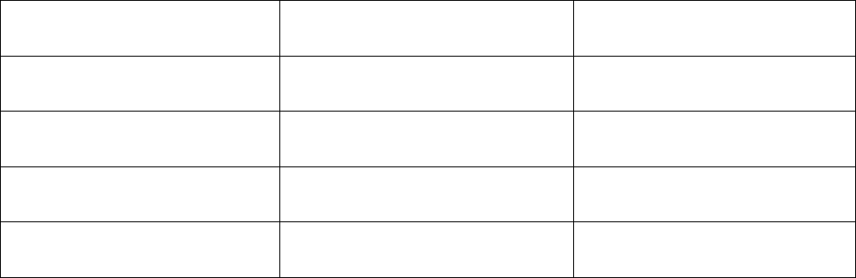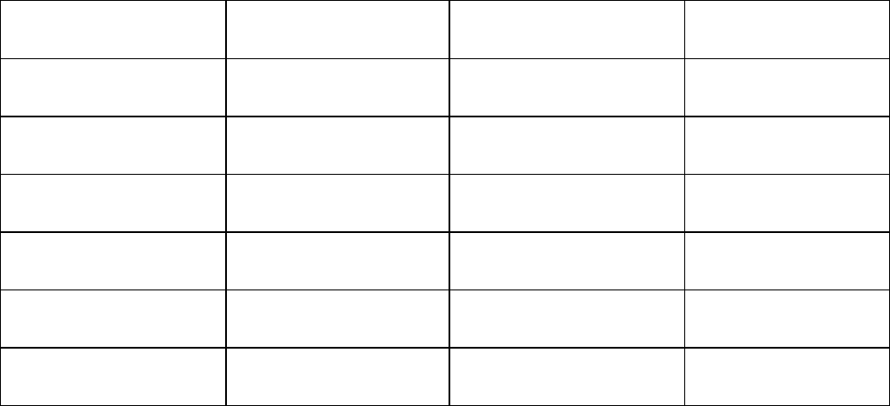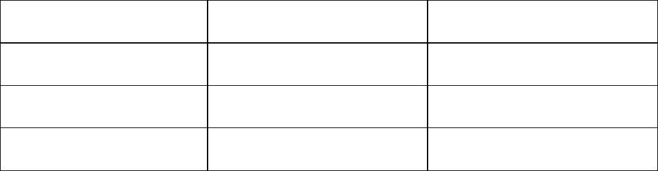



|  |  |  |  |  |
| --- | --- | --- | --- | --- |
|  | **4** | **David** | **6 S Circle Dr** | |
|  | **5** | **Elaine** | **19 Western Blvd** | |
|  | **6** | **Filmon** | **90 Addis Way** | |
| **Booking** |  |  |  |  |
| **hotelNo** | **guestNo** | **dateFrom** | **dateTo** | **roomNo** |
| **100** | **3** | **2021-1-16** | **2021-2-4** | **2** |
| **101** | **2** | **2021-1-13** | **2021-1-16** | **1** |
| **103** | **1** | **2021-2-9** | **2021-3-25** | **3** |
| **101** | **2** | **2021-2-10** | **2021-2-15** | **1** |
| **102** | **4** | **2021-3-4** | **2021-3-9** | **1** |

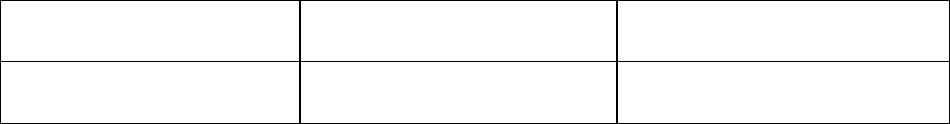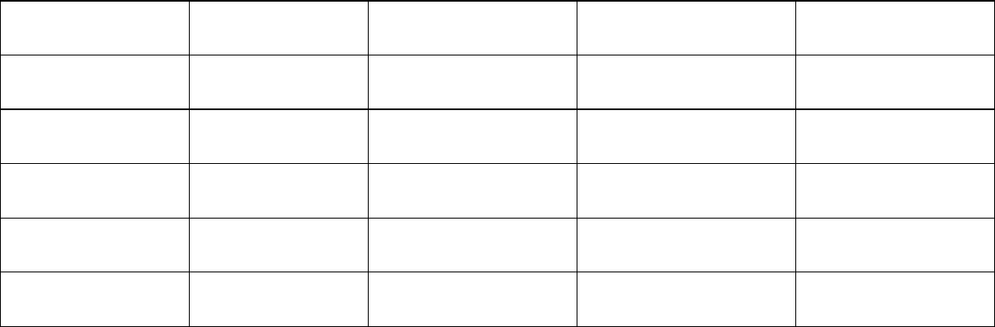

1. **Using the Hotel database, which you now have fully populated with the above data, write SQL DML code for the following:**
   1. **List the names and addresses of all guests living in Chicago, sorted alphabetically by their name, in descending order.**

select g.guestName, g.guestAddress

from `hotel`.`guest` as g

where g.guestNo in

(select b.guestNo

from `hotel`.`booking` as b

where b.hotelNo in

(select h.hotelNo

from `hotel`.`hotel` as h

where h.city = 'chicago'))

order by g.guestName desc;

* 1. **Display List of all Standard rooms with a price of below $130.00 per night, including the room number, room type, price, hotel name and city; Have the list be sorted in order of the prices, from cheapest to most expensive.**

select r.roomNo, r.type, r.price, h.hotelName, h.city

from `hotel`.`room` as r, `hotel`.`hotel`as h

where r.price <130 and h.hotelNo = r.hotelNo

order by r.price desc

* 1. **List the bookings for which no dateTo has been specified**

select *

from `hotel`.`booking` as b

where b.dateTo is null;

* 1. **Display How many hotels are there?**

select count(*)

from `hotel`.`hotel` as h

;

* 1. **What is the average price of a room?**

select avg(r.price)

from `hotel`.`room` as r

;

* 1. **Display list of all hotels that have been booked including for each hotel, how many bookings have been made and showing the hotel number, hotel name and city.**

select h.hotelNo,h.hotelName,h.city, count(b.hotelNo) as count

from `hotel`.`booking` as b, `hotel`.`hotel` as h

where b.hotelNo = h.hotelNo

group by b.hotelNo

* 1. **Display How many total bookings have been made?**

select count(*)

from `hotel`.`booking` as b

;

* 1. **Display list of all guests in the database including both those who have booked a hotel room before and those who have not yet booked a hotel room and for each guest, include how many bookings they have made and show the guest number, guest name and address.**

select g.guestNo,g.guestName,g.guestAddress, count(b.guestNo) as bookings

from `hotel`.`guest` as g left join `hotel`.`booking` as b

on g.guestNo = b.guestNo

group by g.guestNo;

* 1. **Assume the Hotel guest named, Bob, has now provided his address as, "1490 Jersey Village Road". Write SQL DML code to update his information.**

update `hotel`.`guest` as g

set g.guestAddress = '1490 Jersey Village Road'

where g.guestName = 'Bob';

* 1. **Delete every the booking that has been made by the guest named, Bob, if it is scheduled after the month of January 2021.**

delete from `hotel`.`booking` as b

where b.dateFrom > '2021-01-31' and b.guestNo in

(select g.guestNo

from `hotel`.`guest` as g

where g.guestName = 'Bob');

* 1. **Due to the annual cost of inflation, the hotel needs to increase the prices of all Executive rooms by 5% and the prices of all Standard rooms by 3%. Write SQL DML code to do this.**

update `hotel`.`room` as r

set r.price = r.price * 1.05

where r.type = 'executive';

update `hotel`.`room` as r

set r.price = r.price * 1.03

where r.type = 'standard';

* **-- The End --//**