REST

Rujuan Xing

1

What is REST?

- REST = REpresentational State Transfer

- REST is an architectural style consisting of a coordinated set of architectural constraints

- First described in 2000 by Roy Fielding in his doctoral dissertation at UC Irvine

- RESTful is typically used to refer to web services implementing a REST architecture

- Alternative to other distributed-computing specifications such as SOAP

- Simple HTTP client/server mechanism to exchange data

- Everything – the UNIVERSE is available through a URI

- Utilizes HTTP: GET/POST/PUT/DELETE operations

2

Why REST?

Not every Frontend (UI) requires HTMLPages!

Mobile Apps |  | Single Page Web Apps |  | Service APIs
(e.g. Twitter) |  | (e.g. Twitter, github.com) |  | (e.g. Google Maps API)


Frontend (UI) is decoupled from the Backend (Server)

3
REST API Big Picture

Mobile App

Client

SPA
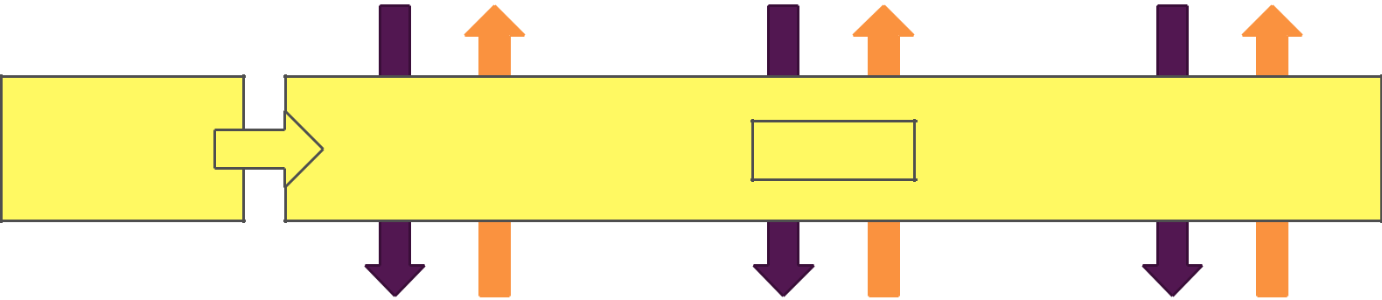

Any App

ONLY the

Data, not

the UI!

Data

App Backend API

Service API

Server

4

Data Formats

HTML

<p>Node.js</p>

Data +Structure

Contains User
Interface

Unnecessarily

difficult to parseif

you just need the

data

5

Plain Text

Node.js

Data

No UI Assumptions

Unnecessarily difficult to parse,no clear data structure

XML |  | JSON
<name>Node.js</name> |  | {"title": "Node.js"}
Data |  | Data
No UI Assumptions |  | No UI Assumptions
Machine-readable |  | Machine-readable
but relatively |  | and concise; Can
verbose; XML-parser |  | easily be converted
needed |  | to JavaScript

Architectural Constraints

- Uniform interface

  - Individual resources are identified in requests, i.e.,using URIs in web-based REST systems.

- Client-server

  - Separation of concerns. A uniform interface separates clients from servers.

- Stateless

  - The client-server communication is further constrained by no client context being stored on the server between requests.

- Cacheable

  - Basic WWW principle: clients can cache responses.

- Layered system

  - A client cannot necessarily tell whether it is connected directly to the end server, or to an intermediary along the way.

- Code on demand (optional)
  - REST allows client functionality to be extended by downloading and executing code in the form of applets or scripts.
This simplifies clients by reducing the number of features required to be pre-implemented.

6
Resource

- The key abstraction of information in REST is a resource.

  - a document or image, a temporal service, a collection of other resources, a non-virtual object (e.g. a person), and so on.

- Resource representation: consists of data, metadata describing the data and hypermedia links which can help the clients in transition to the next desired state.

7
Resource Naming Best Practices

-Use nouns to represent resources

- Document:

  - a singular concept, like an object instance or db record.

  - Use “singular” name to denote document resource archetype.

    - http://api.example.com/device-management/managed-devices/{device-id}

    - http://api.example.com/user-management/users/{id}

    - http://api.example.com/user-management/users/admin

- Collection: sever-managed directory of resources.

  - Use “plural” name to denote collection resource archetype

    - http://api.example.com/device-management/managed-devices

    - http://api.example.com/user-management/users

    - http://api.example.com/user-management/users/{id}/accounts

8
Resource Naming Best Practices

-Use nouns to represent resources

- store

  - a client-managed resource repository.

  - Use “plural” name to denote store resource archetype.

    - http://api.example.com/cart-management/users/{id}/carts

    - http://api.example.com/song-management/users/{id}/playlists

- controller

  - A controller resource models a procedural concept.

  - Use “verb” to denote controller archetype.

    - http://api.example.com/cart-management/users/{id}/cart/checkout

    - http://api.example.com/song-management/users/{id}/playlist/play

9
Resource Naming Best Practices -Consistency is the key

- Use forward slash (/) to indicate hierarchical relationships

  - The forward slash (/) character is used in the path portion of the URI to indicate a hierarchical relationship between resources.

  - http://api.example.com/device-management

  - http://api.example.com/device-management/managed-devices

  - http://api.example.com/device-management/managed-devices/{id}

- Do not use trailing forward slash (/) in URIs

  - http://api.example.com/device-management/managed-devices/
 http://api.example.com/device-management/managed-devices /*This is much better version*/

- Use hyphens (-) to improve the readability of URIs

  - http://api.example.com/inventory-management/managed-entities/{id}/install-script-location //More readable

  - http://api.example.com/inventory-management/managedEntities/{id}/installScriptLocation //Less readable

- Do not use underscores ( _ )

  - http://api.example.com/inventory-management/managed-entities/{id}/install-script-location //More readable

  - http://api.example.com/inventory_management/managed_entities/{id}/install_script_location //More error prone

- Use lowercase letters in URIs

- Do not use file extensions

  - http://api.example.com/device-management/managed-devices.xml /*Do not use it*/
 http://api.example.com/device-management/managed-devices /*This is correct URI*/

10
Resource Naming Best Practices

-Never use CRUD function names in URIs

- HTTP request methods should be used to indicate which CRUD function is performed.

  - HTTP GET http://api.example.com/device-management/managed-devices //Get all devices

  - HTTP POST http://api.example.com/device-management/managed-devices //Create new Device

  - HTTP GET http://api.example.com/device-management/managed-devices/{id} //Get device for given Id

  - HTTP PUT http://api.example.com/device-management/managed-devices/{id} //Update device for given Id

  - HTTP DELETE http://api.example.com/device-management/managed-devices/{id} //Delete device for given Id

11
Resource Naming Best Practices

-Use query component to filter URI collection

- Many times, you will come across requirements where you will need a collection of resources sorted, filtered or limited based on some certain resource attribute. For this, do not create new APIs – rather enable sorting, filtering and pagination capabilities in resource collection API and pass the input parameters as query parameters. e.g.

  - http://api.example.com/device-management/managed-devices

  - http://api.example.com/device-management/managed-devices?region=USA

  - http://api.example.com/device-management/managed-devices?region=USA&brand=XYZ

  - http://api.example.com/device-management/managed-devices?region=USA&brand=XYZ&sort=installation-date

12
HTTP Methods for RESTful APIs

HTTP | CRUD | ENTIRE COLLECTION (E.G. | SPECIFIC ITEM (E.G. /USERS/123)
METHOD | CRUD | /USERS) | SPECIFIC ITEM (E.G. /USERS/123)
POST | Create | 201 (Created), ‘Location’ header with | Avoid using POST on single resource
POST | Create | link to /users/{id} containing new ID. | Avoid using POST on single resource
GET | Read | 200 (OK), list of users. Use pagination, | 200 (OK), single user. 404 (Not Found), if ID not found
GET | Read | sorting and filtering to navigate big lists. | or invalid.
 |  | 405 (Method not allowed), unless you | 200 (OK) or 204 (No Content). Use 404 (Not Found),
PUT | Update/Replace | want to update every resource in the | 200 (OK) or 204 (No Content). Use 404 (Not Found),
PUT | Update/Replace | want to update every resource in the | if ID not found or invalid.
 |  | entire collection of resource. | if ID not found or invalid.
PATCH | Partial | 405 (Method not allowed), unless you | 200 (OK) or 204 (No Content). Use 404 (Not Found),
PATCH | Update/Modify | want to modify the collection itself. | if ID not found or invalid.
 |  | 405 (Method not allowed), unless you
DELETE | Delete | want to delete the whole collection — | 200 (OK). 404 (Not Found), if ID not found or invalid.
 |  | use with caution.
13
What’s MVC?

Separation of Concerns

Routes

Models

Represent your data inyour

code

Work with your data(e.g.
save, fetch)

15

Views

What the userssees

Decoupled from your

application code

Controllers

Split across
Middleware Functions

Connecting your Models

and your Views

Contains the “in-between”

logic

Demo: Shopping Cart - Model
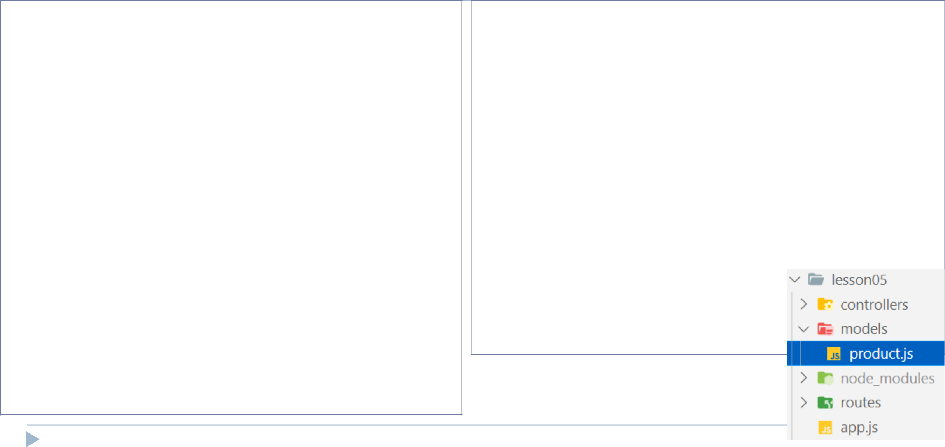

let products = [];

module.exports = class Product {

constructor(id, title, price, description) { this.id = id;

this.title = title;

this.price = price;

this.description = description;

}

save() {

this.id = Math.random().toString(); products.push(this);

return this;

}

update() {

const index = products.findIndex(p => p.id === this.id); if (index > -1) {

products.splice(index, 1, this);

return this;

} else {

throw new Error('NOT Found');

}

}

16

static fetchAll() {

return products;

}

static findById(productId) {

const index = products.findIndex(p => p.id === productId); if (index > -1) {

return products[index];

} else {

throw new Error('NOT Found');

}

}

static deleteById(productId) {

const index = products.findIndex(p => p.id === productId); if (index > -1) {

products = products.filter(p => p.id !== productId);

} else {

throw new Error('NOT Found');

}

}

}

Demo: Shopping Cart – Controller
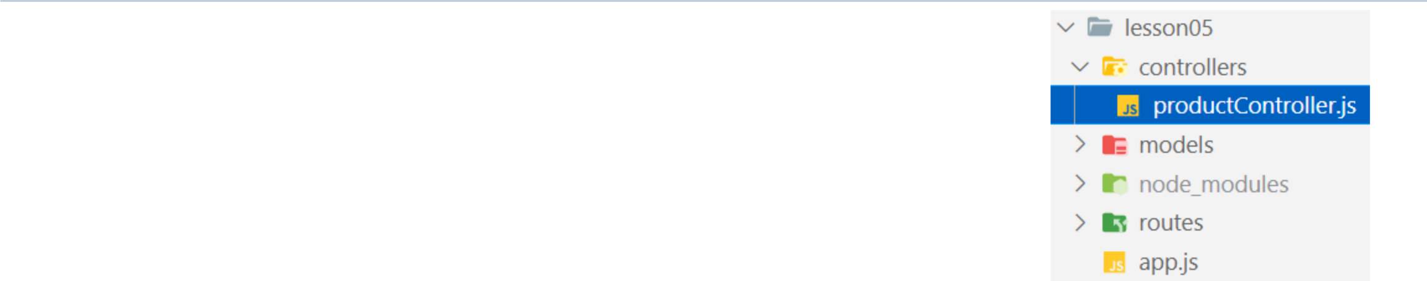

const Product = require('../models/product');

exports.getProducts = (req, res, next) => {

res.status(200).json(Product.fetchAll());

}

exports.getProductById = (req, res, next) => {

res.status(200).json(Product.findById(req.params.prodId));

}

exports.save = (req, res, next) => {

const prod = req.body;

const savedProd = new Product(null, prod.title, prod.price, prod.description).save(); res.status(201).json(savedProd);

}

exports.update = (req, res, next) => {

const prod = req.body;

const updatedProd = new Product(req.params.prodId, prod.title, prod.price, prod.description).update(); res.status(200).json(updatedProd);

}

exports.deleteById = (req, res, next) => {

Product.deleteById(req.params.prodId);

res.status(200).end();

}

17
Demo: Shopping Cart – Route
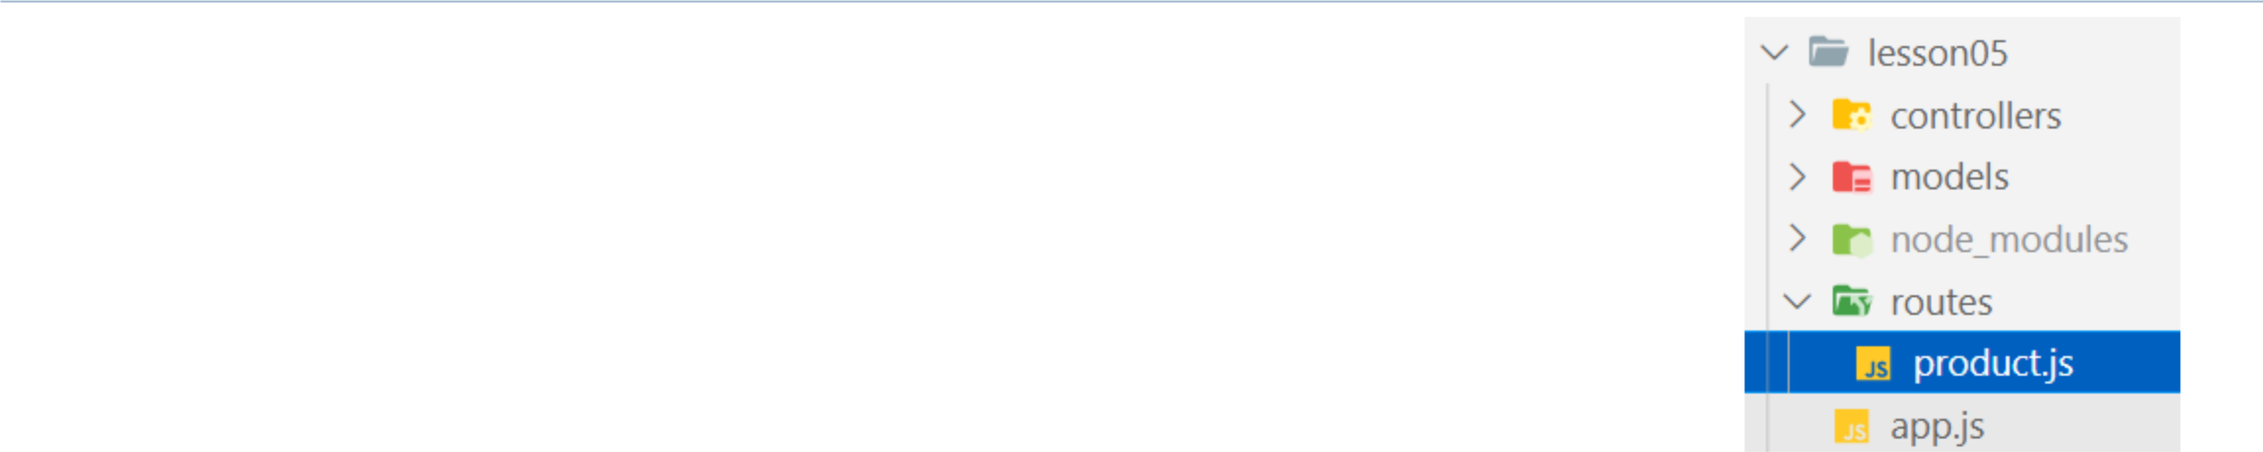

const express = require('express');

const productController = require('../controllers/productController');

const router = express.Router();

router.get('/', productController.getProducts);

router.get('/:prodId', productController.getProductById);

router.post('/', productController.save);

router.put('/:prodId', productController.update);

router.delete('/:prodId', productController.deleteById);

module.exports = router;

18
Demo: Shopping Cart – app.js

const express = require('express');
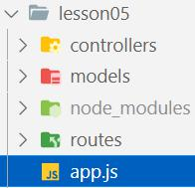

const productRouter = require('./routes/product'); const cors = require('cors');

const app = express();

app.use(cors());

app.use(express.json());

app.use('/products', productRouter);

app.use((req, res, next) => {

res.status(404).json({ error: req.url + ' API not supported!' });

});

app.use((err, req, res, next) => {

if (err.message === 'NOT Found') {

res.status(404).json({ error: err.message });

} else {

res.status(500).json({ error: 'Something is wrong! Try later' });

}

});

app.listen(3000, () => console.log('listening to 3000...'));

19
Demo: Shopping Cart – Testing APIs
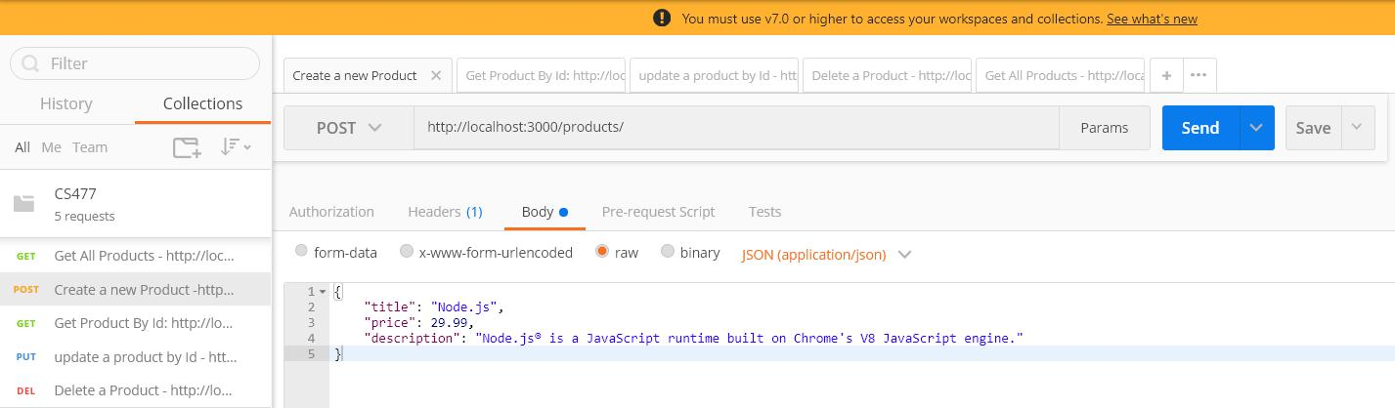

20
Demo: Shopping Cart – Client side
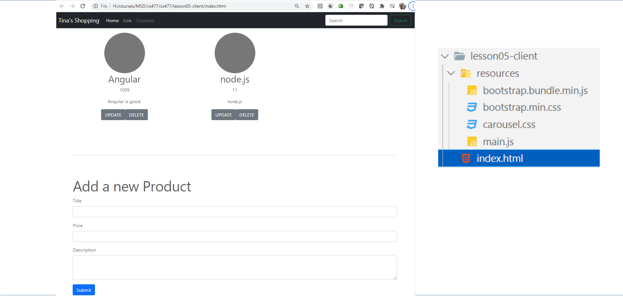

21
CORS (Cross-Origin Resource Sharing)

- Cross-Origin Resource Sharing (CORS) is a mechanism that uses additional HTTP headers to tell browsers to give a web application running at one origin, access to selected resources from a different origin. A web application executes a cross-origin HTTP request when it requests a resource that has a different origin (domain, protocol, or port) from its own.

Client

localhost:3000

Client

localhost:4000

CORS Error


Server

localhost:3000

Server

localhost:3000

22

cors

- npm install cors

- Simple Usage (Enable All CORS Requests)

  - const cors = require('cors');

  - app.use(cors());

- Enable CORS for a Single Route

  - router.post('/users', cors(), userController.insert);

23
Resources

- REST

  - https://restfulapi.net/

- CORS

  - https://developer.mozilla.org/en-US/docs/Web/HTTP/CORS

  - https://github.com/expressjs/cors

25

