Authentication & Authorization

Rujuan Xing

1

Basic Problem

- How do you prove to someone that you are who you claim to be?


2

Authentication

- Authentication is any process by which a system verifies the identity of a user who wishes to access it.

- Authentication may be implemented using Credentials, each of which is composed of a user Id and password. Alternately, Authentication may be implemented with Smart Cards, etc..

3
Authorization

- Authorization is the function of specifying access rights/privileges to resources, which is related to information security and computer security in general and to access control in particular.
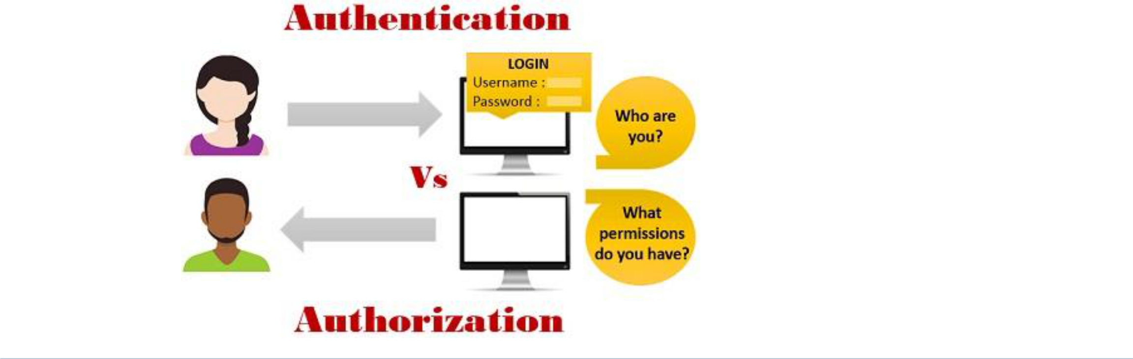

4
Token-Based Authentication Systems
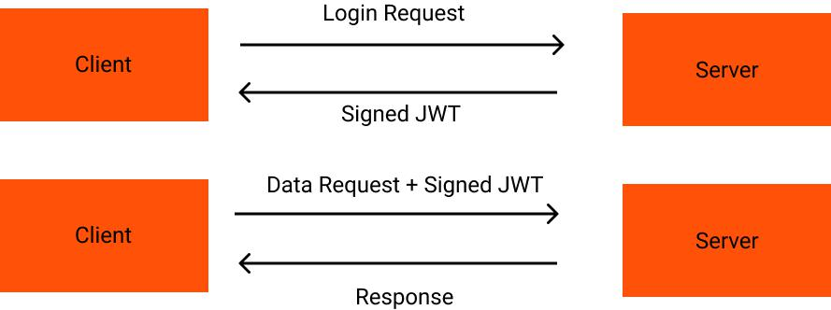

5
Token-based Authorization System

- Stateless: self contained

- Scalability: no need to store session in memory

- CSRF: no session being used

- Digitally-signed

- Decoupled

6
What is JSON Web Token?

- JSON Web Token (JWT) is an open standard (RFC 7519) that defines a compact and self-contained way for securely transmitting information between parties as a JSON object.

- JWTs can be signed using a secret (with the HMAC algorithm) or a public/private key pair using RSA.

- This information can be verified and trusted because it is digitally signed.

- Compact: Because of their smaller size, JWTs can be sent through a URL, POST parameter, or inside an HTTP header. Additionally, the smaller size means transmission is fast.

 Simply a string in the format of header.payload.signature

- Self-contained: The payload contains all the required information about the user, avoiding the need to query the database more than once.

7
JSON Web Token Structure

- JSON Web Tokens consist of three parts separated by dots (.), which are:

  - header

  - payload

  - signature

- Therefore, a JWT typically looks like the following:

  - xxxxx.yyyyy.zzzzz

  - eyJhbGciOiJIUzI1NiIsInR5cCI6IkpXVCJ9.eyJzdWIiOiIxMjM0NTY3ODkwIiwibmFtZSI6I kpvaG4gRG9lIiwiaWF0IjoxNTE2MjM5MDIyfQ.SflKxwRJSMeKKF2QT4fwpMeJf36POk 6yJV_adQssw5c

8
JWT Header

- The header typically consists of two parts: the type of the token, which is JWT, and the hashing algorithm being used, such as HMAC SHA256 or RSA.

- For example:

{

"alg": "HS256",

"typ": "JWT"

}

- Then, this JSON is Base64Url encoded to form the first part of the JWT.

eyJhbGciOiJIUzI1NiIsInR5cCI6IkpXVCJ9.eyJzdWIiOiIxMjM0NTY3ODkwIiwibmF tZSI6IkpvaG4gRG9lIiwiaWF0IjoxNTE2MjM5MDIyfQ.SflKxwRJSMeKKF2QT4fwp MeJf36POk6yJV_adQssw5c

9
HMAC SHA256 vs RSA SHA256 hashing algorithms

- HMAC SHA256: Symmetric Key cryptography, single shared private key. Faster, good between trusted parties.

  - A combination of a hashing function and one (secret) key that is shared between the two parties used to generate the hash that will serve as the signature.

- RSA SHA256: Asymmetric Key cryptography, public/private keys. Slower, good between untrusted parties.

  - The identity provider has a private (secret) key used to generate the signature, and the consumer of the JWT gets a public key to validate the signature.

10
JWT Payload

- The second part of the token is the payload, which contains the claims.

- Claims are statements about an entity (typically, the user) and additional metadata. There are three types of claims:

  - Reserved/Registered

    - These are a set of predefined claims which are not mandatory but recommended, to provide a set of useful, interoperable claims. Some of them are: iss (issuer), exp (expiration time), sub (subject), aud (audience), and others.

  - Public

    - These can be defined at will by those using JWTs. But to avoid collisions they should be defined in the IANA JSON Web Token Registry or be defined as a URI that contains a collision resistant namespace.

  - Private

    - These are the custom claims created to share information between parties that agree on using them and are neither registered or public claims.

11
JWT Payload

- For example:

{

"sub": "1234567890",

"name": "John Doe",

"iat": 1516239022

}

- The payload is then Base64Url encoded to form the second part of the JSON Web Token.

eyJhbGciOiJIUzI1NiIsInR5cCI6IkpXVCJ9.eyJzdWIiOiIxMjM0NTY3ODkwIiwibmFtZSI6I kpvaG4gRG9lIiwiaWF0IjoxNTE2MjM5MDIyfQ.SflKxwRJSMeKKF2QT4fwpMeJf36POk6 yJV_adQssw5c

12
JWT Signature

- To create the signature part you have to take the encoded header, the encoded payload, a secret, the algorithm specified in the header, and sign that.

- The signature is used to verify that the sender of the JWT is who it says it is and to ensure that the message wasn't changed along the way.

- For example if you want to use the HMAC SHA256 algorithm, the signature will be created in the following way:

- eyJhbGciOiJIUzI1NiIsInR5cCI6IkpXVCJ9.eyJzdWIiOiIxMjM0NTY3ODkwIiwib mFtZSI6IkpvaG4gRG9lIiwiaWF0IjoxNTE2MjM5MDIyfQ.SflKxwRJSMeKKF2Q T4fwpMeJf36POk6yJV_adQssw5c
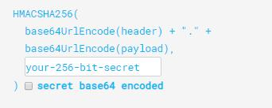

13
jwt.io
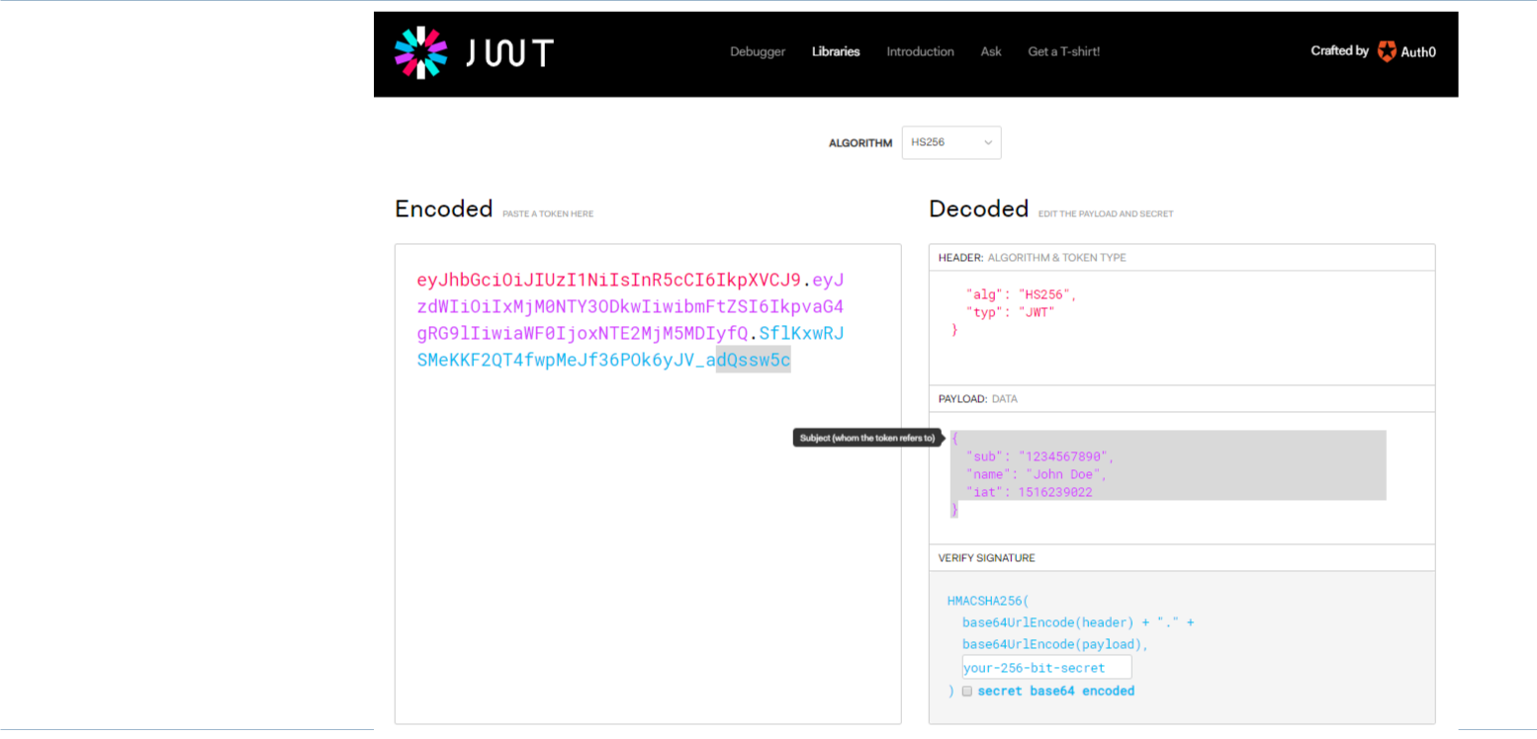

- JWT.IO allows you to decode, verify and generate JWT.

14
How does JWT work?

- In authentication, when the user successfully logs in using their credentials, a JSON Web Token will be returned and must be saved locally (typically in local storage, but cookies can be also used).

- Whenever the user wants to access a protected route or resource, the user agent should send the JWT, typically in the Authorization header using the Bearer schema. The content of the header should look like the following:
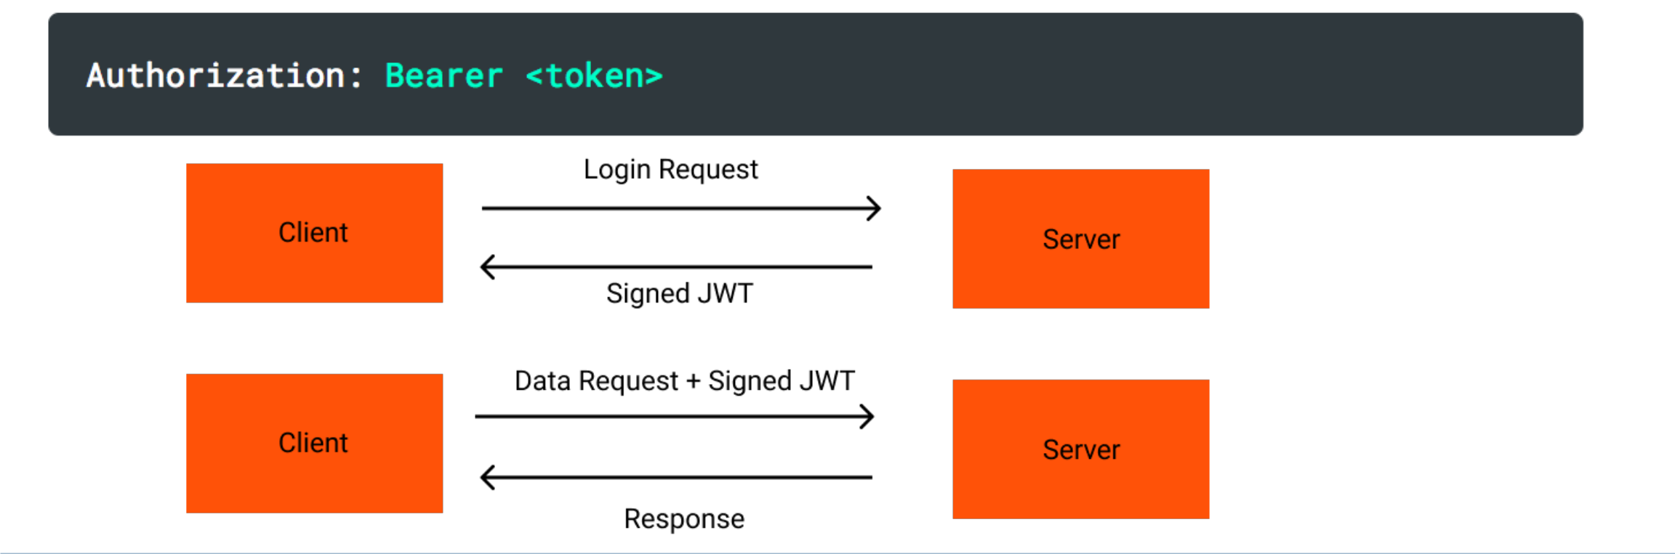

15
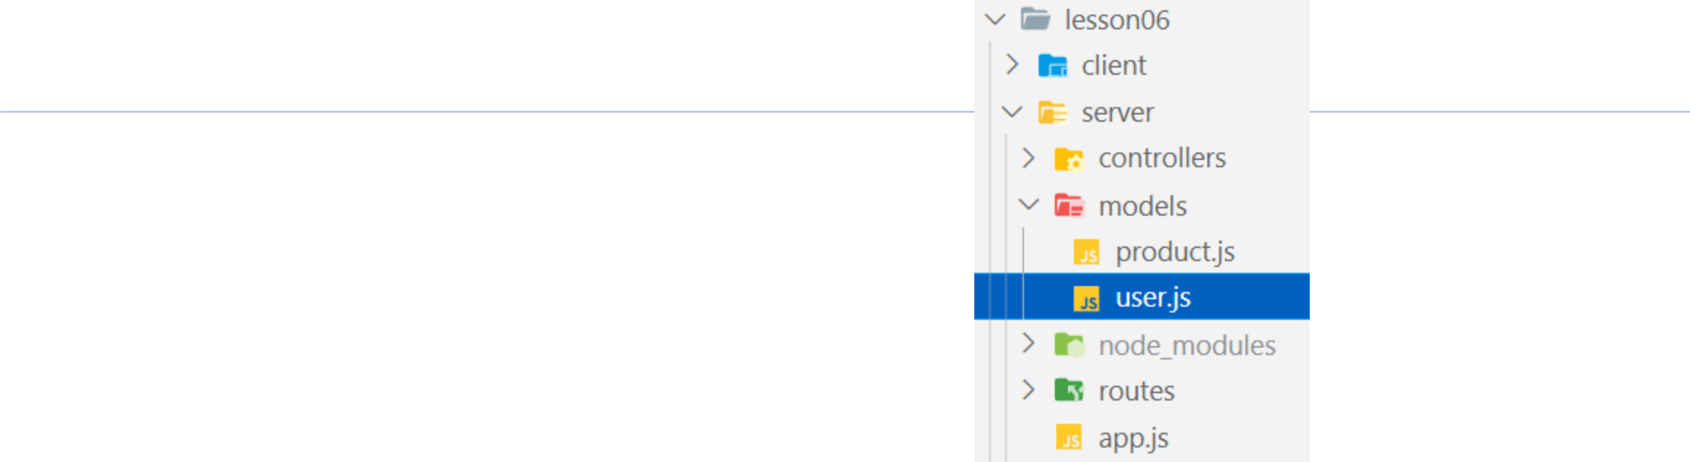
Auth Demo - Model

const users = [];

module.exports = class User {

constructor(username, password, role) {

this.username = username;

this.password = password;

this.role = role;

}

login() {

return users.find(u => { return u.username === this.username && u.password === this.passw
ord });

}

static init() {

users.push(new User('john', 'admin', 'admin')); users.push(new User('bella', 'member', 'member'));

}

}

16

Auth Demo - Controller
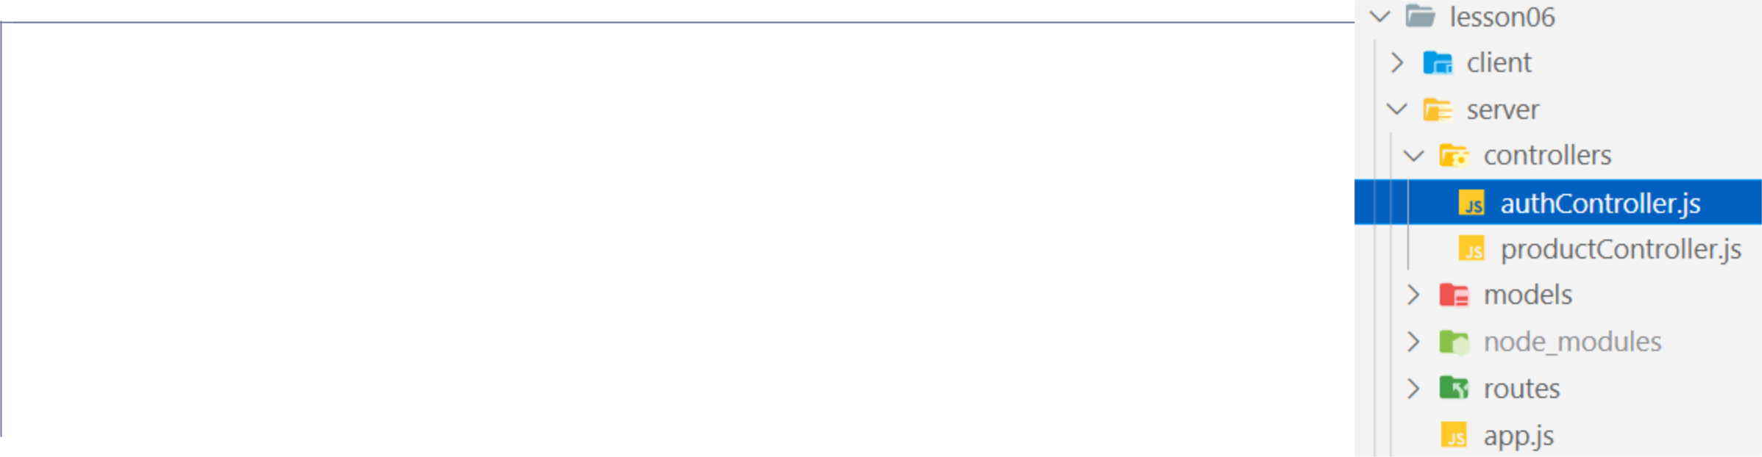

const jwt = require('jsonwebtoken');

const User = require('../models/user');

const accessTokenSecret = "tina's shopping";

exports.login = (req, res, next) => {

const user = new User(req.body.username, req.body.password, null).login(); if (user) {

const accessToken = jwt.sign({ username: user.username, role: user.role }, accessTokenSecret); res.json({ accessToken });

} else {

res.status(200).json({ 'error': 'username or password invalid' });

}

}

 | exports.authorize = (req, res, next) => {
 | const authHeader = req.headers.authorization;
 | if (authHeader) {
 | const token = authHeader.split(' ')[1];
 | jwt.verify(token, accessTokenSecret, (err, user) => {
 | console.log(user);
 | if (err) {
 | return res.status(403).json({ "error": "Forbidden" });
 | }
 | req.user = user;
 | next();
 | });
 | } else {
17 | res.status(401).json({ "error": "Unauthorized" });
17 | }
 | }
Auth Demo - Route
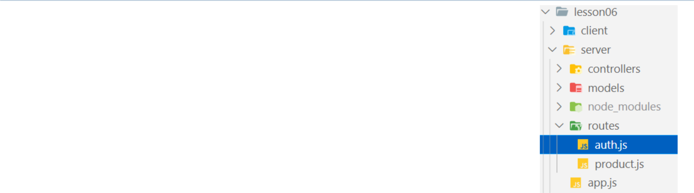

const express = require('express');

const authController = require('../controllers/authController'); const router = express.Router();

router.post('/login', authController.login); router.use(authController.authorize);

module.exports = router;

18
Auth Demo – app.js

const authRouter = require('./routes/auth');

app.use(authRouter); //all urls access after authRouter needs JWT app.use('/products', productRouter);
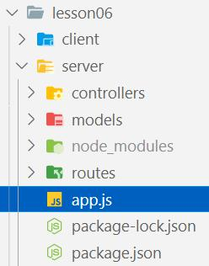

19
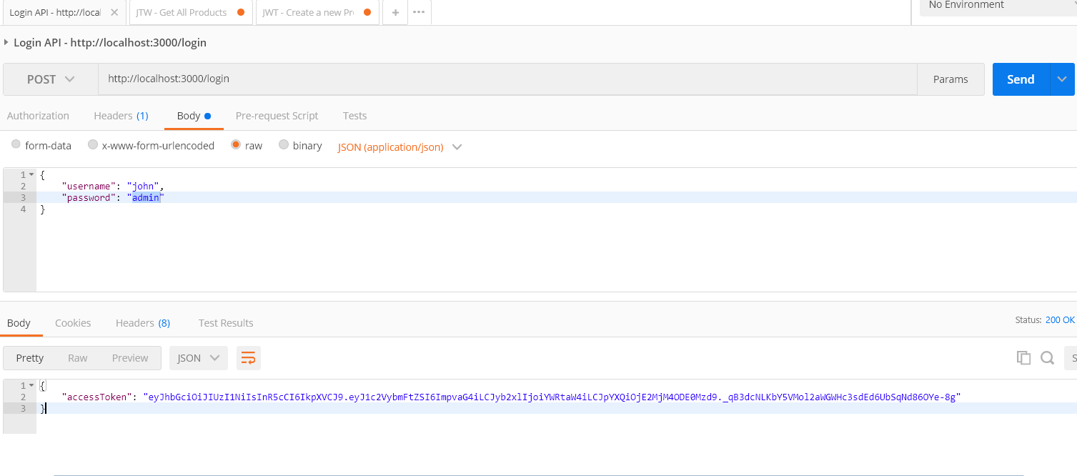

20
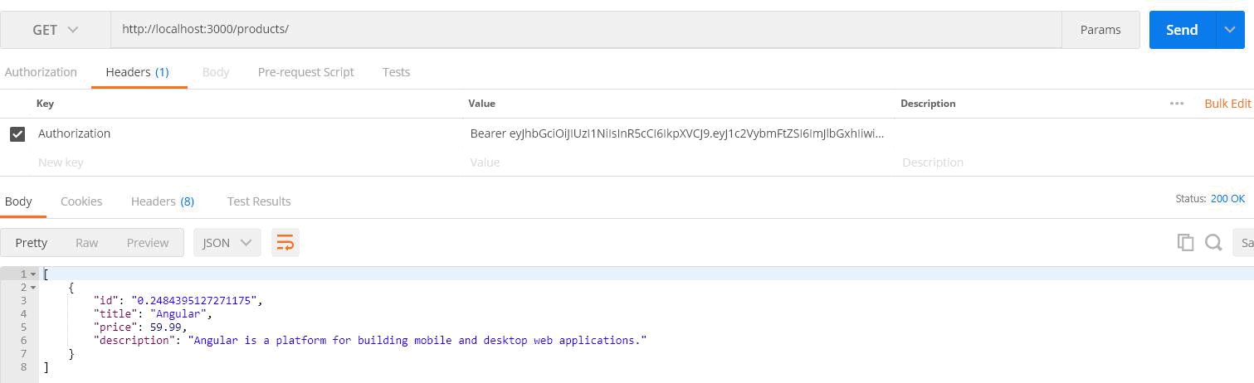

21
Auth Demo - Client
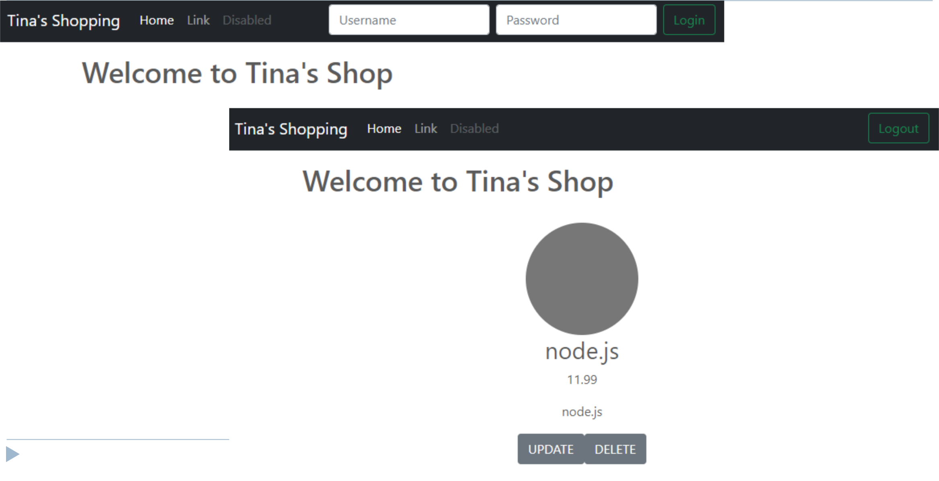

22
Resources

- https://stackabuse.com/authentication-and-authorization-with-jwts-in-express-js

- https://jwt.io/

- https://www.npmjs.com/package/jsonwebtoken

23

