Motion
Distance: The total path length covered by the object. SI Unit : Meter. It is scaler quantity
Displacement: The shortest distance measured from the initial to the final position of an object. SI unit : Meter . It is vector quantity
Speed: Distance travelled by the object in unit time. SI Unit : meter/sec . . It is scaler quantity
The average speed of an object is obtained by dividing the total distance travelled by the total time taken. That is,
average speed = Total distance travelled / Total time taken
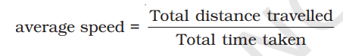
Velocity: Velocity is the speed of an object moving in a definite direction. . It can be changed by changing the object’s speed, direction of motion or both. It is vector quantity. SI Unit : meter/sec .
Velocity = displacement / Total time taken
Acceleration: Change in the velocity of an object per unit time .SI unit: m/s^2
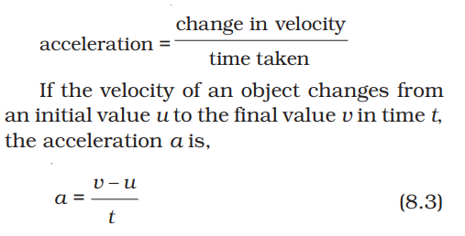

This kind of motion is known as accelerated motion.
If an object travels in a straight line and its velocity increases or decreases by equal amounts in equal intervals of time, then the acceleration of the object is said to be uniform. The motion of a freely falling body is an example of uniformly accelerated motion. On the other hand, an object can travel with non-uniform acceleration if its velocity changes at a non-uniform rate. For example, if a car travelling along a straight road increases its speed by unequal amounts in equal intervals of time, then the car is said to be moving with non-uniform acceleration.

