# Town of Avon

# <https://en.wikipedia.org/wiki/Avon,_Connecticut>

|  |  |  |
| --- | --- | --- |
|  |  |  |

# Tick check <https://www.tickcheck.com/stats/county/connecticut/hartford-county/lyme>

|  |  |
| --- | --- |
|  |  |

Deer population <https://docs.google.com/a/deerfriendly.com/viewer?a=v&pid=sites&srcid=ZGVlcmZyaWVuZGx5LmNvbXxob21lfGd4OjdkZGU3MzY4MWJiZGYyMjA>

|  |  |
| --- | --- |
|  |  |

# Approach 1- Minimize number of cases after treatment

**Objective function:** Minimize number of cases after treatments

$MIN:Z\left(Number of cases after treatment\right)=∑\left(X_{ibefore}- X_{i}after\right) , i-prevention methods$

**Decision variable**: Purchase cost

$∑X_{i}cost*Y_{iselect} ;Y ϵ \left\{0,1\right\}-binary flag for method selection$

**Constrains**

* *No more than 3 chemicals*: $∑Y_{ic}≤3 , c-chemical indicator$
* Vaccination less then town population: $XvacineYvacine≤town Population$
* Deer control should be limited to 10% of deer population: $XdeercontrolYdeercontrol≤10\% Deer Population$
* Spending deviation within 5% of the budget: $0.95*Budget≤∑X_{icost}≤1.05*Budget$
* Area covered within 95% of the town area: $0.95*Area≤∑X_{iarea}≤1.05*Area$
* Minimal area to cover 7 acres
* None-negativity: $X_{i}≥0$



**Results**

# Approach 2- Multi-goal

**Decision Variables:**

$X_{i} , i∈\left\{1..12\right)-prevention methods$

**Objective function:**

$MIN:\frac{w_{l}^{-}}{10}d_{c}^{+}+\frac{2w_{a}^{-}}{18,000}d_{a}^{-}+\frac{2w_{a}^{+}}{18,000}d_{a}^{+}+ \frac{w_{imp}^{-}}{11}d_{imp}^{-}+\frac{w_{c}^{-}}{200,000}d_{c}^{-}+\frac{w_{c}^{+}}{200,000}d_{c}^{+}$

Subject to:

Case reduction goal (priority #1): $∑\left(X_{icasesbefore}-X_{icasedafter}\right)+d_{c}^{-}-d_{c}^{+}=10\%*Total cases$-undesirable overachieve

Environment impact goal (priority #2): $∑X_{ienviroment}+d_{imp}^{-}-d_{imp}^{+}=11$- undesirable underachieve

Area covered goal (priority #3): $∑X_{iareacovered}+d_{a}^{-}-d_{a}^{+}=18,000$- undesirable underachieve, overachieve

Budget Utilization goal (priority #4): $∑X_{icost}+d_{b}^{-}-d_{b}^{+}=200,000$– undesirable underachieve, overachieve

None-negativity:



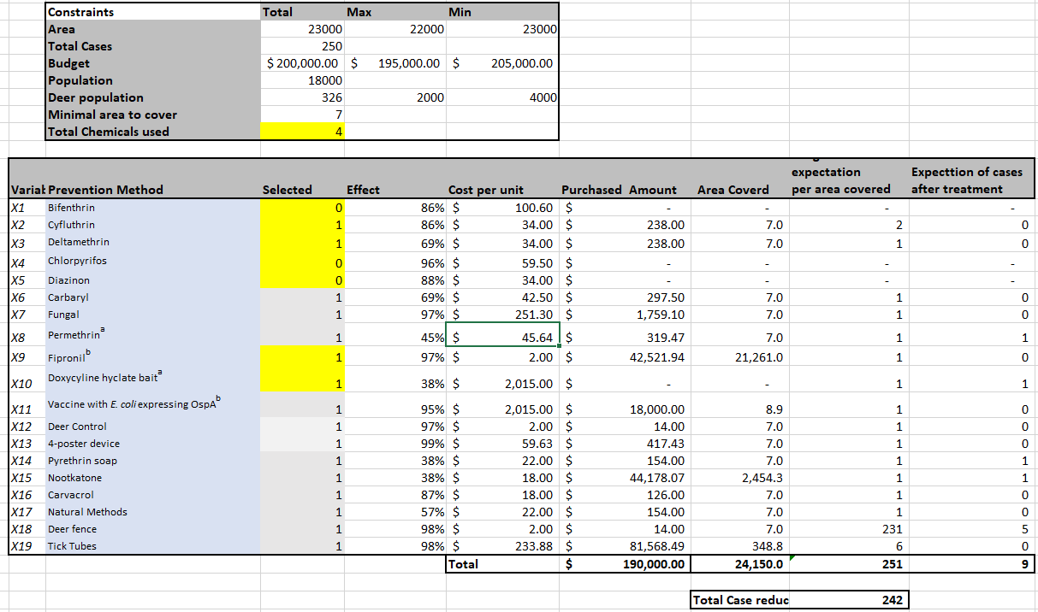

# Approach 3 - Stochastics