Outline

1.    Abstract: use 250 words or less to summarize your problem, methodology, and major outcomes.

o    Andy

2.    Key Words: select a few key words (up to five) related to your work.

o    Probably key prevention techniques

o    Related to environment and cost

o    Andy

3.    Introduction: describe the background and motivation of your decision problem. Be sure to provide a problem statement, research question(s), and/or hypotheses.

o    Slides 1-20 on presentation

o    Andy

4.    Literature Review: discuss how other researchers addressed a similar decision problem, what their achievements were, and what the advantages and drawbacks of each reviewed approach are. Explain how your investigation is similar or different to the state-of-the-art. Please do not discuss each paper one at a time; instead, identify key characteristics of your topic, and discuss them in a whole. Please cite the relevant papers where appropriate.

o    Jimmy to summarize the paper that consolidated studies used for data collection

5.    Methodology: discuss the key aspects of your decision analytics modeling, including a statement of your objectives, proposed methodology, model formulation, and the evaluation measure(s) for the performance of the proposed methodology (if applicable). Be sure to discuss your modeling assumptions. If you work on real data, explain your approach to generating the data parameters, and how you verified and validated your model.

o    Discuss breakdown into 3 model’s

1.    Do 5 and 6 combined by model, then in 7 compare the results of the three

o    Focus’s of the objective functions

o    Compiling the data that was gathered in research compilation paper

o    Discuss how we determined some of the constraints/weighting scales

o    Overall discussion on model validation since we ran it about 8000 times

6.    Computational Experiment and Results: describe what you did and what you found out upon solving your real-world decision problem. Be sure to perform some sensitivity analysis of your model parameters.

o    Discuss results of 3 models and compare findings in each

o    Yuriy and Jared

7.    Discussion and Conclusions: discuss the results and relevant implications for the decision problem at-hand. Be sure to conclude your findings, discuss model limitations, and suggest areas for future work.

o    Discuss different results between models – large changes in model when constraints even had smaller changes

o    Model results varied wildly with small changes to weighting in objective function

8.    References: be sure to cite all references used in the report in APA format.

o    Collect references on google doc for easy compilation

o    Jimmy to create google doc

9.    Appendix:

o    Additional tables and figures

o    Theorems and proofs (if applicable)

o    Supporting information for verification, validation, or data collection and others

o    Spreadsheet(s) with ASPE screenshots, Python or R programming code, etc.

1.    Create second google doc to compile appendix pictures

 Actual paper

Data collection for model 1 and 2

The selected area in a model was town of Avon, CT with area size 23.5 sq miles and 18,000 population.

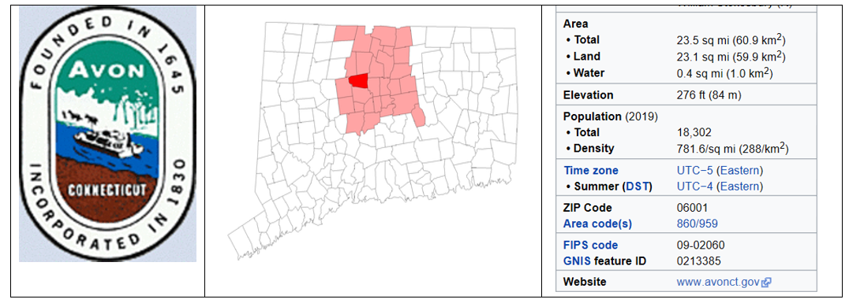

The current occurrence of developing Lyme disease was obtained from the tick check site.

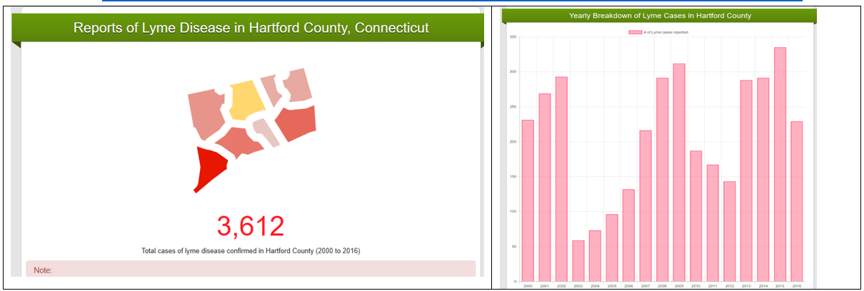

 The deer population from the official Connecticut wildlife monitoring agency. Town of Avon located in area 3 with stable deer population and estimated be between 2500 and 4000.

. 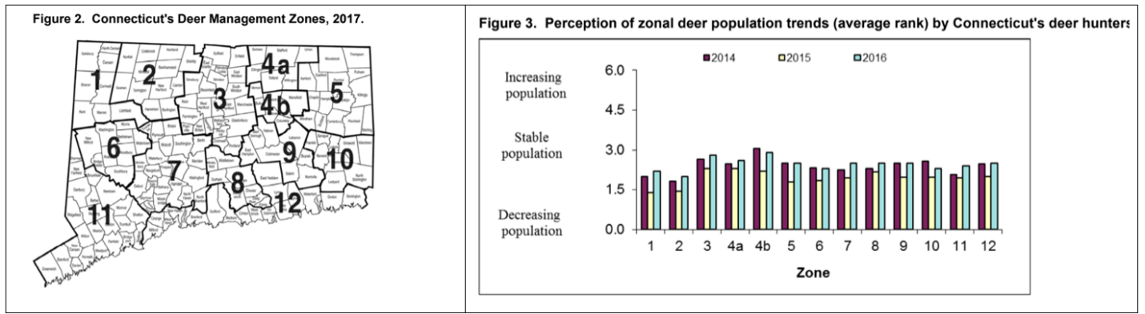

Model 1 - Minimize the number of Lyme disease occurrence after prevention treatment.

The first model was based on the simplistic approach and was focused on most obvious goal - minimization of the Lyme disease cases after the prevention treatment have been applied to an area.

**Objective function:** Minimize number of cases after treatments

$MIN:Z\left(Number of cases after treatment\right)=∑\left(X_{ibefore}- X_{i}after\right) , i-prevention methods$

**Decision variable**: Purchase cost

$∑X_{i}cost*Y_{iselect} ;Y ϵ \left\{0,1\right\}-binary flag for method selection$

**Constrains**

* *No more than 3 chemicals*: $∑Y_{ic}≤3 , c-chemical indicator$
* Vaccination less then town population: $XvacineYvacine≤town Population$
* Deer control should be limited to 10% of deer population:
* Spending deviation within 5% of the budget:
* Area covered within 95% of the town area:
* Minimal area to cover 7 acres
* None-negativity: $X_{i}≥0$



**Results:**

The model has yield 218 case improvement that could be equated to $218*\$24,909-\$205000=\$5,225,162$ short and mid term effect. The long-term prevention effect and quality of life for “saved” patients are not calculated, but have high likelihood to produce favorable outcome.

Model 2 – Multi-Goal objectives

The multi goal approach more complex and tries to find a balance between minimizing number of Lyme disease cases, environmental impact, budgetary restrictions. The model feasible regain also was subject to constraints similar to the model 1.

**Decision Variables:**

$X_{i} , i∈\left\{1..12\right)-prevention methods$

**Objective function:**

$MIN:\frac{w_{l}^{-}}{10}d_{c}^{+}+\frac{2w_{a}^{-}}{18,000}d_{a}^{-}+\frac{2w_{a}^{+}}{18,000}d_{a}^{+}+ \frac{w_{imp}^{-}}{11}d_{imp}^{-}+\frac{w_{c}^{-}}{200,000}d_{c}^{-}+\frac{w_{c}^{+}}{200,000}d_{c}^{+}$

Subject to:

Case reduction goal (priority #1): $∑\left(X_{icasesbefore}-X_{icasedafter}\right)+d_{c}^{-}-d_{c}^{+}=10\%*Total cases$-undesirable overachieve

Environment impact goal (priority #2): $∑X_{ienviroment}+d_{imp}^{-}-d_{imp}^{+}=11$- undesirable underachieve

Area covered goal (priority #3): $∑X_{iareacovered}+d_{a}^{-}-d_{a}^{+}=18,000$- undesirable underachieve, overachieve

Budget Utilization goal (priority #4): $∑X_{icost}+d_{b}^{-}-d_{b}^{+}=200,000$– undesirable underachieve, overachieve

None-negativity: $X_{i},d_{c}^{+}, d_{c}^{-},d_{imp}^{+}, d_{imp}^{-},d_{a}^{+}, d_{a}^{-},d_{b}^{+}, d_{b}^{-}≥0$

**Constrains**

* *No more than 3 chemicals*: $∑Y_{ic}≤3 , c-chemical indicator$
* Vaccination less then town population: $XvacineYvacine≤town Population$
* Deer control should be limited to 10% of deer population:
* Spending deviation within 5% of the budget:
* Area covered within 95% of the town area:
* Minimal area to cover 7 acres
* None-negativity:



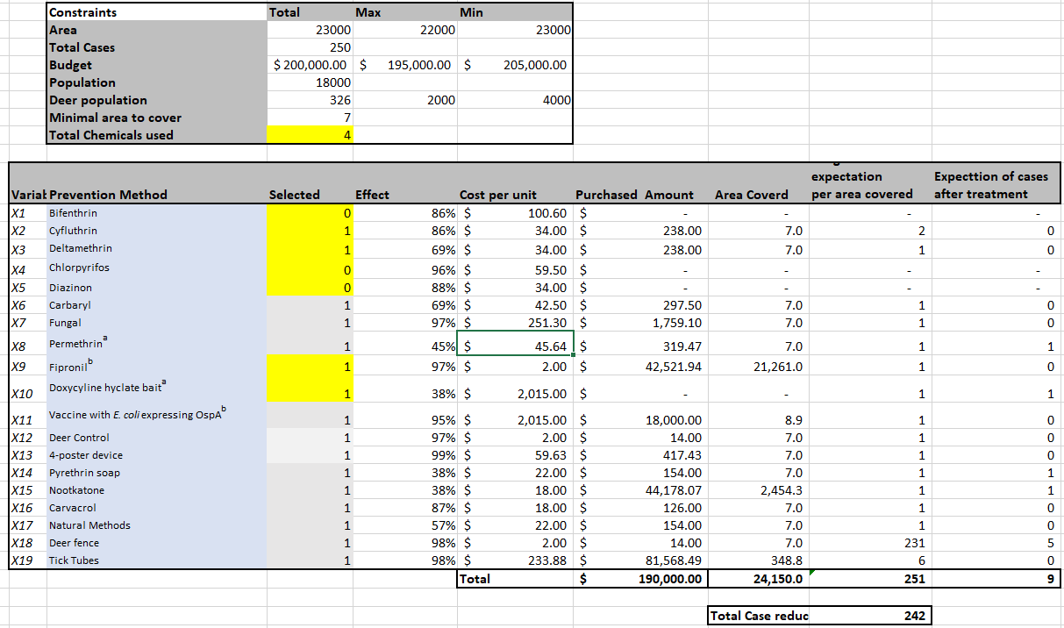

**Results:**

The model has yield 218 case improvement that could be equated to $248*\$24,909-\$190,000=\$5,987,432$ short and mid term effect.

**Findings and questions:**

The outcome from the multi-goal modeling raises following question:

* Why model with less focus on the case minimization and competition coming from others goals has produced better outcome.
* Why the coverage area 24,150 exceeded the town area constraint 18,302.

The bigger area selected by an engine could partially contribute to the better outcome. Averaging reduction by sq mile will produce better comparison matrix. Also, it looks like model would need more tuning and training.

Model 3 - (Section 5-6) -jared

In an attempt to make this a very through simulation and model we had to gather lots of data related to tick prevention methods, how effective that are and their cost.  Of the many types of prevention methods we found most could be bucketed into the following categories: Chemical sprays, Natural sprays, baited animal treatments and environmental modification.  We chose to use 17 different methods to reduce tick population and the Lyme disease infection rate. Since in the real world there will be a range of effective percentages we pulled in a data set1 that was compiled from several studies and included up to 28 different effectivity measures for each of the 17 methods.  We then used PsiDisUniform() to randomly choose a % effectiveness for the simulation portion of our model.

Whenever large-scale insect treatments are considered, unintended environmental impacts must be taken into account.  As you might expect many of the most effective methods for eliminating ticks are powerful chemicals that kill non-target insects as well such as honey bees, spiders, and others. Additionally, these same chemicals can persist in the environment for a long time and end up in food and water supplies affecting the health of the human population.  We used a system of weights to account for this in our model.

Finally we gathered pricing information for each of the methods and standardized them into cost per acre.  This turned out the be some of the hardest data to find as some of the chemicals are only available to licensed professionals.

Chemical sprays all work by deluding with water and applied through high/low pressure sprayers or fogging. Some have average effective rates as high as 99% yet they are toxic, must be handled carefully and kill a large range of insects including honey bees.  The chemical sprays we used in our model are: Bifenthrin, Cyfluthrin, Deltamethrin, Chlorpyrifos, Diazinon, Carbaryl, Permethrina, Fipronilb, Pyrethrin soap.

Natural sprays are applied in the same way as chemical sprays.  They are more targeted towards ticks and will not harm friendly insects such as honey bees and spiders.  Since they are derived from natural ingredients, there is little to no negative environmental impact and are safe for people.  The Natural sprays we modeled are: Fungal and Natural Methods (plant extracts). Met52 is a natural occurring fungus that kills ticks.  Once it is applied it has the tendency to grow and stay in the soil making it a very safe and long lasting treatment.3  Some of the plant extracts for the natural methods are derived from garlic, rosemary, lemongrass, cedar, peppermint, thyme, geraniol, citris fruits, and eucalyptus.2

Baited Animal Treatments attract tick carrying animals with food and dose them with a chemical acaricide like permethrin.  Permethrin it relatively safe at low doses and long lasting. Since it isn’t being sprayed by the gallon, the environmental impact is negligible.  The Baited Animal Treatments we modeled are: Doxycyline hyclate baita, Tick Tubes, 4-poster device. Doxycyline hyclate baita is a device that small rodents enter and get dosed with an antibiotic that will kill the Lyme virus in them and prevent it from spreading to uninfected ticks.  Tick Tubes are small cardboard tubes that contain chemical acaricide treated nesting material for small rodents. A 4-poster device attracts deer by dispensing a small amount of corn. When the deer come to eat, they must rub against chemical acaricide treated rollers.

The Environmental Modification methods we modeled are: Deer Control (hunting), Deer fence, Vaccine with E. coliexpressing OspAb.  Reducing the deer population through an open hunting season is one of the cheapest methods at almost zero cost. Unfortunately, it is also the least effective, averaging around 25%.  Installing fencing to keep deer away from areas where people are more likely visitors is expensive up-front but require very little maintenance and usually lasts for a minimum of 5 years. There is currently Lyme vaccination for dogs that is used in bait boxes to inoculate small rodents.  One day this vaccine may be successfully modified into a human version.4

 After reviewing all the different methods, we realized we would need to include some weights to quantify the related positives and negatives in the model.  We utilized the following weight categories for each of the 17 methods. Reduction in entomological risk, Impacts of adverse health effects, Impact on habitat, Impact on wildlife, Level of public acceptance, Proportion of population benefitting from intervention, Level of public awareness, Sustainability of effect. Footnote to weights yuriy  After compiling this list of weights we summed them by method and converted the totals to a number between 0-1.  Making sure that the total sum of all weights equaled 1. We labeled this new field ‘Total Weight’. Please refer to Appendix A for a full list of the weights used per method.

As mentioned above, finding accurate prices for each method proved difficult.  First, we had to find an accurate price. Then we found the correct mixing ratios for the concentrates and the EPA application guidelines to insure the correct amount was applied per acre and how frequently.  Finally the time/labor cost related to applying the product was calculated. This data was compiled into a new field called ‘Total Cost Per Year Per Acre’. The value ranged from $35.60 for Deltamethrin to $187.25 for Natural plant extracts, to $2015.00 for vaccine bait boxes.  Please refer to Appendix A for a full list of the costs per year per acre per method.

After all this data gathering we setup the model to run for CT on all the state owned land designated as recreational areas; 194,897 acres.5  Then we used the average cases of Lyme disease per year in CT (2061)6 we multiplied by the yearly cost of treatment of acute and chronic Lyme ($24,909)7 and came to the total yearly cost to treat Lyme disease in CT $51,337,449.  We also assumed all 2061 cases of Lyme came from state owned land and calculated the average cases per acre to be 0.010574816.  The model was set to use between 5% and 25% of the total yearly cost to treat Lyme disease and ASPE Solver was set to choose the amount of $ to designate to each method.  The amount of $ applied to each method was divided by the cost per acre per year multiplied by the % effectiveness of the method and multiplied by the total weight for the method.  Then the sum of this column was maximized as the objective function.

Jimmy to build a formula version of objective function

 Since this model used simulation the result was different every time it was run.  Generally the results showed that we should spend the largest amount possible on the prevention methods and the best choices we settled on were to spend 86% of our budget on Fungal, 13% on natural methods and the remaining 1% was spread across other methods like Tick tubes, Pyrethrin soap, vaccine bait boxes and others.  This resulted in a spend of $12,834,362.25 on prevention methods to reduce predicted Lyme infections from 2061 to 281 reduction the cost of treatment from $51,337,449 to $6,993,605 making a total cost reduction of 61%!

References:

1. **Eisen, L. & Dolan M. C. (2016). Evidence for Personal Protective Measures to Reduce Human Contact With Blacklegged Ticks and for Environmentally Based Control Methods to Suppress Host-Seeking Blacklegged Ticks and Reduce Infection with Lyme Disease Spirochetes in Tick Vectors and Rodent Reservoirs. Retrieved from** [**https://www.ncbi.nlm.nih.gov/pmc/articles/PMC5788731/?tool=pmcentrez**](https://www.ncbi.nlm.nih.gov/pmc/articles/PMC5788731/?tool=pmcentrez)
2. **CDC (December 21, 2018). Natural Tick Repellents and Pesticides** [**https://www.cdc.gov/lyme/prev/natural-repellents.html**](https://www.cdc.gov/lyme/prev/natural-repellents.html)
3. **Cary Institute (2018). The tick project** [**https://www.caryinstitute.org/science-program/research-projects/tick-project**](https://www.caryinstitute.org/science-program/research-projects/tick-project)
4. **NIH (November 16, 2018). Lyme Disease Vaccines** [**https://www.niaid.nih.gov/diseases-conditions/lyme-disease-vaccines**](https://www.niaid.nih.gov/diseases-conditions/lyme-disease-vaccines)
5. **Office of Policy and Management (December 17, 2015). State Owned Lands** [**https://data.ct.gov/Government/State-Owned-Lands/meyk-xprb**](https://data.ct.gov/Government/State-Owned-Lands/meyk-xprb)
6. **US Dept. of Health and Human Services (February 28, 2019). LymeDisease_9211_county** [**https://catalog.data.gov/dataset/lymedisease-9211-county**](https://catalog.data.gov/dataset/lymedisease-9211-county)
7. **Lorraine Johnson, JD, MBA (19, JUL 2018). LYMEPOLICYWONK: Lyme disease costs may exceed $75 billion per year** [**https://www.lymedisease.org/lymepolicywonk-costs-75billion/**](https://www.lymedisease.org/lymepolicywonk-costs-75billion/)

Appendix:

**Appendix A:  
Model 3: Cost, Coverage, and Weights for Prevention Methods**

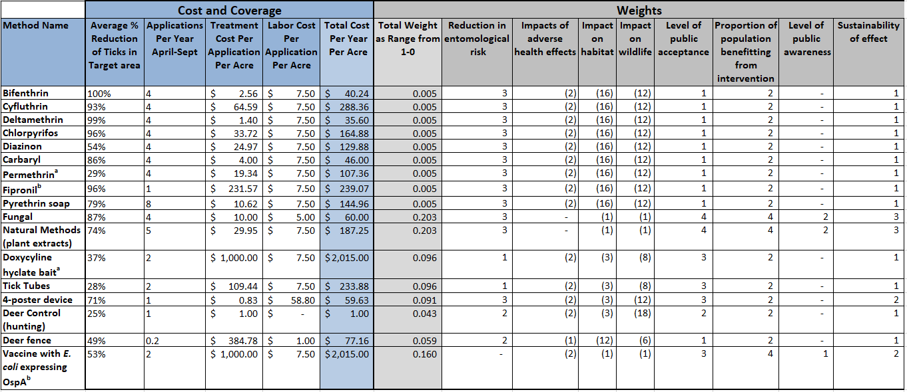

**Apendix B:**