Maize6KGSP
Maize6K-GS Array-Based Genomic Prediction Platform
User Manual · Graphical User Interface
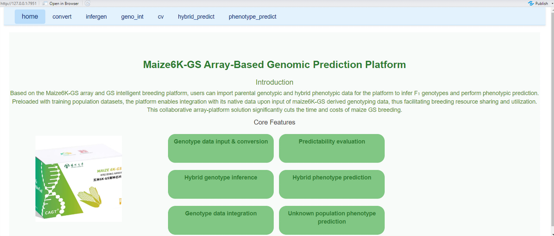
Maize6KGSP home page and integrated workflow.
Version 0.1
Guangning Yu · Yang Xu · Chenwu Xu
Contact: mx120200746@yzu.edu.cn

1. Overview
Maize6KGSP is an R package developed for the Maize6K-GS array. It integrates genotypic data generated with the array, phenotypic data from training populations, and genomic selection (GS) models into a unified workflow. A built-in graphical user interface (GUI) enables code-free data processing, genotype inference, model evaluation, and phenotype prediction.
The GUI contains seven modules: home, convert, infergen, geno_int, cv, hybrid_predict, and phenotype_predict. The modules are designed to work sequentially, so outputs from upstream modules can be reused directly in downstream analyses.
Module | Purpose
home | Platform overview and one-click navigation to all functional modules.
convert | Import HapMap/VCF/numeric genotype data, convert formats, perform QC, and optionally impute missing values.
infergen | Infer F1 hybrid genotypes from parental genotypes and cross information.
geno_int | Integrate genotype datasets for inbred or hybrid populations and prepare data for prediction.
cv | Evaluate trait predictability using cross-validation and six embedded GS models.
hybrid_predict | Predict phenotypes of all possible parental combinations and rank candidate hybrids.
phenotype_predict | Predict phenotypes for target inbred or hybrid breeding populations using integrated genotype data and training phenotypes.

2. Getting started

2.1 Requirements
- R >= 4.1.0 is required. RStudio is recommended for convenient installation and GUI use.
- An internet connection is required for direct installation from GitHub.
- Sample identifiers and marker identifiers should be consistent across genotype, phenotype, and crossing files.

2.2 Installation
Install Maize6KGSP directly from GitHub using the following commands:
library(devtools)
devtools::install_github("ygn1231/Maize6KGSP", force = TRUE)

2.3 Launch the GUI
After installation, load the package and launch the graphical interface:
library(Maize6KGSP)
Maize6KGSP.GUI()
The interface opens in the default web browser or the RStudio Viewer, depending on the local R environment.

2.4 GUI implementation and package dependencies
The graphical interface is implemented in R Shiny and is launched from the installed package using Maize6KGSP.GUI(). The GUI integrates seven interactive modules: home, convert, infergen, geno_int, cv, hybrid_predict, and phenotype_predict. DT is used for interactive data-table display. No separate desktop executable is required.
The package imports the following R packages: BGLR, glmnet, xgboost, pls, data.table, doParallel, foreach, shiny, DT, and utils. These dependencies are declared in the DESCRIPTION file and are normally installed automatically during package installation.

2.5 Example datasets
The repository provides example datasets that can be used to test the major functions of Maize6KGSP:
- train_inbred.hmp.txt — example training-population inbred genotype data
- test_inbred.hmp.txt — example target/breeding-population inbred genotype data
- train_inbredphe.csv — example inbred phenotype data
- train_hybridphe.csv — example hybrid phenotype data for model training
- test_crosses_id.csv — example parental combinations for hybrid genotype inference

3. Input data

3.1 Genotype data
The convert module accepts commonly used genotype formats and converts them to the numerical format required by downstream analyses. Supported inputs shown in the GUI include HapMap single-bit, HapMap double-bit, VCF, and numerical genotype matrices.
Example: HapMap double-bit genotype data
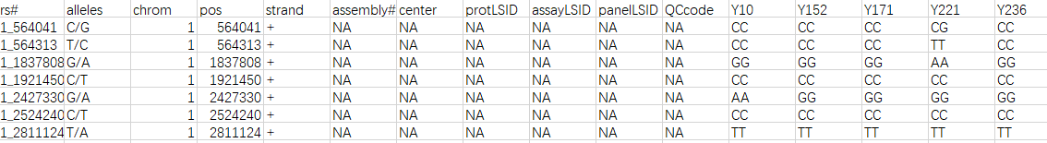
Example: VCF genotype data
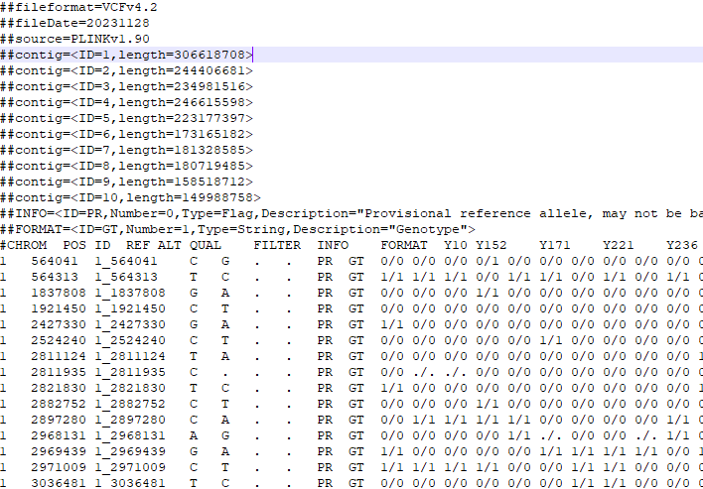

3.2 Hybrid phenotype data
Hybrid phenotype data should contain three columns: the male parent ID, the female parent ID, and the observed phenotypic value. Parental IDs must match the row names in the inbred genotype dataset. Missing phenotype values are not allowed for records used in model training.
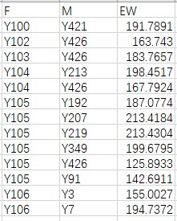

3.3 Cross information
Cross files used by infergen should contain two columns specifying the two parents of each target cross. Parent names must match the inbred genotype dataset exactly.
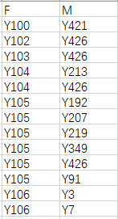

4. convert: genotype conversion and quality control
The convert module imports raw genotype files, converts them to numerical genotypes, applies marker-level quality control, and optionally imputes missing genotypes. The converted data can be passed directly to downstream modules.

4.1 Upload genotype data
- Open the convert tab.
- Select the genotype file type from the drop-down menu.
- Upload the genotype file and confirm that the upload is complete.
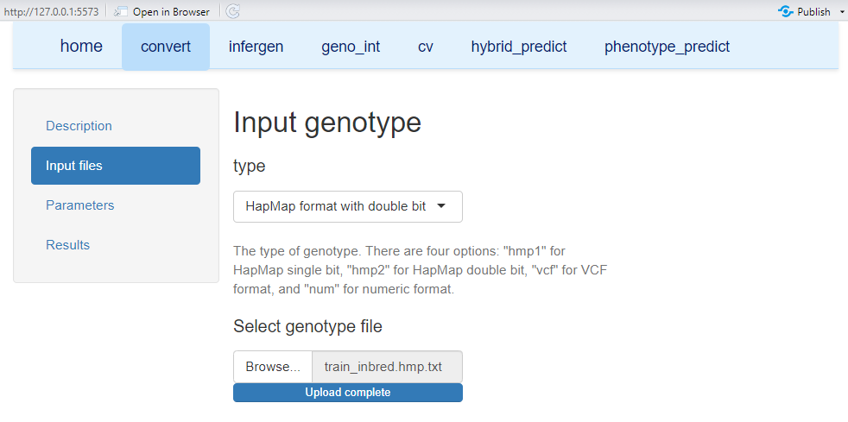

4.2 Set quality-control parameters

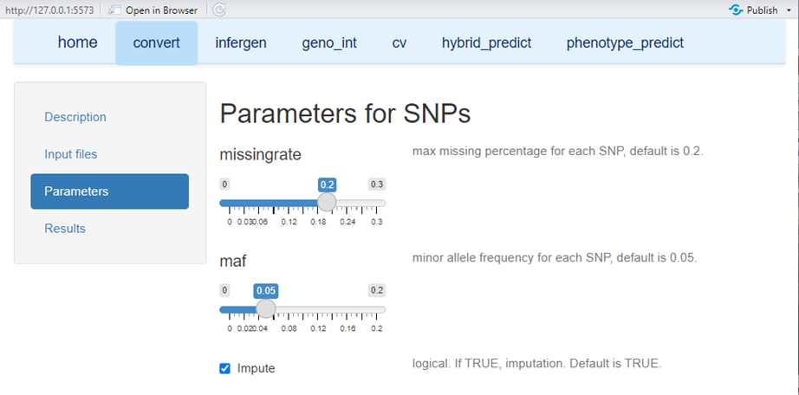

4.3 Run and download
After file upload and parameter setting, click Run Genotype data conversion. The converted genotype matrix is displayed as an interactive table that supports browsing and searching. Use Download genotype to save the complete result.
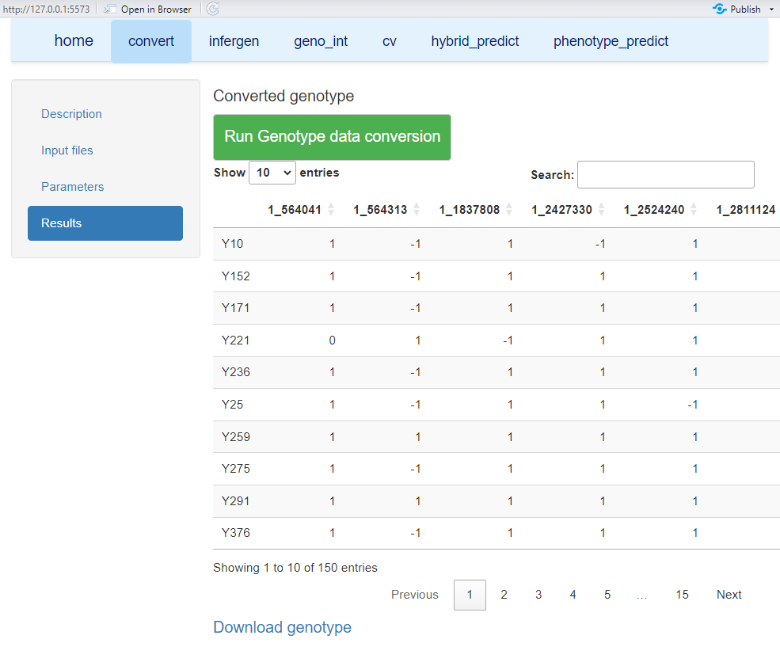

5. infergen: hybrid genotype inference
The infergen module infers F1 hybrid genotypes from the genotypes of their parental inbred lines. Users can upload an inbred genotype file directly or reuse the output generated by convert, then provide the target cross list.

5.1 Select the inbred genotype source
1. Open the infergen tab.
2. Choose Upload file or Use convert result as the inbred genotype source.
3. If Use convert result is selected, complete the convert module first.
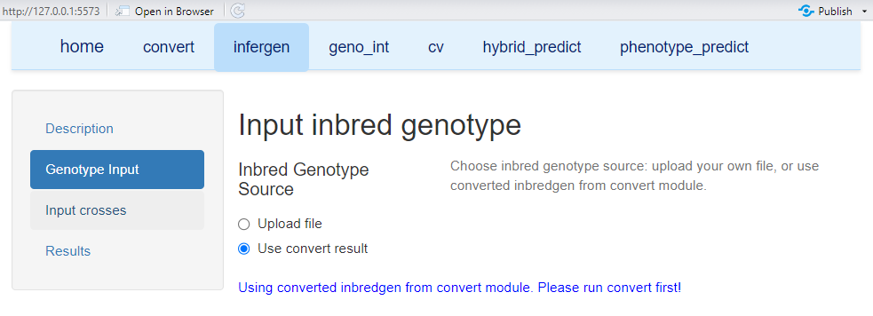

5.2 Upload target crosses
Upload a two-column cross file containing the parental IDs for the hybrids to be inferred. The parental names must be present in the inbred genotype matrix.
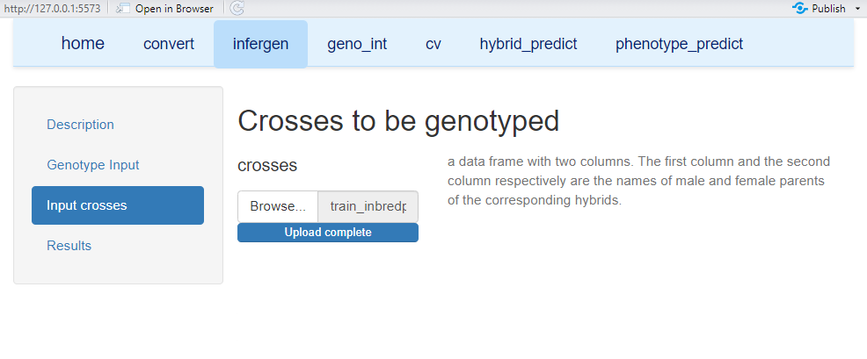

5.3 Generate hybrid genotypes
Click Run Hybrid genotype inference. The inferred hybrid genotype matrix is displayed online and can be downloaded for subsequent prediction analyses.
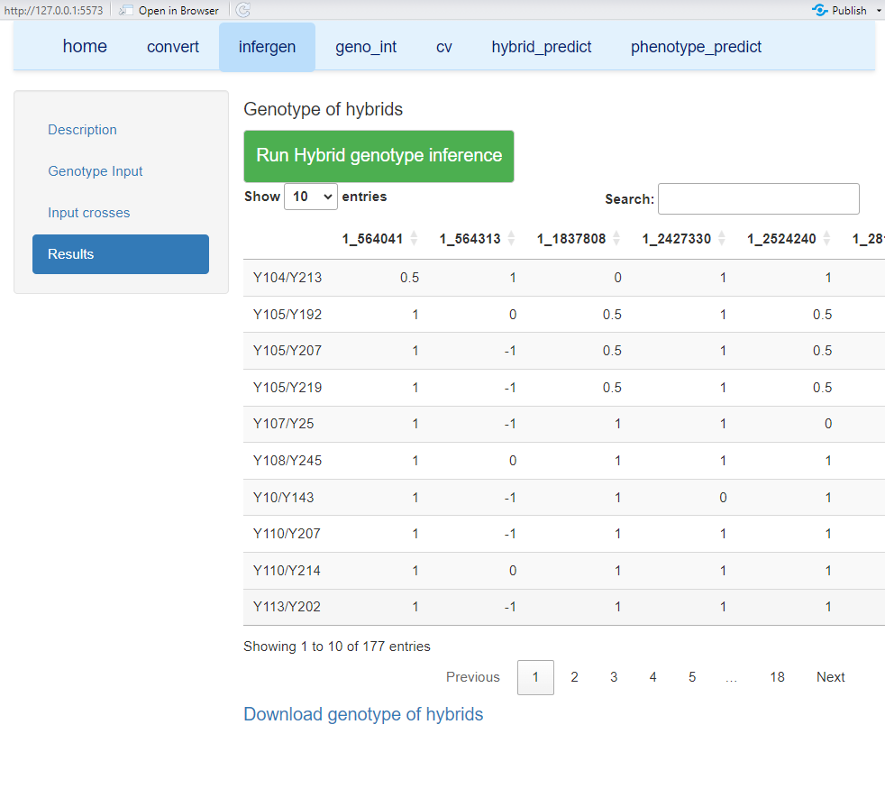

6. geno_int: genotype integration
The geno_int module harmonizes genotype data from the training and breeding populations before phenotype prediction. Users can provide genotype datasets for the two populations in supported formats, and the module generates matched training and breeding genotype matrices that can be reused directly by phenotype_predict. This step is particularly useful when the training population and prediction population were prepared or genotyped separately.

6.1 Upload training and breeding population genotypes
Open the geno_int tab and select the genotype format. The interface supports HapMap single-bit, HapMap double-bit, VCF, and numerical formats. Upload the genotype file for the training population and the genotype file for the breeding population. Sample identifiers should be unique within each dataset, and marker identifiers should be correctly formatted so that the two genotype datasets can be matched during integration.
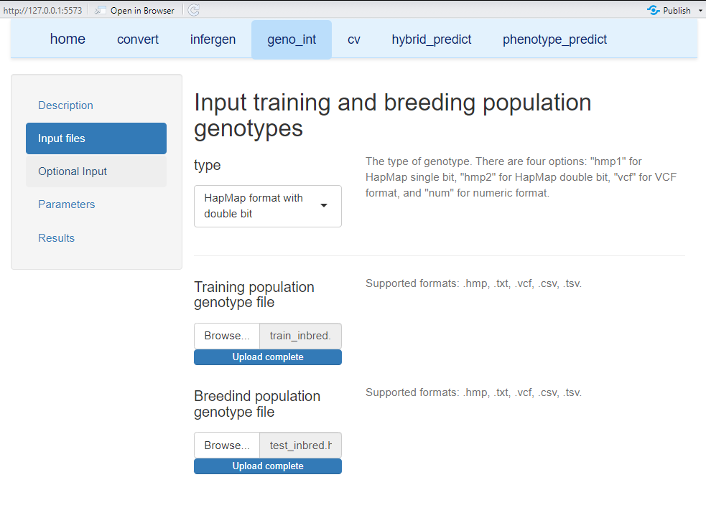

6.2 Match and integrate genotype data
After the two genotype datasets are uploaded, click Run Genotype data integration. Maize6KGSP matches the genotype information between the training and breeding populations and generates two compatible matrices: Training Genotype (train_geno) and Breeding Genotype (breed_geno). The matched matrices are displayed as interactive tables, allowing users to inspect sample IDs and marker genotypes before proceeding to phenotype prediction.
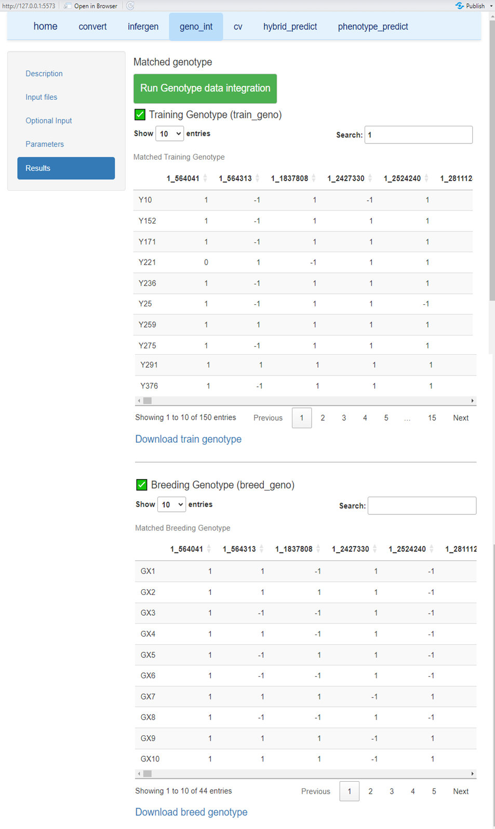

6.3 Download or reuse the integrated genotypes
The matched train_geno and breed_geno datasets can be downloaded separately using Download train genotype and Download breed genotype. Alternatively, they can be passed directly to the phenotype_predict module within the same GUI session. When geno_int results are reused directly, repeated file conversion and manual marker matching are avoided.
Important: The phenotype records used for model training must correspond to individuals in train_geno. The individuals to be predicted must correspond to breed_geno. Keep sample names consistent across genotype and phenotype files.

7. cv: predictability evaluation
The cv module evaluates the predictive ability of GS models by cross-validation. It can directly reuse hybrid genotypes inferred by infergen or accept an uploaded genotype file. A phenotype file for the target trait is required.

7.1 Input genotype and phenotype data
Choose the genotype source and upload the phenotype file. The phenotype interface displays a preview after sample matching and filtering.
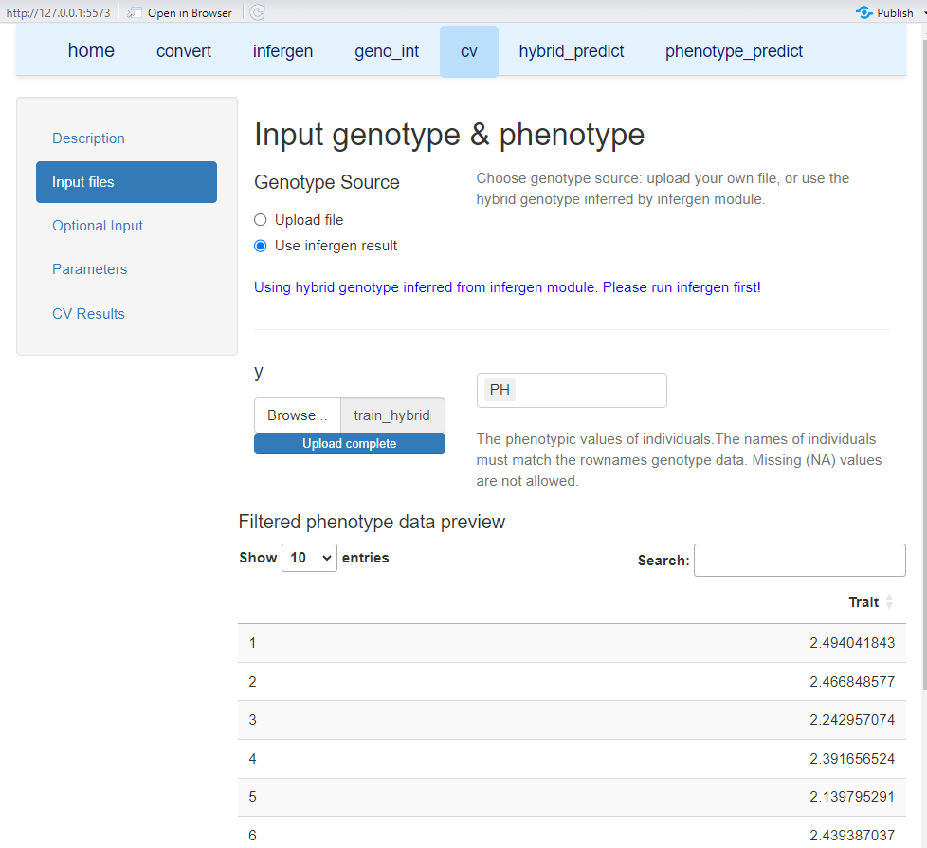

7.2 Select model and cross-validation parameters
Six GS models are embedded in the current Maize6KGSP workflow: GBLUP, BayesB, RKHS, PLS, LASSO, and XGBoost.

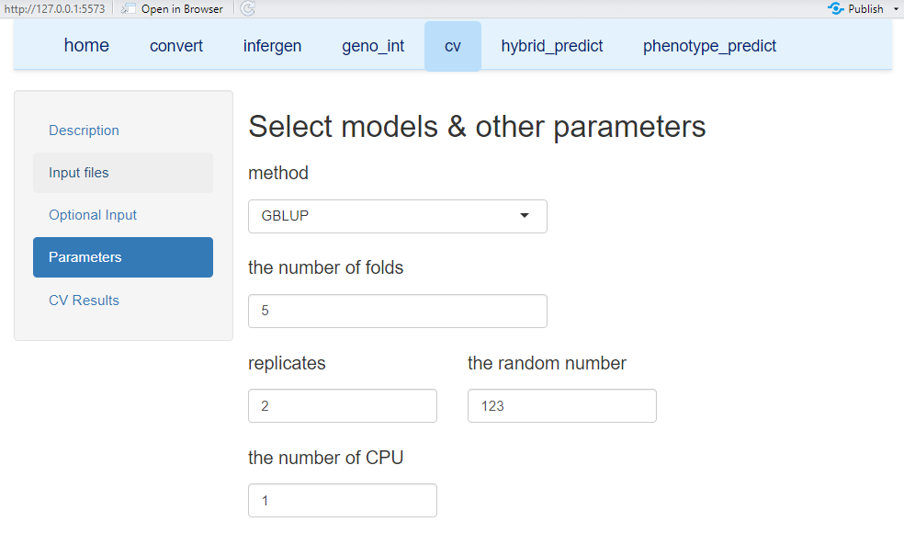

7.3 Run predictability evaluation
Click Run Predictability evaluation. Results are displayed in an interactive table and can be exported using Download CV Results.
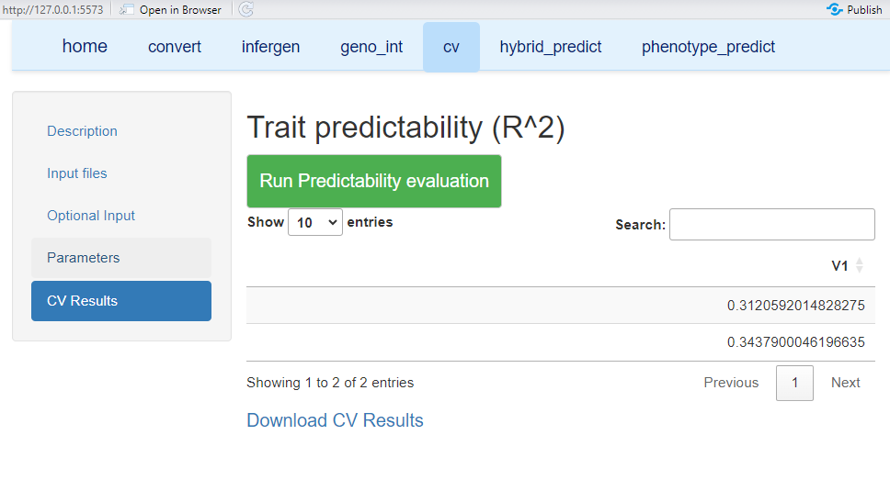

8. hybrid_predict: prediction of potential crosses
The hybrid_predict module predicts hybrid performance for all possible combinations among a given set of parental inbred lines. Users provide parental genotype data and phenotypic observations from a training set of hybrids. The platform infers F1 genotypes and predicts all possible n(n−1)/2 crosses.

8.1 Input data
Upload or reuse the parental genotype data and provide the hybrid phenotype training dataset. The GUI displays the matched phenotype records before model fitting.
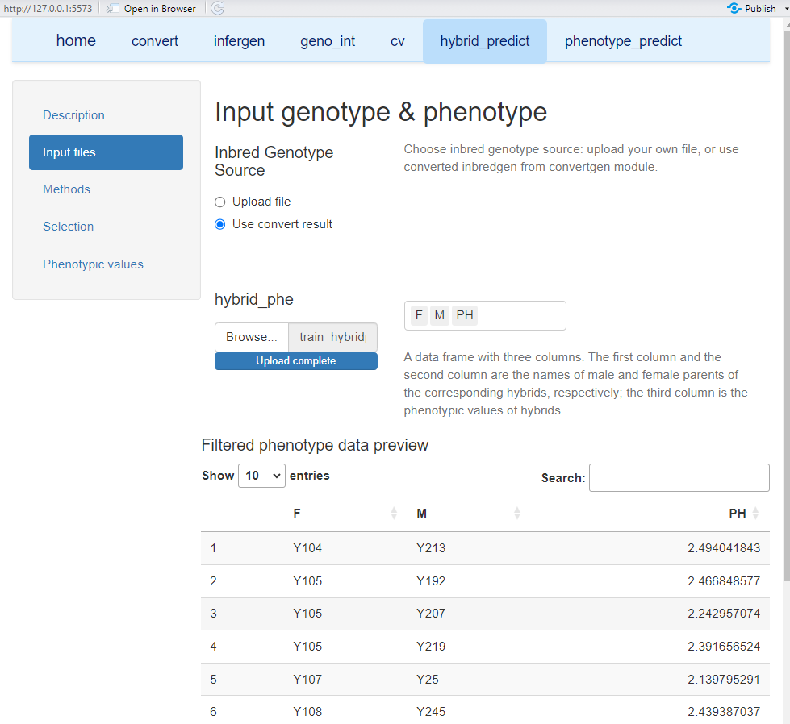

8.2 Select candidate hybrids
Candidate hybrids can be selected according to predicted performance. The interface provides three modes: all potential crosses, the top n crosses, or the bottom n crosses. When top or bottom is selected, specify the number of crosses to retain.
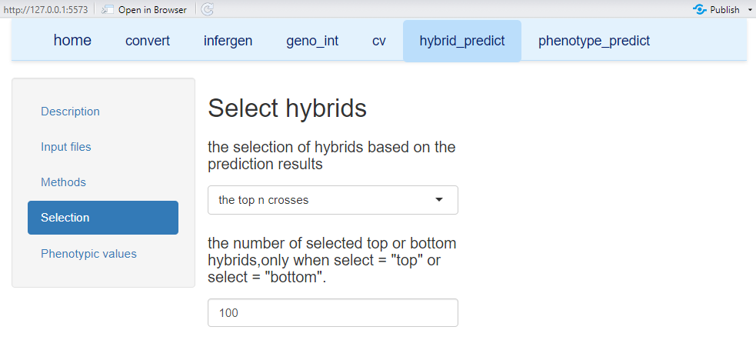

8.3 Select a GS model
Choose one of the available GS methods for hybrid performance prediction. The model should ideally be selected based on cross-validation performance for the trait and population under study.
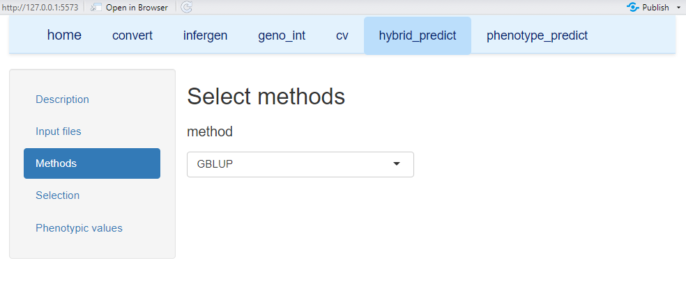

8.4 Run prediction and export results
Click Run Hybrid phenotype prediction. The predicted crosses and phenotypic values are displayed in an interactive table. Users can search, filter, and download the complete prediction results.
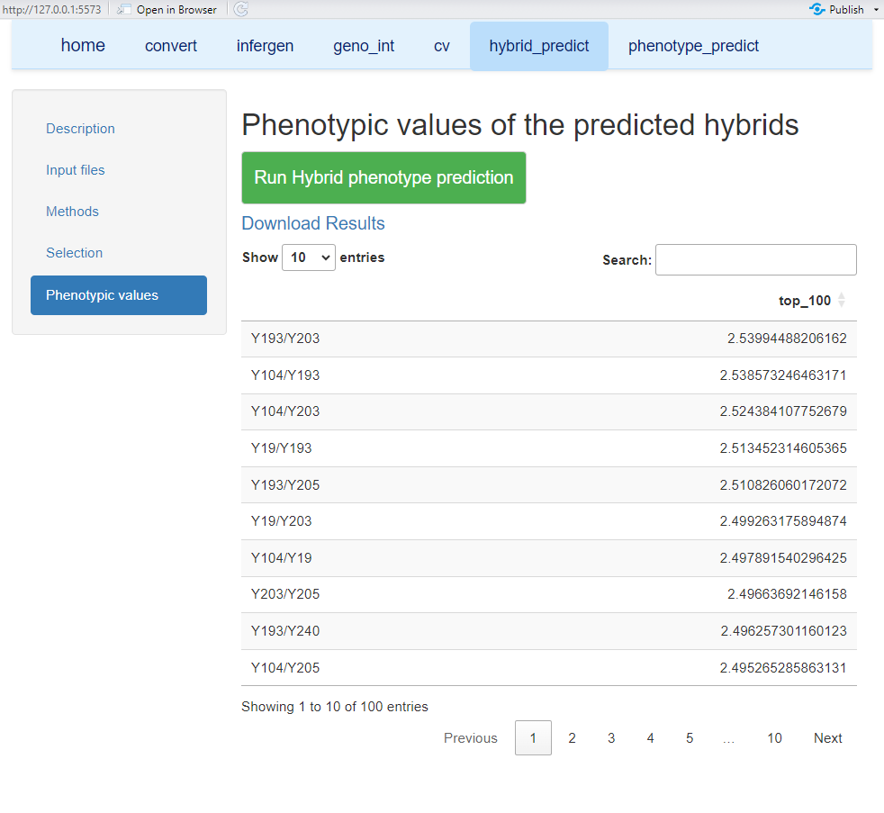

9. phenotype_predict: phenotype prediction for breeding populations
The phenotype_predict module predicts phenotypic values for a target breeding population using a genomic selection model trained with a reference population. It can be applied to inbred or hybrid populations, provided that compatible training and breeding genotype matrices are available. Users may upload genotype files directly or reuse the matched train_geno and breed_geno generated by geno_int.

9.1 Select genotype sources and upload training phenotypes
Two genotype inputs are required: the training-population genotype matrix used for model fitting and the breeding-population genotype matrix containing the individuals to be predicted. For each input, select Upload file to provide an external file or Use geno_int result to reuse the matched genotype matrix produced in the geno_int module. When the geno_int option is used, run geno_int first in the same GUI session.
Upload the training-population phenotype file in the train_phe field and specify the target trait. The phenotype input is a single trait vector corresponding to the training individuals. After upload, the GUI displays the filtered phenotype data preview so that users can confirm that phenotypic records have been correctly loaded before model fitting.
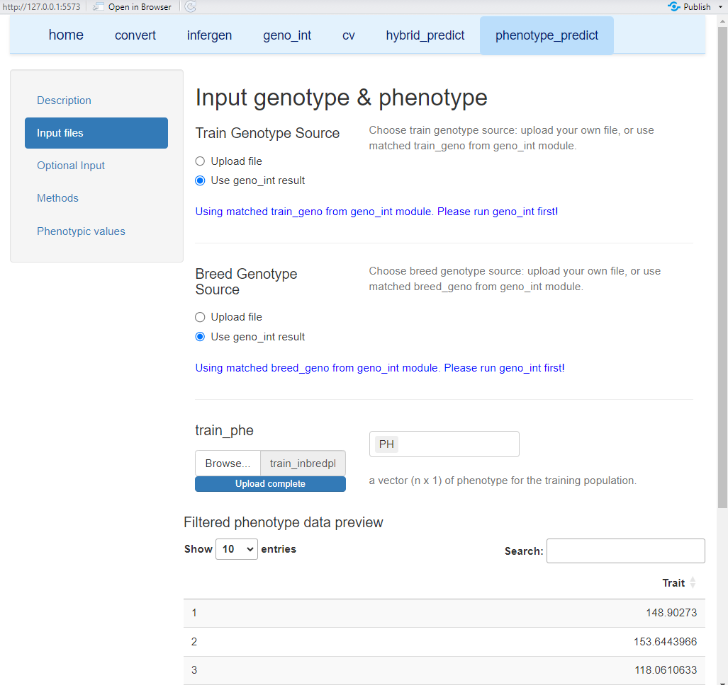

9.2 Select a genomic selection model
Open the Methods panel and select the GS model used to train the prediction model. For routine analyses, the model can be chosen according to its performance in the cv module for the same trait and a comparable training population. This helps ensure that large-scale phenotype prediction is based on an appropriately performing model.

9.3 Run phenotype prediction and inspect results
After the genotype sources, training phenotypes, and GS model have been specified, open the Phenotypic values panel and click Run Phenotype Prediction. The fitted model is applied to breed_geno, and the predicted phenotypic value of each target individual is displayed in an interactive results table. The search box can be used to locate specific individuals, and pagination allows large breeding populations to be reviewed efficiently.
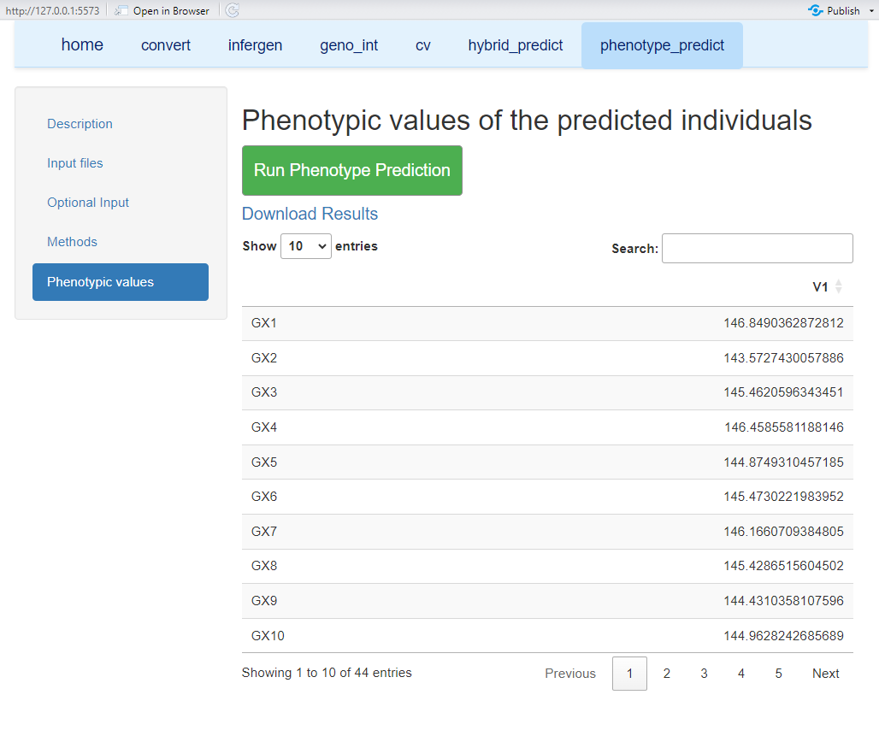

9.4 Download prediction results
Click Download Results to export the complete prediction table for downstream selection, ranking, or breeding decisions. For reproducible analyses, retain the genotype integration output, training phenotype file, selected model, and downloaded prediction results together.

