The objective of the testing strategy is to verify the correctness, consistency, and reliability of the SmartAudit system in terms of functionality, architecture, interaction, and intelligent analysis. The testing process focuses not only on functional correctness but also on the logical consistency among design documents and the validity of AI-generated analysis results.
The system testing framework: Unit Testing, Functional Testing, System Testing, Non-functional Testing.
This framework ensures that the system is verifiable throughout the entire lifecycle from design to implementation and that all critical design elements are covered by testing.

1. Functional Testing
Functional testing focuses on the core business workflow of the system.
Main process:
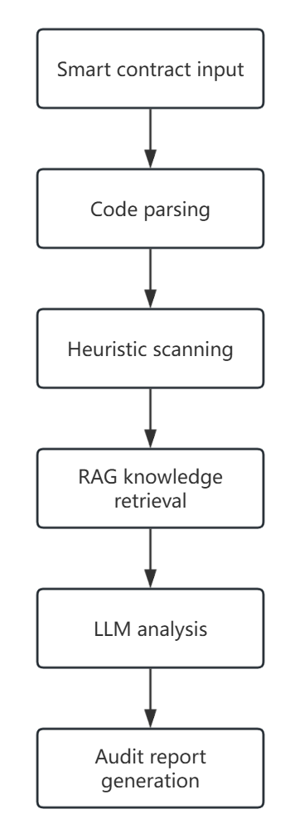
Key testing aspects include: Correctness and robustness of contract input, Vulnerability detection capability, Validity of AI analysis results, Structured audit report generation
Test scenarios include:
- Valid smart contracts
- Contracts containing known vulnerabilities
- Contracts with complex logic
- Invalid or malformed contracts

2. System Testing
System testing validates the integration of all modules and verifies end-to-end behavior.
Focus areas include:
- Interface consistency between modules
- Data flow integrity
- Correct execution of the full analysis pipeline
- User interaction completeness

3. AI-Specific Testing
Evaluation dimensions:
- Verify compliance between system functions and design requirements
- Validate system architecture and module design
- Verify correctness of interfaces and data flow
- Validate completeness of user interaction workflows
- Evaluate accuracy and stability of AI analysis results
- Ensure consistency among design documents

4. Testing Environment
The testing environment includes:
- Operating systems: Windows / Linux / macOS
- Programming language: Python
- AI models: GPT / Gemini (replaceable)
- Frameworks: LangChain, Streamlit
- Vector database: FAISS
- Test data: Real and synthetic smart contract samples

5. Test Execution Process
The test execution process includes:
- Test plan preparation
- Test case design
- Environment setup
- Test execution
- Defect logging and analysis
- Regression testing
- Test result summary

6. Risk Analysis
Potential testing risks include:
- Unstable LLM outputs
- Insufficient test data
- AI hallucination

7. AI-Specific Testing
Since SmartAudit relies on AI-based analysis, additional evaluation is required.
AI testing focuses on:
- Accuracy: correctness of detected vulnerabilities
- Consistency: stability of results across multiple runs
- Relevance: alignment between analysis output and contract code
- Explainability: clarity of vulnerability explanations and remediation suggestions

8. DevOps and CI/CD Testing
CI/CD-related testing ensures automation and deployment reliability.
Key aspects include:
- Automatic triggering of tests on code commits
- Successful execution of all tests in CI pipelines
- Blocking deployment when tests fail
- Consistent build behavior across environments

9. Test Case Overview
Representative test cases include:
- Smart contract parsing validation
- Known vulnerability detection
- AI analysis consistency across runs
- Invalid input handling
- Test failure blocking deployment
- Docker image build verification
- Docker container runtime validation

10. Docker and Containerization Testing
Docker is used to ensure environment consistency.
Testing includes:
- Docker image build verification using Dockerfile
- Container startup and runtime validation
- Service orchestration testing using docker-compose.yml
- Verification of application accessibility within containers
This ensures consistent behavior across development, testing, and deployment environments.

11. Test Cases Design
(1) Smart Contract Parsing Test
Objective
Verify that the system can correctly parse valid Solidity smart contracts.
Input
A syntactically correct Solidity contract file (.sol) without vulnerabilities.
Test Steps
- Upload the smart contract to the SmartAudit system.
- Trigger the parsing module.
- Observe parsing output and logs.
Expected Result
- The contract is parsed successfully.
- No parsing errors or exceptions are raised.
(2) Known Vulnerability Detection Test
Objective
Ensure that the system can detect known vulnerabilities using heuristic rules.
Input
A Solidity contract containing a known vulnerability.
Test Steps
- Upload the vulnerable smart contract.
- Run the vulnerability scanning module.
- Review the detected vulnerability list.
Expected Result
- The known vulnerability is correctly identified.
- The vulnerability type matches the expected classification.
- The detection result is passed to the AI analysis module.
(3) AI Analysis Consistency Test
Objective
Evaluate the consistency of AI-generated vulnerability analysis across multiple runs.
Input
A smart contract with one or more vulnerabilities.
Test Steps
- Analyze the same smart contract multiple times.
- Compare AI-generated reports across runs.
- Check whether core conclusions remain stable.
Expected Result
- The detected vulnerabilities remain consistent.
- Explanations and recommendations are semantically similar.
- Minor wording differences are acceptable, but no contradictory conclusions appear.
(4) Invalid Contract Handling Test
Objective
Verify system robustness when handling invalid or malformed inputs.
Input
An invalid Solidity file (e.g., syntax errors or incomplete contract structure).
Test Steps
- Upload the invalid contract file.
- Start the analysis process.
- Observe system behavior and error messages.
Expected Result
- The system detects the invalid input.
- A clear and user-friendly error message is returned.
- The system does not crash or hang.

12.Conclusion
This testing plan establishes a structured and automated approach to quality assurance and deployment for the SmartAudit system. By integrating functional testing, AI-specific evaluation, and DevOps practices, the testing process ensures system reliability, correctness, and maintainability.

