**Explanation**

The application will take as input a distance in mega lights (MGLT).

The output should be a collection of all the star ships and the total amount of stops required to make the distance between the planets.

The solution should not assume the data is static.

All other application details are at your own discretion.

```Sample output for 1000000:

Y-wing: 74

Millennium Falcon: 9

Rebel Transport: 11```

**Requirements**

1) The completed code should be submitted along with

2) Accompanying documentation

3) Tests and instructions on the usage of the application.

**Instructions**

1. Starships ASP.NET, open the Visual Studio 2015 and open the project

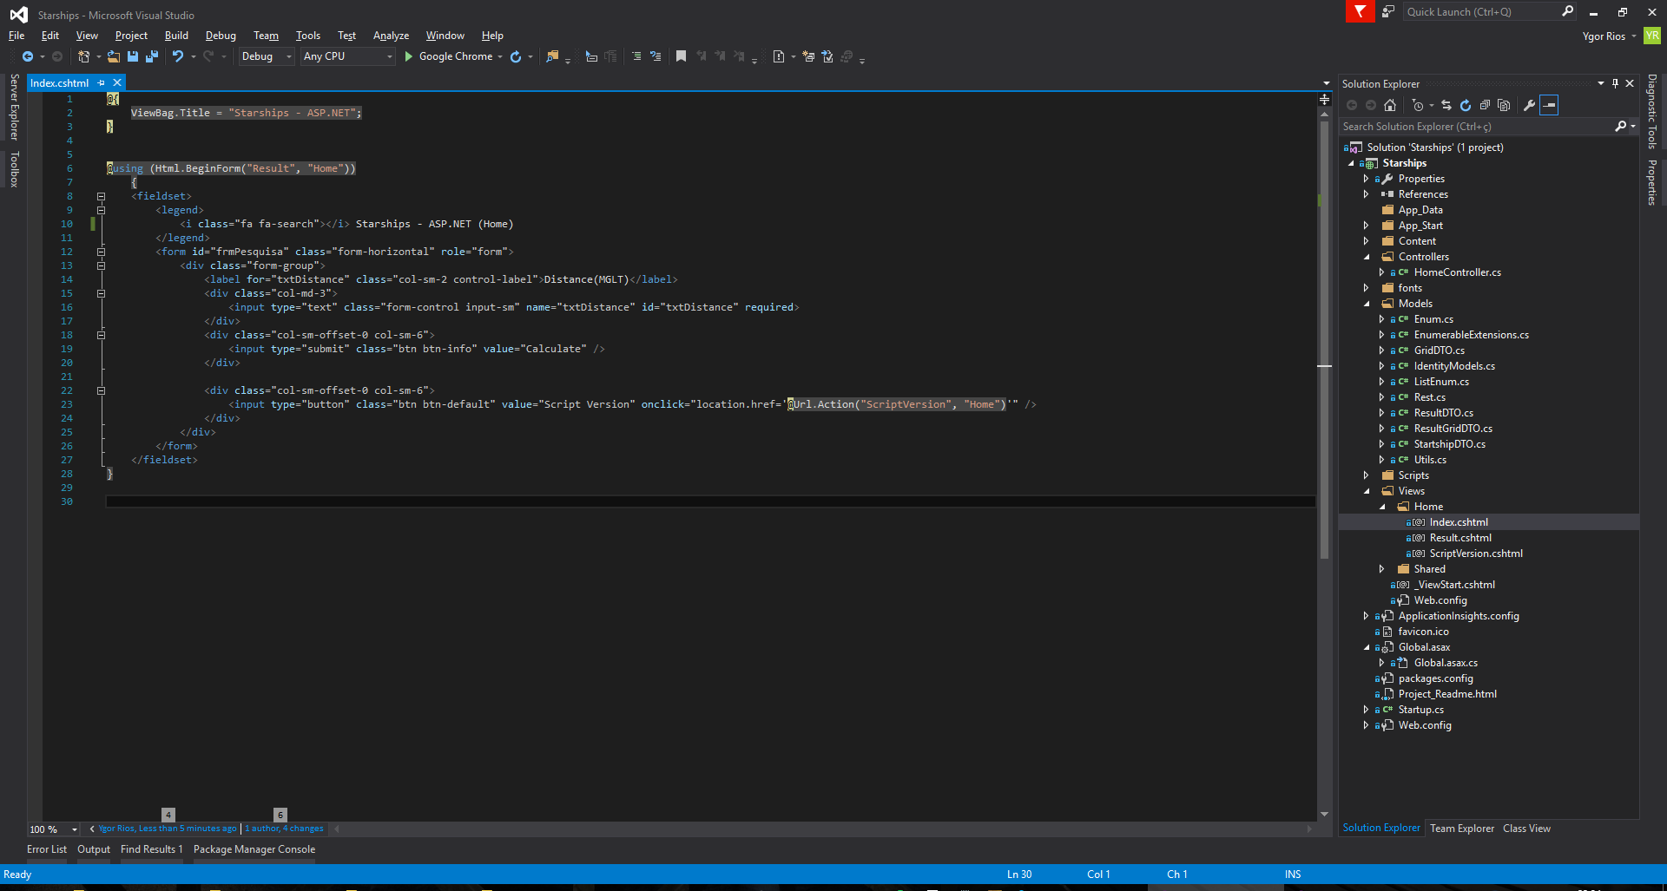

Figure 1 - Visual Studio 2015

1. Insert value in TextBox and click in “Calculate”

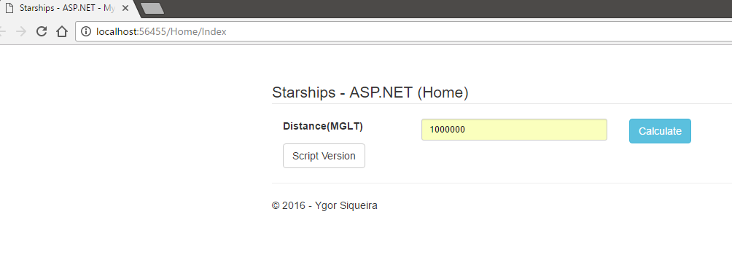

Figure 2 - HomePage in ASP.NET

1. This View show the result. If you want to search for another distance, click in “Home” and repeat the 2nd step

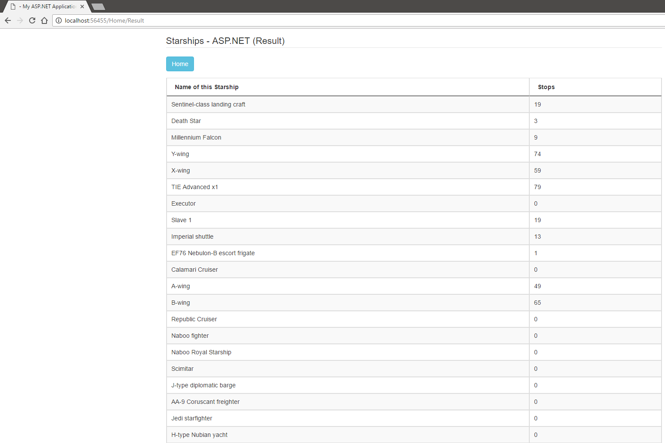 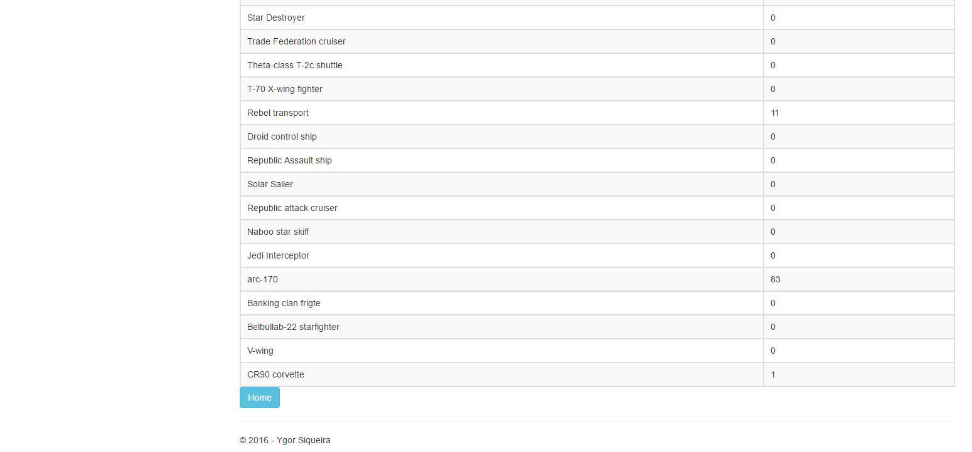

Figure 3 - Starships result in ASP.NET

1. If you would like to check a short version in JavaScript. Click in “Script Version”

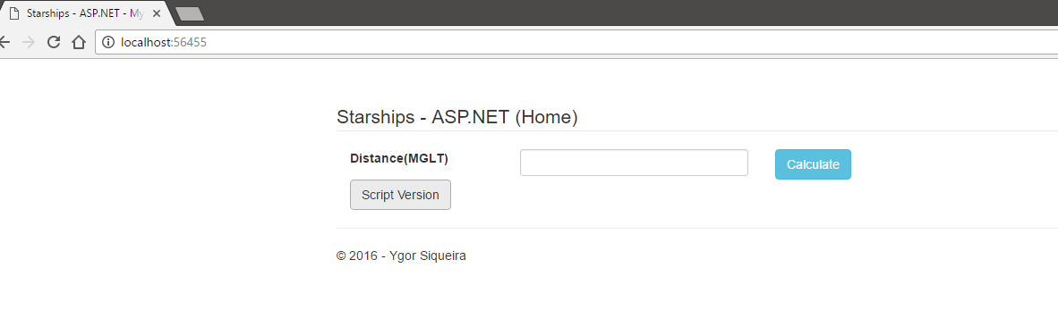

Figure 4 - Homepage in ASP.NET

1. Insert value in TextBox and click in “Calculate

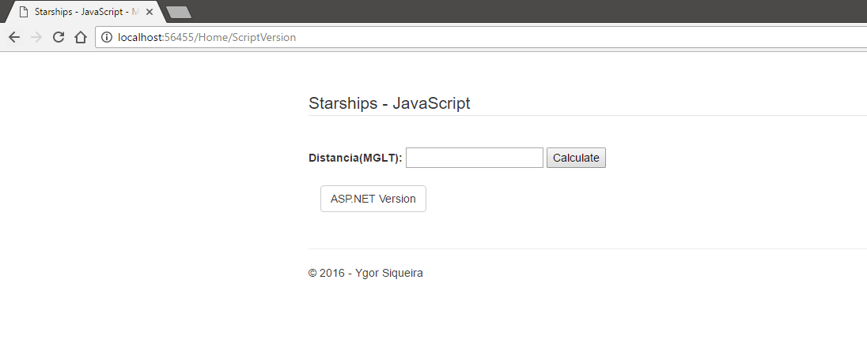

Figure 5 - Homepage in JavaScript

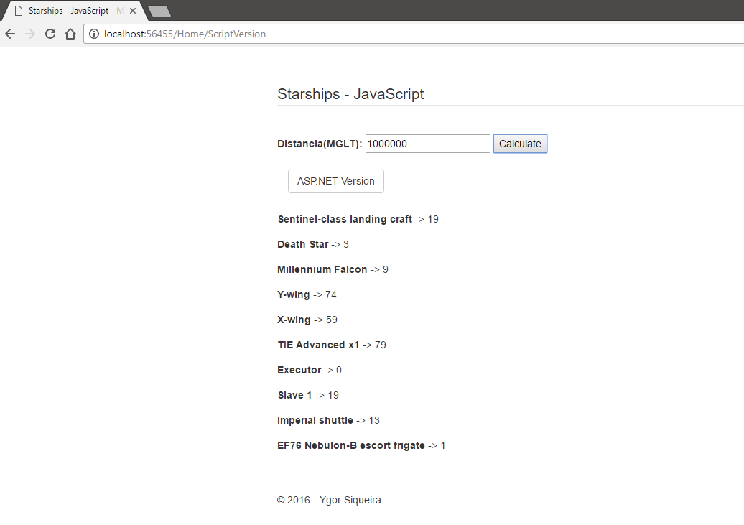

Figure 6 - Starships result in JavaScript