From Tissue Engineering, Saltzman  
Exercise 4.2 (provided by Peter Zandstra)  
In part a and b replace “the uptake” with “the amount of cell-associated”

Cells take up EGF from the extracellular medium by receptor-mediated endocytosis and horseradish peroxidase (HRP) by fluid-phase endocytosis. An example of the cell uptake of EGF and HRP as a function of the concentration in the medium is shown in Figure 4.27.

1. Explain why the uptake of HRP is linear whereas the EGF uptake is hyperbolic.

* Receptor-mediated endocytosis is strictly mediated by receptors on the surface of the cell which can be modeled by the law of mass action equation similar to the equation 4-6 in “Tissue Engineering, Saltzman”. In this process, the limiting factor for the number of proteins to enter the cell is the number of available receptors for the EGF protein to bind to enter the cell by endocytosis. At T0, the time of the beginning of the experimentation, all the receptors are available. As extracellular EGF concentration in the medium is increased, the cell takes up EGF proteins exponentially, this is represented on the EGF protein concentration curve for protein concentration between 0 and 6. Until all the receptors are bound to EGF proteins. Beyond this concentration threshold, around the value 70 on the EGF graph, saturation happens: each additional increment of EGF concentration in the medium results in smaller and smaller increase of cell concentration in EGF, and the curve plateau: the cell in EGF concentration reaches asymptotically its maximum, a value about 180 on the y-axis.
* In fluid-phase endocytosis of HRP: the cell concentration increase in HRP is linearly proportional to the extracellular HRP medium concentration: doubling the amount of concentration results in the doubling of the cell concentration in HRP. Unlike the receptor-mediated endocytosis, this endocytosis is not preceded by a specific binding to the plasma membrane or concentration of HRP molecules to specific sites.

1. Explain why the rate of uptake of EGF is much faster than that for HRP.

In receptor-mediated endocytosis, the receptor facilitates the EGF proteins to cross the cell membrane: the EGF proteins bind to receptors concentrated in regions of the cell membrane: the clathrin-coated pits. These pits bud from the membrane to form clathrin-coated vesicles which then fuse with early endosomes which are then sorted for transport to lysosomes.

By opposition, fluid-phase endocytosis (FPE) involves the invagination of the plasma membrane and is limited by the rate of diffusion cross the cell membrane which remain constant for the cells through which the HRP molecules diffuse.

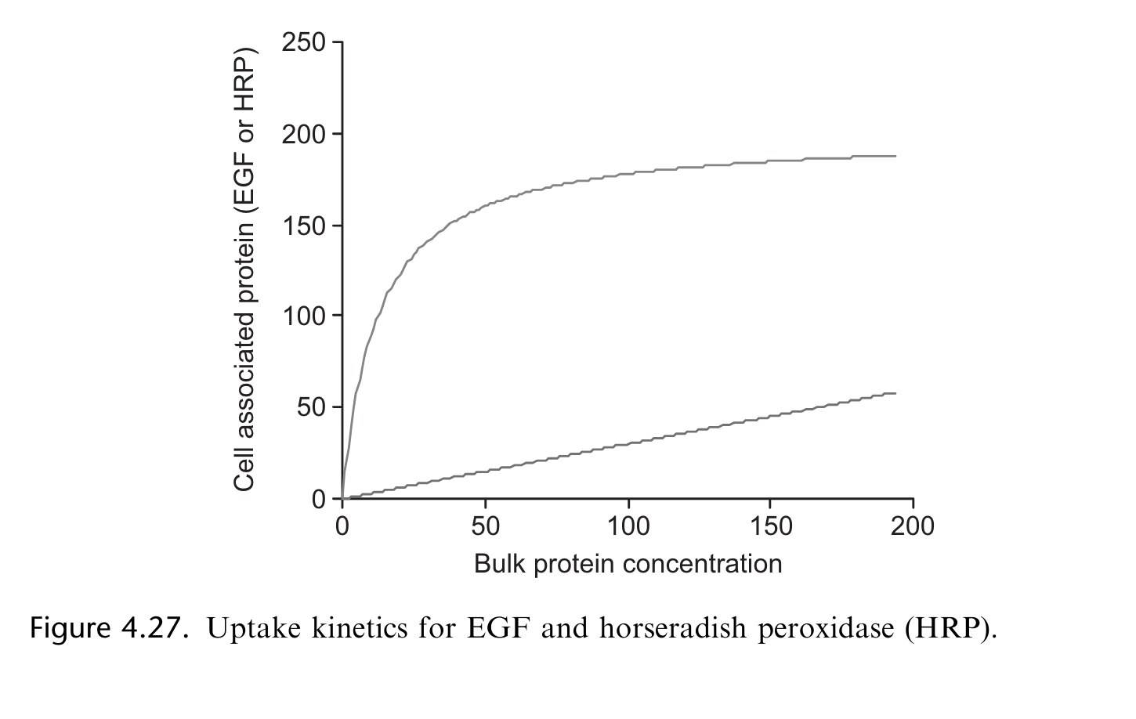

2. In order to model the protein dynamics of a ligand binding to a receptor you need to both write appropriate equations and know appropriate parameter values. In this problem you will investigate a 2- state receptor-ligand network. In this network the receptor is either active (called A) or inactive (called B). As we discussed earlier this semester – regulation occurs on many levels in the body and changing the activity state of a receptor is one level of regulation that allows for quick changes to the cell behavior. Instead of turning on a gene, transcribing, translating, folding and translocating – the cell can keep all of the receptors made in an inactive state and simply activate them when needed.

1. Please write ODEs to describe this system (following the Laws of Mass action). There should be 5 equations, one for each species present in this system (for example d[A]/dt)

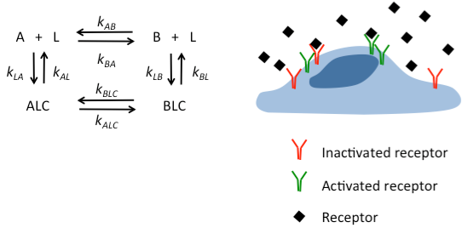

Applying the laws of mass action, we have:

d[A]/dt = k***AL*** [ALC] + k***AB*** [B] [L] – k***LA*** [A] [L] – k***BA*** [A] [L]

d[A]/dt = k***AL*** [ALC] + k***AB*** [B] [L] – (k***LA*** + k***BA***) [A] [L] [eq. 1]

Similarly

d[B]/dt = k***BL*** [BLC] + k***BA*** [A] [L] – (k***LB*** + k***AB***) [B] [L] [eq. 2]

d[ALC]/dt = k***LA*** [A][L] + k***BLC*** [BLC] – (k***AL*** + k***ALC***) [ALC] [eq. 3]

d[BLC]/dt = k***LB*** [B][L] + k***ALC*** [ALC] – (k***BL*** + k***BLC***) [BLC] [eq. 4]

d[L]/dt = k***AL*** [ALC] + k***BL*** [BLC] – k***LA*** [A] [L] – k***LB*** [B] [L] [eq. 5]

1. Please describe methods you could use to experimentally measure the necessary parameters including rate constants and species concentration.

Overall method: using a method such a yeast two hybrid systems we build an interaction map. Next, at equilibrium, we measure the different pairwise concentrations: [A], [B], [L], [ALC], and [BLC] which help us by the laws of Mass Actions, to determine the dissociation or association constants hence the ratio of constant rates, and the species concentrations.

Once we have recorder the various concentrations at equilibrium, Scatchard analyses can then be performed and the slopes of the lines; ratio of bound ligand to free ligand concentration; help us to determine the different association or dissociation equilibrium constants. These constants being the ratio of forward and reverse rate constants, allow us to express; for example, reverse rate constants in function of forward rate constants. Next, we plot the various concentrations [A], [B], [L], [ALC], and [BLC] over time and since we assume that the kinetic dynamics of these concentrations are determined by the laws of Mass Action, we can fit hyperbolic curves to the data. Expressing reverse rate constants in function of forward rate constants and substituting in the ODE equations, allow us to determine the forward rate constants hence the reverse rate constants. Finally, we have determined all the constants of this 2- state receptor-ligand network, and we have the kinetic modeling equations; and their solutions which are the change in concentrations during the experiment. We can then compute the different concentrations at any point of time of the experiment.