**Assignment 5: Morphogenesis**

**Cell and Tissue Engineering**

1. Exercise 3.1 From Tissue Engineering, Saltzman
   1. What are the three germ layers? Where do they reside in the embryo following gastrulation? What are two tissue types that result from each?

|  |  |  |  |
| --- | --- | --- | --- |
| **Layer** | **Location** | **2 tissues** | |
| Endoderm | Inner most of the 3 germ layers of the gastrula[1] | GI tract | Respiratory tract |
| Mesoderm | Middle layer of the 3 germ layers of the gastrula1 | Muscles | Connective tissue |
| Ectoderm | Outer most layer of the 3 germ layers of the gastrula1 | Nervous tissue | Epithelial tissues |

* 1. Though all of a tissue type often derives from a given germ layer, what are two counter examples to this generalization?
* Epithelial tissue can be derived from ectoderm and endoderm.
* Teratoma is a rare type of germ cell tumor, composed of various tissues derived from 3 germ layers which differentiate to form somatic tissues [1].

1. Explain why fingerprints can be used to tell identical twins apart.

Fingerprints are ubiquitous in forensic sciences because they are unique for everyone including twins, and do not change in life. Also, because the finger print patterns are encoded between dermis and epidermis, they cannot be destroyed by superficial skin injuries. Different theories and mathematical models, have been established for understanding the embryology of the fingerprints, each one comes with its limitations:

* Folding and mechanical processes: ridges are the results of undulations in the basal cell layer of the fetal epidermis. The source of stress that produces the observed patterns have not been identified.
* Biochemical: repetition of spatial pattern is due to morphogens, but due to the complex influence of biochemical and mechanical factors, experimentation is challenging.

Although no universal accepted mechanism exists for fingerprints, the overall consensus is that genetic and environment play a role in their formation, and thus fingerprints are the result of complex factors and mechanical instability [2][3].

1. Describe how semaphorins and slits function similarly in directed migration.

Both slit proteins and semaphorins act as chemorepellants:

* During neural development, slit proteins act as a midline repellant, preventing some neurons to cross the midline or others to recross the midline. It also specifies the distance from the midline for longitudinal pathways. Slits bind to Robo receptors to form a signaling pathway. In addition of the nervous system, Slit/Robo signaling plays an important role in the development of diaphragm, kidney, heart and is involved like semaphorins in angiogenesis by altering endothelial cell motility and polarity[4][5].
* In the CNS, semaphorins prevent the incorrect sprouting of developing neurons and allow their proper organizations. Semaphorin signaling is mostly mediated through plexin receptors. During blood vessel growth, semaphorins bind to plexinD1 to keep the vessels out of the somatic space. Like splits, semaphorins were initially identified as axon guidance but since then have been linked to different physiological processes including vascularization, cardio myogenesis, metastasis, osteoclastogenesis and immunomodulation [6][7].

1. Gradient calculations.
   1. Gradients of soluble morphogen are used to direct both cell specification and cell migration in the embryo. Given the diagram quantitatively determine the location (2μm or 32μm) at which the blue cells feel the steepest gradient.

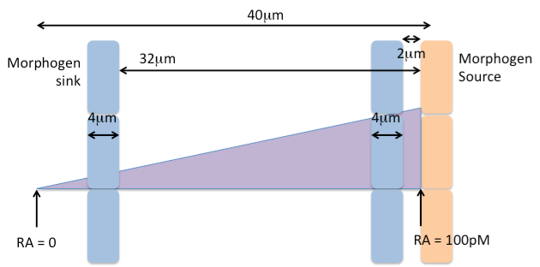

Overall gradient is: 100pM/40μm = 2.5pM/μm

At 2μm from the morphogen source

* RA at the front of the cell at 2μm from source = 38μm * 2.5pM/μm = 95pM
* RA at the back of the cell at 6μm from source = 34μm * 2.5pM/μm = 85pM

Gradient seen by the cell: (95 – 85) / 85 = 11.76%

At 32μm from the morphogen source

* RA at the front of the cell at 32μm from source = 8μm * 2.5pM/μm = 20pM
* RA at the back of the cell at 36μm from source = 4μm * 2.5pM/μm = 10pM

Gradient seen by the cell: (20 – 10) / 10 = 100%

The cell feels the steepest gradient at location 32μm.

* 1. Cells use special structures called filopodia to sense their local environment. These thin projections of the actin cytoskeleton reach out and survey both the chemical and mechanical composition of the environment as the cell decides what direction to migrate in. Quantitatively determine how filopodia change the gradient sensed by the cell in the diagram below.

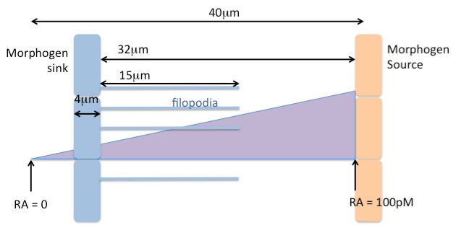

Overall gradient is: 100pM/40μm = 2.5pM/μm

At the tips of the filopodia

* RA at 17μm from source = 23μm * 2.5pM/μm = 57.5pM
* RA at the back of the cell at 36μm from source = 4μm * 2.5pM/μm = 10pM
* Gradient seen by the cell: (57.5 – 10) / 10 = 475%

The filopodia helps the cell to detect a gradient 4 times larger than the steepest gradient detected by the cell itself.

Sources

[1] M. TAKAMATSU *et al.*, “Teratoma showing the features of retinal structure: A case of sacrococcygeal teratoma,” *Oncol Lett*, vol. 3, no. 5, pp. 1023–1026, May 2012, doi: 10.3892/ol.2012.636.

[2] A. Lh and T. Mg, “Embryogenesis and Applications of Fingerprints- a review,” *International Journal of Human Anatomy*, vol. 1, no. 1, pp. 1–8, Jun. 2017, doi: 10.14302/issn.2577-2279.ijha-17-1539.

[3] M. Kücken and A. C. Newell, “Fingerprint formation,” *Journal of Theoretical Biology*, vol. 235, no. 1, pp. 71–83, Jul. 2005, doi: 10.1016/j.jtbi.2004.12.020.

[4] A. Bagri *et al.*, “Slit Proteins Prevent Midline Crossing and Determine the Dorsoventral Position of Major Axonal Pathways in the Mammalian Forebrain,” *Neuron*, vol. 33, no. 2, pp. 233–248, Jan. 2002, doi: 10.1016/S0896-6273(02)00561-5.

[5] M. Tong, T. Jun, Y. Nie, J. Hao, and D. Fan, “The Role of the Slit/Robo Signaling Pathway,” *J Cancer*, vol. 10, no. 12, pp. 2694–2705, Jun. 2019, doi: 10.7150/jca.31877.

[6] S. Hu and L. Zhu, “Semaphorins and Their Receptors: From Axonal Guidance to Atherosclerosis,” *Front. Physiol.*, vol. 9, p. 1236, Oct. 2018, doi: 10.3389/fphys.2018.01236.

[7] L. T. Alto and J. R. Terman, “Semaphorins and their Signaling Mechanisms,” *Methods Mol Biol*, vol. 1493, pp. 1–25, 2017, doi: 10.1007/978-1-4939-6448-2_1.

1. Saltzman, W. M. (2004). Tissue Engineering: Engineering principles for the design of replacement organs and tissues. Oxford University Press. Chapter 3: Elements of Tissue Development 