**Failed valve replacement**

This module is all about how cells adhere and migrate, which are critical cell behaviors for many natural and engineered tissues. Sometimes you want to promote these behaviors to ensure cells infiltrate and remain in your scaffold while simultaneously limiting the infiltration of other cells (namely immune or cancerous cells). Below is an abstract from a clinical trial reporting the failure of a valve replacement construct. This valve failed in part because it allowed for adhesion and migration of immune cells.

**Abstract**

**Objectives:** The first tissue engineered decellularized porcine heart valve, Synergrafte (Cryolife Inc., USA) was introduced in Europe as an alternative to conventional biological valves. This is the first report of the rapid failure of these new grafts in a small series.

**Materials and methods:** In 2001, 2 model 500 and 2 model 700 Synergrafte valves were implanted in four male children (age 2.5–11 years) in the right ventricular outflow tract as a root. Two patients had a Ross operation and two had a homograft replacement.

**Results:** The cryopreserved Synergrafte valves appeared macroscopically unremarkable at implantation. Recovery from surgery was uneventful and good valve function was demonstrated postoperatively. Three children died, two suddenly with severely degenerated Synergrafte valves 6 weeks and 1 year after implantation. The third child died on the 7th day due to Synergrafte rupture. Subsequently the fourth graft was explanted prophylactically 2 days after implantation. Macroscopically all four grafts showed severe inflammation starting on the outside (day 2 explant) leading to structural failure (day 7 explant) and severe degeneration of the leaflets and wall (6 weeks and 1 year explant). Histology demonstrated severe foreign body type reaction dominated by neutrophil granulocytes and macrophages in the early explants and a lymphocytic reaction at 1 year. In addition, significant calcific deposits were demonstrated at all stages. Surprisingly pre-implant samples of the Synergrafte revealed incomplete decellularization and calcific deposits. No cell repopulation of the porcine matrix occurred.

**Conclusion:** The xenogenic collagen matrix of the Synergrafte valve elicits a strong inflammatory response in humans which is non-specific early on and is followed by a lymphocyte response. Structural failure or rapid degeneration of the graft occurred within 1 year. Calcific deposits before implantation and incomplete decellularization may indicate manufacturing problems. The porcine Synergrafte treated heart valves should not be implanted at this stage and has been stopped.

Imagine that you are a researcher in this group. Brainstorm ideas to improve this therapy; specifically, ideas that would allow the desired cells to populate your construct but limit the population of undesirable cells. Describe 1 or 2 ideas in your initial post. Be creative – your ideas don’t need to be published or validated. Think out of the box. Focus on regulation through adhesion and migration regulatory mechanisms. Do not repeat ideas that have been mentioned by your peers. Respond to at least two of your classmates.

Full article referenced in this discussion: Simon, P., M. T. Kasimir, G. Seebacher, G. Weigel, R. Ullrich, U. Salzer-Muhar, E. Rieder, and E. Wolner. "Early failure of the tissue engineered porcine heart valve SYNERGRAFT® in pediatric patients." European journal of cardio-thoracic surgery 23, no. 6 (2003): 1002-1006.

Immediately after implant of a prosthetic valve, upon contact with blood, blood proteins and platelets adsorb to the surface of the biomaterial. Agglutination of reactive antibodies can cause hyper-acute rejection of the valve. These protein influx leads to the formation of a provisional matrix for cell proliferation leading to neutrophil and monocyte adhesion. These immune cells are activated through interaction of adhesion receptors such as integrins with the adsorbed proteins. The integrin molecules promote leukocyte survival, activation and differentiation. Activation of immune cells lead to chemoattractant cytokines production and chemokine recruitment of more immune cells. Within day-week period, recruited monocytes differentiate into dendritic cells or macrophages. Dendritic cells stimulate an immune response including T cells and B cell to reject the xenogeneic heart valve. Prolonged pro-inflammatory response leads to fibrous infiltration and reactive oxygen species (ROIs) which can degrade the mechanical properties of the valve. An improved version of the Synergrafte valve could have its surface coated to push immunoglobulins away (chemorepulsant). It has been shown that topographical gradient could determine cell adhesion, spreading and proliferation. The Scaffold could be reengineered to support differentiation of the monocytes part of the pro-inflammatory reaction into M2-type anti-inflammatory macrophages which promote tissue repair and regeneration. Accelerated material degradation of the scaffold can hinder the valve functions; at same time excessive chronic inflammation due the presence of the biomaterial results in fibrosis, or calcification (like it was reported in 6 weeks and 1 year explant). Degradation is tunable by proper selection of material polymers used in the scaffold and by tuning the copolymer ratio. Chemotaxis could also be part of the strategy to improve the Synergrafte valve by incorporating growth factors into the scaffold (VEGF has shown to enhance angiogenesis), or other bioactive components to stop the influx of neutrophils (like pro-resolving inflammatory mediators such as lipoxins or glucocorticoids). These molecules could be pre-seeded into the scaffold. To reduce the severity of the immune response due the damage of host tissue, for example a minimally invasive transapical valve implantation of a pre-seeded Synergrafte valve might need to be considered. Finally, the long period of degradation reported suggests to develop modalities to assess the quality of the mechanical properties of the valve over time and a monitoring of the biomarkers characterizing the inflammation using MRI or other imaging protocols.

**Reference**:

[1] G. Yan *et al.*, “Experimental and computational models for tissue-engineered heart valves: a narrative review,” *Biomater Transl*, vol. 2, no. 4, pp. 361–375, Dec. 2021, doi: 10.12336/biomatertransl.2021.04.009.

[2] L. Musumeci, N. Jacques, A. Hego, A. Nchimi, P. Lancellotti, and C. Oury, “Prosthetic Aortic Valves: Challenges and Solutions,” *Front Cardiovasc Med*, vol. 5, p. 46, May 2018, doi: 10.3389/fcvm.2018.00046.

[3] M. L. Wong and L. G. Griffiths, “Immunogenicity in xenogeneic scaffold generation: Antigen removal versus decellularization,” *Acta Biomater*, vol. 10, no. 5, pp. 1806–1816, May 2014, doi: 10.1016/j.actbio.2014.01.028.

[4] S. L. M. van Loon, A. I. P. M. Smits, A. Driessen-Mol, F. P. T. Baaijens and C. V. C. Bouten – DOI: 10.5772/54354 -[The Immune Response in In Situ Tissue Engineering of Aortic Heart Valves](https://www.intechopen.com/chapters/45069)

[Results of decellularized porcine heart valve into the Juvenile Sheep Model](https://journal.hsforum.com/index.php/HSF/article/view/963)

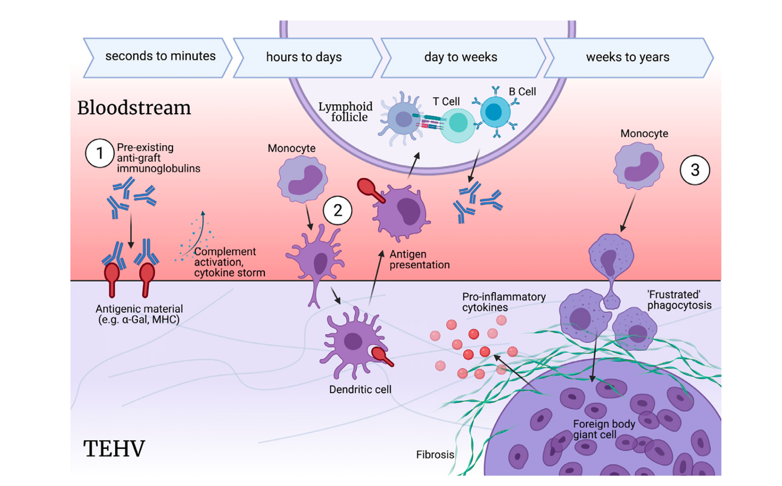

Adverse Immune scenarios that a TEHV may experience – Ground et al., Model of immunogenicity

in preclinical assessment of tissue engineered heart valves (TEHV).