A Multimodal Predictive Framework Combining Radiomics, Deep Learning, and Clinical Data for Visual Outcome Assessment in Craniopharyngioma

ABSTRACT
We created a predictive pipeline (Figure 1) that uses pre-operative data, including MRI scans, medical history, and visual function measurements, to assess the risk of visual deterioration before or after surgery.

RESEARCH IN CONTEXT
Craniopharyngiomas (CPs) are rare, epithelial tumors that develop in the sellar and suprasellar region.¹ Although classified as benign or low-grade (WHO Grade 1) histologically, they display a high-risk, "malignant behavior" because of their locally aggressive growth patterns.² These tumors tend to infiltrate and adhere strongly to vital nearby neurovascular structures, including the hypothalamus, pituitary stalk, and, most often, the afferent visual pathways.³
Consequently, visual impairment is a primary and severe symptom, present in 37% to 68% of patients at diagnosis.⁴ The clinical signs vary, including deficits in visual acuity, impaired color vision, and characteristic visual field defects.⁵ Color vision, in particular, is a highly sensitive indicator of afferent system damage, being abnormal in 71% of patients at diagnosis.⁶ The tumor's typical location, pressing upward on the optic chiasm, usually causes bitemporal hemianopsia.⁵
The primary management goal for craniopharyngioma is tumor resection to prevent recurrence, but this must be carefully balanced with the preservation of critical functions, especially vision, endocrine function, and hypothalamic integrity.⁶ The surgical outcomes for vision are profoundly variable. While surgical decompression can significantly improve vision in some patients ¹, many experience worsening vision postoperatively.
Visual impairment results from multiple causes, including the tumor's mass effect and the consequences of complications.
- Pre-operative Damage: The main mechanism is direct, chronic compression of the optic nerves, chiasm, and tracts.⁴ This compression causes optic neuropathy and, if it persists, leads to irreversible nerve fiber atrophy.⁷
- Post-operative Deterioration: Visual loss can occur even after a successful tumor resection.
The complications could be caused by medical treatment itself (e.g., surgery, medications, or other medical procedures), by physiological factors (e.g., ischemia caused by vasospasm), or by changes that can follow rapid decompression of a chronically compressed nerve.⁸

Given the high incidence of post-operative visual deterioration (9.1% in a large cohort undergoing the Endoscopic Endonasal Approach (EEA))⁸ and its potential irreversibility, the ability to reliably predict visual outcomes pre-operatively is an urgent and clinically significant unmet need in neurosurgery.
To address this gap, we developed a multimodal predictive framework that combines high-dimensional imaging features, handcrafted radiomics, and detailed clinical data. Our approach uses nnU-Net–based tumor segmentation to extract deep learning latent embeddings that capture complex spatial information not represented by traditional metrics. These embeddings are integrated with quantitative measures of tumor–chiasm proximity (distance, contact, overlap, and surface similarity) and relevant clinical and visual function variables to model both preoperative and postoperative predictors of visual outcomes.
METHODS
Dataset
A total of 83 patients were included in the study (35 females and 48 males). Female patients had an average age of 39 years (39.14 ± 23.4), while male patients had an average age of 42 years (42.5 ± 22.3) (Table 1). Frailty and comorbidity measures (MFI-5, MFI-11, CCI) indicated that most patients were low-frailty and generally healthy (Table 2). Twenty-one patients (25.3%) had a gross-total resection, and 35 patients (42.17%) underwent EEA (Table 2). Preoperative visual scores were available for 36 patients, with an average VIS score of 28.3 (SD 28.6; median 23.5) (Table 3 & 4). Postoperative VIS scores (n=50) showed a mean of 22.6 (22.6 ± 23.7; median 17) (Table 3 & 4). Postoperatively, neurosurgeons reported improved vision in 40 patients (48.2%), while vision remained unchanged in 28 patients (33.7%) (Table 5). Clinical variables included in the predictive modeling were age, sex, preoperative VIS score, preoperative visual field deficit, CCI, MFI-5, MFI-11, and race. For the post-operative models, EEA and extent of resection (EOR) were also incorporated.

Radiomics
Radiomic features included the minimum distance between the tumor and optic chiasm, the Hausdorff95 distance, the overlap volume, and a binary contact indicator (Table 6). Based on the contact metric, 42 patients (57.5%) demonstrated direct tumor–chiasm contact, whereas 31 patients (42.5%) had no contact (Table 7).

Computational Platform
The primary difficulty with using deep learning for auto-segmentation is that the optic nerve is a small, winding structure with low-contrast tissue, and it is also the area most frequently distorted and compressed by the tumor. Since segmentation accuracy directly impacts all downstream predictive models, these optic nerve modeling challenges create a significant performance bottleneck.
The proposed research pipeline integrates imaging features with clinical data to generate predictive vision risk scores. The process consists in four stages:
- Registration (Chiasm Prior Creation): For each patient, the MNI152 atlas's T1-weighted image is non-linearly registered to each patient's T1-weighted image. This generates a "Chiasm Prior," creating a standardized anatomical reference for the expected location of the optic chiasm.
- Segmentation (Tumor Mask Generation): A deep learning model (nnUNet) is trained to automatically segment the craniopharyngioma tumor from the patient's MRI scans, producing a 3D tumor mask.
- Feature Extraction (Imaging Features): We extract radiomic features by computationally analyzing the spatial relationship between the 3D tumor mask (from Step 2) and the Chiasm Prior (from Step 1). These features quantify metrics including tumor-chiasm distance, surface contact area, and volume overlap.
- Predictive Modeling: Imaging features (handcrafted radiomics and latent vectors) are combined with preoperative clinical history and visual function measurements (e.g., visual field deficit and visual score). These data points are used to train two distinct machine learning models:
- Pre-operative Model (pre-op): Acts as a diagnostic tool for surgical planning
- Post-operative Model (post-op): also includes surgical variables such as Endoscopic Endonasal Approach (0 or 1) and Extent of Resection (EOR; 1: Gross Total Resection, 2: Near Total Resection, 3: Subtotal Resection) to predict visual recovery outcomes after surgery.

This segmentation and radiomics pipeline provide computational proxies, for tumor invasiveness and may help in identifying regions of adherence to the optic nerves or optic chiasm.
Deep Learning Model
The dominant deep learning architecture for biomedical image segmentation is the U-Net.⁹ Its innovative encoder-decoder structure, connected by "skip connections," enables the network to learn both deep, contextual information (the "what") and spatial information (the "where"). This makes it highly effective for outlining complex structures in medical images. We use nnUNet, which is a state-of-the-art deep learning-based segmentation framework¹⁰.
The nnUNet framework automatically self-configures the entire segmentation pipeline through a standardized procedure.¹¹ Once the data is organized into the required folder structure, nnUNet computes a data fingerprint that summarizes dataset-specific characteristics, such as intensity distributions, image sizes and shapes, voxel spacing, and modality information. Using this fingerprint together with GPU memory constraints, nnUNet determines the network architecture, patch size, batch size, intensity normalization scheme, and resampling strategy.
Several components are fixed across tasks unless explicitly changed by modifying the codebase. These include:
- Loss function: a combination of soft Dice loss and cross-entropy
- Optimizer: Adam
- Training duration: 1,000 epochs using a polynomial learning-rate decay starting at 0.01
- Data augmentation: a fixed, extensive set of transforms (spatial, intensity, noise, gamma,
mirroring, etc.)
- Training scheme: by default, five-fold cross-validation, enabling test-time ensembling of all
folds to improve prediction robustness.

RESULTS
We evaluated four predictive models: pre-operative and post-operative binary classifiers of visual improvement, along with corresponding multinomial classifiers predicting improved, unchanged, or worsened visual outcomes. All models were trained and assessed using 5-fold cross-validation across three regularization penalties (L1, L2, and Elastic Net). We performed a grid search on the regularization parameter C (0.001, 0.01, 0.1, 1, 3, 10, 30, 100, 150, 200) and, for Elastic Net, the l1 ratio (0.1, 0.3, 0.5, 0.7, 0.1,0.3,0.5,0.7,0.9). The best performance was observed for the binary Elastic Net models (C = 0.1, L1 ratio = 0.3), each achieving an AUC of 0.68 (p = 0.03–0.04) (Table 8). In contrast, the multinomial models showed lower discrimination, with maximum AUC values of 0.48. The optimal L1 ratio of 0.3 suggests that L1-driven sparsity was not the dominant regularization force, implying that the high-dimensional setting (320 latent features, 4 radiomics variables, and 10 clinical variables) did not necessitate a strongly sparse solution (Table 9).
For prediction, the training dataset included 45 patients, and the held-out test dataset included 12 patients (6 improved, 6 not improved). Given the small test set, both preoperative and postoperative binary models showed low discrimination on the test dataset, with AUC values of 0.28 (Table 10). Similarly, the multinomial models had comparable per-class precision, recall, and F1-scores in both pre- and post-operative settings. In the multinomial case, neither model successfully identified the “worsened” class (precision and recall of 0), due to class imbalance and limited sample size (Tables 11 & 12).
Overall, the similarity between pre- and post-operative performance indicates that adding post-operative clinical variables (MFI, EOR, EEA) did not significantly improve prediction. However, these findings should be interpreted carefully: the lack of improvement might reflect an inadequate sample size and limited test-set power rather than a true lack of predictive value of the added variables.
Feature Importance
Across both binary and multinomial models, the deep learning–derived latent features consistently ranked as the most important predictors, surpassing all clinical and radiomic variables (Figures 2 & 3). Among clinical parameters, EOR was the highest-ranking variable and ranked among the top 20 predictors in the post-operative binary model (Figure 2). In the multinomial models, race (White and Asian Indian) and radiomic descriptors related to tumor–chiasm spatial interaction (contact and Hausdorff95) showed strong importance, underscoring the relevance of anatomical proximity and interface complexity for predicting visual outcome (Figure 3).

These results indicate that:
- Deep learning latent features capture rich structural information that strongly influences prediction.
- EOR remains a significant clinical variable even in the presence of high-dimensional image features.
- Specific radiomic features reflecting tumor–optic-chiasm spatial relationships contribute meaningfully to classification, particularly in multinomial settings.

Latent feature 284 consistently ranks as the strongest predictor of postoperative visual improvement in the Elastic Net models. To explore its biological significance, we used a DeepDream-based interpretability method that creates input patterns maximizing activation of this latent channel. The visualizations reveal that feature 284 is most responsive to boundary-driven anatomical cues, including sharp tumor–CSF interfaces, curvature along suprasellar contours, and compression surfaces near the optic chiasm (Figure 4).

CONCLUSION
Despite the small dataset, this study demonstrates the feasibility of combining deep learning–derived features, handcrafted radiomics, and clinical variables to predict postoperative visual outcomes in CP. The findings emphasize the importance of latent structural features and suggest future directions, including multi-modal data collection, improved segmentation accuracy, and balanced model training.

REFERENCES
[1] Müller H. L. (2014). Craniopharyngioma. Endocrine reviews, 35(3), 513–543. https://doi.org/10.1210/er.2013-1115
[2] Karavitaki, N., Cudlip, S., Adams, C. B., & Wass, J. A. (2006). Craniopharyngiomas. Endocrine reviews, 27(4), 371–397. https://doi.org/10.1210/er.2006-0002
[3] Drapeau, A., Walz, P. C., Eide, J. G., Rugino, A. J., Shaikhouni, A., Mohyeldin, A., Carrau, R. L., & Prevedello, D. M. (2019). Pediatric craniopharyngioma. Child's nervous system : ChNS : official journal of the International Society for Pediatric Neurosurgery, 35(11), 2133–2145. https://doi.org/10.1007/s00381-019-04300-2
[4] Craniopharyngiomas | Research Starters - EBSCO, https://www.ebsco.com/research-starters/health-and-medicine/craniopharyngiomas
[5] Calandrelli, R., D’Apolito, G., Martucci, M., Giordano, C., Schiarelli, C., Marziali, G., Varcasia, G., Ausili Cefaro, L., Chiloiro, S., De Sanctis, S. A., Serioli, S., Doglietto, F., & Gaudino, S. (2024). Topography and Radiological Variables as Ancillary Parameters for Evaluating Tissue Adherence, Hypothalamic–Pituitary Dysfunction, and Recurrence in Craniopharyngioma: An Integrated Multidisciplinary Overview. Cancers, 16(14), 2532. https://doi.org/10.3390/cancers16142532
[6] Repka, M. X., Miller, N. R., & Miller, M. (1989). Visual outcome after surgical removal of craniopharyngiomas. Ophthalmology, 96(2), 195–199. https://doi.org/10.1016/s0161-6420(89)32914-9
[7] Stanford, Doctor fernandez-Miranda, MD About Craniopharyngiomas
[8] Qiao, N., Li, C., Zheng, F., Zhang, L., Yang, X., Xu, J., Chen, X., Qiao, H., Zhang, Y., & Gui, S. (2025). Development and validation of a radiomics-visual evoked potential nomogram for preoperative prediction of visual outcome after endoscopic craniopharyngioma resection. Journal of neurosurgery, 142(6), 1663–1673
[9] Ronneberger, O., Fischer, P., & Brox, T. (2015, October). U-net: Convolutional networks for biomedical image segmentation. In International Conference on Medical image Computing and Computer-Assisted Intervention (pp. 234-241). Cham: Springer international publishing.
[10] Isensee, F., Jaeger, P. F., Kohl, S. A., Petersen, J., & Maier-Hein, K. H. (2021). nnU-Net: a self-configuring method for deep learning-based biomedical image segmentation. Nature methods, 18(2), 203-211.
[11] N. McConnell, N. Ndipenoch, Y. Cao, A. Miron, Y. Li- Exploring advanced architectural variations of nnUNet - Neurocomputing, 560 (2023), Article 126837

Figures
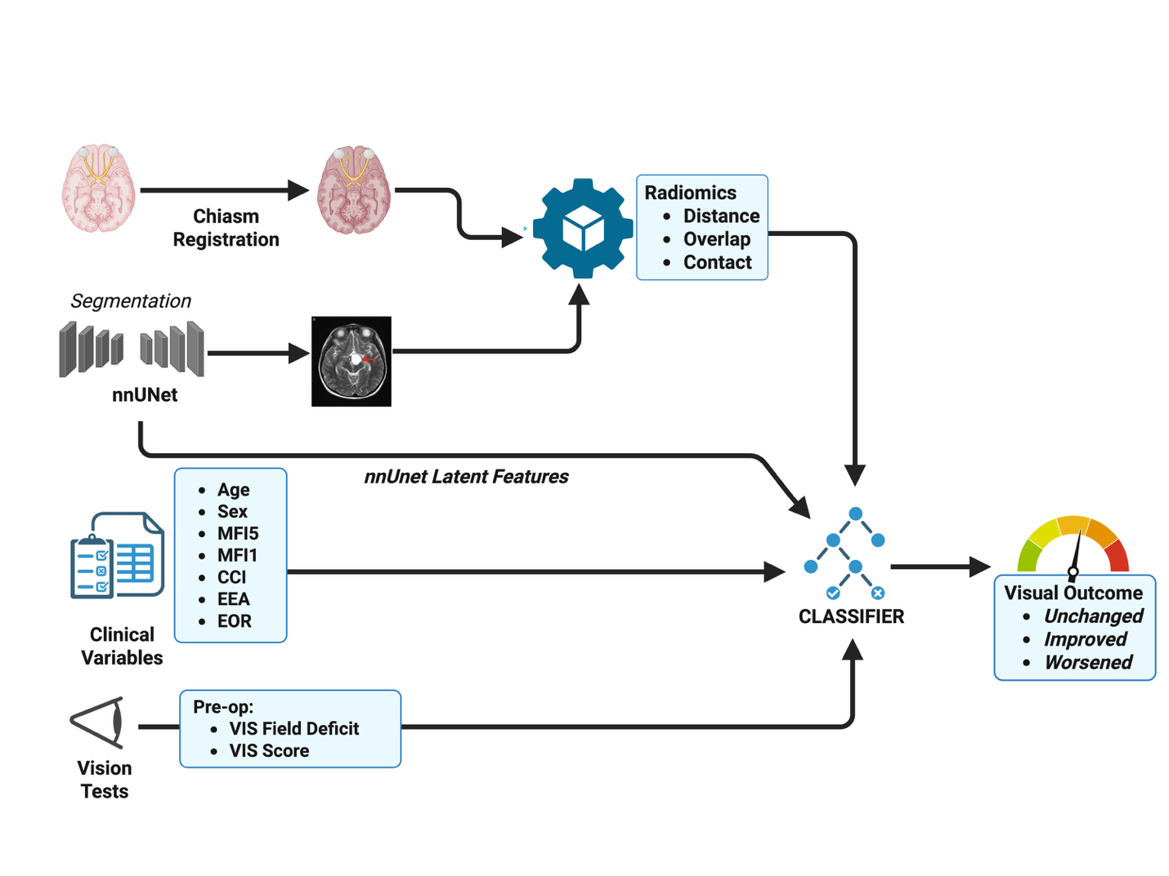
Figure 1: Pipeline

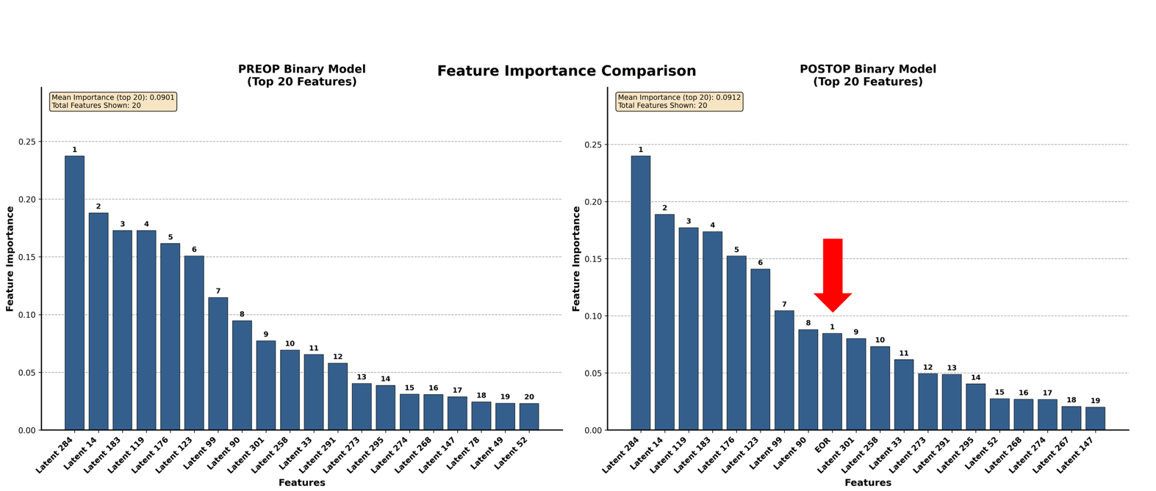
Figure 2: Feature importance for the pre-operative and post-operative binary Elastic Net models (l1-ratio = 0.3).
This figure displays the ranked feature importance values derived from Elastic Net models predicting binary visual outcome (improved vs. not improved). Latent features extracted from the deep learning segmentation model dominate the upper ranks, indicating that high-level image representations capture discriminative structural variation relevant to visual recovery. Among clinical variables, extent of resection (EOR) is the highest-ranking predictor and appears within the top 20 features for the post-operative model.
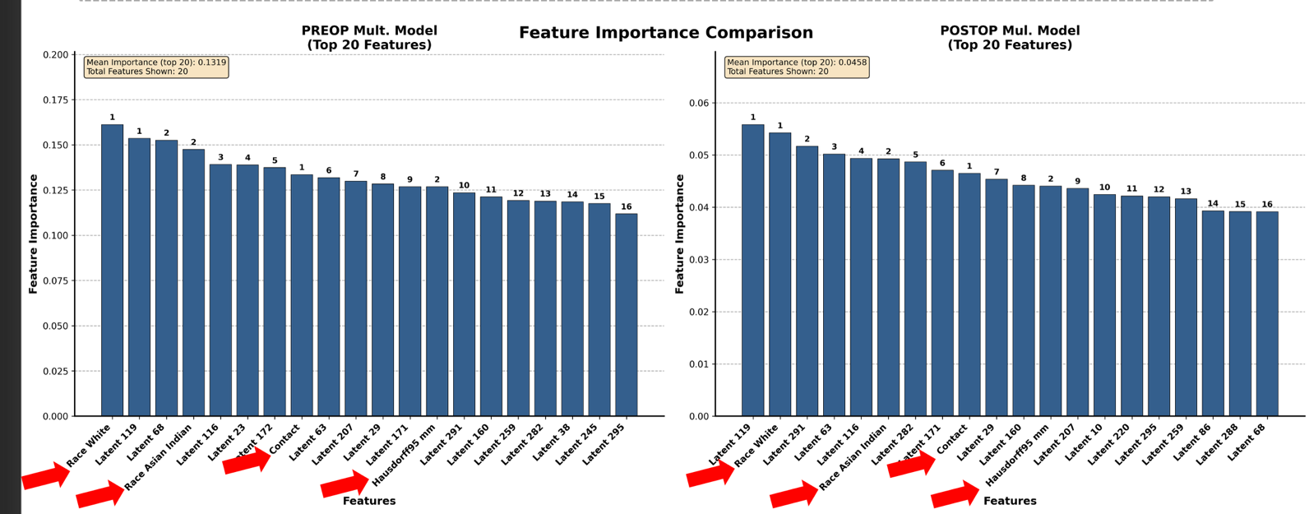
Figure 3: Feature importance for the pre-operative and post-operative multinomial logistic regression models (L2-penalized).
This figure presents the feature importance rankings for multinomial models predicting three post-surgical visual outcome categories: improved, unchanged, and worsened. As in the binary models, deep learning latent features account for most of the predictive weight, highlighting the strong contribution of high-dimensional image embeddings. In contrast to the binary setting, several clinical and radiomic variables achieve top positions: race (White, Asian Indian) ranks first and second among clinical predictors, while the radiomic features contact and Hausdorff95 emerge as the leading handcrafted features.
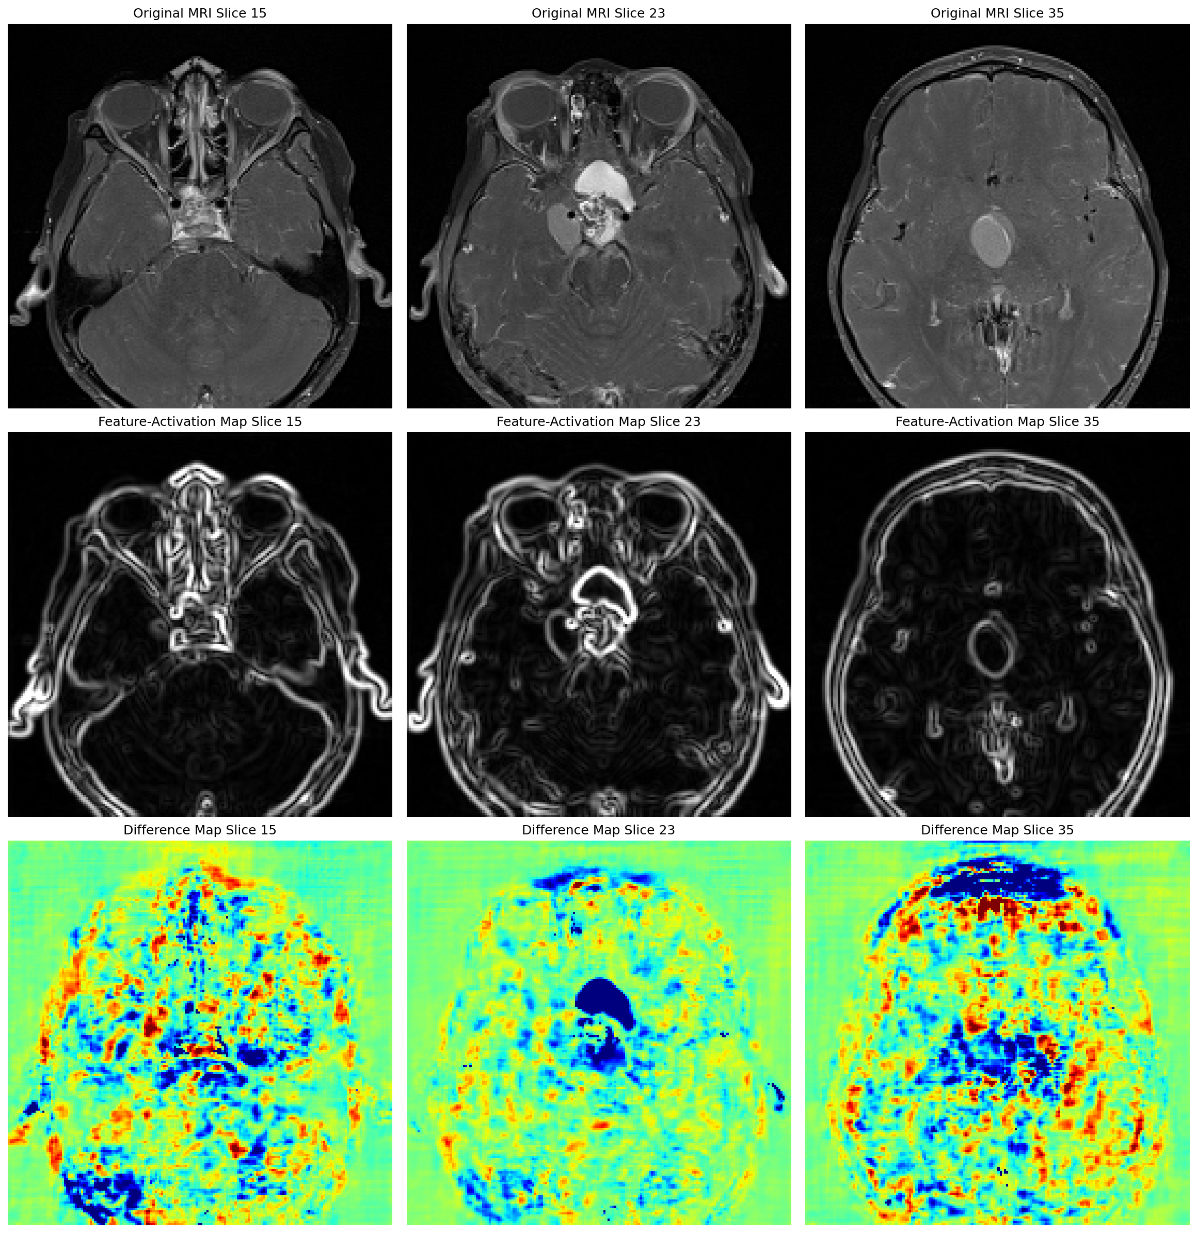
Figure 4: DeepDream visualization of latent feature 284, the top predictor in the Elastic Net model. DeepDream optimization highlights the anatomical patterns that maximally activate this latent feature, particularly boundary-enhancing structures such as the tumor–CSF interface, suprasellar contours, and regions of chiasmal compression.
Tables
Group | N | Mean Age | Std Dev Age | P Value Ttest
Female | 35 | 39.14 | 23.45 | 0.51
Male | 48 | 42.52 | 22.34 | 0.51
Table 1: Gender and Age
Variable | Level | Count | Percentage
Race | White | 47 | 56.63
 | Black or African American | 21 | 25.3
 | Other | 9 | 10.84
 | Asian Indian | 4 | 4.82
 | Asian | 2 | 2.41
MFI5 | 0 | 51 | 61.45
 | 1 | 26 | 31.33
 | 2 | 5 | 6.02
 | 3 | 1 | 1.2
MFI11 | 0 | 47 | 56.63
 | 1 | 24 | 28.92
 | 2 | 6 | 7.23
 | 3 | 5 | 6.02
 | 4 | 1 | 1.2
CCI | 3 | 10 | 12.05
 | 4 | 19 | 22.89
 | 5 | 6 | 7.23
 | 6 | 7 | 8.43
 | 7 | 4 | 4.82
 | 8 | 1 | 1.2
EOR | 1 | 21 | 25.3
 | 2 | 22 | 26.51
 | 3 | 40 | 48.19
EEA | 0 | 48 | 57.83
 | 1 | 35 | 42.17
Table 2: Clinical variables, Race, MFI5, MFI11, CCI, EOR and EEA
Variable | N | Mean | Std Dev | Median
Preop VIS Score | 36 | 28.25 | 28.56 | 23.5
Postop VIS Score | 50 | 22.6 | 23.72 | 17
Table 3: Visual Scores
Value | Preop Visual Field Deficit | Postop Visual Field Deficit
0 | 25 | 18
1 | 25 | 32
Table 4: Visual Field Deficits
Variable | Level | Count | Percentage
Neurosurgeon_Postop_Visual_Outcome | Improved | 40 | 48.19
 | Unchanged | 28 | 33.73
 | Worsened | 10 | 12.05
 | NA | 5 | 6.02
Table 5: Post-op Visual Outcome
Variable | Mean | Std | Median
Min_Distance (mm) | 2.92 | 6.43 | 0
Hausdorff95 (mm) | 8.49 | 11.17 | 0
Overlap Volume (mm3) | 146.8 | 253 | 25.74
Table 6: Radiomics
Contact | N | Percentage
0 (no contact) | 31 | 42.47
1 (contact) | 42 | 57.53
Table 7: Contact Table

Model | Penalty | C | l1 Ratio | AUC+/-SD | p | F1 | Sensitivity | Specificity
PreOp | l1 | 100 |  | 0.59+/-0.2 | 0.32 | 0.63 | 0.59 | 0.66
PreOp | l2 | 0.001 |  | 0.62+/-0.18 | 0.14 | 0.69 | 0.67 | 0.66
PreOp | ElasticNet | 0.1 | 0.3 | 0.68+/-0.19 | 0.03 | 0.66 | 0.66 | 0.60
PostOp | l1 | 100 |  | 0.59+/-0.23 | 0.38 | 0.59 | 0.54 | 0.70
PostOp | l2 | 0.001 |  | 0.64+/-0.14 | 0.02 | 0.57 | 0.50 | 0.70
PostOp | ElasticNet | 0.1 | 0.3 | 0.68 | 0.04 | 0.69 | 0.70 | 0.60
Table 8. Best cross-validated performance metrics for pre-operative and post-operative binary models across
three regularization penalties (L1, L2, and Elastic Net). Values show the mean AUC with standard deviation across
5-fold cross-validation, along with the corresponding p-values, F1-scores, sensitivity, and specificity.
Model | Penalty | C | l1 Ratio | AUC+/-SD | Sensibility Improved | Specificity  Improved | Sensibility  Unchanged | Specificity  Unchanged | Sensibility  Worst | Specificity  Worst
PreOp | l1 | 3 |  | 0.38+/-0.07 | 0.60 | 0.43 | 0.33 | 0.70 | 0.2 | 0.9
PreOp | l2 | 0.1 |  | 0.48+/-0.07 | 0.64 | 0.48 | 0.27 | 0.73 | 0 | 0.82
PreOp | ElasticNet | 3 | 0.7 | 0.38+/-0.09 | 0.64 | 0.43 | 0.33 | 0.73 | 0.2 | 0.9
PostOp | l1 | 3 |  | 0.4+/-0.07 | 0.60 | 0.43 | 0.33 | 0.73 | 0.2 | 0.88
PostOp | l2 | 0.01 |  | 0.48+/-0.06 | 0.55 | 0.53 | 0.27 | 0.70 | 0 | 0.77
PostOp | ElasticNet | 3 | 0.9 | 0.38+/-0.06 | 0.43 | 0.33 | 0.33 | 0.73 | 0.2 | 0.88
Table 9. Top 5-fold cross-validated performance metrics for pre-operative and post-operative multinomial models across three regularization penalties (L1, L2, and Elastic Net). Reported metrics include class-specific sensitivity and specificity for improved, unchanged, and worsened visual outcomes, along with mean AUC (± SD).
Model | C | Accuracy | Precision | Recall | Sensitivity | Specificity | F1 | AUC
PreOp | 0.1 | 0.25 | 0.2 | 0.17 | 0.17 | 0.33 | 0.18 | 0.28
PostOp | 0.1 | 0.25 | 0.2 | 0.17 | 0.17 | 0.33 | 0.18 | 0.28
Table 10 (Binary classification): Performance of the pre-operative and post-operative binary models for predicting visual improvement on the independent test dataset (n = 12; 6 improved, 6 not improved). Both models produced similar results, with accuracy of 0.25 and AUC of 0.28, indicating limited discriminative ability given the small test set.

Model | C | Accuracy | Precision Macro | Weighted Precision | Macro Recall | Weighted Recalled | Macro F1 | Weighted F1
PreOp | 0.1 | 0.42 | 0.31 | 0.38 | 0.33 | 0.42 | 0.32 | 0.40
PostOp | 0.01 | 0.42 | 0.33 | 0.42 | 0.33 | 0.42 | 0.33 | 0.42
Table 11 (Multinomial Overall Performance): Performance of the pre-operative and post-operative multinomial models predicting improved, unchanged, or worsened outcomes on the test dataset (n = 12). Macro- and weighted-average precision, recall, and F1-scores were similar across models, with an overall accuracy of 0.42. No improvement was observed from including post-operative variables
Model | C | Class | Precision | Recall | Sensitivity | F1
PreOp | 0.10 | Improved | 0.43 | 0.50 | 0.50 | 0.46
PreOp | 0.10 | Unchanged | 0.50 | 0.50 | 0.50 | 0.50
PreOp | 0.10 | Worsened | 0.00 | 0.00 | 0.00 | 0.00
PostOp | 0.01 | Improved | 0.50 | 0.50 | 0.50 | 0.50
PostOp | 0.01 | Unchanged | 0.50 | 0.50 | 0.50 | 0.50
PostOp | 0.01 | Worsened | 0.00 | 0.00 | 0.00 | 0.00
Table 12 (Multinomial Per Class Performance): Per-class precision, recall, and F1-scores for the pre-operative and post-operative multinomial models on the test dataset. Both models correctly identified the “improved” and “unchanged” classes with moderate performance.
Still, they failed to detect the “worsened” class (precision and recall = 0), likely due to class imbalance and limited sample size.

