Amyotrophic lateral sclerosis (ALS) is motor neurodegenerative neuromuscular disease. ALS cases are classified as” sporadic” ALS (sALS) or “familial” ALS (fALS). With the fALS form, the disease is inherited. It has been reported that mutations of genes have been associated with fALS. And for this model, we will focus on the mutated FUS/TLS gene on chromosome 16. The FUS/TLS protein binds to RNA, single-stranded DNA and double-stranded DNA. It also interacts with gene-specific transcription factors and appears in double-strand break sites for repair of DNA damages. Mutations in the FUS NLS (Nuclear localization sequence) impairs the poly (ADP-ribose) polymerase (PARP)-dependent DNA damage response. This impairment leads to FUS aggregate formation which appear to be a common pathologic hallmark for ALS.

**AIM**: Mutation in the FUS nuclear localization sequence (NLS) induces impairment of poly (ASP-ribose) polymerase (PARP)-dependent DNA damage response and cytoplasmic FUS mislocalization leading to FUS aggregate formation. Along this process, we will develop motor neurons model of FUS-ALS with endogenously tagged proteins.

**Methodology**

**Patient selection**

R521C and R521H mutations are the most prevalent mutations within the NLS region of FUS. In addition of normal patients, patients carrying diverse NLS mutations (R521C, R521H) will be selected.

**Line cells**

Line cells will be established from biopsies (skin or hair cells) obtained after consent from the fALS patients and healthy individuals. The fibroblast lines will be plated in a media, and reprogrammed into induced pluripotent stem cells (hiPSCs) using “Yamanake-factors”. These vectors could be transfected into the cells with a transfection agent. These cell lines, then can be constantly regenerated in subcultures and will be monitored until colonies will develop enough.

**CRISPR/Cas9 genome editing**

To increase the significance of the research, mutations which have been linked to ALS will be performed using CRISPR/Cas9 vector and guide RNAs (gRNA) to create double strand break at the target site and insert the FUS mutated gene with mutation in the C-terminal nuclear localization sequence (NLS) (see figure 1 – GFP-FUS mutants).

**Study**

Electrophysiology of motor neurons will be performed to check the presence of voltage-gated Na+ and K+ channels, action potentials and intracellular calcium. After extended maturation of the cultures, we will look for an increase for FUS aggregates and will check for occurrence of DNA double strand breaks in lines of normal cells extracted from healthy patients compared to the mutated lines.

References:

Kwiatkowski et Al. - Mutations in the FUS/TLS gene on chromosome 16 cause familial amyotrophic lateral sclerosis, DOI: <10.1126/science.1166066> - <https://pubmed.ncbi.nlm.nih.gov/19251627/>

<https://en.wikipedia.org/wiki/RNA-binding_protein_FUS>

Marcel Naumann et Al – Nature Communication, volume 9, Article number: 335 (2018)- [Impaired DNA damage response signaling by FUS-NLS mutations leads to neurodegeneration and FUS aggregate formation](https://www.nature.com/articles/s41467-017-02299-1) – Nature 20 January 2018

Lucia Corrade – Journal of Medical Genetics 47 (3): 19-4. DOI: 10.1136- [Mutations of FUS gene in sporadic amyotrophic lateral sclerosis](https://www.researchgate.net/figure/FUS-sequence-variations-predicting-changes-in-the-protein-sequence-identified-in-patients_tbl2_38040513) - [DOI: https://jmg.bmj.com/content/47/3/190](https://jmg.bmj.com/content/47/3/190)

Zi Chao Zhang and Yuh Min Chook - Proceedings of the National Academy of Sciences of the Unites States - [Structural and energetic basis of ALS-causing mutations in the atypical proline–tyrosine nuclear localization signal of the Fused in Sarcoma protein (FUS)](Structural%20and%20energetic%20basis%20of%20ALS-causing%20mutations%20in%20the%20atypical%20proline–tyrosine%20nuclear%20localization%20signal%20of%20the%20Fused%20in%20Sarcoma%20protein%20(FUS))

Yulei Shang, Eric J.Hung Elsevier - <https://doi.org/10.1016/j.brainres.2016.03.036> -

[Mechanisms of FUS mutations in familial amyotrophic lateral sclerosis](https://www.sciencedirect.com/science/article/pii/S0006899316301652#f0010)

Caroline et al. – doi: [10.1093/hmg/ddt117](https://dx.doi.org/10.1093%2Fhmg%2Fddt117) - [ALS mutant FUS disrupts nuclear localization and sequesters wild-type FUS within cytoplasmic stress granules](https://www.ncbi.nlm.nih.gov/pmc/articles/PMC3674807/).

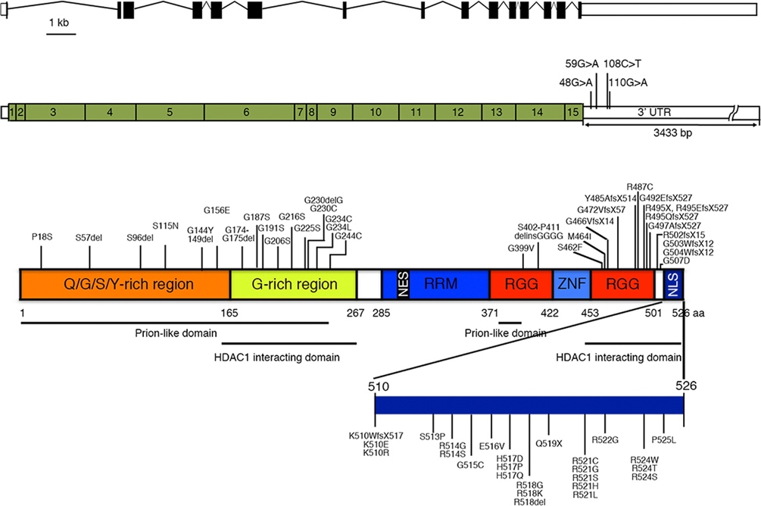

**Fig1. FUS NLS mutations**

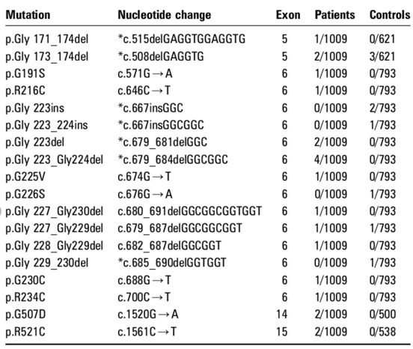

**Fig 2 . R521C nucleotide change: C->T**