1. **What is the significance of this research topic?**

Recombinant DNA (rDNA) is considered one of the most important technologies of the 20th century and started the biotechnology revolution. rDNA technologies allow the production of new proteins, and biochemicals by inserting DNA fragments using appropriate vectors into other organisms to develop for example human insulin or engineered vaccines like hepatitis B vaccine. Once introduced into the cell, multiple clones of the incorporated DNA fragments are produced and harvested. The introduced genes can be turned on to create the desired protein.

rDNA has been applied since the late 70s in research, agriculture, engineering, medicine, food and many other areas. By 2001 over 80 rDNA-based products were approved for treating disease and for vaccination and a further 350 recombinant DNA-based drugs were tested.

In 2021, all COVID-19 vaccines with FDA approval, were produced using recombinant DNA technology containing either mRNA derived from recombinant plasmids or a recombinant adenovirus. Since 2016, the number of investigational new drugs (INDs) applications to the FDA, which include genetically modified therapies have increased exponentially. Today according to D. Eisenman and al., current major developments in recombinant (or synthetic) nucleic acid molecules can be divided in 3 revolutions:

* Clinical applications of mRNA-based technology: two days after SARS-CoV-2 sequence was posted on line, Moderna in collaboration with NIAID[1], developed a vaccine in 2 days.
* CAR T Cell therapy: patient cells are collected and reengineered to produce chimeric antigen receptor proteins or CARs. CAR T cells multiply in the patient’s body after being reinjected and bind to cancer cells to kill them.
* Drugs for rare diseases: although more than 30 million people in the United States are affected by 7,000 rare diseases, by comparison for a specific rare disease, only few patients are identified, and is not a strong financial incentive for pharmaceutical companies. Recent advancements in recombinant DNA technology have enable the creation of drug discovery platforms in which a single product can be adapted for many uses. Recently FDAA approved two novel drugs: Luxturna to treat patients with a rare form of inherited vision loss and Zolgensma to treat children less than 2 years old with spinal muscular atrophy (SMA).

Polymerase chain reaction (PCR) and has been a major breakthrough in rDNA technology, and has become the ubiquitous molecular biology workhorse. Every few minutes, at each PCR cycle, the number of double-stranded copies of the original DNA is double, i.e., 2n at cycle n. PCR since its inception in 1987 by Mullis and al., has been successful due to its overall simplicity, low cost and reduced error rate. Over the years, its operational procedures have been highly optimized (real-time PCR) and many modifications have been made to the original PCR to extend its capabilities, major PCR variations, are:

* **Amplified fragment length polymorphism** (AFLP): uses selective amplification on a subset of DNA fragments to compare unique fingerprints for genome of interest (criminal and paternity tests).
* **Colony PCR**: is an effective high-throughput method to determine presence of genetic constructs in colonies of yeast or bacteria.
* **Asymmetric, inverse, long range PCR and others**: variations of PCR methods for amplification of specific DNA fragments.

One of the most significant applications of PCR technique is the generation of sequencing templates that allows to study DNA molecule in details for research.

**2. Who is working in this area?**

**3. What methods are used to study the concepts described in the paper?**

**4. Does the review article lead to new questions or hypotheses in this technical area (by the authors, by other researchers)?**

**5. What are some practical applications of the research discussed in the article?**

**6. How does this topic relate to other areas of cell biology, bioengineering, or medicine?**

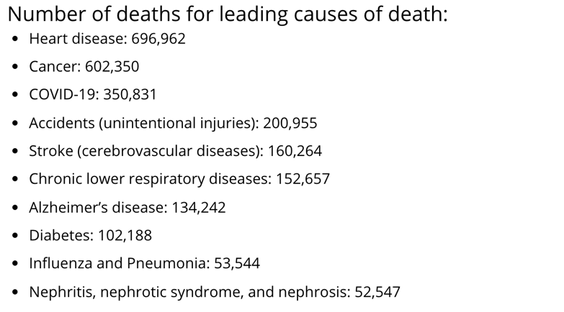

<https://www.rpi.edu/dept/chem-eng/Biotech-Environ/Projects00/rdna/rdna.html>

<https://www.cliffsnotes.com/study-guides/biology/microbiology/dna-and-gene-expression/recombinant-dna-and-biotechnology>

<https://www-sciencedirect-com.proxy1.library.jhu.edu/topics/immunology-and-microbiology/recombinant-dna-technology>

<https://www.liebertpub.com/doi/full/10.1089/apb.2021.0020>

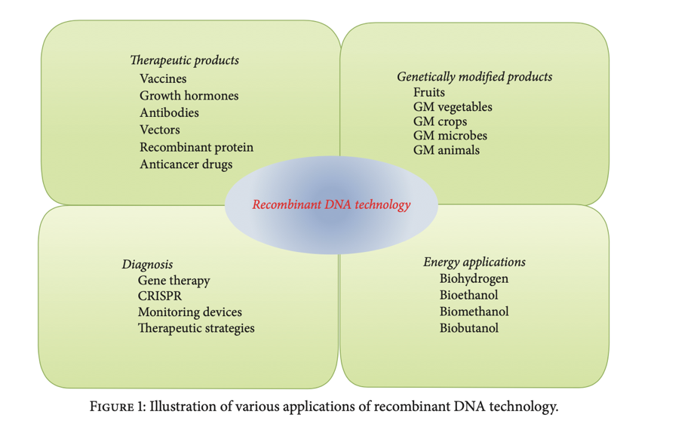

1. National Institute of Allergy and Infectious Diseases