**Identify a signal transduction pathway that results in a specific disease and share this in a post to the class**

**NOTCH1** gene provides instructions for making the receptor protein Notch1. Attachment of a ligand to the Notch 1 receptor, sends signals important in embryonic development, cell-to-cell interaction; they regulate cell growth, cell differentiation, division and cell apoptosis. Notch1 is involved in many types of cancers, including brain cancers, breast cancers and leukemias. NOTCH1 can act as oncogene and a tumor suppressor. T-cell acute lymphoblastic leukemia (T-ALL) is an acute bone marrow cancer, accounting for ~20% of acute lymphocytic leukemia (ALL), for which survival outcomes have not changed significantly for last 30 years.

Mutations in the **PEST** (Proline, Glutamic acid, Serine, and Threonine (PEST) sequence acts as a signal peptide for protein degradation) and heterodimerization (HD) domains of NOTCH1 have been present in more than 50% of T-ALL patients which is represented in *“overall signaling by NOTCH1 in Cancer”* diagram below. These mutations interfere with ubiquitination-mediated NOTCH1 downregulation and lead to defective ubiquin-dependent degradation, increasing NOTCH1 transcriptional activity by 40-fold.

**γ-secretase inhibitors** (GSIs) to inhibit NOTCH1 signaling have faced many challenges including gastrointestinal adverse effects, other strategies like combined therapies or small molecules are currently investigated.

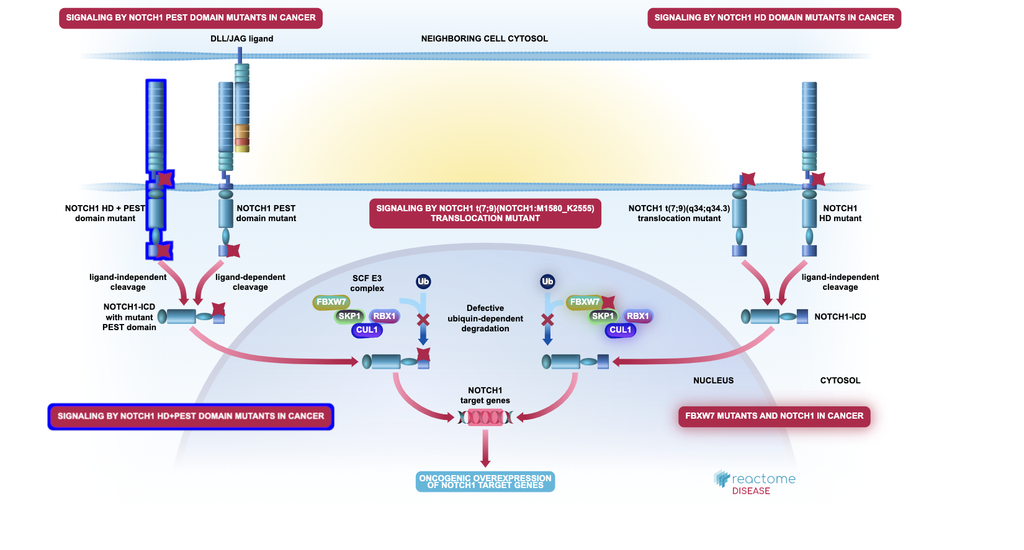

**What else did you find interesting or useful about this database?**

Initial starting point in *Reactome* is an event or reaction, a series of connected reactions define a biological pathway. The focus in *Reactome* is the human pathway, yet non-human pathways are inferred for ortholog proteins. Events are grouped into concepts which cover many areas in cellular biology like: immune system, neuronal system, including transport of small molecules or circadian Clock. Each piece of information has been curated and supported by a variety of scientific literature references which can be accessed at any point of the navigation within the application. The search allows plain text questions or gene symbols with large list of predefined filters on the results of a search. Extensive zooming capabilities allow to have an eagle-eye view of the intricacies of pathways which can give a sense of the complex inter-connections of these pathways and to zoom in if required. A click on a molecule gives access to a full description of its chemical and biological properties, its 3-D folding shapes and many other details through several protein databases. Expression in TPM for each part of the human body, regarding the genes involved in the formation of proteins, is provided with access to experiments related to the quantification of these expression levels. Also, a graphical representation of the reaction complements the Systems Biology Graphical Notation diagrams (SBGN diagrams), they are colorful and high-level description of these complex reactions. Analysis of specific data set is possible manually or programmatically. Overall, user experience is very smooth, the UI is fast and intuitive, and quickly the application gives access to a huge amount of information at different level of details or explanations.