# Module 2- Macromolecules of the cell

## For each of the six biological polymers listed, indicate which of the properties apply. Each polymer has multiple properties, and a given property may be used more than once.

Polymers:

(a)  Cellulose

(b)  Messenger RNA

(c)  Globular protein

(d)  Amylopectin

(e)  DNA

(f)  Fibrous protein

Properties  
1. Branched-chain polymer  
2. Extracellular location  
3. Glycosidic bonds  
4. Informational macromolecule

5. Peptide bond  
6. beta linkage  
7. Phosphodiester bridge  
8. Nucleoside triphosphates  
9. Helical structure possible

10. Synthesis requires a template.

A: 2-3-6

B: 4-7-9-10

C: 4-5-9-10

D: 1-3-9

E: 4-7-9-10

F: 4-5-9-10

## Protein Bonds

|  |  |  |
| --- | --- | --- |
| **Bond** | **Amino Acids** | **Levels of Structure** |
| Peptide | All | Primary |
| Hydrogen | All | Secondary |
| Disulfide (covalent) | Cysteine | Tertiary |
| Hydrogen | All | Secondary |
| Hydrophobic | Leucine | Tertiary, Quaternary |
| Ionic | Glutamate | Tertiary, Quaternary |

## Features of Nucleic Acids

For each of the following features of nucleic acids, indicate whether it is true of DNA only (D), of RNA only (R), of both DNA and RNA (DR), or of neither (N).

(a)  Contains the base uracil. R

(b)  Contains the nucleotide deoxythymidine monophosphate. N

(c)  Is usually double-stranded. D

(d)  Is a polymer. DR

(e)  Contains a phosphate group. DR

(f)  Is an inherently directional molecule, with an N-terminus on one end and a C-terminus on the other end. N

## Wrong Again. For each of the following false statements, change the statement to make it true, and explain why it is false as written:

(a) Nucleic acids are polymers consisting of chemically ~~identical~~ repeating nucleotide monomers.

(b)  A protein may have an alpha helical secondary structure. An alpha helix is spiral in shape and stabilized by covalent bonds between the NH group and the CO group in the adjacent polypeptide backbone.

(c)  Whereas a protein can be denatured by high-temperature treatment, extremes of pH both of which disrupt ~~generally have no effect on~~ tertiary structure.

(d)  Nucleic acids are synthesized from monomers that contain a high. Energy phosphodiester bond. They are already activated and do not require carrier molecule.

~~are activated by linking them to a carrier molecule in an energy-requiring reaction.~~

(e)  The disaccharide sucrose comprises two monosaccharide ~~glucose~~ monomers covalently linked together.

(f)  A beta-pleated sheet is an extended sheet-like conformation with the R groups of successive amino acids jutting out on the alternating ~~same~~ side of the sheet.

(g)  It is not easy to predict the final folded structure of a protein from its amino acid sequence using today’s powerful supercomputers.

## Telling Them Apart. For each of the following pairs of molecules, specify a property that would distinguish between them, and indicate two different tests that could be used to make that distinction:

(a)  The protein insulin and the DNA in the gene that encodes insulin

Phosphodiester bonds in DNA but not in protein.

(b)  The DNA that encodes insulin and the messenger RNA for insulin

Presence of purine thymine or pentose deoxyribose in DNA but not in RNA.

(c)  Starch and cellulose

Starch repeating unit: alpha-D glucose Cellulose repeating unit: beta-D glucose.

Use the enzyme amylase that can digest alpha (1-4) but not beta (1-4).

(d)  Amylose and amylopectin

Starch occurs in branched amylose alpha (1-6) glycosidic bonds or unbranched amylopectin alpha(1-4) glycosidic bonds.

(e)  The monomeric protein myoglobin and the tetrameric protein hemoglobin

Presence of 4 subunits in hemoglobin but not in myoglobin.

(f)  A triacylglycerol and a phospholipid with a very similar fatty acid content

Presence of glycerol but absence of phosphorus in triacylglycerol.

(g)  A glycolipid and a sphingolipid

Carbohydrate group (glycolipid) instead of phosphate group. (sphingolipid).

(h)  A bacterial cell wall polysaccharide and chitin

# Module 3 – Introduction to Cells and Organelles

**Describe and similarities and differences between archaea, bacteria and eukaryotes**

* They came from the same ancestor cell.
* Eukaryote cell has a plasma membrane, a nucleus, membrane bounded organelles and cytosol supported by the cytoskeleton.
* Main distinction between prokaryote (bacteria and archaea) and eukaryote cell (plant, animal, fungi, algae and protozoa) types is the membrane-bound nucleus of eukaryotic cells.
* Eukaryotic DNA is organized into linear molecules complexed with large amounts of histones.
* Bacterial DNA is present as a circular molecule associated with few proteins.
* Archaeal DNA is circular and complexes with proteins similar to eukaryotic histone proteins.

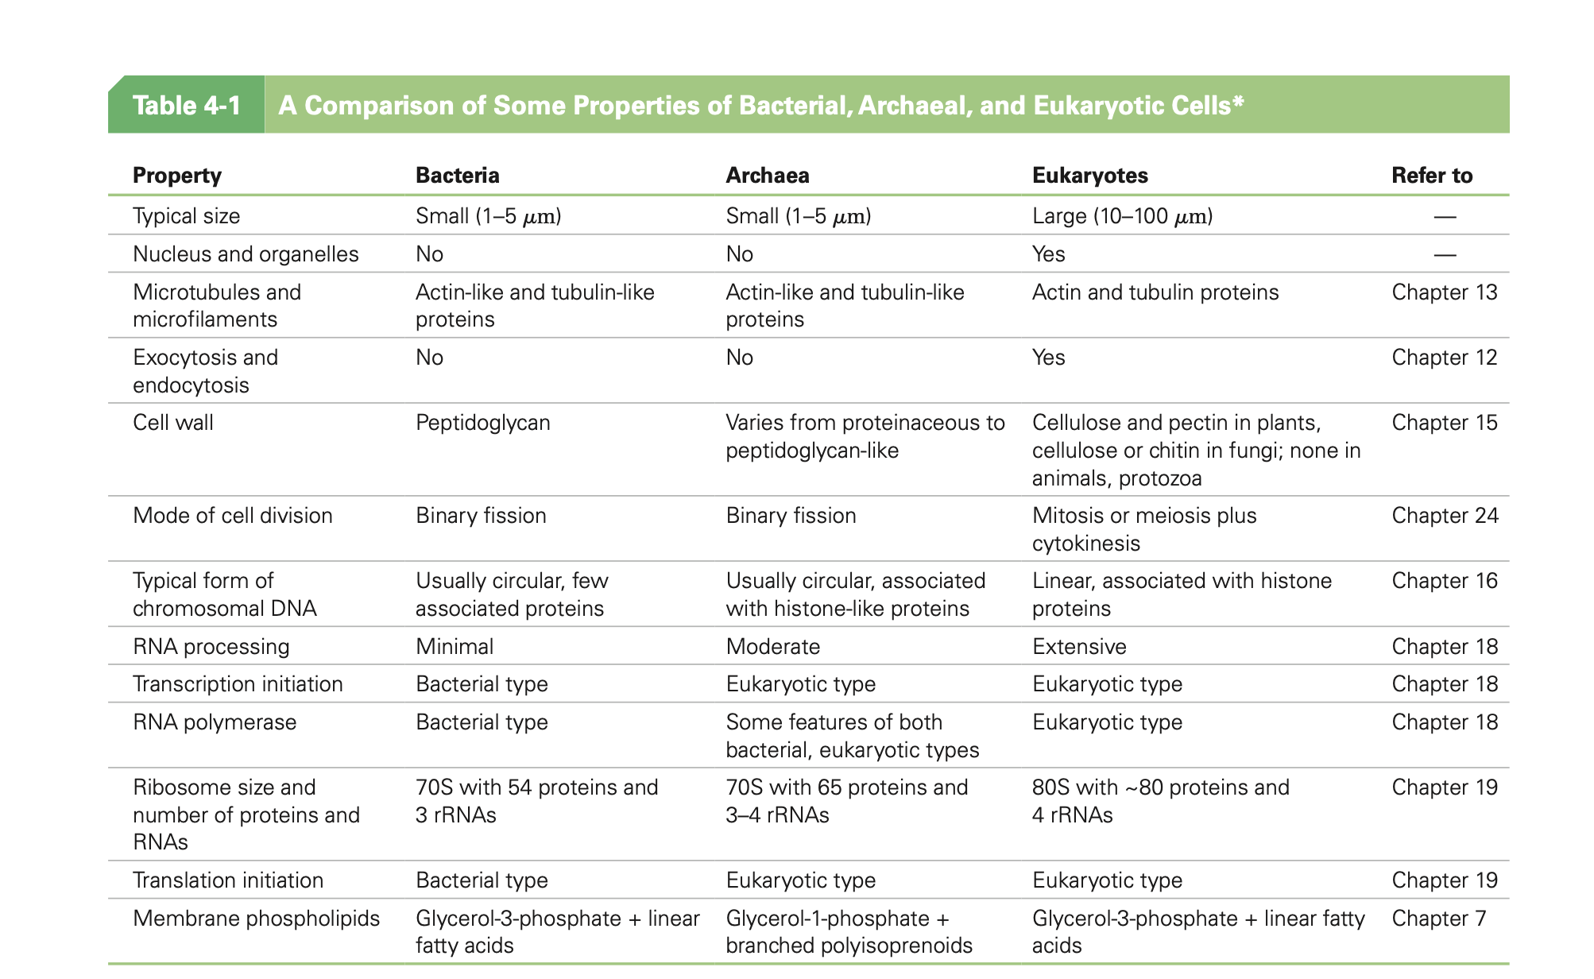

**Discuss the 3 main limitations on cell size**

1. Need to maintain adequate surface area to volume ratio

Larger cells have proportionally smaller surface areas.

Beyond a certain threshold of this ratio, large cells do not have enough surface area to accommodate the need for nutrients and release of enough wastes.

Cells like cells lining the small intestine have characteristics like fingerlike projections that increase the surface area.

1. Rate of diffusion of proteins decreases as the size of molecules increases

Eukaryotic cells avoid the problem by using carrier proteins or vesicles.

1. Need for adequate local concentrations and essential substances

To maintain the necessary concentration of a specific molecule, number of molecules must increase with cell volume. An effective solution to the concentration problem is the compartmentalization of activities within organelles.

**Discuss the role of plasma membrane**

**The main role: ensures that cell contents are retained.**

* Serves as a permeability barrier between the cell and outside environment.
* Localizes and organizes different functions within the cell.
* Facilitates transport of different molecules within the cell between organelles and also its outside environment: nutrients, ions or water, and wastes.
* Helps the cell to perceive its external environment and respond appropriately thru receptor mediated signal transduction, transmission of signals from outer surface to cell interior.
* Mediate interactions with other cells.

**List several eukaryotic organelles and their basic functions**

* Mitochondrion

Site of aerobic respiration

Provide energy to cell by oxidation of sugars and other fuel molecules.

* Rough ER

Has ribosomes either on the side of the membrane facing the cytosol or free in the cytosol which synthesize proteins; some of them to be transported out of the cell.

* Smooth ER

Involved in the synthesis of lipids and steroids such as cholesterol and steroid hormones derived from it.

* Golgi Complex

The post office: involved in processing and packaging secretory vesicles which are then passed to other components of the cell, and in polysaccharide synthesis. Glycoproteins and membrane lipids from the ER undergo further process, sorting and are packaged for transport (via the trans-Golgi network or TGN).

* Lysosome

Storage for hydrolase enzymes capable of digesting any biological molecules.

Cells involved in synthesis of secretory proteins have prominent rough ER networks (fibroblasts in skin secrete collagen). Cell producing steroid hormones have extensive networks of smooth ER (e.g., cells of adrenal gland).

**Describe the Endosymbiont Theory**

Suggests that mitochondria and chloroplast evolved from the same ancestor bacteria. This is based on similarities in size, membrane lipid composition, rRNA sequences, presence of circular DNA molecules, and bacterial type ribosomes, and ability to reproduce autonomously.

**Describe the eukaryotic cytoskeleton and its structural components**

Eukaryotic cytoskeleton is an array of fibers giving structure to the cytoplasm giving the cell its shape. In addition, it plays a role in cell movement and cell division.

A 3-D array of interconnected microfilaments, microtubules, and intermediate filaments.

A microtubule is a cylinder of protofilaments with a hollow center (lumen). Each protofilament is a linear polymer of tubulin with polarity. Tubulin consists of two proteins: alpha-tubulin and beta-tubulin.

Microfilaments are polymers of F-actin strands twisted in a helical structure. F-actin polymers are made of G-actin. Microfilaments have a polarity.

Explain key characteristics of prions, viruses, and bacteriophages

* **Viruses** are small and consists of a coat of protein surrounding a core, containing DNA or RNA. They have no cytoplasm, organelles or ribosome and infect cells, using their machinery to produce more viruses. When they infect bacteria, they are called bacteriophages or phages. They are responsible for many diseases, also important tools as research tools.
* **Prions** are infective particles which induce existing, properly folded proteins to convert into disease-associated prion form, and they induce amyloid plaques.
* A **bacteriophage** exists in theory for every type of bacterium, can be highly specific for their hosts.

# Module 4 – Enzymes

**Describe the basic properties of the enzymes**

<https://infinitabiotech.com/blog/properties-of-enzymes/>

* Act as biological catalyst by increasing the rate of reactions without increasing the temperature.
* Are proteins.
* Have a globular shape.
* A complex 3-D structure.
* They are depleted and remain unchanged at the end of a reaction.
* Specificity.

**Explain why enzymes are good biological catalysts**

* They increase the rate of a reaction by lowering the activation energy requirements, without increasing the temperature.
* They change the rate at which equilibrium is achieved without changing its position.
* Most of the enzyme catalyzed reactions are reversibility.

**Explain why enzymes only work on a single substrate**

Because of the precise chemical fit between the active site of the enzyme and its reactants, enzymes are very specific.

Two models to explain this specificity: lock-and-key and induce-fit (conformational change of the enzyme).

**Explain that enzymes function by lowering the activation energy for biochemical reactions**

Before a chemical reaction happens, there is an activation energy, which is the minimal amount of energy the reactants must contain before collisions between them will be successful in giving rise to products. Enzymes lower the activation energy ensuring that a higher proportion of molecules possess enough energy to undergo reaction without increasing the temperature.

**The Need for Enzymes. You should now be in a position to appreciate the difference between the thermodynamic feasibility of a reaction and the likelihood that it will actually proceed.**

1. Define the terms activation energy and transition state.

**Activation energ**y: minimum amount of energy reactants must contain before a chemical reaction happens.

**Transition state**: chemical state which separate the state in which molecules exists as reactants and the state in which they exist as product.

1. Describe the effect of heat on enzyme activity and explain why using heat to alter enzyme activity is problematic in cells.

Reaction rate is the highest at the optimal temperature (370c for human enzymes). Above this optimal temperature, enzyme activity decreases sharply until the enzyme is denatured (inactive).

1. An alternative solution is to lower the activation energy barrier. What does it mean in molecular terms to say that a catalyst lowers the activation energy barrier of a reaction?

A catalyst by lowering the activation energy requirements, allows a higher proportion of the molecules to possess sufficient energy to undergo reaction without elevation of temperature.

1. Organic chemists often use inorganic catalysts such as nickel, platinum, or cations in their reactions, whereas cells use proteins called enzymes. What advantages can you see to the use of enzymes? Can you think of any disadvantages?

**Advantages**: specificity and more exact control.

**Disadvantages**: more susceptible to inactivation by heat, pH, substrate concentration and; also, more energy needed to be expanded to synthesize the enzyme molecules.

Temperature and pH Effects. Figure 6-4 illustrates enzyme activities as functions of temperature and pH. In general, the activity of a specific enzyme is highest at the temperature and pH that are characteristic of the environment in which the enzyme normally functions.

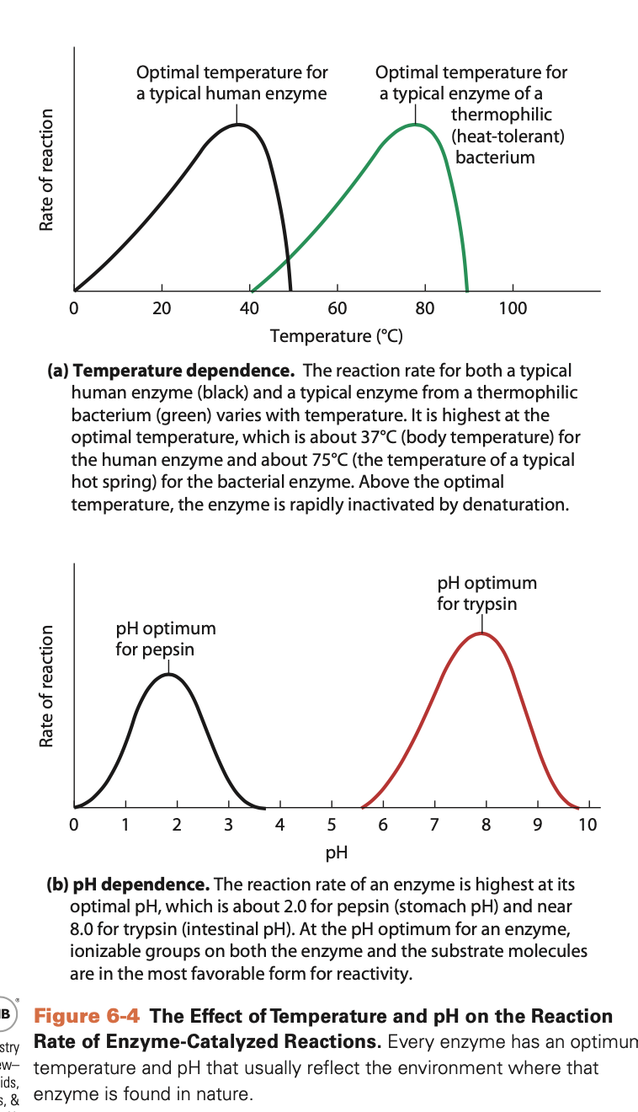

1. **Explain the shapes of the curves in Figure 6-4 in terms of the major chemical or physical factors that affect enzyme activity.**

Figure 6-4a: The velocity of the reaction increases as the temperature is increased consistent with the effect of temperature in general on chemical reaction, which usually double in reaction velocity for every 100C increase. As the T is raised above the optimum, sharp decline in activity as the enzyme undergoes denaturation.

Figure 6-4b: pH optimum corresponds to the ionizable groups on both the enzyme and the substrate molecules are in the most favorable form for chemical reactivity. pH away from optimum, results in loss of enzyme activity due to titration of the ionizable groups on the enzyme or substrate.

1. **For each enzyme in Figure 6-4, suggest the adaptive advantage of having the enzyme activity profile shown in the figure.**

Figure 6-4a shows that both enzymes are maximally active at or near the temperature of the milieu in which they are found.

Figure 6-4b shows the differences in pH optima for the two enzymes reflects the different environments in which the two enzymes are active.

**(c)- Some enzymes have a very flat pH profile—that is, they have essentially the same activity over a broad pH range. How might you explain this observation?**

They have no amino acids at its active site that undergo ionization or protonation, and probably catalyzes a reaction in which neither substrates nor the products can be ionized or protonated.

# Module 5 – Membrane and the Endomembrane system

**Describe 5 important function of membranes and give examples**

1. Boundary and permeability barrier

The plasma membrane surrounds the cell and regulates passage of molecules both into and out of the cells. Also, intracellular membranes compartmentalize functions in eukaryotic cells.

1. Organization and localization of function

Mitochondrial membranes are critical for respiration.

1. Cell-to-cell interactions

Cadherin is a membrane protein which has extracellular sequences of amino acids that binds Ca2+, and promote adhesion between similar types of cells in tissue.

1. Signal transduction

Chemical signal molecules bind to membrane protein receptors, on the outer surface of plasma membrane which are transmitted to the interior of the cell: e.g., muscle and liver cell membrane contain insulin receptors and can respond to this hormone, which helps cells take in glucose.

1. Transport processes

Membranes are sites of specific proteins which carry out and regulate the transport of substances across the membrane: e.g., **aquaporin** which is an integral membrane protein that transports water.

**Differential centrifugation**: used to separate organelles by size and density differences.

**Immunostaining**: technique in which antibodies are labeled with a fluorescent dye to enable them to be identified and localized microscopically based on their fluorescence.

**Explain the Fluid Mosaic**

The fluid part is that the plasma membrane is as lipid bilayer – main classes of lipids: phospholipids, glycolipids and sterols.

The mosaic part includes proteins attached or embedded in the bilayer membrane, and lipid rafts and other lipid domains.

**Describe the 3 classes of membrane proteins**

* Integral
* Peripheral
* Lipid-anchored

**Explain what is meant by membrane asymmetry**

Refers to the difference in both the kinds of lipids present and the degree of unsaturation of the fatty acids in the phospholipid molecule; e.g., most of the glycolipids present in plasma membrane are restricted to the out monolayer (carbohydrate groups protrude from outer membrane surface). Once established, asymmetry mostly maintained because movement of lipids from one monolayer to the other requires the passage of hydrophilic head groups through the hydrophobic interior of the membrane**., flip-flop** or **transverse diffusion**.

**Explain laboratory techniques that can be used to study membranes and membrane-associated molecules**

**Thin-Layer Chromatography**: useful to separate membrane lipids according to their degree of polarity. The sample is spotted on a glass TLC plate. Components of the sample are carried upward by the solvent on the plate.

**FRAP** (Fluorescent recovery after photobleaching): molecules in a living cell are tagged with a fluorescent protein (e.g., GFP). A high-density laser beam is used to bleach the dye in a tiny spot on the cell surface, and is seen with a fluorescence microscope ass a dark spot. Eventually fluorescent proteins diffuse in and the pot is indistinguishable from the rest of the cell surface.

Differential scanning calorimetry: the membrane is placed in a sealed chamber, the calorimeter, and its uptake of heat is measured as the temperature is slowly increased.

**Freeze-fracturing**: A lipid bilayer or a membrane is frozen and then hit sharply with a diamond knife. The resulting fracture often follows the plane between the two layers of membrane lipid: split between its inner and outer monolayers, revealing the inner surface of each.

Electrophoresis: several techniques which use electric field to separate molecules according to size.

**X-ray crystallography** – determine 3-D structure of proteins.

**DNA sequencing** - Amino acid and nucleotide sequences can be deduced from DNA thus it reveals functionally important amino acids, families of homologous proteins, structure and orientation of proteins in membrane and functional relationships between proteins. Also, it, allows specific mutation in the protein sequence to allow determination effects on function.

**Describe glycosylation**

Initial steps of N-glycosylation (addition of short-chain of carbohydrates to oligosaccharides) starts on cytosolic surface of the ER membrane; later steps take place in the lumen of the rough ER. The process is usually completed within the Golgi complex. This process forms **glycoproteins**. Enzymes catalyzes this reaction.

**Describe the theory of lipid rafts and give examples of where they have important functions**

Lipid rafts or lipid microdomains are involved in cell signaling. In the outer membrane layer of animal cells, they are characterized by elevated concentrations of cholesterol and glycosphingolipids. Moreover, the glycosphingolipids in lipid rafts, are more unsaturated, and the rigidity and hydrophobic nature of the cholesterol, and the hydrocarbon tails of the glycosphingolipids and the phospholipids, allow tight packing, making lipid rafts thicker and less fluid than the rest of the membrane.

Lipid rafts have roles in:

* Detection and response to extracellular signals.

Lipid rafts containing receptors are coupled to lipid rafts on the inner mono layer. Receptor-mediate endocytosis starts when a specific molecule (ligands) binds to their receptor molecules on the outer surface of the plasma. Receptor-ligand complexes accumulate in coated pits where invagination is facilitated by adaptor proteins: clathrin and dynamin. The coated vesicle that loses its clathrin, now fuses with an early endosome. It can also, move into lipid rafts located in the outer monolayer. Some lipid rafts contain **kinases**, enzymes that generate second messengers in a cell phosphorylation (addition of a phosphate group) of target molecules.

* Transport of nutrients and ions across membranes.
* Binding of activated immune system cells to microbial target.
* Transport of cholera toxin into intestinal cells.

**Explain how DNA sequencing is used to study membrane proteins**

**DNA sequencing** - Amino acid and nucleotide sequences can be deduced from DNA thus it reveals functionally important amino acids, families of homologous proteins, structure and orientation of proteins in membrane and functional relationships between proteins. Also, it, allows specific mutation in the protein sequence to allow determination effects on function.

**List the organelles that make up the endomembrane system and describe how molecules are trafficked through this system**

ER (rough and smooth)

Golgi complex

Vacuoles

Lysosome

Proteins synthesized in the rough ER must be directed to various destinations within the cell and outside. Sorting of proteins begins in the ER and early compartments of the Golgi (vesicular transport model and cisternal maturation model). The final sorting that will leave the Golgi complex occurs in the TGN. Once a protein reached its destination, it must be prevented from leaving. Each protein contains a tag targeting to a transport vesicle that will take it to the correct destination. Some tags can also be used to exclude materials from certain vesicles. Tags may be an amino acid sequence, a hydrophobic domain, oligosaccharide side chain, membrane lipids, or lipid phosphate groups

Describe endocytosis, exocytosis and phagocytosis

**Endocytosis**: taking in of matter by a cell by invagination of its membrane to form a vacuole.

**Exocytosis**: process by which the content of a cell vacuole is released to the outside of the cell though fusion of the vacuole with cell membrane.