Table of Contents

Frank-Starling curves 2

Afterload 3

Preload 4

Mean Arterial Pressure 6

Arterial and Aortic Pulse Pressure 7

Central Venous Pressure 8

Vascular Compliance 9

Systemic Vascular Resistance 10

Blood Volume 10

Vascular Tone 10

Cardiac Function Curve 11

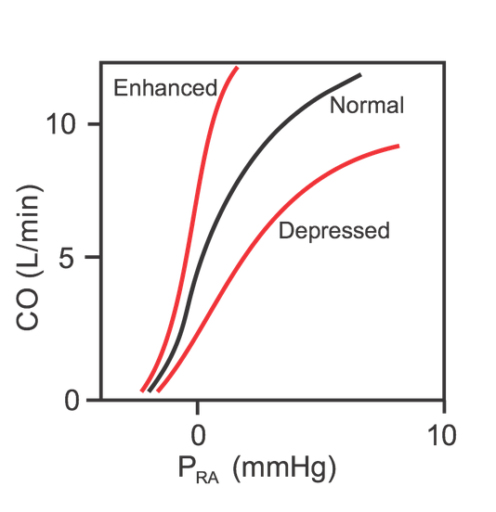 11

Systemic Vascular Function Curve 11

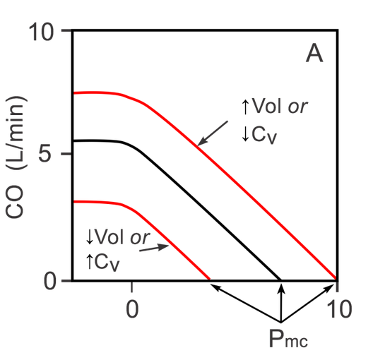 12

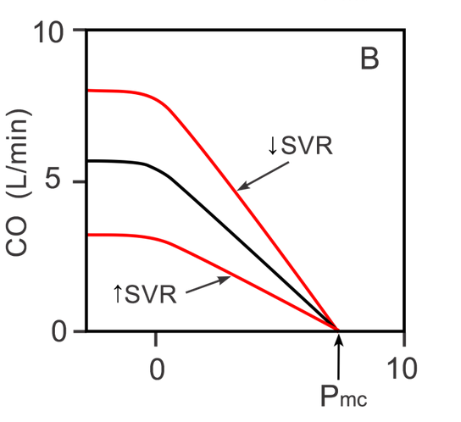 12

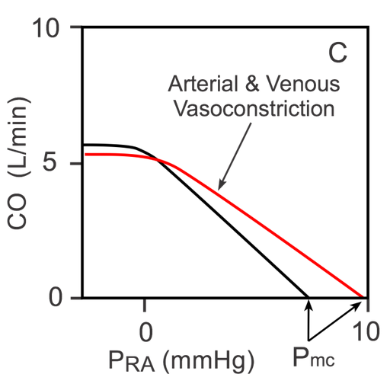 13

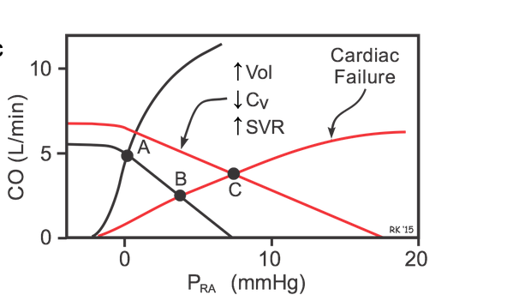 14

Cardiac Output 14

CO = SV x HR 14

− SV in mL/beats 14

− HR in beats/min 14

− CO in ml/min 14

Heart Rate 14

Stroke Volume 15

SV = EDV - ESV 15

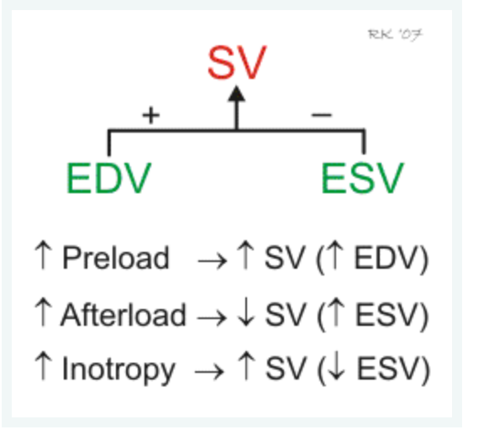 16

Preload 16

Afterload 16

Contractility 16

Changes in ventricular inotropy (contractility) alter the rate of ventricular pressure development, thereby affecting ESV and SV. For example, an increase in contractility (e.g., produced by sympathetic activation of the heart) increases SV and decreases ESV. Conversely, a decrease in contractility (e.g., heart failure) reduces SV and increases ESV. 16

Adrenergic and Cholinergic Receptors in the Heart 17

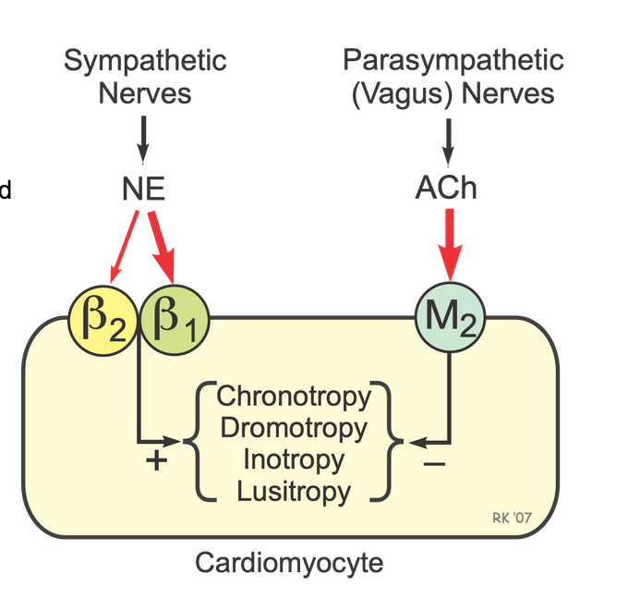 17

Cardiac Signal Transduction Mechanisms (G-Protein-Linked) 17

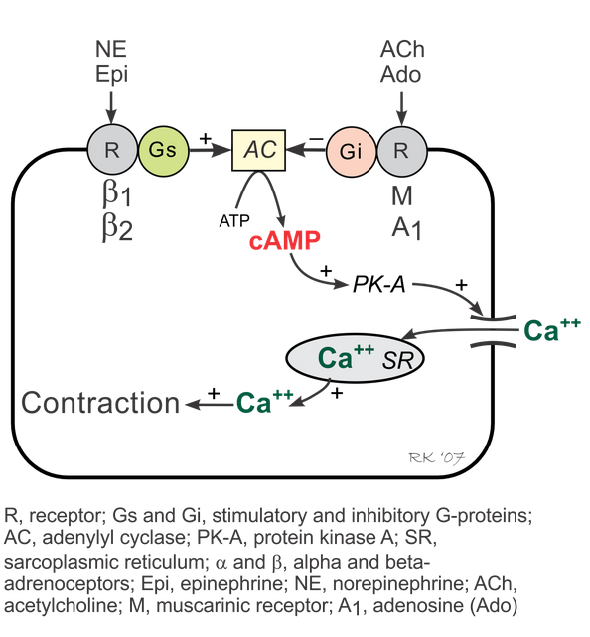 18

Vascular Smooth Muscle Contraction and Relaxation 18

Force-Velocity Relationship 19

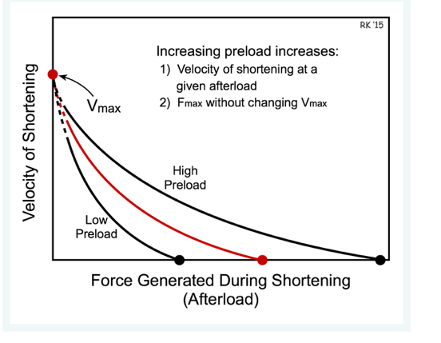 20

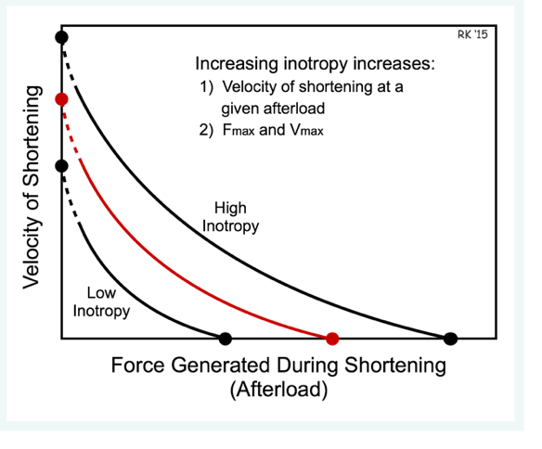 20

Ejection Fraction 20

EF = (SV/EDV) * 100 20

Cardiac contractility 21

Effects of Inotropy on Frank-Starling Curves 21

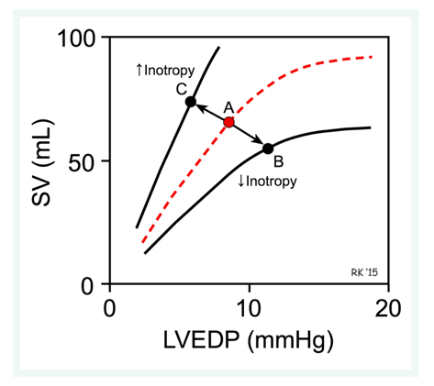 21

Effects of Inotropy on Ventricular Pressure-Volume Loops 21

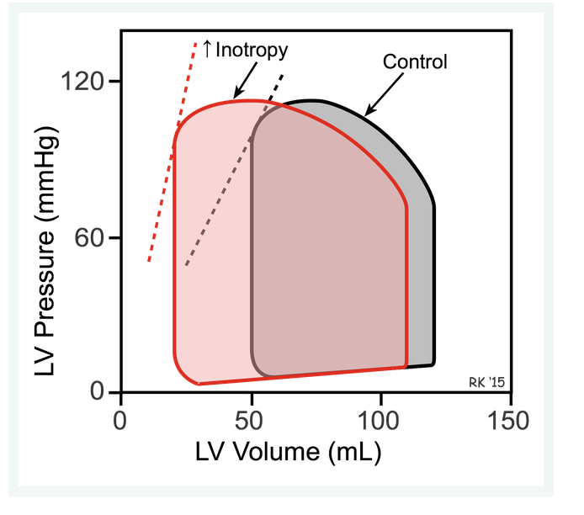 22

Factors Regulating Inotropy 22

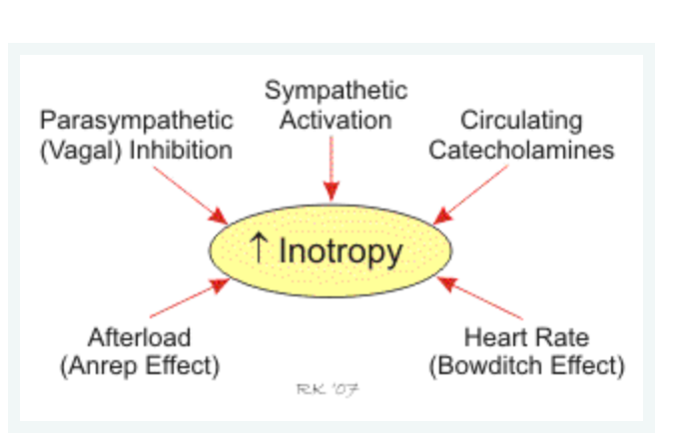 22

Other factors affecting Preload 23

Ventricular filling and therefore preload is increased by 23

Ventricular preload is decreased by 23

Regulation of Conduction 24

EKG – ECG 25

P wave 25

QRS complex 25

ST segment 26

T wave 26

QT interval 27

Cardiac Output computation based on Frick principle 27

Pressure Gradients 27

Ventricular Pressure-Volume Relationship 28

Turbulent Flow 29

Coronary Blood Flow 30

Resistance To Blood Flow 31

Bernoulli's Principle and Energetics of Flowing Blood 31

Vascular Network 32

Bits 33

# Frank-Starling curves

More blood into ventricle:

↑ venous return => ↑ SV

↓ venous return => ↓ SV

↑ afterload or ↓ contractility: shifts Frank-starling curve down to the right

↓ afterload or ↑ contractility: shifts curve up to the left

Changes in venous return cause the ventricle to move up or down along a single Frank-Starling curve; however, the slope of that curve is defined by the existing conditions of afterload and inotropy.

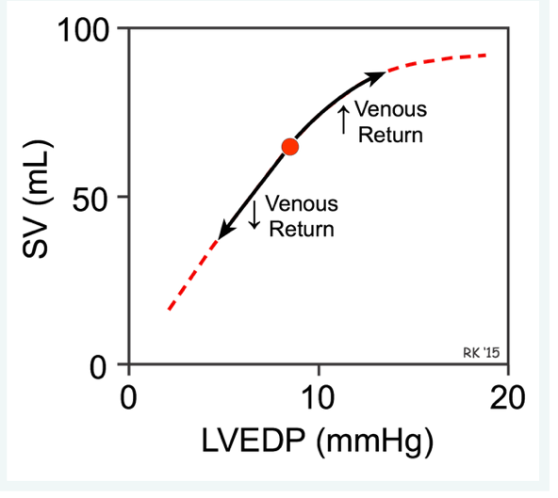

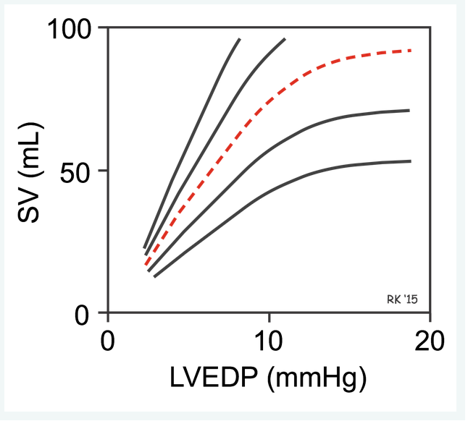

↑ venous return => ↑ EDV => ↑ preload => ↑ SV

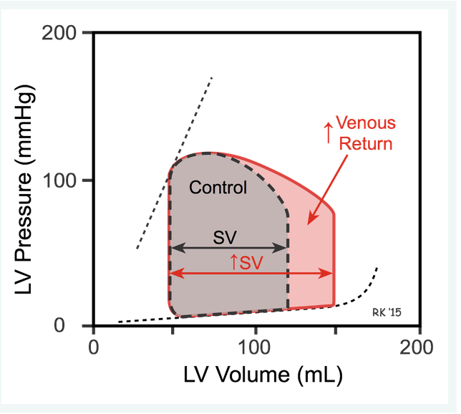

# Venous Return

[Venous Return](https://www.cvphysiology.com/Cardiac%20Function/CF016)

Venous return (VR) is the flow of blood back to the heart. Under steady-state conditions, venous return must equal cardiac output (CO) when averaged over time because the cardiovascular system is essentially a closed loop (see figure).

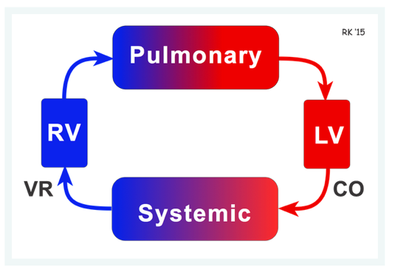

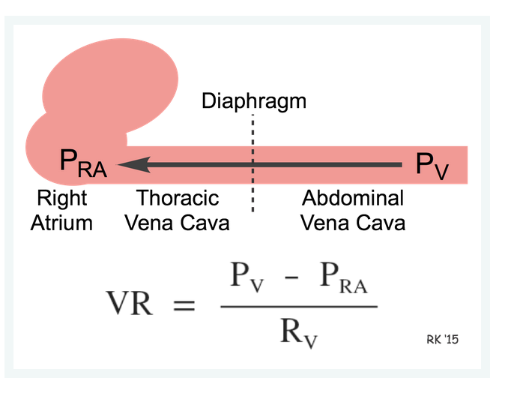

The pressure gradient driving venous return from peripheral veins to the heart is relatively low (<10 mmHg). Because of this, small changes of only a few mmHg pressure in either PV or PRA can cause a large percent change in the pressure gradient, and therefore significantly alter the return of blood to the right atrium. For example, during [lung expansion (inspiration)](https://www.cvphysiology.com/Cardiac%20Function/CF018), PRA can transiently fall by several mmHg, whereas the PV in the abdominal compartment may increase by a few mmHg. These changes result in a large increase in the pressure gradient driving venous return from the peripheral circulation to the right atrium.

# Afterload

Afterload is referred to as the pressure necessary to open the valve; actually, afterload is the pressure to open the valve and to pump blood from the ventricle (here the LV) into its circulation (here the systemic circulation). In the normal heart and circulation, the pressure drop across the aortic valve during ejection is small compared to aortic pressure and so, as a first approximation, may be neglected - hence, we can get away with saying that afterload is the pressure needed to open the valve.

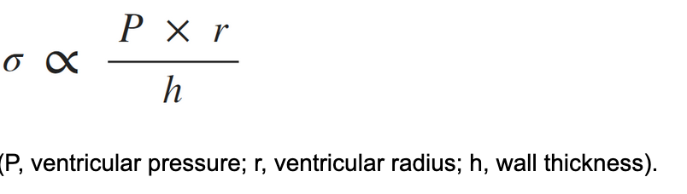

The afterload of the left ventricle is closely related to the aortic pressure.

↑ aortic pressure or ↑ SVR (systemic vascular resistance) => ↑ afterload

↑ afterload => ↓ SV, ↑ LVEDP (↑ preload)

↓ arterial pressure => ↓ afterload => ↑ SV

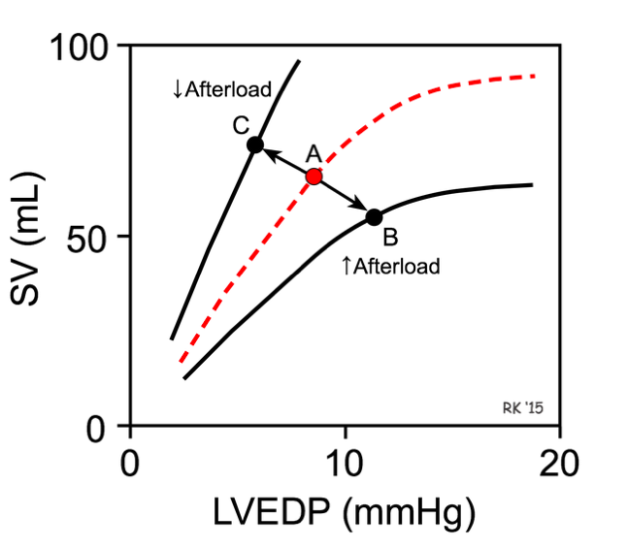

At a fixed preload and inotropic state, decreasing the afterload on the ventricular muscle fiber increases the rate of fiber shortening.

# 

# Preload

Preload can be defined as the initial stretching of the cardiac myocytes prior to contraction.

EDV good indicator of preload.

Changes in preload are associated with altered calcium handling and troponin C affinity for calcium, which increases the rate of cross-bridge attachment and detachment, and the amount of tension developed by the muscle fiber

↑ preload => ↑ SV

↓ preload => ↓ SV

↓ contractility => ↑ preload

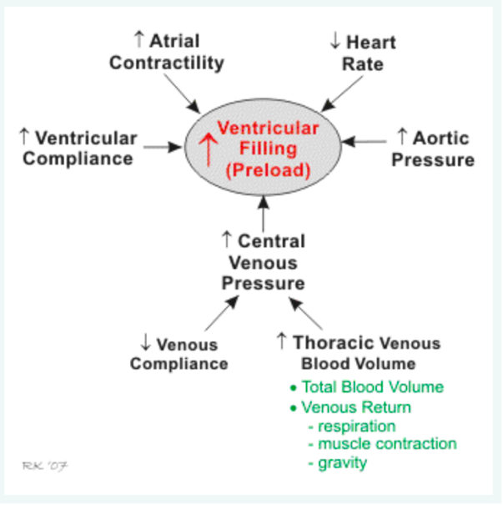

Increase afterload:

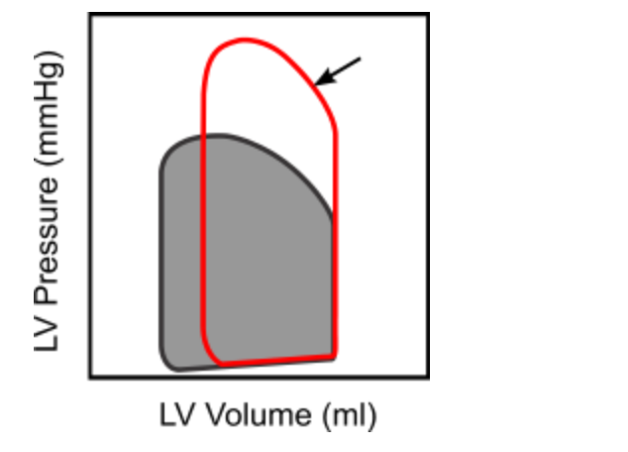

Decreased contractility:

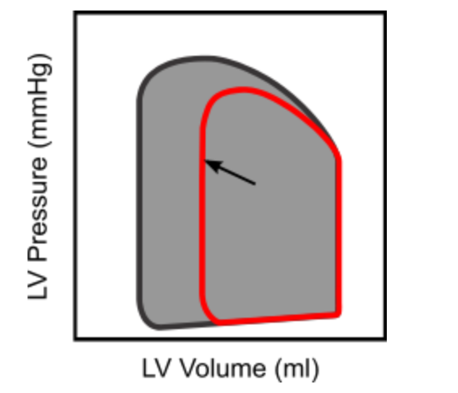

Increased inotropy and afterload, and decreased preload:

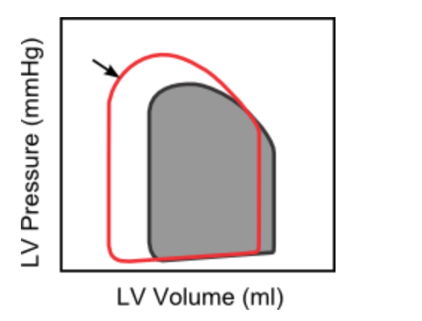

# Mean Arterial Pressure

MAP = (CO x SVR) + CVP

CO: cardiac output

SVR: systemic venous return

CVP: central venous pressure (usually 0)

MAP ≈ CO x SVR

MAP ≈ Pdiag + 1/3 (Psys – Pdiag)

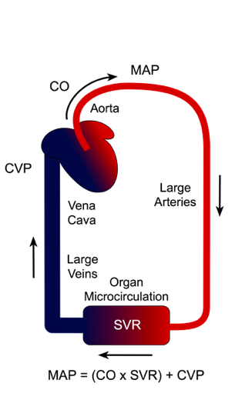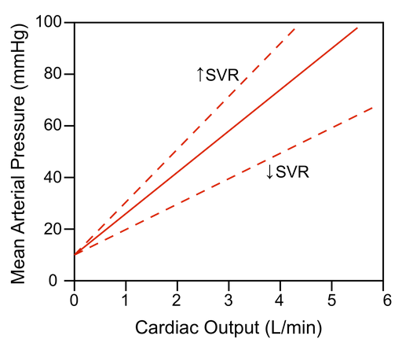

# Arterial and Aortic Pulse Pressure

As the left ventricle ejects blood into the aorta, the aortic pressure increases.  The greater the stroke volume, the greater the change in aortic pressure during ejection.

Pulse Pressure = Psys – Pdiag

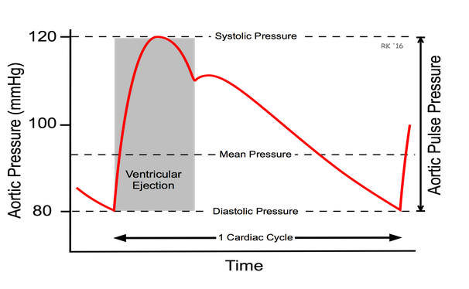

* A highly compliant aorta (i.e., less stiff, normal aorta) has a smaller pulse pressure for a given stroke volume into the aorta than a stiff, low compliant aorta.
* A larger stroke volume (not shown in the figure) produces a larger pulse pressure at any given compliance.
* [Aortic compliance decreases with age](https://www.cvphysiology.com/Blood%20Pressure/BP004) due to structural changes, thereby producing age-dependent increases in pulse pressure.
* For a given stroke volume, compliance determines pulse pressure and not mean aortic pressure.
* However, because vessels display [dynamic compliance](https://www.cvphysiology.com/Blood%20Pressure/BP004), increasing the rate of ventricular ejection (as occurs with increased ventricular inotropy) will increase the pulse pressure compared to the same volume ejected at a lower rate.

# Central Venous Pressure

CVP represents the average blood pressure within the venous compartment. The term "**central venous pressure**" (CVP) describes the pressure in the thoracic vena cava near the right atrium (therefore CVP and right atrial pressure are essentially the same).

ΔCVP = ΔV / C

ΔV: Change in volume of blood within the thoracic veins

C: compliance of the veins

↓ compliance => ↑ CVP

↑ venous blood volume => ↑ CVP

Therefore, CVP is increased by either an increase in venous blood volume or by a decrease in venous compliance.  The latter change can be caused by contraction of the smooth muscle within the veins, which increases the venous vascular tone and decreases compliance.

The curve that point A is on is the compliance curve for the thoracic veins. If the volume of blood within these veins is increased, then the operating point will shift up and to the right (from A to B) along the same compliance curve. This will lead to an increase in pressure that is determined by the change in volume and the venous compliance (slope of the curve). CVP will also be increased if venous smooth muscle contraction is enhanced (e.g., by sympathetic nerve stimulation). When this occurs, the venous compliance decreases (dashed red line), and the new operating point C will reflect a smaller venous volume but at a greater venous pressure.

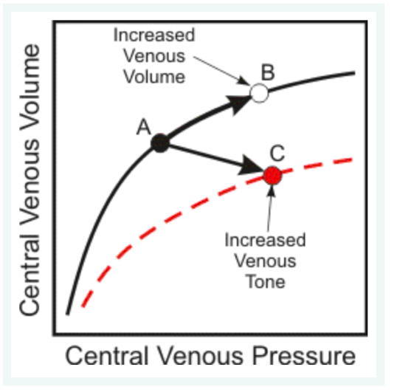

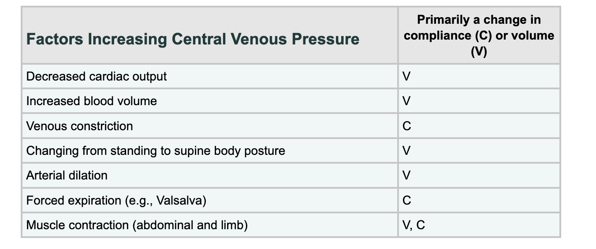

# Vascular Compliance

The ability of a vessel to distend and increase volume with increasing **transmural pressure** (inside minus outside pressure) is quantified as vessel compliance (C)

ΔC = ΔV / ΔP

For example, vascular smooth muscle contraction, which increases [vascular tone](https://www.cvphysiology.com/Blood%20Flow/BF002), reduces vascular compliance (dashed lines in figure) and shifts the volume-pressure relationship downward. Conversely, smooth muscle relaxation increases compliance and shifts the compliance curve upward. Contraction of smooth muscle in arteries reduces their compliance, thereby decreasing arterial blood volume and increasing arterial blood pressure within the arterial system. Another example of changing compliance is reduced aortic compliance with age or disease (e.g., arteriosclerosis).

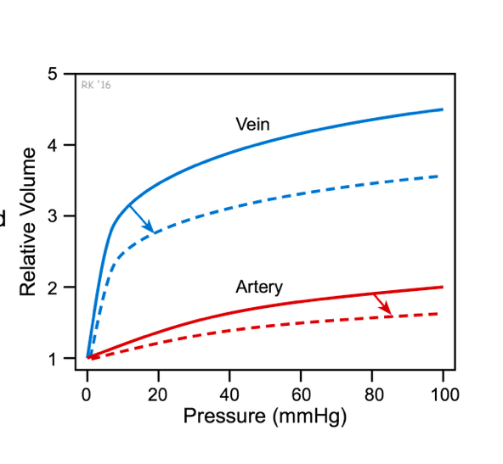

# Systemic Vascular Resistance

Systemic vascular resistance (SVR) refers to the resistance to blood flow offered by all of the systemic vasculature, excluding the pulmonary vasculature. This is sometimes referred as total peripheral resistance (TPR). SVR is therefore determined by factors that influence [vascular resistance](https://www.cvphysiology.com/Hemodynamics/H002) in individual vascular beds. Mechanisms that cause vasoconstriction increase SVR, and those mechanisms that cause vasodilation decrease SVR. Although SVR is primarily determined by changes in blood vessel [diameters](https://www.cvphysiology.com/Hemodynamics/H003), changes in blood [viscosity](https://www.cvphysiology.com/Hemodynamics/H011) also affect SVR.

SVR = (MAP – CVP) / CO

CO: cardiac output

MAP: mean arterial pressure

CVP: central venous pressure

SVR ≈ MAP / CO

SVR is not determined by either of these variables. A more accurate way to view this relationship is that at a given CO, if the MAP is very high, it is because SVR is high. Mathematically, SVR is the dependent variable in the above equations; however, physiologically, SVR and CO are normally the independent variables and MAP is the dependent variable.

# Blood Volume

Changes in blood volume affect arterial pressure by changing cardiac output. An increase in blood volume increases [central venous pressure](https://www.cvphysiology.com/Blood%20Pressure/BP020). This increases right atrial pressure, right ventricular [end-diastolic pressure](https://www.cvphysiology.com/Cardiac%20Function/CF014) and volume.  This increase in ventricular [preload](https://www.cvphysiology.com/Cardiac%20Function/CF007) increases ventricular stroke volume by the [Frank-Starling mechanism](https://www.cvphysiology.com/Cardiac%20Function/CF003). An increase in right ventricular stroke volume increases pulmonary venous blood flow to the left ventricular, thereby increasing left ventricular preload and stroke volume. An increase in stroke volume then increases cardiac output and arterial blood pressure.

# Vascular Tone

[Vascular Tone](https://www.cvphysiology.com/Blood%20Flow/BF002)

Intrinsic mechanism for regulating coronary vascular tone

* adenosine
* Endothelial-derived nitric oxide
* Smooth muscle myogenic response

Sympathetic activation does play a role in regulating coronary vascular tone, and it is an extrinsic mechanism because it involves autonomic nerves.

# Cardiac Function Curve

↑ contractility or ↑ HR , and ↓ afterload => ↑ CO

↓ contractility or ↓ HR , and ↑ afterload => ↓ CO

**

# Systemic Vascular Function Curve

If, for example, blood volume is increased due to renal retention of sodium and water, or venous compliance is decreased due to sympathetic activation of the veins (Panel A), there is a parallel shift to the right in the vascular function curve, which leads to an increase in the Pmc when the heart is stopped. The opposite shift occurs with decreased blood volume or increased venous compliance. If the heart is restarted, then PRA decreases as the CO increases (moved upward and leftward on black curve).

As the PRA starts to fall below zero, the increase in CO begins to plateau because the vena cava collapses, thus limiting venous return to the heart.



If SVR is increased (Panel B) by administering an [arterial vasoconstrictor drug](https://cvpharmacology.com/vasodilator/vasoconstrictor), the slope of the systemic vascular function curve decreases, but there is little or no change in the Pmc. The opposite occurs with a decrease in SVR. The Pmc does not change appreciably with arterial constriction or dilation because arterial diameter changes required to change resistance causes only a small change in total vascular compliance.



If both arteries and veins are constricted during sympathetic activation, then the curve will shift to the right as shown in Panel C (increased Pmc due to decreased CV) and the slope will decrease due to the increase in SVR.



If SVR were decreased by administering an arterial vasodilator drug, this would rotate the systemic function curve to the right (red curve) and Pmc would remain unchanged. The new equilibrium would be point B showing that arterial dilation would lead to an increase in PRA and CO. The PRA increases because the decrease in SVR would decrease arterial pressure (and arterial blood volume) thereby [shifting blood volume](https://cvphysiology.com/Blood%20Pressure/BP040) to the venous side. The CO increases primarily because stroke volume is enhanced by the [Frank-Starling mechanism](https://www.cvphysiology.com/Cardiac%20Function/CF003) in response to the increase in preload, and because ventricular [afterload](https://www.cvphysiology.com/Cardiac%20Function/CF008) is reduced as represented by the small shift to the left in the cardiac function curve.

If cardiac function were enhanced (not shown), the cardiac function curve would shift up and to the left along the vascular function curve. There would only be, however, a very small increase in CO because decreasing the PRA below zero causes venous collapse which impedes venous return and hence filling of the ventricle.

.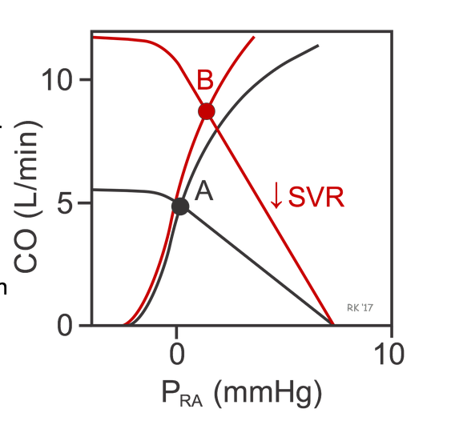

If cardiac function is depressed (e.g., as occurs in systolic heart failure), the cardiac function curve shifts down and to the right (red cardiac function curve in figure), and the intercept will change from Point A to B. This shows that depressing the heart leads to an increase in PRA and venous pressures along with the decrease in CO. If this depressed cardiac function is also accompanied by an increase in blood volume, venous constriction (decreased venous compliance, CV) and arterial constriction (increased SVR) as occurs in heart failure, the systemic function curve will shift to the right and have a reduced slope. The new operating point (C) represents this equilibrium condition. Notice that these systemic vascular function changes help to partially restore CO (from point B to C) despite the depressed cardiac function curve. This, however, occurs at the expense of further increasing PRA and venous pressures.



# Cardiac Output

Averaged over time, the amount of blood ejected per beat into the aorta is essentially the same as the volume of blood ejected per beat into the pulmonary artery. This [stroke volume](https://www.cvphysiology.com/Cardiac%20Function/CF002) (SV), times the number of beats per minute ([heart rate](https://www.cvphysiology.com/Arrhythmias/E010), HR), equals the **cardiac output** (CO).

CO = SV x HR

* SV in mL/beats
* HR in beats/min
* CO in ml/min

# Heart Rate

Heart rate is normally determined by the pacemaker activity of the [sinoatrial node](https://www.cvphysiology.com/Arrhythmias/A002) (SA node) located in the posterior wall of the right atrium. The SA node exhibits automaticity that is determined by spontaneous changes in [*Ca++, Na+, and K+ conductances*](https://www.cvphysiology.com/Arrhythmias/A004). This intrinsic automaticity, if left unmodified by neurohumoral factors, exhibits a spontaneous firing rate of 100-115 beats/min. This intrinsic firing rate decreases with age.

Heart rate is decreased below the intrinsic rate primarily by activation of the [*vagus nerve*](https://www.cvphysiology.com/Blood%20Pressure/BP008) innervating the SA node. Normally, at rest, there is significant vagal tone on the SA node so that the resting heart rate is between 60 and 80 beats/min. This vagal influence can be demonstrated by administration of atropine, a muscarinic receptor antagonist, which leads to a 20-40 beats/min increase in heart rate depending upon the initial level of vagal tone.

For heart rate to increase above the intrinsic rate, there is both a withdrawal of vagal tone and an activation of [*sympathetic nerves*](https://www.cvphysiology.com/Blood%20Pressure/BP008) innervating the SA node. This reciprocal change in sympathetic and parasympathetic activity permits heart rate to increase during exercise, for example.

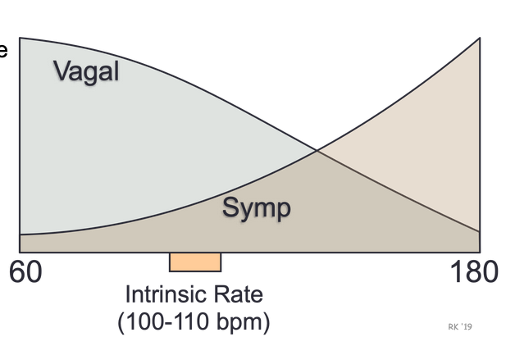

# Stroke Volume

Ventricular stroke volume (SV) is often thought of as the amount of blood (mL) ejected per beat by the left ventricle into the aorta (or from the right ventricle into the pulmonary artery).

The EDV is the filled volume of the ventricle prior to contraction and the ESV is the residual volume of blood remaining in the ventricle after ejection. In a typical heart, the EDV is about 120 mL of blood and the ESV about 50 mL of blood. The difference in these two volumes, 70 mL, represents the SV. Therefore, any factor that alters either the EDV or the ESV will change SV.

SV = EDV - ESV



## Preload

Changes in [preload](https://www.cvphysiology.com/Cardiac%20Function/CF007) affect the SV through the [Frank-Starling mechanism](https://www.cvphysiology.com/Cardiac%20Function/CF003). Briefly, an increase in venous return to the heart increases the filled volume (EDV) of the ventricle, which stretches the muscle fibers thereby increasing their [preload](https://www.cvphysiology.com/Cardiac%20Function/CF007). This leads to an increase in the force of ventricular contraction and enables the heart to eject the additional blood that was returned to it. Therefore, an increase in EDV results in an increase in SV. Conversely, a decrease in venous return and EDV leads to a decrease in SV by this mechanism.

## Afterload

[Afterload](https://www.cvphysiology.com/Cardiac%20Function/CF008) is related to the pressure that the ventricle must generate in order to eject blood into the aorta. Changes in afterload affect the ability of the ventricle to eject blood and thereby alter ESV and SV. For example, an increase in afterload (e.g., increased aortic pressure) decreases SV, and causes ESV to increase. Conversely, a decrease in afterload augments SV and decreases ESV. It is important to note, however, that the SV in a normal, non-diseased ventricle is not strongly influenced by afterload because of compensatory changes in preload. In contrast, the SV of hearts that are failing are very sensitive to changes in afterload.

## Contractility

Changes in ventricular [inotropy](https://www.cvphysiology.com/Cardiac%20Function/CF010) (contractility) alter the rate of ventricular pressure development, thereby affecting ESV and SV. For example, an increase in contractility (e.g., produced by sympathetic activation of the heart) increases SV and decreases ESV. Conversely, a decrease in contractility (e.g., [heart failure](https://www.cvphysiology.com/Heart%20Failure/HF005)) reduces SV and increases ESV.

It is important to note that the effects of changes in EDV and ESV on SV are not independent.  For example, an increase in ESV usually results in a compensatory increase in EDV. Furthermore, if SV is increased by increasing EDV, this can lead to a small increase in ESV because of the influence of increased afterload on ESV caused by an increase in aortic pressure. Therefore, while the primary effect of a change in preload, afterload or inotropy may be on either EDV or ESV, secondary changes can occur that can partially compensate for the initial change in SV.

# Adrenergic and Cholinergic Receptors in the Heart



# Cardiac Signal Transduction Mechanisms (G-Protein-Linked)

G-proteins are linked to an enzyme, adenylyl cyclase, that dephosphorylates ATP to form cyclic AMP (cAMP). Gs-protein (stimulatory G-protein) activation (e.g., via β-adrenoceptors) increases cAMP by activating adenylyl cyclase. cAMP then activates PK-A (cAMP stimulated protein kinase) and causes increased cellular influx of Ca++ by phosphorylation and activation of L-type calcium channels, and enhanced release of Ca++ by the sarcoplasmic reticulum in the heart. These and other intracellular events increase inotropy (muscle contractility), chronotropy (heart rate), dromotropy (velocity of electrical conduction) and lusitropy (relaxation rate).

Activation of **Gi-proteins** (inhibitory G-protein), for example by adenosine and muscarinic agonists binding to their receptors, decreases cAMP (through adenylyl cyclase inhibition), inactivates PK-A, decreases Ca++ entry into the cell and release by the sacroplasmic reticulum, and increases [outward, hyperpolarizing K+ currents](https://www.cvphysiology.com/Arrhythmias/A019).

Gi-protein activation produces effects that are opposite to those elicited by Gs-protein activation. Because Gi-protein effects are primarily found in the [SA node](https://www.cvphysiology.com/Arrhythmias/A002) and [AV node](https://www.cvphysiology.com/Arrhythmias/A003) where there are important Gi-protein coupled receptors, activation of this pathway leads to a decrease in sinus rate and AV nodal conduction velocity with minimal effects on muscle contractility. In contrast, Gs-protein strongly stimulates muscle contraction in addition to having nodal effects.

# 

# Vascular Smooth Muscle Contraction and Relaxation

[SmoothMuscleContractionAndRelaxation](https://www.cvphysiology.com/Blood%20Pressure/BP026)

[Like heart muscle](https://www.cvphysiology.com/Blood%20Pressure/BP011a), the **Gs-protein** coupled pathway in smooth stimulates **adenylyl cyclase** (AC), which catalyzes the formation of **cAMP**. Unlike the heart, however, an increase in cAMP in vascular smooth muscle causes reduced contraction (i.e., relaxation). The reason for this opposite effect is that [calcium-calmodulin](https://www.cvphysiology.com/Blood%20Pressure/BP026) activates myosin light chain kinase (MLCK) in vascular smooth muscle, which phosphorylates myosin and causes contraction; however, [MLCK is inhibited by cAMP](https://www.cvphysiology.com/Blood%20Pressure/BP026). In contrast to cardiac cells, Gs-protein stimulated increases in cAMP does not increase intracellular calcium.

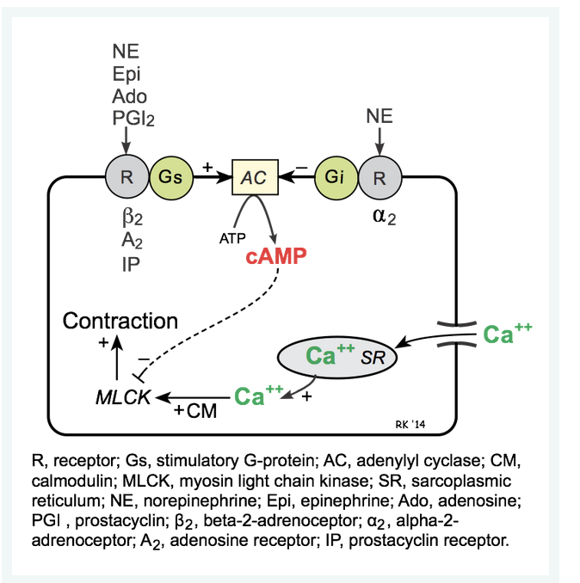

# Force-Velocity Relationship

The x-intercept in the force-velocity relationship represents the point at which the afterload is so great that the muscle fiber cannot shorten, and therefore represents the maximal isometric force. The y-intercept represents an extrapolated value for the maximal velocity of shortening (Vmax) that would be achieved if there were no afterload.

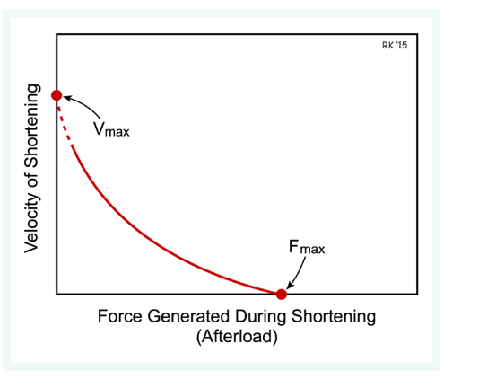

Increasing the preload enables to muscle to contract faster against a given afterload. Note that increasing preload increases the maximal isometric force (Fmax), as well as increases the shortening velocity at a given afterload, but does not alter Vmax.



The increase in velocity at any given preload results from the increased  inotropy enhancing force generation by the [actin and myosin](https://www.cvphysiology.com/Cardiac%20Function/CF020) filaments, and increasing the rate of cross bridge turnover. The increase in Vmax is particularly noteworthy because Vmax represents the intrinsic capability of a muscle fiber to generate force independent of load. Therefore, Vmax is sometimes used in experiments as an index or measure of inotropy for a muscle fiber.



According to the length-tension relationship for cardiac muscle, an increase in muscle sarcomere length within its normal operating range increases active tension development.

# Ejection Fraction

EF = (SV/EDV) * 100

# Cardiac contractility

The inotropic property of cardiac muscle is displayed in the [force-velocity relationship](https://www.cvphysiology.com/Cardiac%20Function/CF006) as a change in Vmax; that is, a change in the maximal velocity of fiber shortening at zero [afterload](https://www.cvphysiology.com/Cardiac%20Function/CF008). The increased velocity of fiber shortening that occurs with increased inotropy increases the rate of ventricular pressure development, which is manifested as an increase in maximal dP/dt (i.e., rate of pressure change) during the phase of [isovolumetric contraction](https://www.cvphysiology.com/Heart%20Disease/HD002). Because of these changes in the mechanical properties of contracting cardiac muscle, an increase in inotropy leads to an increase in ventricular stroke volume.

## Effects of Inotropy on Frank-Starling Curves



## Effects of Inotropy on Ventricular Pressure-Volume Loops

When inotropy is increased (at constant arterial pressure and heart rate) SV increases, which reduces the end-systolic volume to 20 mL. This is accompanied by a secondary reduction in ventricular end-diastolic volume (to 110 mL) and pressure because when the SV is increased the ventricle contains less residual blood volume after ejection (decreased end-systolic volume), which can be added to the incoming venous return during filling. Therefore, ventricular filling (end-diastolic volume) is reduced.



## Factors Regulating Inotropy



# Other factors affecting Preload

* Ventricular filling and therefore preload is increased by

1. Increased [central venous pressure](https://www.cvphysiology.com/Blood%20Pressure/BP020) that can result from decreased [venous compliance](https://www.cvphysiology.com/Blood%20Pressure/BP004) (e.g., caused by sympathetic activation of venous smooth muscle) or increased thoracic [blood volume](https://www.cvphysiology.com/Blood%20Pressure/BP025). The latter can be increased by either increased total blood volume or by [venous return](https://www.cvphysiology.com/Cardiac%20Function/CF016) augmented by increased [respiratory activity](https://www.cvphysiology.com/Cardiac%20Function/CF018), increased [skeletal muscle pump activity](https://www.cvphysiology.com/Cardiac%20Function/CF018), or by effects [gravity](https://www.cvphysiology.com/Cardiac%20Function/CF017) (e.g., head-down tilt).
2. Increased [ventricular compliance](https://www.cvphysiology.com/Cardiac%20Function/CF014), which results in a greater expansion of the chamber during filling at a given filling pressure.
3. Increased atrial force of contraction resulting from [sympathetic stimulation of the atria](https://www.cvphysiology.com/Blood%20Pressure/BP008) or from increased filling of the atria and therefore increased atrial contractile force through the [Frank-Starling mechanism](https://www.cvphysiology.com/Cardiac%20Function/CF003).
4. Reduced heart rate, which increases [ventricular filling time](https://www.cvphysiology.com/Heart%20Disease/HD002).
5. Increased aortic pressure, which increases the [afterload](https://www.cvphysiology.com/Cardiac%20Function/CF008) on the ventricle, reduces stroke volume by increasing [end-systolic volume](https://www.cvphysiology.com/Cardiac%20Function/CF002), and leads to a secondary increase in ventricular preload.
6. Pathological conditions such as [ventricular systolic failure](https://www.cvphysiology.com/Heart%20Failure/HF005) and valve defects such as [aortic stenosis](https://www.cvphysiology.com/Heart%20Disease/HD004), and [aortic regurgitation](https://www.cvphysiology.com/Heart%20Disease/HD005) ([pulmonary valve stenosis](https://www.cvphysiology.com/Heart%20Disease/HD004) and [regurgitation](https://www.cvphysiology.com/Heart%20Disease/HD005) have similar effects on right ventricular preload).

### Ventricular preload is decreased by

1. Decreased [venous blood pressure](https://www.cvphysiology.com/Blood%20Pressure/BP020), most commonly resulting from reduced [blood volume](https://www.cvphysiology.com/Blood%20Pressure/BP025) (e.g., hemorrhage) or [gravity](https://www.cvphysiology.com/Cardiac%20Function/CF017) causing blood to pool in the lower limbs when standing upright.
2. Impaired atrial contraction that can result from [atrial arrhythmias](https://www.cvphysiology.com/Arrhythmias/A012) such as atrial fibrillation.
3. Increased heart rate (e.g., [atrial tachycardia](https://www.cvphysiology.com/Arrhythmias/A012)), which reduces [ventricular filling time](https://www.cvphysiology.com/Heart%20Disease/HD002).
4. Decreased ventricular [afterload](https://www.cvphysiology.com/Cardiac%20Function/CF008), which enhances forward flow (i.e., ejection) thereby reducing end-systolic volume and end-diastolic volume secondarily.
5. [Ventricular diastolic failure](https://www.cvphysiology.com/Heart%20Failure/HF006) (decreased ventricular compliance) caused, for example, by ventricular hypertrophy or impaired relaxation (lusitropy).
6. Inflow (mitral and tricuspid) [valve stenosis](https://www.cvphysiology.com/Heart%20Disease/HD004), which reduces ventricular filling.

# Regulation of Conduction

The conduction of electrical impulses throughout the heart, and particularly in the specialized conduction system, is influenced by [autonomic nerve activity](https://www.cvphysiology.com/Blood%20Pressure/BP008). This autonomic control is most apparent at the AV node. Sympathetic activation increases conduction velocity in the AV node by increasing the rate of depolarization (increasing slope of [phase 0](https://www.cvphysiology.com/Arrhythmias/A004)) of the action potentials. This leads to more rapid depolarization of adjacent cells, which leads to a more rapid conduction of action potentials (positive dromotropy). Sympathetic activation of the AV node reduces the normal delay of conduction through the AV node, thereby reducing the time between atrial and ventricular contraction. The increase in AV nodal conduction velocity can be seen as a decrease in the [PR interval](https://www.cvphysiology.com/Arrhythmias/A009) of the electrocardiogram

Sympathetic nerves exert their actions on the AV node by releasing the [neurotransmitter norepinephrine](https://www.cvpharmacology.com/autonomic_ganglia) that binds to [beta-adrenoceptors](https://www.cvphysiology.com/Blood%20Pressure/BP010), leading to an increase in intracellular [cAMP](https://www.cvphysiology.com/Blood%20Pressure/BP011). Therefore, drugs that block beta-adrenoceptors ([beta-blockers](https://www.cvpharmacology.com/cardioinhibitory/beta-blockers)) decrease conduction velocity and can produce [AV block](https://www.cvphysiology.com/Arrhythmias/A008b).

The firing rate of SA nodal pacemaker action potentials is decreased by vagus nerve activation which decreases the slope of phase 4.

Resting heart rate is normally slower than the intrinsic firing rate of the SA node because vagal tone decreases the slope of phase 4.

Parasympathetic (vagal) activation decreases conduction velocity (negative dromotropy) at the AV node by decreasing the slope of phase 0 of the nodal action potentials. This leads to slower depolarization of adjacent cells, and reduced velocity of conduction. Acetylcholine, released by the [vagus nerve](https://www.cvpharmacology.com/autonomic_ganglia), binds to cardiac [muscarinic receptors](https://www.cvphysiology.com/Blood%20Pressure/BP010), which decreases intracellular [cAMP](https://www.cvphysiology.com/Blood%20Pressure/BP011). Excessive vagal activation can produce [AV block](https://www.cvphysiology.com/Arrhythmias/A008b). Drugs such as [digitalis](https://www.cvpharmacology.com/cardiostimulatory/digitalis), which increase vagal activity to the heart, are sometimes used to reduce AV nodal conduction in patients that have atrial [flutter or fibrillation](https://www.cvphysiology.com/Arrhythmias/A012). These atrial arrhythmias lead to excessive ventricular rate (tachycardia) that can be suppressed by partially blocking impulses being conducted through the AV node.

Phase 0 of action potentials at the AV node is not dependent on fast sodium channels as in [non-nodal tissue](https://www.cvphysiology.com/Arrhythmias/A006), but instead is generated by the entry of calcium into the cell through slow-inward, L-type calcium channels. Blocking these channels with a [calcium-channel blocker](https://www.cvpharmacology.com/vasodilator/CCB) such as verapamil or diltiazem reduces the conduction velocity of impulses through the AV node and can produce [AV block](https://www.cvphysiology.com/Arrhythmias/A008b).

In non-nodal cardiac tissue, cellular hypoxia leads to membrane depolarization, inhibition of [fast Na+ channels](https://www.cvphysiology.com/Arrhythmias/A006), a decrease in the slope of [phase 0](https://www.cvphysiology.com/Arrhythmias/A006), and a decrease in action potential amplitude. These membrane changes result in a decrease in speed by which action potentials are conducted within the heart. This can have a number of consequences. First, activation of the heart will be delayed, and in some cases, the sequence of activation will be altered. Conduction velocity in non-nodal cardiac cells is decreased by decreasing the slope of phase 0

Phase 3 of non-pacemaker action potentials results primarily from increased potassium conductance

# EKG – ECG

## P wave

The P wave represents the wave of depolarization that spreads from the [SA node](https://www.cvphysiology.com/Arrhythmias/A002) throughout the atria, and is usually 0.08 to 0.10 seconds (80-100 ms) in duration. The brief isoelectric (zero voltage) period after the P wave represents the time in which the impulse is traveling within the [AV node](https://www.cvphysiology.com/Arrhythmias/A003) (where the conduction velocity is greatly retarded) and the [bundle of His](https://www.cvphysiology.com/Arrhythmias/A003).

The period of time from the onset of the P wave to the beginning of the QRS complex is termed the **PR interval**, which normally ranges from 0.12 to 0.20 seconds in duration. This interval represents the time between the onset of atrial depolarization and the onset of ventricular depolarization. If the PR interval is >0.20 sec, there is an [AV conduction block](https://www.cvphysiology.com/Arrhythmias/A008b), which is called a [first-degree heart block](https://www.cvphysiology.com/Arrhythmias/A012.htm#AV nodal blocks) if each impulse from the atria is still able to be conducted into the ventricles.

## QRS complex

The QRS complex represents ventricular depolarization. Ventricular rate can be calculated by determining the time interval between QRS complexes. [Click here](https://www.cvphysiology.com/Arrhythmias/A020) to see how ventricular rate is calculated.

The duration of the QRS complex is normally 0.06 to 0.10 seconds. This relatively short duration indicates that [ventricular depolarization](https://www.cvphysiology.com/Arrhythmias/A006) normally occurs very rapidly. If the QRS complex is prolonged (> 0.10 sec), conduction is impaired within the ventricles. This can occur with [bundle branch](https://www.cvphysiology.com/Arrhythmias/A003) blocks or whenever a ventricular foci (abnormal pacemaker site) becomes the pacemaker driving the ventricle. Such an [ectopic foci](https://www.cvphysiology.com/Arrhythmias/A017) nearly always results in impulses being conducted over slower pathways within the heart, thereby increasing the time for depolarization and the duration of the QRS complex.

## ST segment

The isoelectric period (ST segment) following the QRS and ending at the beginning of the T wave is the time at which both ventricles are completely depolarized. This segment roughly corresponds to the [plateau phase](https://www.cvphysiology.com/Arrhythmias/A006) of the ventricular action potentials. The ST segment is very important in the diagnosis of ventricular ischemia or hypoxia because under those conditions, the ST segment can become either [depressed or elevated](https://www.cvphysiology.com/CAD/CAD012). When both ventricles are depolarized, zero voltage is measured by the ECG, which represents the normal ST segment.

## T wave

The T wave represents [ventricular repolarization](https://www.cvphysiology.com/Arrhythmias/A006). Generally, the T wave exhibits a positive deflection. The reason for this is that the last cells to depolarize in the ventricles are the first to repolarize. This occurs because the last cells to depolarize are located in the subepicardial region of the ventricles and these cells have shorter action potentials than found in the subendocardial regions of the ventricular wall. So, although the depolarization of the subepicardial cells occurs after the subendocardial cells, the subepicardial cells undergo phase 3 repolarization before the subendocardial cells. Therefore, repolarization waves generally are oriented opposite of depolarization waves (green versus red arrows in figure), and repolarization waves moving away from a positive recording electrode produce a positive voltage.

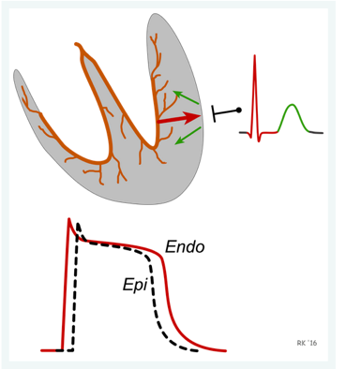

The T wave is longer in duration than the QRS complex that represents depolarization. The longer duration occurs because conduction of the repolarization wave is slower than the wave of depolarization. The reason for this is that the repolarization wave does not utilize the high-velocity bundle branch and purkinje system, and therefore primarily relies on cell-to-cell conduction.

Sometimes a small positive **U wave** may be seen following the T wave (not shown in figure at top of page). This wave represents the last remnants of ventricular repolarization. Inverted T waves or prominent U waves indicates underlying pathology or conditions affecting repolarization.

The T wave of the electrocardiogram begins to occur during systolic ejection.

## QT interval

The QT interval represents the time for both ventricular depolarization and repolarization to occur, and therefore roughly estimates the duration of an average ventricular action potential. This interval can range from 0.20 to 0.40 seconds depending upon heart rate.  At high heart rates, ventricular action potentials shorten in duration, which decreases the QT interval. Because prolonged QT intervals can be diagnostic for susceptibility to certain types of tachyarrhythmias, it is important to determine if a given QT interval is excessively long.

There is no distinctly visible wave representing atrial repolarization in the ECG because it occurs during ventricular depolarization. Because the wave of atrial repolarization is relatively small in amplitude (i.e., has low voltage), it is masked by the much larger ventricular-generated QRS complex

A positive voltage will be recorded by an ECG electrode wave of depolarization travels toward a positive electrode

Unipolar limb leads have a single positive recording electrode and utilize a combination of the other electrodes to serve as a composite negative electrode.

# Cardiac Output computation based on Frick principle

CO = VO2 / (CaC02 – CvO2)

# Pressure Gradients

A normal valve, like a normal large artery, has a very small resistance to flow, and therefore the pressure gradient across the valve is very small. In contrast, with vascular or valvular [stenosis](https://www.cvphysiology.com/Hemodynamics/H008) the pressure gradient is increased because of the increased resistance to flow (e.g., by decreased vessel radius or valve cross-sectional area). Furthermore, as flow increases across the stenotic lesion (e.g., when cardiac output increases during exercise), the pressure gradient (ΔP) increases further. Increased flow across a heart valve, particularly when it is stenotic, causes a large increase in [velocity](https://www.cvphysiology.com/Hemodynamics/H012) that can lead to a significant degree of [turbulence](https://www.cvphysiology.com/Hemodynamics/H007), which will further augment the pressure gradient across the valve and lead to a [functional murmur](https://www.cvphysiology.com/Heart%20Disease/HD006) or enhance the intensity of a preexisting murmur.

# Ventricular Pressure-Volume Relationship

<https://www.cvphysiology.com/Cardiac%20Function/CF024>

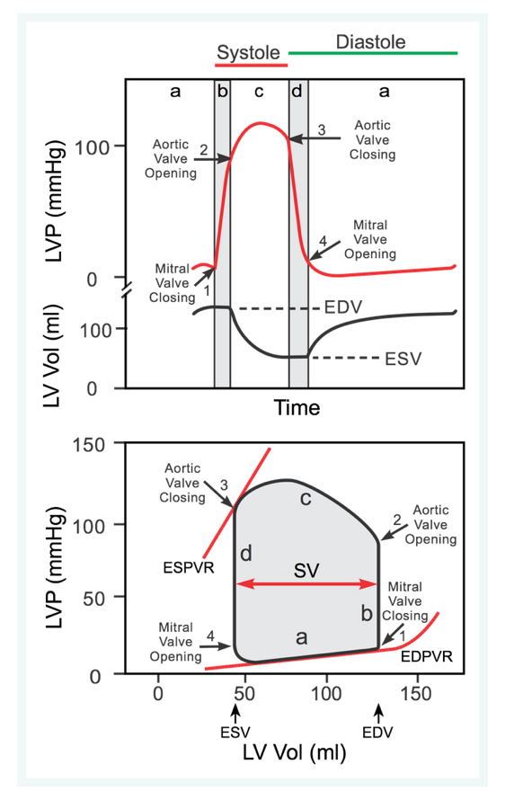

The width of the loop represents the difference between EDV and ESV, which is by definition the stroke volume (SV). The area within the loop is the ventricular [stroke work](https://www.cvphysiology.com/Cardiac%20Function/CF019).

The slope of the EDPVR is the reciprocal of [ventricular compliance](https://www.cvphysiology.com/Cardiac%20Function/CF014). Therefore, changes in ventricular compliance alter the slope of the passive filling curve. For example, in [ventricular hypertrophy](https://www.cvphysiology.com/Cardiac%20Function/CF014) the ventricle is less compliant (i.e., it is stiffer) and therefore the slope of the filling curve in increased. This results in higher pressures during filling at a given ventricular volume. Another example of how the EDPVR can be altered is when a ventricle chronically dilates (remodels) as occurs in [dilated cardiomyopathy](https://www.cvphysiology.com/Cardiac%20Function/CF014) or in valve disease. A dilated ventricle has a higher passive compliance and therefore the slope of the filling curve is reduced. This results in lower ventricular pressures during filling at any given ventricular volume.

End-systolic pressure-volume relationship (ESPVR), which represents the [inotropic state](https://www.cvphysiology.com/Cardiac%20Function/CF010) of the ventricle.

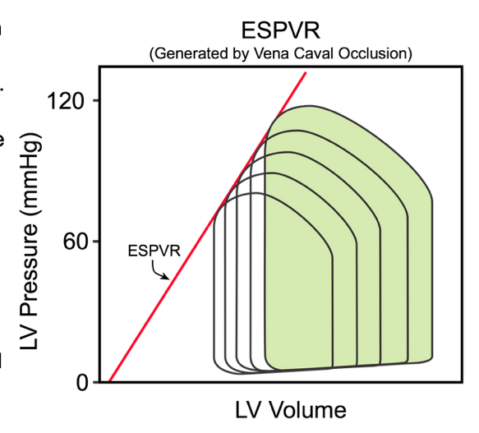

# Turbulent Flow

[Turbulent Flow](https://www.cvphysiology.com/Hemodynamics/H007)

Turbulence increases the energy required to drive blood flow because turbulence increases the loss of energy in the form of friction, which generates heat. When plotting a pressure-flow relationship (see figure), turbulence increases the [perfusion pressure](https://www.cvphysiology.com/Hemodynamics/H001) required to drive a given flow. Alternatively, at a given perfusion pressure, turbulence leads to a decrease in flow.

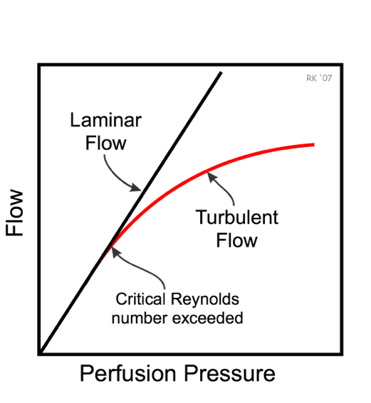

Turbulence increases the energy required to drive blood flow because turbulence increases the loss of energy in the form of friction, which generates heat. When plotting a pressure-flow relationship (see figure to right), turbulence increases the [perfusion pressure](https://www.cvphysiology.com/Hemodynamics/H001) required to drive a given flow. Alternatively, at a given perfusion pressure, turbulence leads to a decrease in flow. (**pressure difference** ΔP; sometimes called **driving pressure**, **perfusion pressure**, or **pressure gradient**)



As can be seen in this equation, Re increases as velocity increases, and decreases as [viscosity](https://www.cvphysiology.com/Hemodynamics/H011) increases. Therefore, high velocities and low blood viscosity (as occurs with anemia due to reduced hematocrit) are more likely to cause turbulence. An increase in diameter without a change in velocity also increases Re and the likelihood of turbulence; however, the velocity in vessels ordinarily decreases disproportionately as diameter increases. The reason for this is that flow (F) equals the product of mean velocity (V) times cross-sectional area (A), and area is proportionate to radius squared; therefore, the velocity at constant flow is inversely related to radius (or diameter) squared. For example, if radius (or diameter) is doubled, the velocity decreases to one-fourth its normal value, and Re decreases by one-half.

Turbulence generates sound waves (e.g., ejection [murmurs](https://www.cvphysiology.com/Heart%20Disease/Murmurs), carotid bruits) that can be heard with a stethoscope. Because higher velocities enhance turbulence, murmurs intensify as flow increases. Elevated cardiac outputs, even across anatomically normal aortic valves, can cause [physiological murmurs](https://www.cvphysiology.com/Heart%20Disease/HD006) because of turbulence. This sometimes occurs in pregnant women who have elevated cardiac output and who may also have anemia, which decreases blood viscosity.  Both factors increase the Reynolds number, which increases the likelihood of turbulence.

# Coronary Blood Flow

In non-diseased coronary vessels, whenever cardiac activity and oxygen consumption increases there is an increase in coronary blood flow ([active hyperemia](https://www.cvphysiology.com/Blood%20Flow/BF005)) that is nearly proportionate to the increase in oxygen consumption.

Sympathetic activation to the heart results in coronary vasodilation and increased coronary flow due to increased metabolic activity (increased heart rate, contractility) despite direct vasoconstrictor effects of sympathetic activation on the coronaries. This is termed "functional sympatholysis."

Increased cardiac activity increases oxygen demand and production of vasodilator metabolites that override sympathetic vasoconstrictor influences

[Parasympathetic stimulation of the heart](https://www.cvphysiology.com/Blood%20Pressure/BP009) (i.e., vagal nerve activation) elicits modest coronary vasodilation (due to the direct effects of released acetylcholine on the coronaries). However, if parasympathetic activation of the heart results in a significant decrease in [myocardial oxygen demand](https://www.cvphysiology.com/CAD/CAD003) due to a reduction in heart rate, then intrinsic [metabolic mechanisms](https://www.cvphysiology.com/Blood%20Flow/BF008) will increase coronary vascular resistance by constricting the vessels.

Coronary blood flow is lower during ventricular systole than during diastole because extravascular compression increases coronary vascular resistance:

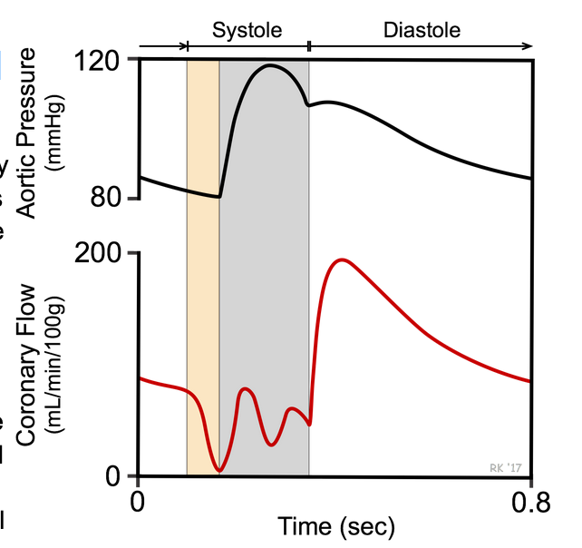

The ratio of flow to oxygen consumption determines the amount of oxygen extracted from the blood. Decreased flow or increased consumption leads to an increase in extraction.

# [Resistance To Blood Flow](https://www.cvphysiology.com/Hemodynamics/H002)

Resistance to blood flow within a vascular network is determined by the size of individual vessels ([length and diameter](https://www.cvphysiology.com/Hemodynamics/H003)), the organization of the vascular network ([series and parallel](https://www.cvphysiology.com/Hemodynamics/H004) arrangements), physical charactersistics of the blood ([viscosity](https://www.cvphysiology.com/Hemodynamics/H011), [laminar](https://www.cvphysiology.com/Hemodynamics/H006) flow versus [turbulent flow](https://www.cvphysiology.com/Hemodynamics/H007)), and extravascular [mechanical forces](https://www.cvphysiology.com/Blood%20Flow/BF001) acting upon the vasculature.

Of the above factors, changes in vessel [diameter](https://www.cvphysiology.com/Hemodynamics/H003) are most important quantitatively for regulating blood flow within an organ, as well as for regulating [arterial pressure](https://www.cvphysiology.com/Blood%20Pressure/BP002). Changes in vessel diameter, particularly in [small arteries](https://www.cvphysiology.com/Blood%20Pressure/BP019) and [arterioles](https://www.cvphysiology.com/Blood%20Pressure/BP019), enable organs to adjust their own blood flow to meet the metabolic requirements of the tissue. Therefore, if an organ needs to adjust its blood flow (and therefore, [oxygen delivery](https://www.cvphysiology.com/CAD/CAD002)), cells surrounding these blood vessels release [vasoactive substances](https://www.cvphysiology.com/Blood%20Flow/BF002) that can either constrict or dilate the [resistance vessels](https://www.cvphysiology.com/Blood%20Pressure/BP019).

The ratio of flow to oxygen consumption determines the amount of oxygen extracted from the blood. Decreased flow or increased consumption leads to an increase in extraction.

The ability of an organ to regulate its own blood flow is termed [local regulation of blood flow](https://www.cvphysiology.com/Blood%20Flow/BF003) and is mediated by [vasoconstrictor and vasodilator substances](https://www.cvphysiology.com/Blood%20Flow/BF002) released by the tissue surrounding blood vessels ([vasoactive metabolites](https://www.cvphysiology.com/Blood%20Flow/BF008)) and by the vascular [endothelium](https://www.cvphysiology.com/Blood%20Flow/BF010). There is also a mechanism intrinsic to the vascular smooth muscle ([myogenic mechanism](https://www.cvphysiology.com/Blood%20Flow/BF009)) that is involved in local blood flow regulation.

In organs such as the [heart](https://www.cvphysiology.com/Blood%20Flow/BF001) and skeletal muscle, mechanical activity (contraction and relaxation) produces compressive forces that can effectively decrease vessel diameters and increase resistance to flow during muscle contraction (see [extravascular compression](https://www.cvphysiology.com/Blood%20Flow/BF001.htm#Extravascular%20compression)).

Besides local regulatory mechanisms, there are extrinsic mechanisms acting on the vasculature to regulate vessel diameter. One important extrinsic mechanism regulating vascular diameter operates through the [autonomic innervation](https://www.cvphysiology.com/Blood%20Pressure/BP008) of blood vessels. In general, [sympathetic adrenergic](https://www.cvphysiology.com/Blood%20Pressure/BP008) influences acting through vascular [alpha-adrenoceptors](https://www.cvphysiology.com/Blood%20Pressure/BP010b) cause resistance vessels as well as veins to be partially constricted under basal conditions. This is termed "sympathetic vascular tone." Therefore, removal of sympathetic adrenergic influences (for example, by administration of an [alpha-adrenoceptor antagonist](https://www.cvpharmacology.com/vasodilator/alpha) or by sympathectomy) leads to vasodilation and an increase in organ blood flow. A second type of extrinsic influence on the vasculature is circulating vasoactive hormones such as [angiotensin II](https://www.cvphysiology.com/Blood%20Pressure/BP015), [epinephrine and norepinephrine](https://www.cvphysiology.com/Blood%20Pressure/BP018), [vasopressin](https://www.cvphysiology.com/Blood%20Pressure/BP016) (antidiuretic hormone, ADH), [atrial natriuretic peptide](https://www.cvphysiology.com/Blood%20Pressure/BP017) (ANP), and [endothelin](https://www.cvphysiology.com/Blood%20Flow/BF012). Both the neural and humoral factors, while affecting organ blood flow, primarily serve the function of regulating [arterial pressure](https://www.cvphysiology.com/Blood%20Pressure/BP002) by altering [systemic vascular resistance](https://www.cvphysiology.com/Blood%20Pressure/BP021).

# Bernoulli's Principle and Energetics of Flowing Blood

Because flowing blood has mass and velocity it has **kinetic energy** (KE). This KE is proportionate to the mean velocity squared (V2; from KE = ½ mV2). Furthermore, as the blood flows inside a vessel, pressure is exerted laterally against the walls of the vessel; this pressure represents the **potential or pressure energy** (PE). The total energy (E) of the blood flowing within the vessel, therefore, is the sum of the kinetic and potential energies (assuming no gravitational effects) as shown below.

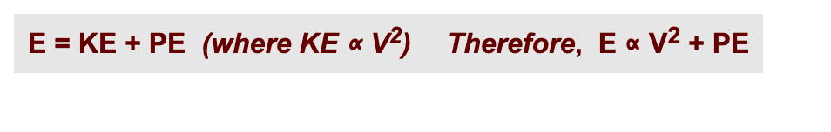

Quantitatively, [V ∝ 1/D2](https://www.cvphysiology.com/Hemodynamics/H013) because flow (F) is the product of mean velocity (V) and vessel cross-sectional area (A) (F = V x A), and A is directly related to diameter (D) (or radius, r) squared (from A = π r2). If the diameter is reduced by one-half in the region of the stenosis, the velocity increases 4-fold. Because KE ∝ V2, the KE increases 16-fold.

# Vascular Network

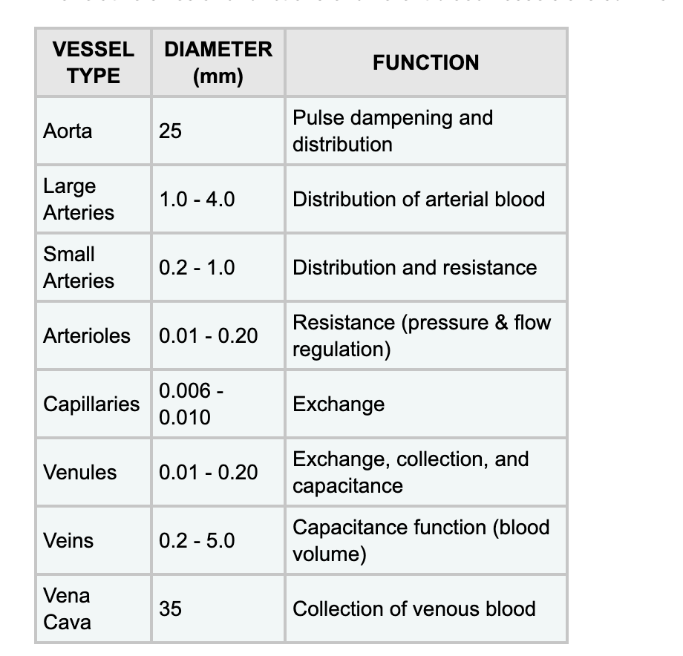

# Bits

An increase in blood volume and arterial pressure will occur if the kidneys excrete excessive amounts sodium and water.

Arterial systolic pressure occurs during left ventricular ejection, whereas arterial diastolic pressure occurs just before left ventricular ejection.

Vascular smooth muscle contraction is increased by activation of myosin light chain kinase

Activation of efferent sympathetic nerves increases arterial pressure by increasing the rate of sinoatrial node firing:

The heart is innervated by [vagal and sympathetic fibers](https://cvpharmacology.com/vasodilator/Ganglion). The right vagus nerve primarily innervates the [SA node](https://www.cvphysiology.com/Arrhythmias/A002), whereas the left vagus innervates the [AV node](https://www.cvphysiology.com/Arrhythmias/A003); however, there can be significant overlap in the anatomical distribution. Atrial muscle is also innervated by vagal efferents, whereas the ventricular myocardium is only sparsely innervated by vagal efferents. Sympathetic efferent nerves are present throughout the atria (especially in the SA node) and ventricles, including the [conduction system](https://www.cvphysiology.com/Arrhythmias/A003) of the heart.

Sympathetic stimulation of the heart increases [heart rate](https://www.cvphysiology.com/Arrhythmias/A005) (positive chronotropy), [inotropy](https://www.cvphysiology.com/Cardiac%20Function/CF010) and [conduction velocity](https://www.cvphysiology.com/Arrhythmias/A003) (positive dromotropy), whereas parasympathetic stimulation of the heart has opposite effects.  Sympathetic and parasympathetic effects on heart function are mediated by beta-adrenoceptors and muscarinic [receptors](https://www.cvphysiology.com/Blood%20Pressure/BP010), respectively.

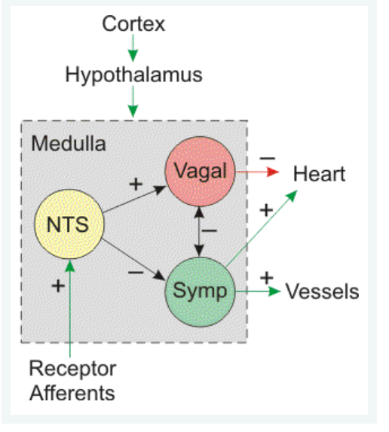

The carotid sinus baroreceptors are located on the internal carotid arteries and are innervated by the vagus nerve.

A sudden fall in arterial blood pressure as occurs when a person rapidly stands up causes increased sympathetic adrenergic efferent activity.

Sympathetic activation of the adrenal medulla increases epinephrine secretion, which can bind to alpha and beta adrenoceptors on the heart and blood vessels.

When hypoxemia results in a PO2 lower than about 80 mmHg (threshold PO2), receptor firing is stimulated (normal arterial PO2 is about 95 mmHg). Any elevation of PCO2 above a normal value of 40 mmHg, or a decrease in pH below 7.4 causes receptor firing. If respiratory activity is not allowed to change during chemoreceptor stimulation (thus removing the influence of lung mechanoreceptors), then chemoreceptor activation causes bradycardia and coronary vasodilation (both via vagal activation) and systemic vasoconstriction (via sympathetic activation). If respiratory activity increases in response to the chemoreceptor reflex, then increased sympathetic activity stimulates both the heart and vasculature to increase arterial pressure. A decrease in carotid body blood flow as can occur during circulatory shock also increases receptor firing.

Compared to laminar flow, what hemodynamic changes occur in a blood vessel when turbulent flow is present?

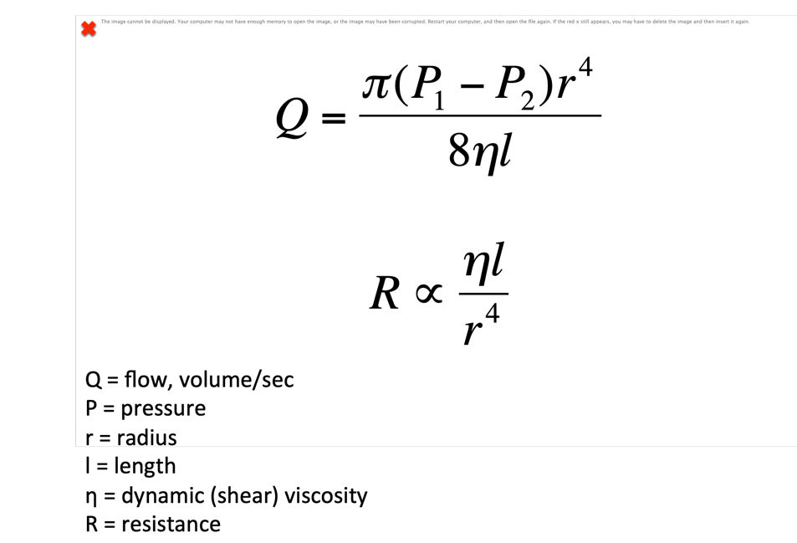

Q = Δ P / R

Decreasing red cell concentration (i.e., hematocrit) decreases viscosity, which will decrease resistance and increase flow at a given perfusion pressure.

Sympathetic activation does play a role in regulating coronary vascular tone, but it is an extrinsic mechanism because it involves autonomic nerves.

