# Module 6 - Cardiac Electrophysiology

**Lectures**

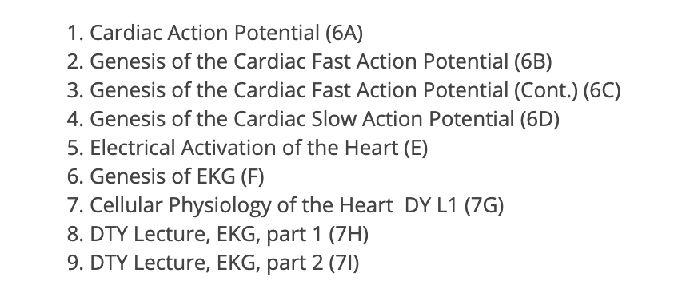

**Readings**

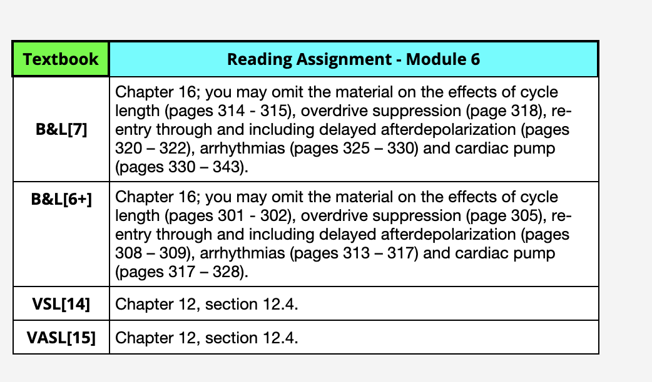

**Module 7 – Heart As a Pump**

**Lectures**

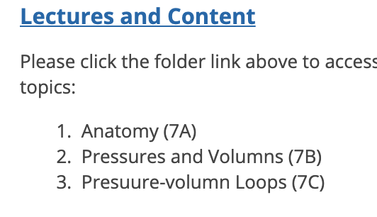

**Readings**

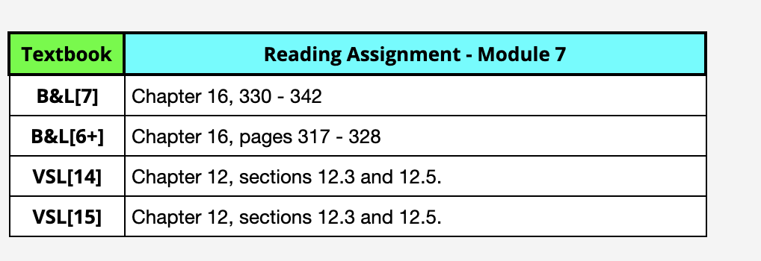

**Module 8 – Circulation**

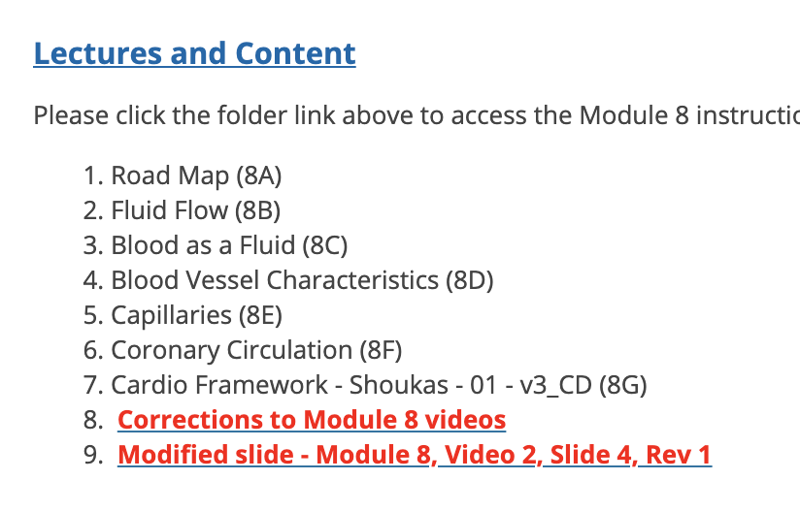

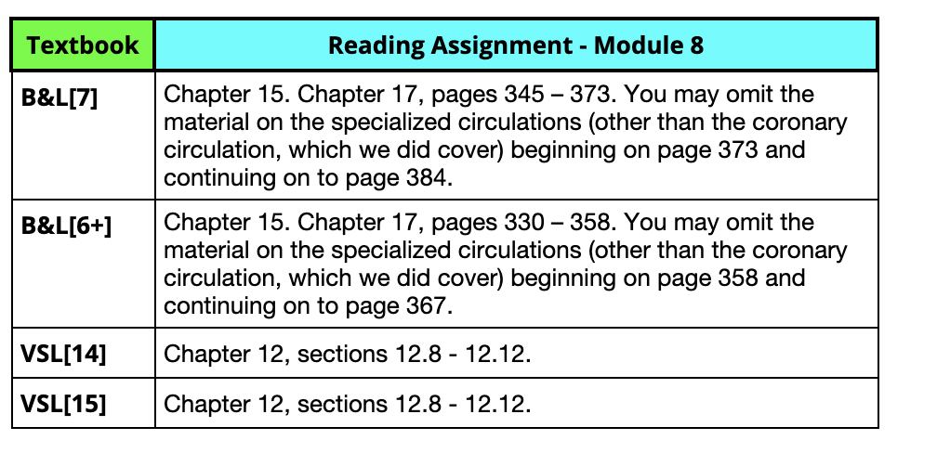

**Module 9 – Regulation of the Circulatory System**

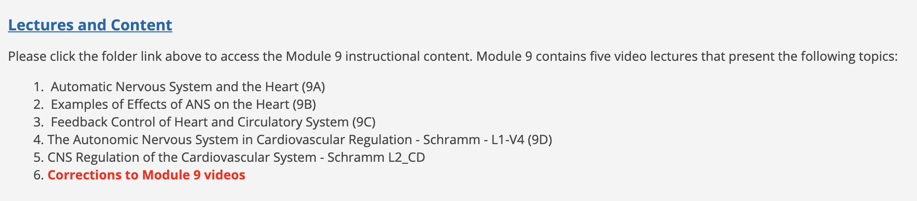

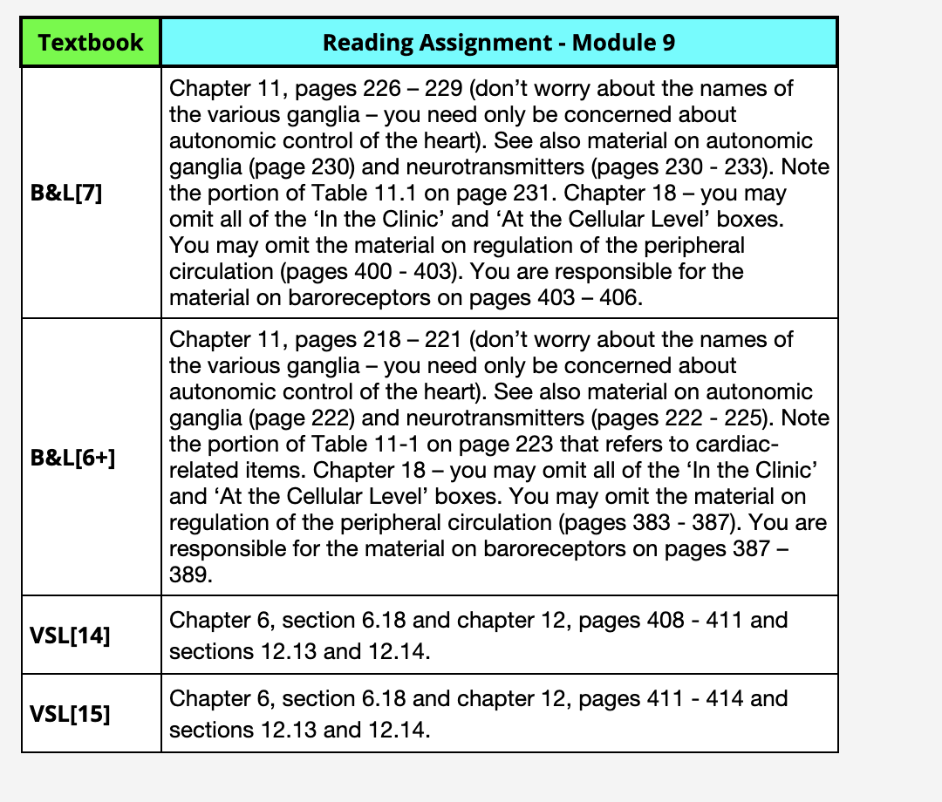

**Module 10 –**

**Integration of The Heart And Circulatory System**

