# Module 11 – Respirator Mechanics

**Lectures**

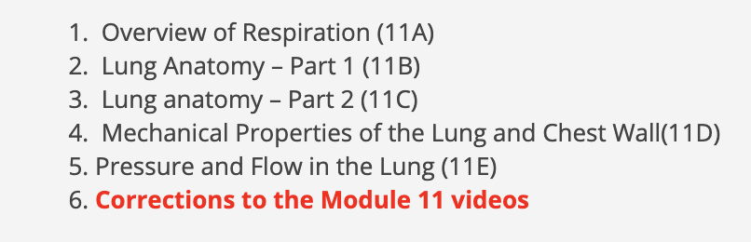

**Readings**

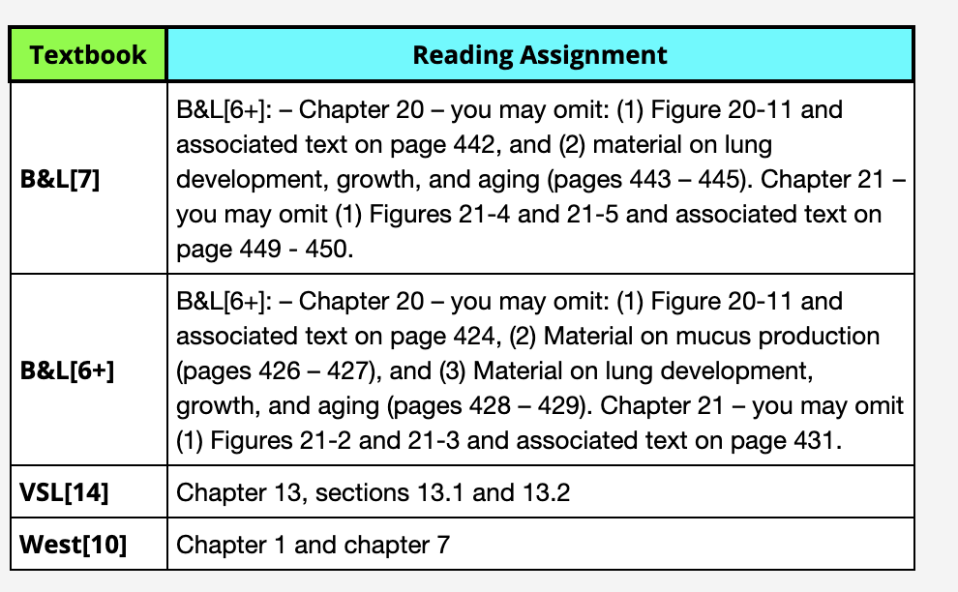

**Module 12 –**

Ventilation(V), Perfusion(Q), and V/Q matching

**Lectures**

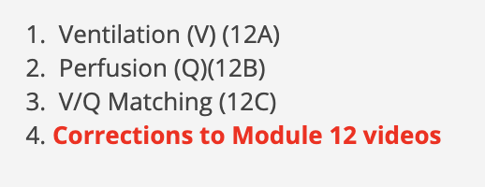

**Readings**

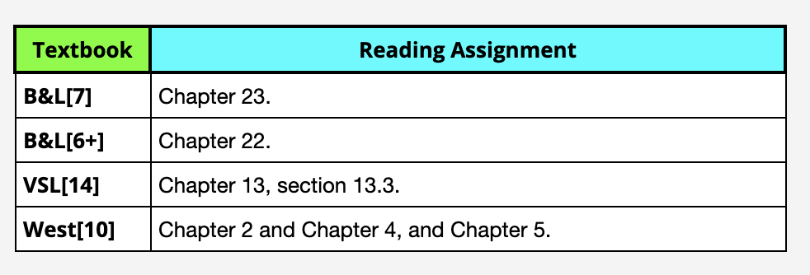

**Module 13 –** Respiratory Gas Transport

**Lectures**

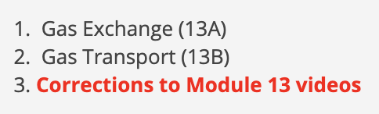

**Readings**

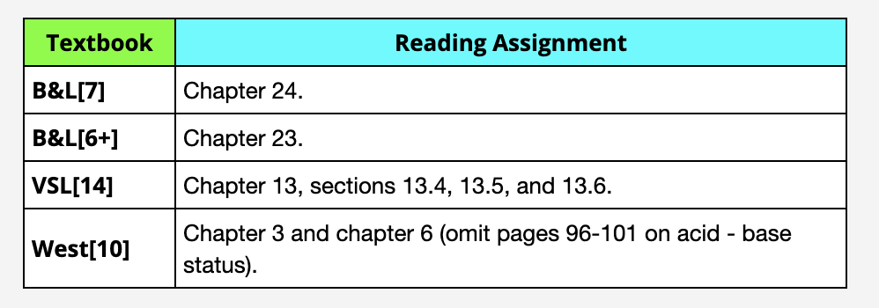

**Module 14 –** Control Of The Respiratory System

**Lectures**

**Readings**