1. With reference to the fluid mosaic model of the cell membrane, which of the following statements is the most correct?
2. Only electrically charged molecules can move through the membrane.
3. The positions of various channels with respect to each other is fixed within the membrane.
4. A particular protein that at a given time is located at the outer surface of the membrane can migrate to the inner surface of the membrane.
5. The lipids that make up the outer membrane layer are always identical to those that make up the inner membrane layer.
6. Only electrically charged molecules can move through the membrane.

Non polar molecules such as O2, CO2, fatty acids, and steroid hormones, diffuse rapidly through the lipid bilayer. Whereas most polar molecules diffuse into cells very slowly across plasma membranes. (ref: VSL[15], p 98).

1. The positions of various channels with respect to each other is fixed within the membrane.

Some of the integral membrane proteins form ion channels. All membranes have the general structure known as the fluid-mosaic model, because membrane proteins cam move freely. However certain membrane proteins are anchored to cytoplasmic proteins. (ref: VSL[15], p 48 and p49)

1. A particular protein that at a given time is located at the outer surface of the membrane can migrate to the inner surface of the membrane.

Transmembrane proteins traverse the lipid bilayer (VSL[15], figure 3.7 on p.49).

1. The lipids that make up the outer membrane layer are always identical to those that make up the inner membrane layer.

Plasma membrane phospholipids, phosphatidylcholine and sphingomyelin, are primarily found in the outer leaflet of the membrane, whereas, phosphatidylethanolamine or phosphatidylserine are found in the inner leaflet. Cholesterol molecules of the bilayer membrane is found in both leaflets. ref: Berne & Levy, Physiology, Ed.15, page 4, Table 1.2 page 5 and beginning of page 5.

1. Which of the following statements about channels in mammalian cell membranes is the most correct?
   1. Polar molecules do not pass through channels of any type.
   2. Some channels are selective for a class of molecules (e.g., singly charged molecules); other channels are selective for only one molecular species (e.g., Na+).
   3. As a general rule, it is easier for larger, as compared to smaller, molecules to pass through channels.
   4. VHF channels, due to their lower frequency, allow the passage of larger molecules than UHF channels (channel width is inversely proportional to frequency; c = fl).
   5. Polar molecules do not pass through channels of any type

Polar molecules diffuse into cells but compared to non-polar molecules, they diffuse into cells very slowly [VSL[15], p 98, First paragraph).

* 1. Some channels are selective for a class of molecules (e.g., singly charged molecules); other channels are selective for only one molecular species (e.g., Na+).

Some channels can be selective to a class of ions (Cations, Barium, Magnesium) or very selective such as only Na+ ions (Module 1 – Video 3 – Slide 7)

* 1. As a general rule, it is easier for larger, as compared to smaller, molecules to pass through channels.

Channels selectivity is, first, based on the type of ion or ions, it allows to pass through. The selectivity of an ion channel is based on its diameter, the charged and polar surfaces of the polypeptide subunits, and the number of water molecules associated with the ions (VSL[15], p98, second paragraph).

* 1. VHF channels, due to their lower frequency, allow the passage of larger molecules than UHF channels (channel width is inversely proportional to frequency; c = fl).

Transport proteins channels are water and ion channels and not related to frequencies (<https://en.wikipedia.org/wiki/Ion_channel>).

1. Using the concentrations provided in the table (below) calculate the

Nernst potential at T = 24° C for Na+, K+, and Cl-.

|  |  |  |
| --- | --- | --- |
| Ion | Intracellular, mM | Extracellular, mM |
| Cl- | 2.0 | 80 |
| K+ | 120 | 4.0 |
| Na+ | 10 | 127 |
| Ca2+ | 110 µM | 2.4 |
| HCO3- | 12.4 | 29 |

The Nernst potential for an ion is given by the Nernst equation (reference for example: Vander, 15 ed., p146):

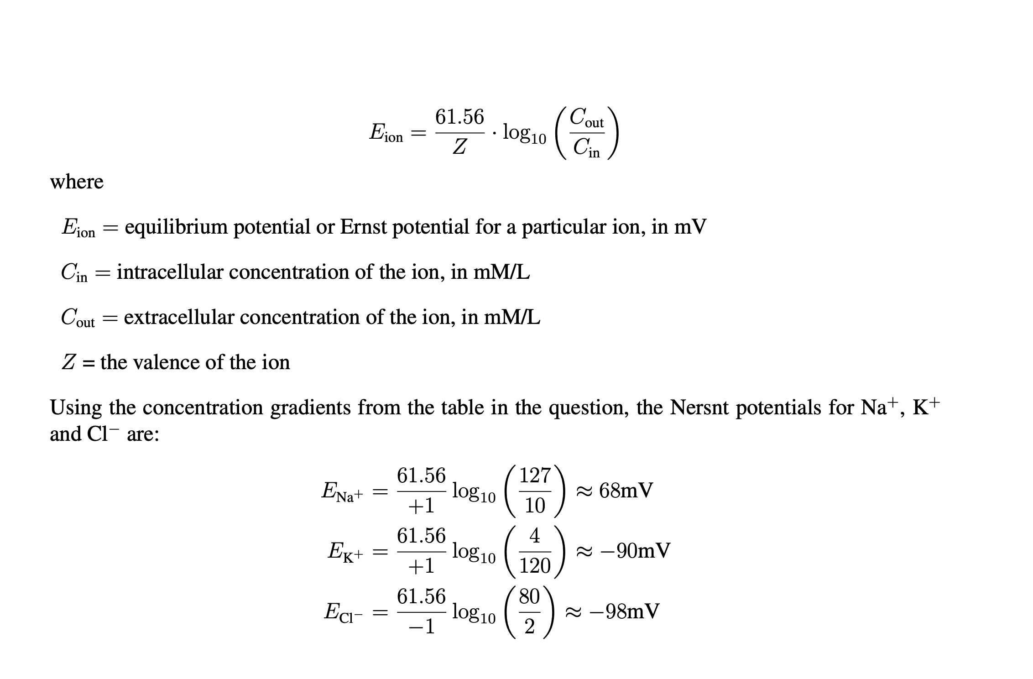

1. In our derivation of the Nernst potential we made several assumptions, one of which was that the concentration of the permeant ion(s) on each side of the cell membrane did not change as the problem went to completion.

Assume a cylindrical cell of radius R meters and length L meters, having a membrane capacitance Ca farads/m2, one singly-charged permeant species, X, with an intracellular concentration of [X]i mol/L and an extracellular concentration of [X]o mol/L (assume that [X]i > [X]o so that some X moves out of the cell to establish electrochemical equilibrium) and a membrane potential (= Nernst; assume no membrane ion pumps) of Vm volts.

Derive an expression for the ratio of the amount (in mol) of ion X moved (to establish the Nernst potential, Vm, of the cell) to the initial amount (in mol) of ion X inside the cell.

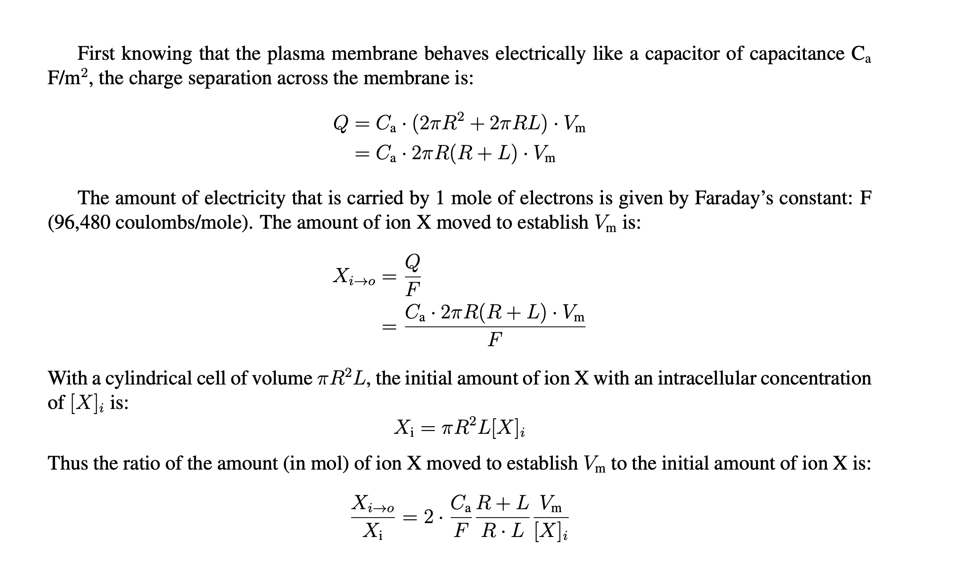

1. With reference to slide 5 of video 7 explain why [Cl]i appears in the numerator and [Cl]o appears in the denominator of the GHK equation.

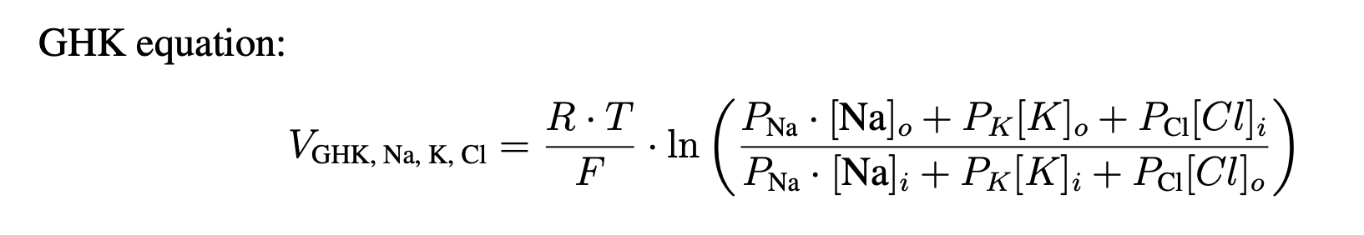

The Cl concentrations are reversed as compared to Na+ and K+ on the numerator and denominator of the GHK equation, because Cl- is an anion, it has negative charge, so it **has** the **reverse** effect on the voltage potential. Also, for consistency, if we ignore the other ions in the GHK equation, we have to find back, the expression of the Nernst potential for the ion Cl- with valence (–1) (ref: Module 1 – Video 6 – Slide 13):

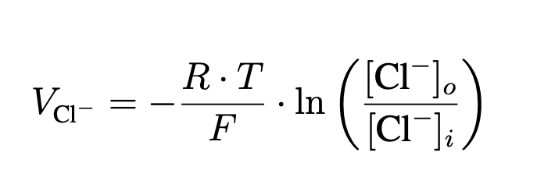

1. Using the intracellular and extracellular concentrations of Na+ and K+ and their calculated Nernst potentials as given in slide 8 of video 7, calculate the ratio of gNa to gK.

Using the calculated Nernst potentials for Na+, K+ and the equation on slide 7 of video for the resting membrane potential we obtain:

