Framing, Preprocessing & Synchronization
Architect's Design — Standalone Reference
A clean-slate design for the three layers underneath the model pipeline — written to stand on its own, elaborated in full, and corrected against how coach assignment actually works: gap detection on the OCR camera, not a generic presence signal.
Scope: Capture policy, preprocessing tasks, coach-boundary assignment, dashboard hierarchy Input: 7 genlocked cameras, mp4 per pass Updated: 2026-07-11

0. Overview
One decision drives everything below: input arrives as genlocked mp4 files, one complete recording per camera per train pass — not a live per-frame socket. That makes synchronization a batch manifest-building problem: build one correct, complete record of what happened, once, before any model runs — not a live-stream timeout/join problem where you're guessing whether a message is still coming.
The other load-bearing fact, corrected in this version: coach boundaries aren't inferred from a vague “presence signal.” The OCR camera itself detects the physical gap between two coaches and timestamps it. Everything captured between two consecutive gap timestamps — from any of the 7 cameras — belongs to whichever coach number the OCR camera read in that same window. That's the actual assignment rule, and it's simpler and more auditable than anything inferred statistically.

1. Framing
Three extraction policies, one per camera role, all reconciled against the shared genlock clock. Framing isn't “pick a frame rate” here — each role has a different physical reason for its own policy, and a dropped frame is accounted for explicitly rather than assumed away.
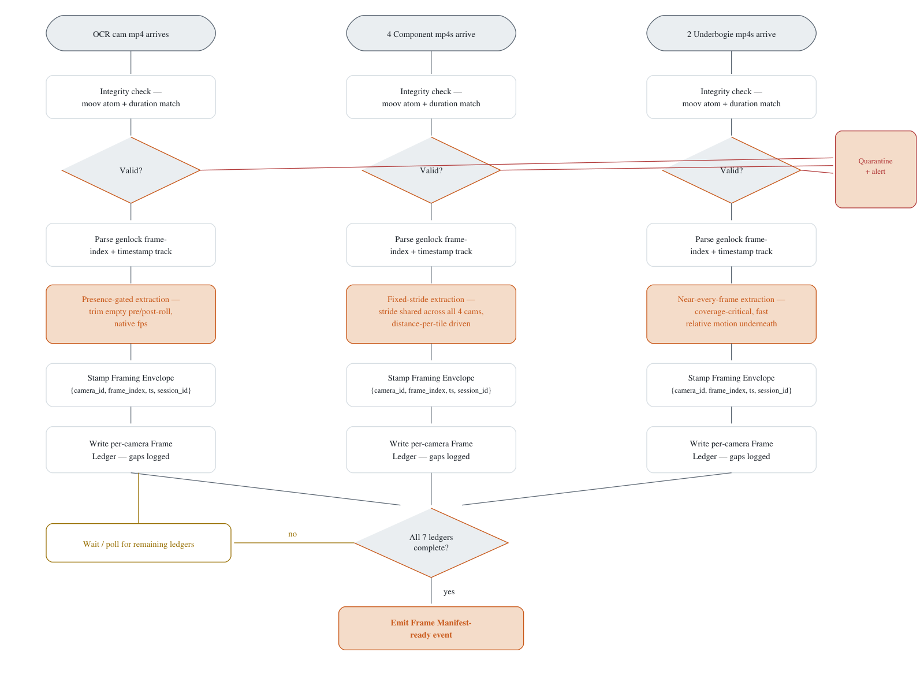
All 3 lanes share the same shape — integrity check, parse genlock index, role-specific extraction, stamp envelope, write ledger. They differ only in the amber policy box.

Walkthrough
- Files land per pass. Each of the 7 cameras writes its own mp4 for a train pass. Nothing starts until all 7 are present and readable.
- Integrity check first, always. A truncated or corrupt file (power blip, storage hiccup — normal in a rail yard, not exceptional) gets quarantined and alerted immediately, not discovered three stages later when a model chokes on it.
- Genlock index is the join key. Every frame's physical index and embedded timestamp is read from the container before anything else happens — this is what every later synchronization step keys off, not wall-clock time.
- Extraction policy differs by physical role, not preference. OCR only needs the plate read once — trimming empty roll saves calls. Component cameras must sample at an identical stride or the 4-way tile desyncs geometrically. Underbogie needs near-every-frame because a part passing underneath doesn't get a second look.
- Every frame is stamped with a full identity envelope before it goes anywhere else — camera, index, timestamp, session. This is what lets synchronization later be a lookup, not a guess.
- Ledgers record what actually happened, not what was expected — declared frame count vs. actual extracted count, with gap ranges explicit. This is the raw material the coach-assignment step in §3 depends on.
- The barrier only waits on completeness, not on cross-camera agreement — genlock already guarantees agreement; the barrier just confirms all 7 ledgers exist before declaring the pass ready to process.

Role | Extraction policy | Why
OCR (1 cam) | Presence-gated, native fps | Plate only needs to be read once clearly — trimming empty roll saves OCR calls on frames with nothing to read
Component (4 cams) | Fixed stride, identical across all 4 | Tiling assumes 4 simultaneous frames — any stride mismatch between cams desyncs the composite geometrically, not just temporally
Underbogie (2 cams) | Near-every-frame | Components pass directly beneath at speed with no second look — under-sampling here is unrecoverable

2. Preprocessing
Three stages apply to every frame regardless of source, then each camera role gets its own specialized chain. Two things are easy to skip in a first build — geometric calibration and low-light handling — and both are exactly what the MVIS spec's measurement-based defects (buffer height in mm, wheel-shelling depth in mm) depend on.
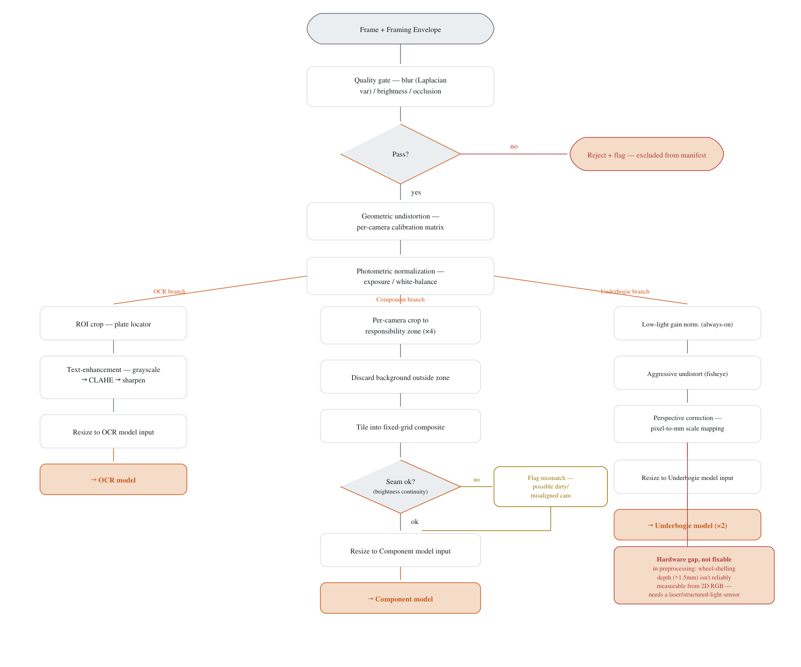
Crit dashed box = a physics limit, not an engineering gap. Warn = flagged but non-blocking. Trunk above the fork is the only preprocessing shared by all 7 cameras.

Walkthrough
- Quality gate runs before anything expensive. Blur, brightness, occlusion — reject here, and every downstream stage (undistort, tile, model inference) never has to touch a useless frame.
- Undistortion is not optional. Every camera has lens distortion. Skip correction and every pixel-based measurement downstream — buffer height, wheel-shelling depth — is measuring a warped image, not the real part.
- Photometric normalization gets 7 cameras onto one distribution. Different mounts, different ambient light — models trained once need consistent input, not 7 different lighting conditions arriving unannounced.
- The fork happens only after the shared corrections — each role gets exactly what it needs: OCR gets text-specific enhancement, Component gets zone-cropped before tiling, Underbogie gets low-light handling that's always on, not conditional, because the pit is never daylight.
- The seam-consistency check doesn't fix anything — it flags. A lighting mismatch between two tiles usually means a dirty lens or a drifting mount, worth surfacing as a maintenance signal, not silently averaged away.
- Wheel-shelling depth is called out as a hardware limit, not a software gap. A single 2D RGB camera cannot reliably resolve sub-2mm surface depth. This defect class needs a different sensor (laser line scanner or structured light), or should be marked out-of-scope for the current rig.

Stage | Applies to | Task | Why it's here
Common | All 7 cams | Quality gate — blur / brightness / occlusion | Rejects unusable frames before any GPU cycle is spent
Common | All 7 cams | Geometric undistortion (per-camera calibration matrix) | Required for every mm-based measurement in the MVIS spec
Common | All 7 cams | Photometric normalization | One consistent input distribution, not 7
OCR | 1 cam | ROI crop + grayscale/CLAHE/sharpen | Plate legibility is the only goal here
Component | 4 cams | Per-cam zone crop → tile → seam-consistency flag | Correcting each camera before tiling makes the composite trustworthy
Underbogie | 2 cams | Low-light gain → aggressive undistort → perspective correction | Pit environment is never daylight — the only mode, not a branch

3. Coach Assignment & Synchronization
This is the corrected mechanism. The OCR camera does two jobs at once: it reads the plate number, and it watches for the physical gap between two coaches — the brief moment where no coach body is in frame. Every gap gets a timestamp. Everything captured between two consecutive gap timestamps, from any of the 7 cameras, belongs to whichever coach number was read in that same window.
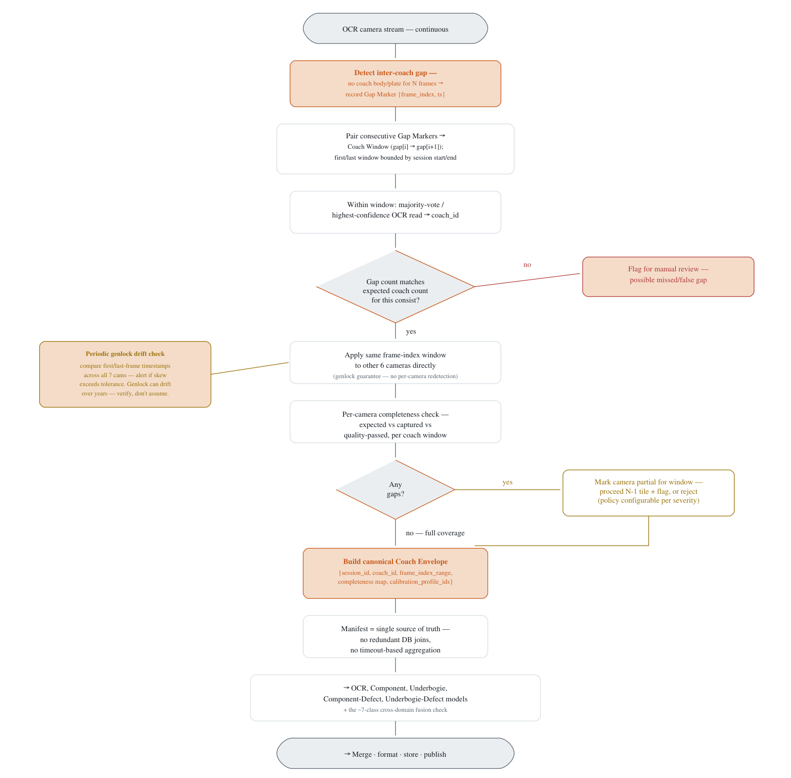
Warn dashed = the two places this design admits it could be wrong (genlock drift, camera gaps) and handles explicitly. Crit = a mismatch worth stopping for, not silently absorbing.

Walkthrough
- The OCR camera is the boundary detector, not just the reader. It watches continuously across the whole pass. When no coach body or plate is visible for a short run of frames, that's a gap, and it gets a timestamp the moment it's detected.
- Two consecutive gaps define one coach's window. Everything the OCR camera reads between gap[i] and gap[i+1] belongs to one coach. The first coach's window starts at session start; the last ends at session end.
- The coach number comes from a vote, not a single read. Take the highest-confidence or majority OCR read across all frames in the window as that window's coach_id.
- Sanity-check against the known consist. Compare the number of detected windows to the train's expected coach count. A mismatch means a missed or falsely-triggered gap — flag it for a human rather than silently mis-assigning components.
- Genlock does the rest of the work for free. Once a coach's window is defined in the OCR camera's frame-index space, the identical range applies directly to all 6 other cameras — no separate boundary detection per camera.
- Coverage gaps are still checked per camera, per window — genlock guarantees timing alignment, not that every camera actually captured every frame.
- The Coach Envelope is the one object everything downstream reads. Built once, deterministically, before any model runs — coach_id, frame range, per-camera completeness, calibration profile.

Case | Handling
First / last coach has no gap on one side | Window bounded by session start / session end instead of a Gap Marker
Two coaches merged into one window (missed gap) | Caught by the consist-count check — flagged for manual review, not silently assigned
False gap (glare, reflection, camera blip) | Same consist-count check catches an over-count of windows
OCR reads conflict within one window | Majority-vote / highest-confidence resolves it; a genuinely split vote gets flagged low-confidence
Camera drops frames mid-window | Per-camera completeness check inside the window, independent of coach assignment itself

4. Dashboard Data Hierarchy
The Coach Envelope is the engineering object. What a station operator actually looks at is simpler: Train number → Coach number → Components (Undercarriage + Bottom). This is that hierarchy, built directly from the coach-assignment mechanism above and the defect taxonomy already established.
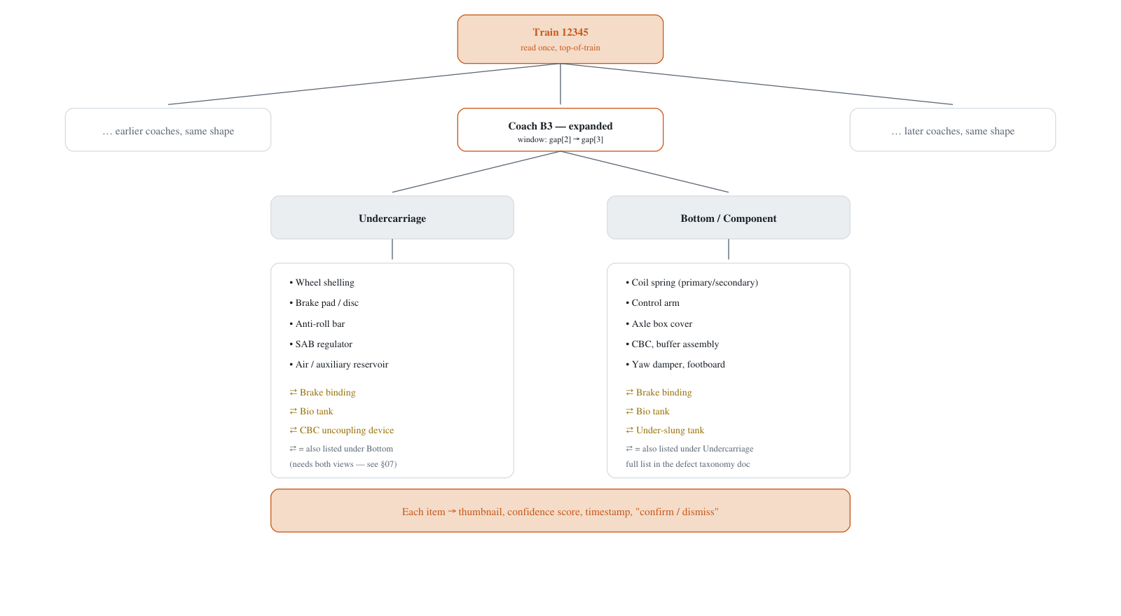
⇄ marks the ~7 cross-domain defect classes — they show up under both buckets because they genuinely need both camera views.

Walkthrough
- Train number is the root — read once from the OCR camera, shared by every coach in the pass.
- Coach number comes straight from the gap-window mechanism in §3 — each coach the operator sees is exactly one Coach Envelope, no separate lookup needed.
- Two buckets under each coach, matching what an inspector actually walks under and around — Undercarriage (what the 2 underbogie cameras saw) and Bottom/Component (what the 4 tiled component cameras saw).
- Cross-domain defects appear in both buckets, marked, not hidden. An operator searching “brake” under Undercarriage should find it — and the same entry under Bottom should say so plainly.
- Leaf level is the actual actionable unit — a defect entry with a thumbnail, a confidence score, and a confirm/dismiss action, not a raw model output.

5. Pros and Cons, for This System Specifically
 | Point | Why it matters here
Pro | Coach assignment is deterministic and auditable | A gap timestamp either exists or it doesn't — no statistical inference
Pro | No timeout guessing anywhere in the sync path | The manifest is complete and correct before any model runs
Pro | Genlock does cross-camera alignment for free | One boundary detection (on the OCR camera) instead of 7 independent ones
Pro | Durable audit trail by construction | The Coach Envelope + Gap Markers are themselves the record of what was seen and when
Con | Not real-time | Whole file must land before the manifest builds — no mid-pass alerting with this design
Con | Consist-count check needs a known consist | Without an expected-coach-count reference, a missed or false gap won't be caught automatically
Con | Bet entirely on genlock holding | Mitigated by the drift-check, but the whole design assumes hardware sync stays correct for years
Con | Gap detector itself needs tuning | Too strict = false-split on small couplings; too loose = two coaches merge into one window
Companion to the main pipeline architecture doc — see the 7-camera topology and MVIS defect taxonomy sections there for the full component/defect list this hierarchy is drawn from.

