COMP 306: Database Management Systems

Spring 2023 - Homework 5

Yakup Enes Güven – 64045

Figure 1: brew services start mongodb-community@6.0



Figure 2: use hw5



Figure 3: mongoimport --db hw5 --collection zipcodes --file zips.json



Figure 4: show collections

Figure 5: db.zipcodes.find().limit(15)

Figure 6:db.zipcodes.find().sort().limit()

Figure 7: db.zipcodes.find()

Figure 8: db.zipcodes.aggregate()

Figure 9: db.zipcodes.aggregate()

Figure 10: db.createCollection("customers",)

Figure 11: db.customers.insertMany()

Figure 12: db.customers.find()

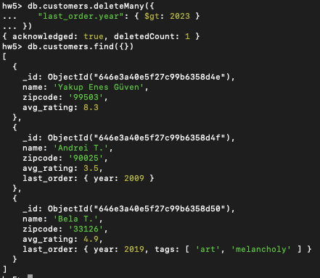

Figure 13: db.customers.deleteMany()

Figure 14: db.customers.updateOne()

The error message indicates that the validation failed for the "avg_rating" field. It states that the schema rules for the "avg_rating" property were not satisfied. Based on the previous information, the "avg_rating" field must be a double between 0.0 and 10.0. In this case, it seems that the attempted update set the "avg_rating" field to a value that is outside the allowed range of 0.0 to 10.0. To resolve this issue, we should update the code with a valid value within the specified range for the "avg_rating" field.

Figure 15: db.customers.aggregate()



Figure 16: mongoexport --db hw --collection customers --out customers.json