Project 5

COMP301 Spring 2023

AYDA KANIL - 0064641

YAKUP ENES GÜVEN - 0064045

**1. WORKLOAD**

1. Ayda Kanıl   
   ● Part - B Coding   
   ● Part - A Coding (help)   
   ● Report

* Yakup Enes Güven (coding mostly done by me)  
  ● Part - B Coding (help) (partly working)  
  ● Part - A Coding (working)  
  ● Part - C Coding (working)   
  ● Report

**2. PART - A**

In this partwe add vector to EREF. In Figure 1 we implement new operators newvector, update-vector, read-vector, length-vector, and swap-vector with the given definitions in **lang.scm**.

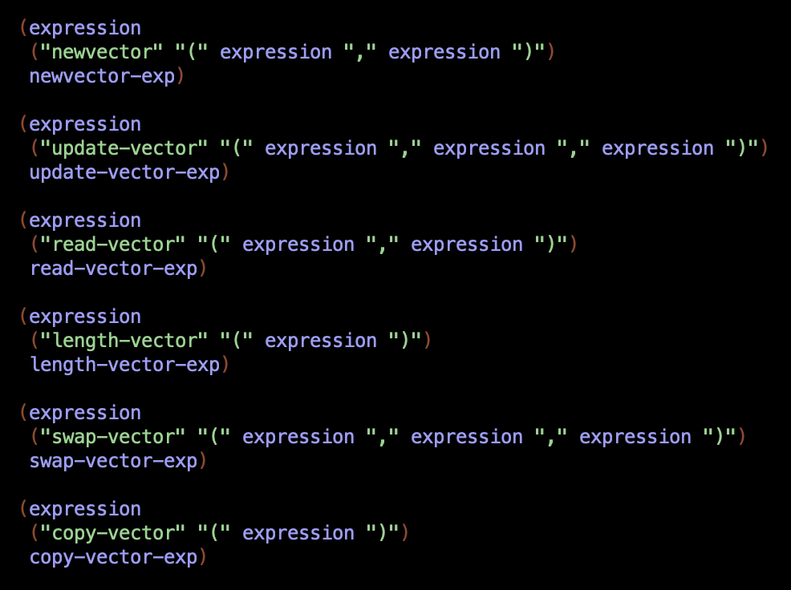**Figure 1**

Then, we added vector-val and pair-val to expval to **data-structures.scm** class as it’s shown in Figure 2.

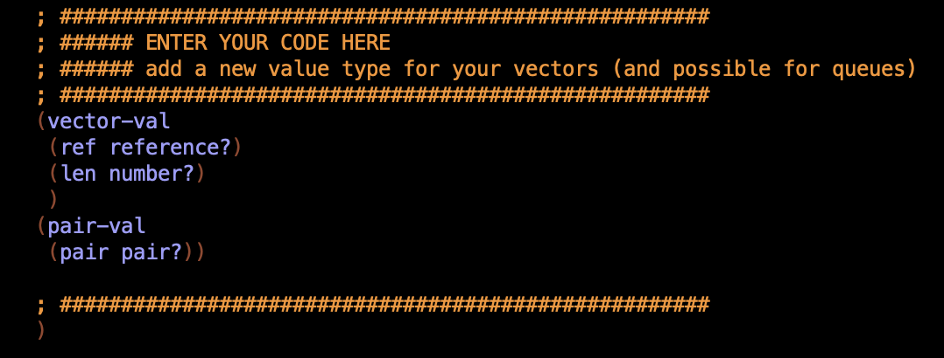**Figure 2**

In Figure 3 we added the extractors.

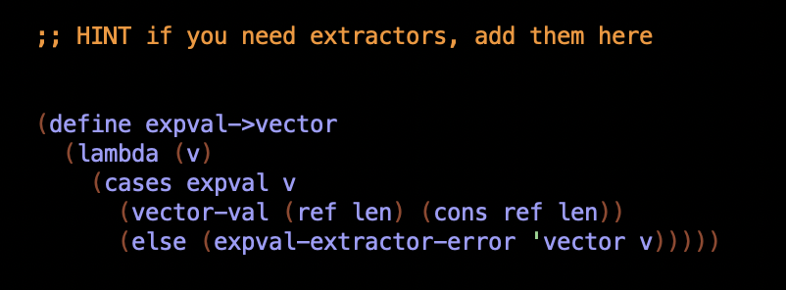

**Figure 3**

After these, we first define the vector. Then, we have included the following functions, in **data_structures.scm**, to be used in the interp.scm file.

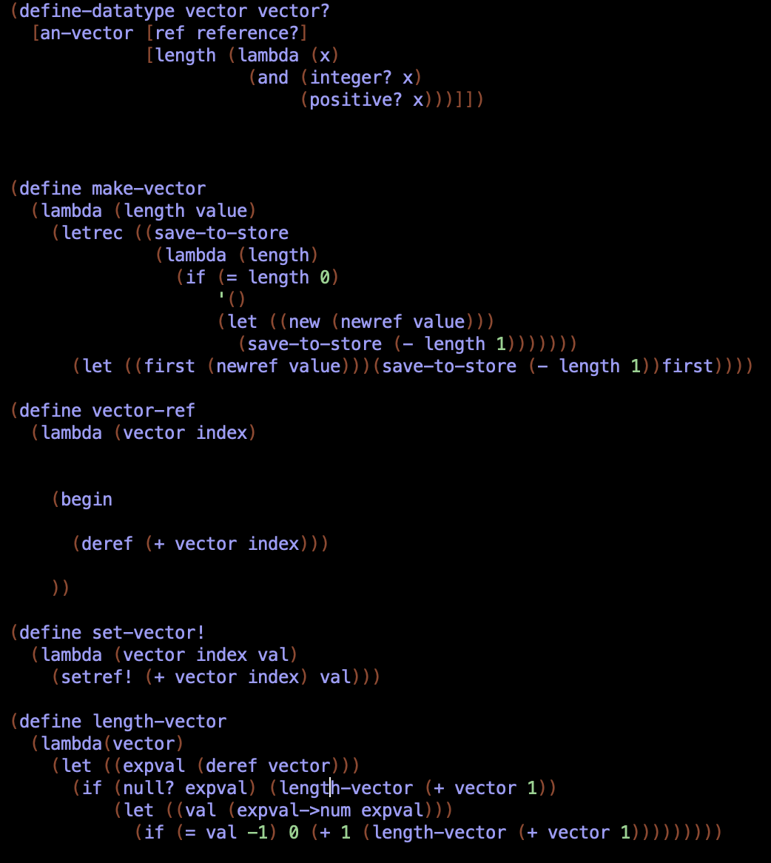

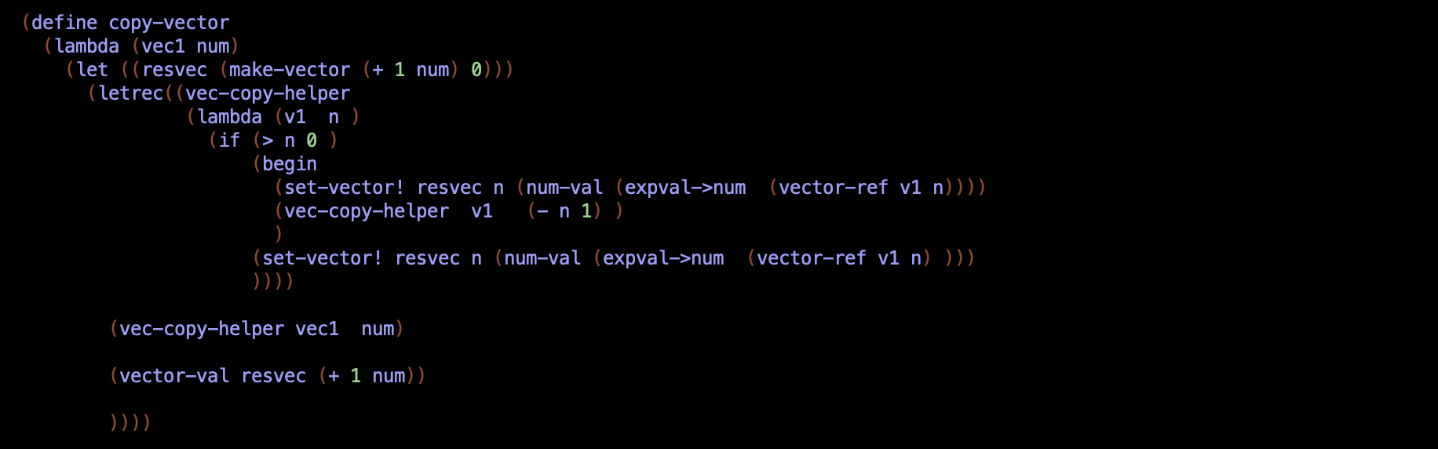

**Figure 4**

In interp.scm class, we implemented the vector expressions as shown in Figure 5.

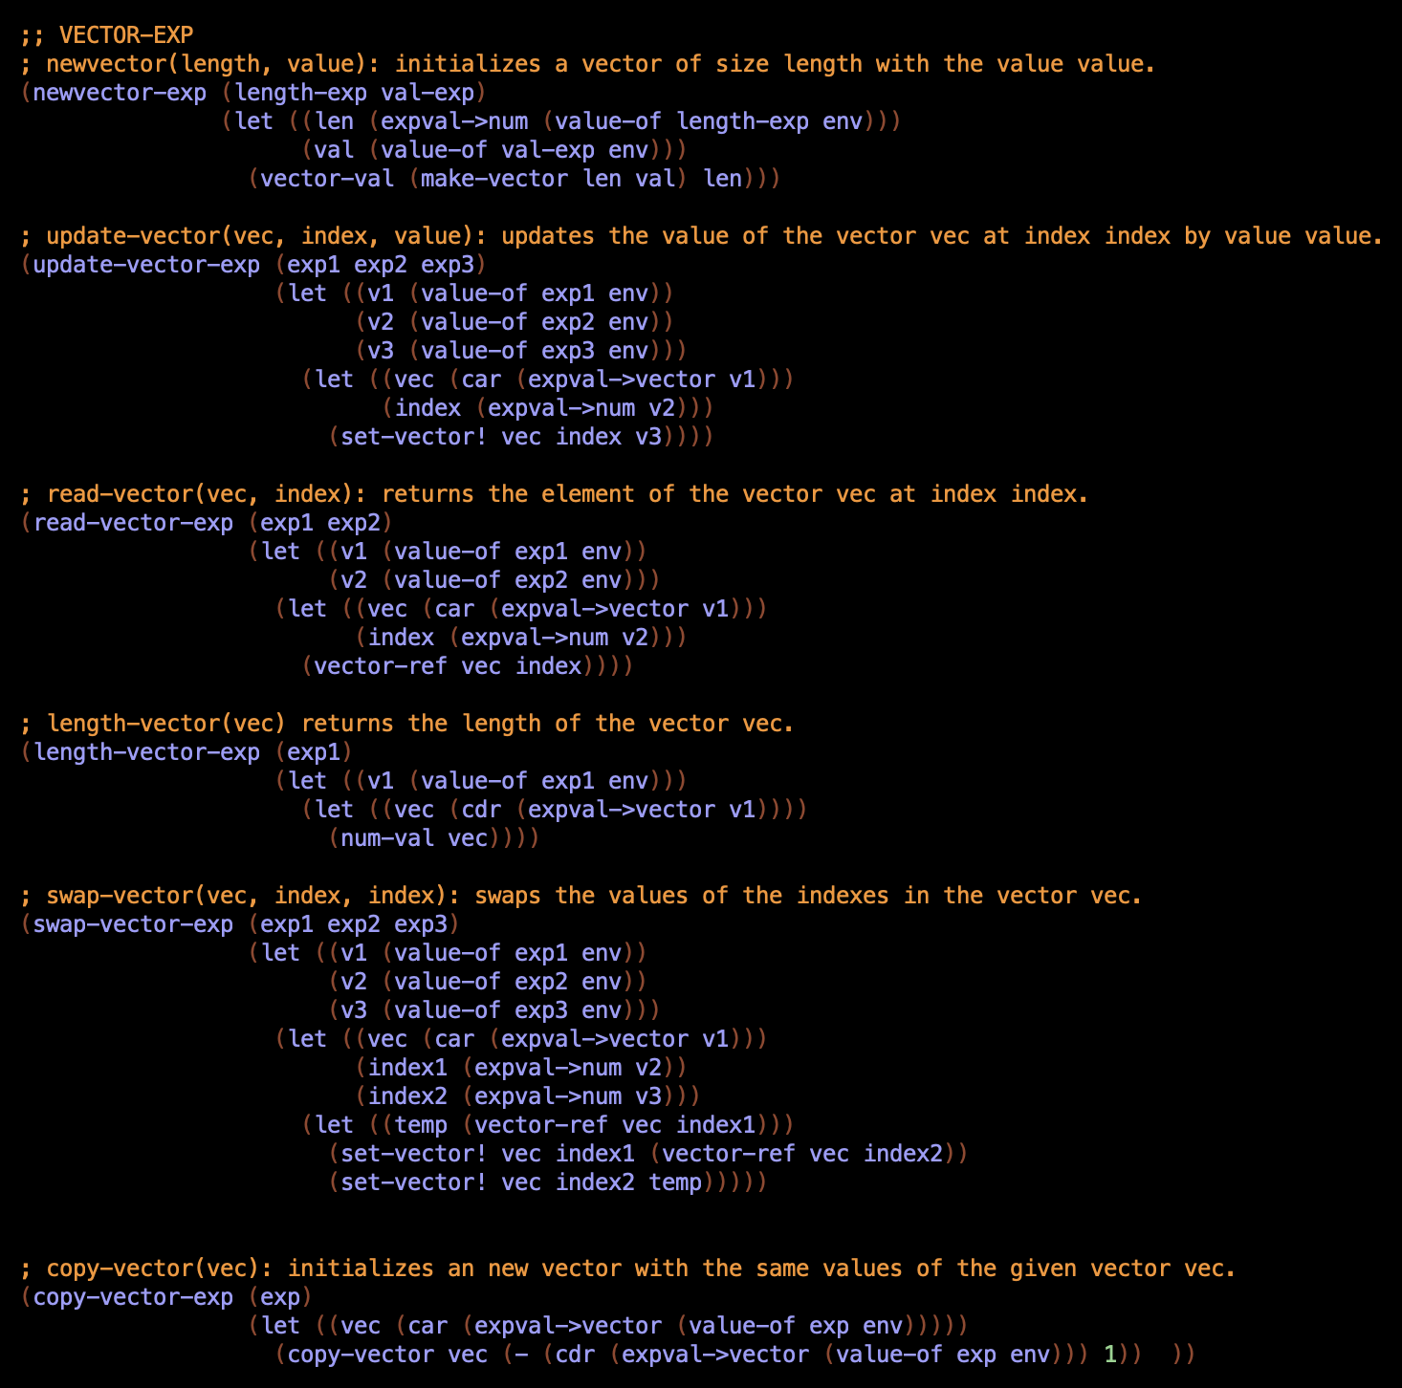

**Figure 5**

**3. PART - B**

In this part, we implemented a Queue using vectors that we implemented in Part A.

First, we add the language in lang.scm as shown in Figure 6.

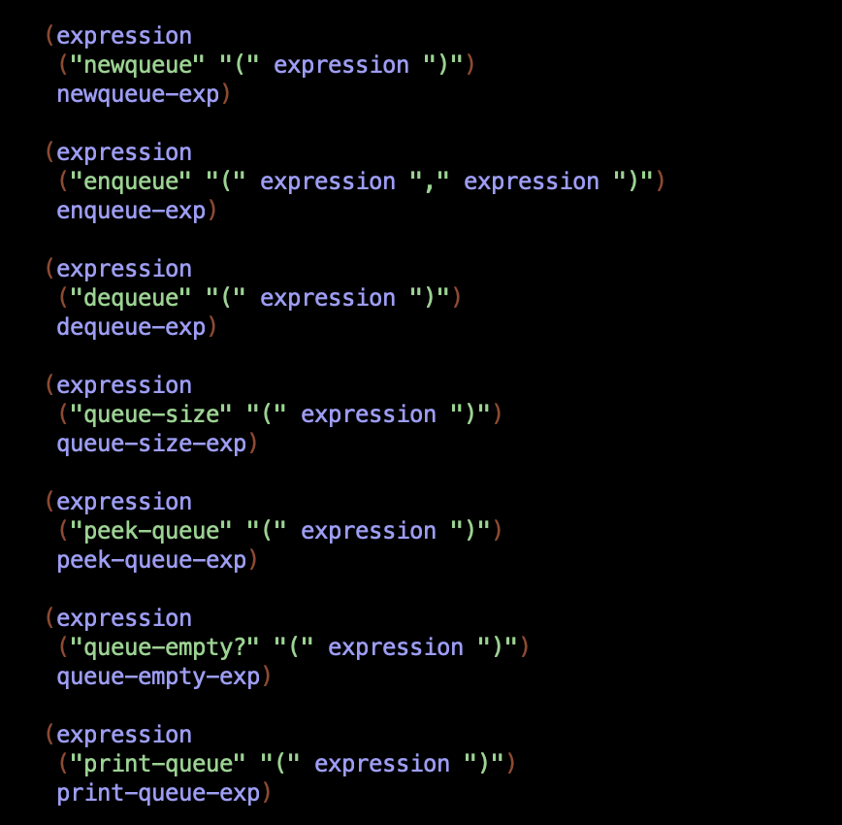

**Figure 6**

Then, in interp.scm class we use vectors to implement a Queue as shown in Figure 7.

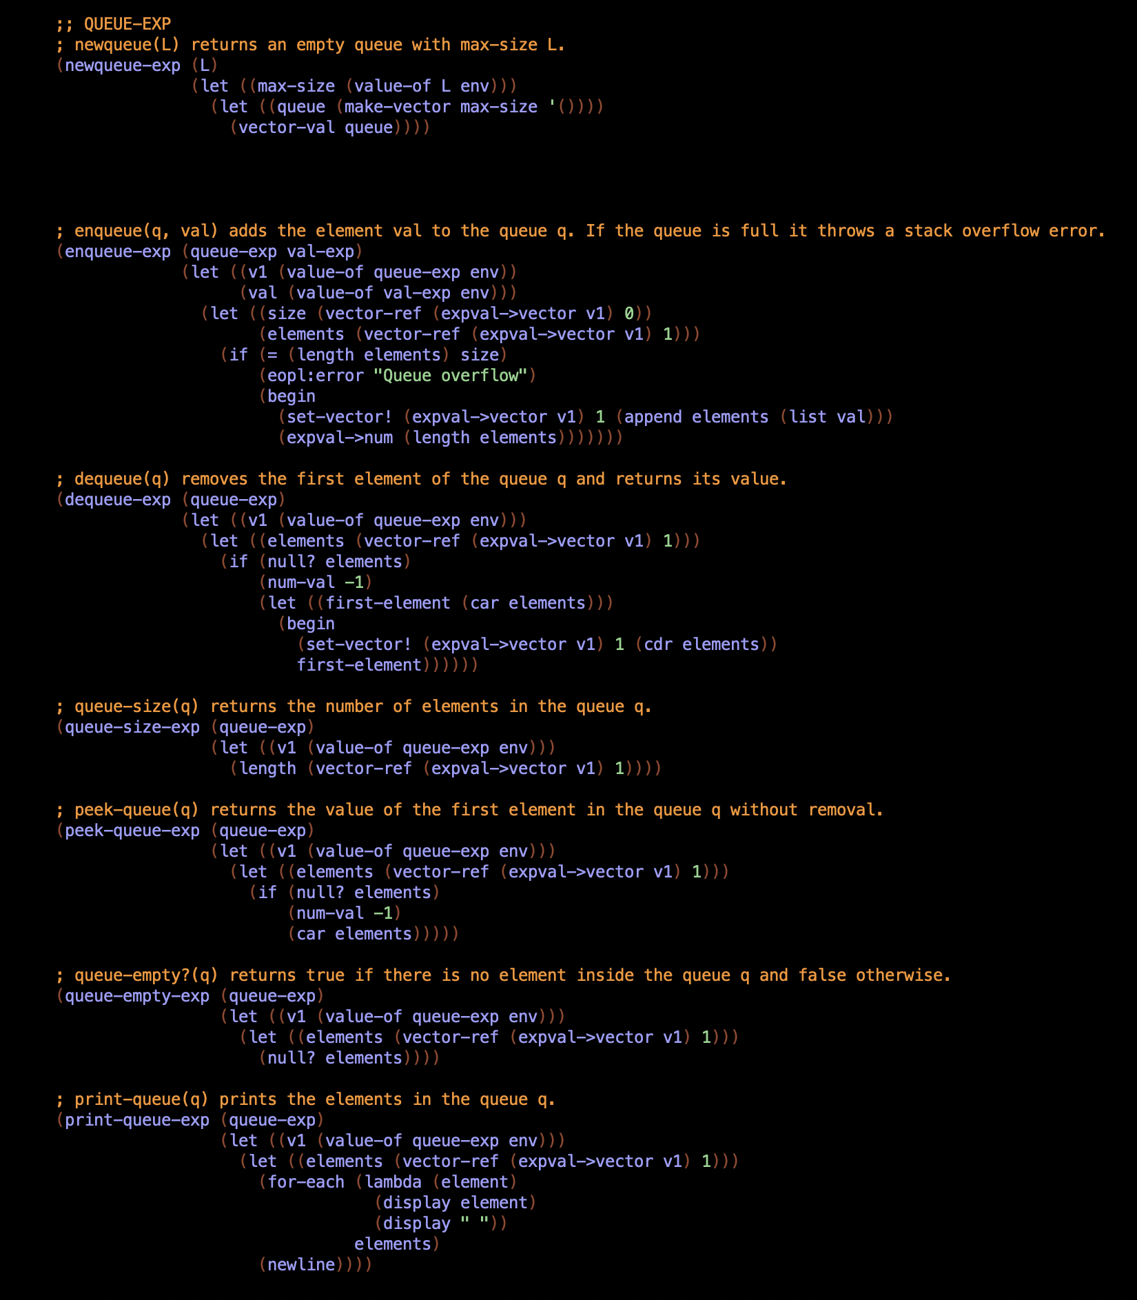

**Figure 7**

Also, we implemented some helper functions as shown in Figure 8.

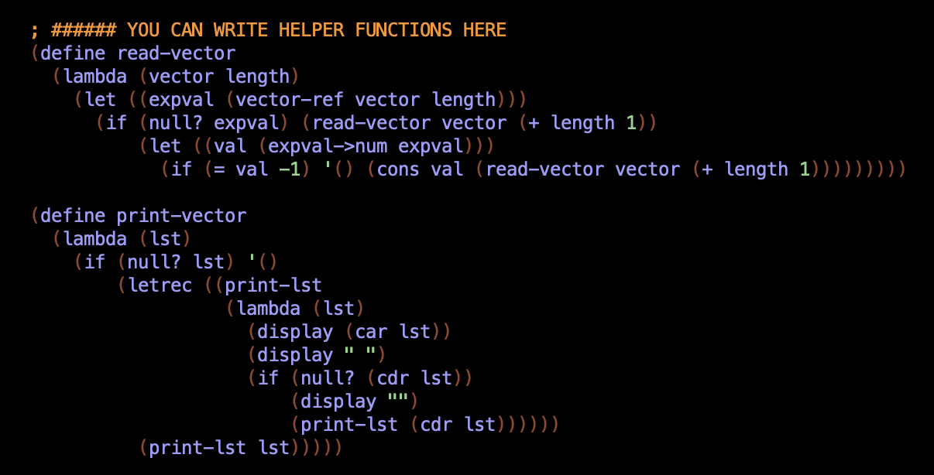**Figure 8**

**4. PART - C**In this part, we implemented the language for vec-mult-exp in **lang.scm** class as shown in Figure 9.

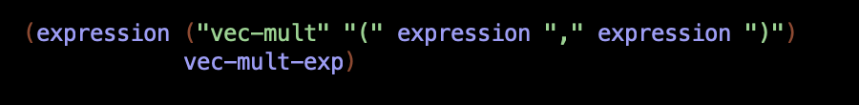**Figure 9**

We implemented the definition of vec-mult function in **data_structures.scm** class as shown in Figure 10.

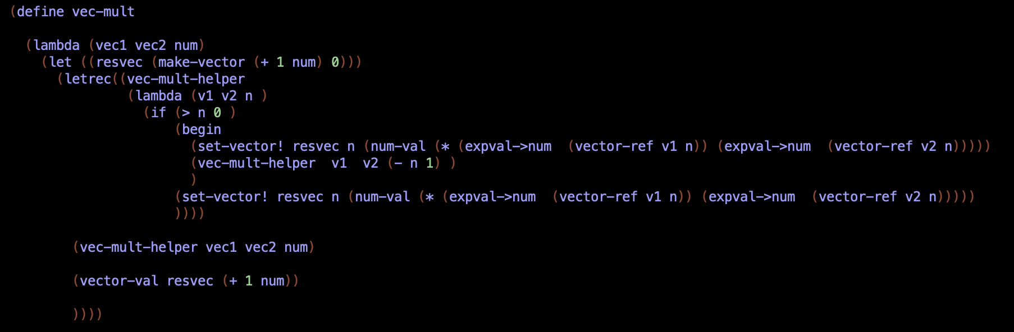

**Figure 10**

Then, we implemented the vec-mult in **interp.scm** class as shown in Figure 11.

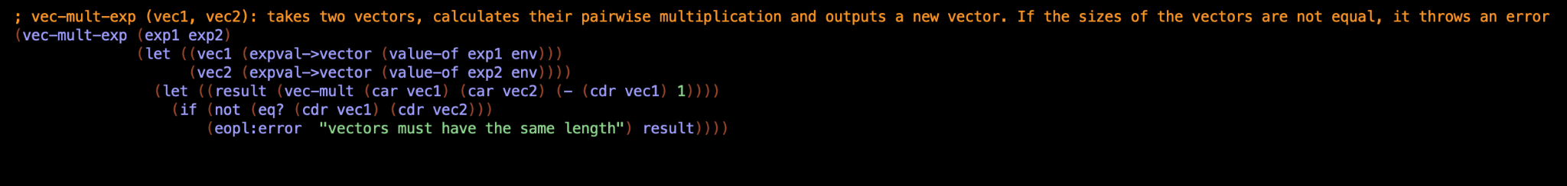**Figure 11**