ELEC 301 PROJECT3 REPORT

YAKUP ENES GÜVEN – 64045

PART1

a)

metin, vitrin, ekran görüntüsü içeren bir resim

Açıklama otomatik olarak oluşturuldu

Figure1:Scope of sine wave with a = 2, f= 200\*pi, Ts= 2e − 4.

We know that T=1/f. So, when we apply 200\*pi as f, T will be 0,01. From the graph we can say that the period is 0,01. The graph is as expected.

b)

metin, ekran görüntüsü, elektronik eşyalar, vitrin içeren bir resim

Açıklama otomatik olarak oluşturuldu

Figure2: Spectrum analyze of Part1.

The peak values are expected after viewing scope values.

c)

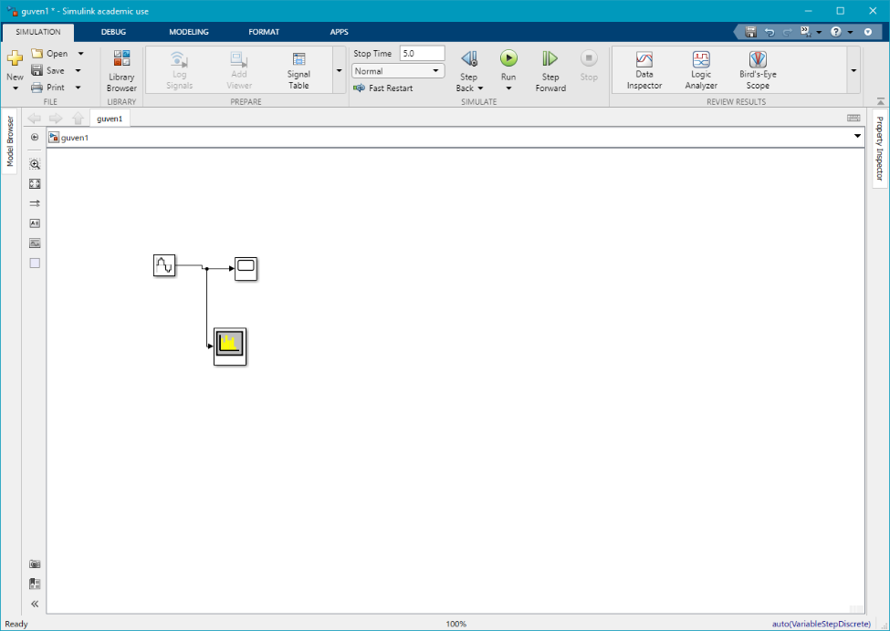

Figure3: Model of Part1

PART2

a)

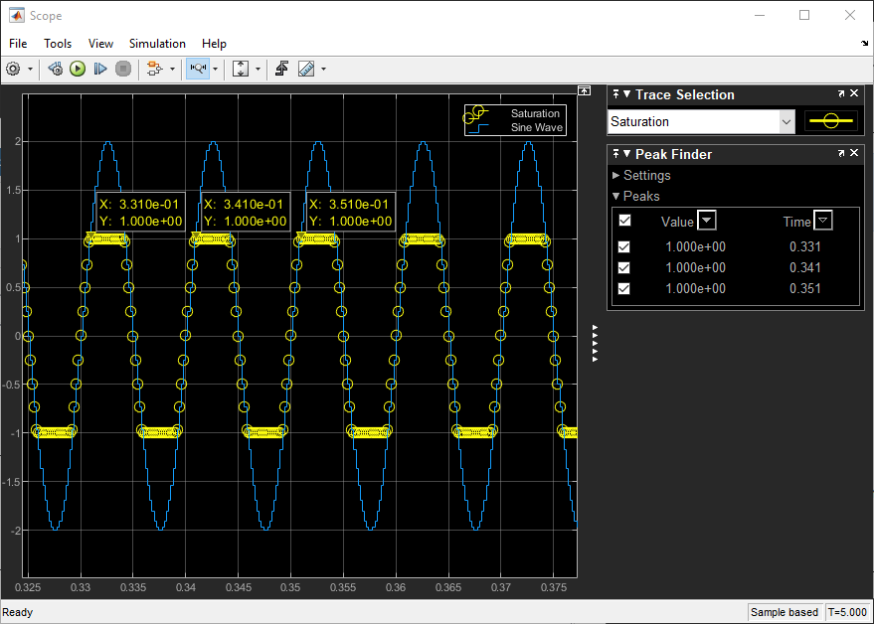

Figure4: Scope of saturation of sine wave.

b)

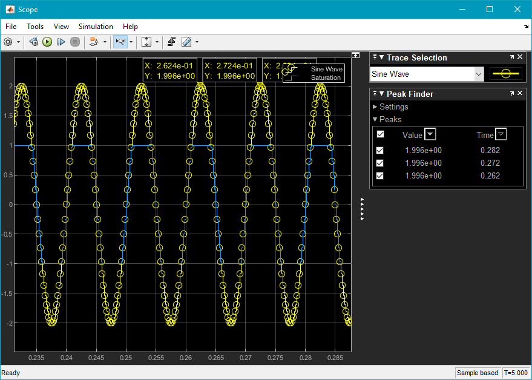

Figure5: Scope of saturation of sine wave with Spectrum analyzer.

metin, elektronik eşyalar, vitrin, ekran görüntüsü içeren bir resim

Açıklama otomatik olarak oluşturuldu

Figure6: Spectrum analyze of Part2

From the graph of spectrum analyze , we can see that there are some peaks, I assume that the first peak is the fundamental period. And it is almost 0,9kHz.

c)

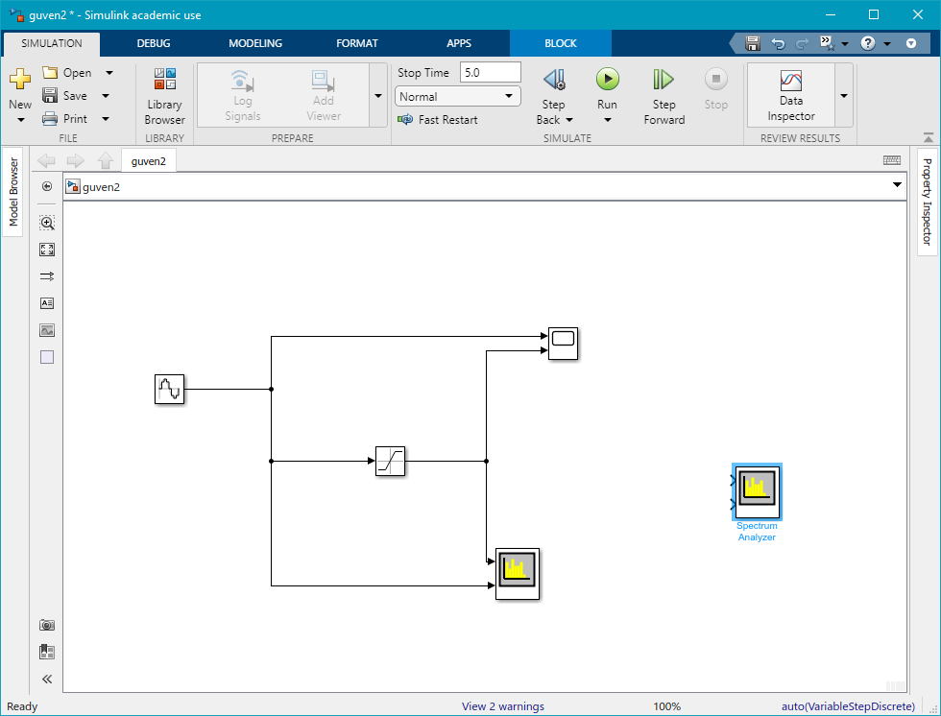

Figure7: Model of Part2

PART3

a)

metin, ekran görüntüsü, vitrin, elektronik eşyalar içeren bir resim

Açıklama otomatik olarak oluşturuldu

Figure8: Scope of triangle wave.

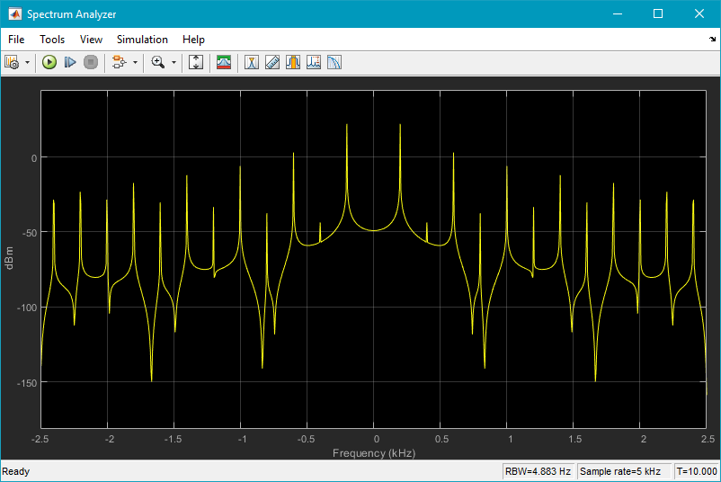

Figure9: Spectrum analyze of triangle wave

b)

metin, elektronik eşyalar, ekran görüntüsü, vitrin içeren bir resim

Açıklama otomatik olarak oluşturuldu

Figure10: Spectrum analyze of triangle wave with 3 peaks point

You can consider the value displayed for the peak value of the harmonics  as

20\*log(|ak|) +C where ak is the Fourier Series coefficient and C is a constant corresponding to a scaling due to the spectrum estimation process.

The difference of these values between two consecutive peaks would eliminate this C constant: 20\*log(|ak|)+C - ( 20\*log(|ak+1 |)+C)= 20\*log(|ak|/| ak+1|)

After pulling in known values and calculations,

c)

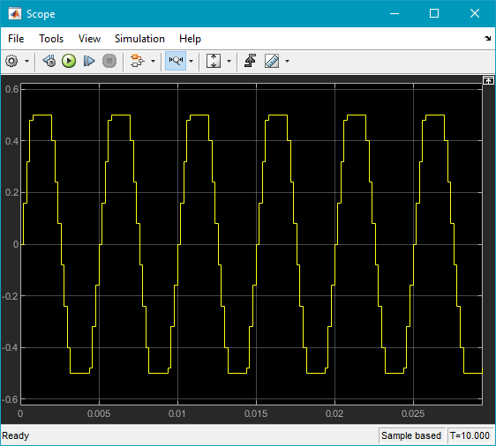

Figure11: Scope of LTI system using triangle wave and saturation with upper and lower limit to equals 0.5 to generate square wave

d)

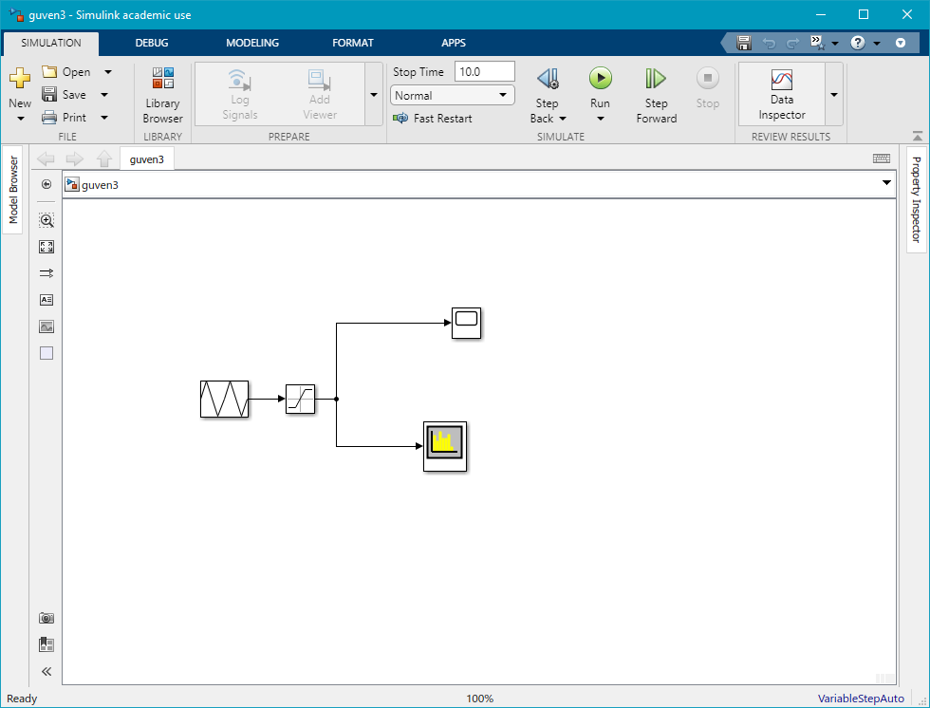

Figure12: Model of Part3

Conclusion

In this project, I have learned and improve some MATLAB Simulink skills. Sine and triangle waves application and getting square wave from triangle wave has learned. Also from the scope screen, period, max ,min and frequency values of the wave has been determined. From the spectrum analyze screen, I learned that first peak value is fundamental frequency. In part 3 I created a almost square wave by using triangle wave and saturation, and figured out that if max value of saturation becomes close to period, the wave becomes more likely to square wave.