|  |  |  |
| --- | --- | --- |
| USE CASE # 11 | Transfer money | |
| Goal in Context | Transfer money from a Group to an adjacent Group | |
| Scope & Level | Affects the user | |
| Preconditions | Player must have chosen to take a regular action | |
| Success End Condition | Money has been transferred to an adjacent Group | |
| Failed End Condition | Money was transferred to a non-adjacent Group | |
| Primary Actors | User (Player) | |
| Secondary Actors | System, Group | |
| Trigger | The “Regular Action” option is chosen in the menu | |
| DESCRIPTION | Step | Action |
| 1 | User chooses “Regular Action” |
| 2 | User chooses which adjacent Group to transfer money to |
| 3 | User decides how much money to transfer |
| 4 | System transfers money to chosen Group |
| 5 | Adjacent Group receives money |
| 6 |  |
| 7 |  |
| 8 |  |
| 9 |  |
| 10 |  |
| 11 |  |
| 12 |  |
| EXTENSIONS | Step | Branching Action |
| 1a | User chooses to transfer money a second time |
| 1a.1 | Rejoin step 1 |
| 2a |  |
|  |  |
|  |  |
|  |  |
|  |  |
|  |  |
|  |  |
|  |  |
| SUB-VARIATIONS | Step | Branching Action |
| 1 | If User runs out of money to transfer, system does not transfer money |
| 2 | If User runs out of turns to transfer money, system moves on to next player |
|  |  |
|  |  |
|  |  |
|  |  |
|  |  |
|  |  |
|  |  |
|  |  |
| RELATED INFORMATION | Use Case #11 | |
| Priority: | Medium | |
| Performance | 3 hrs. | |
| Frequency | During any player’s turn | |
| Channels to actors | N/A | |
| OPEN ISSUES | Menus must be finished beforehand; Use Case #2 must be finished | |
| Due Date | July 03, 2019 | |
| ...any other management information... | N/A | |
| Super ordinates | Use Case #2 | |
| Subordinates | N/A | |
| AUTHOR | Yosselin Velasco | |
| Create date | June 11, 2019 | |

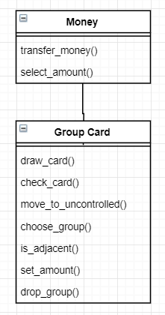

|  |  |  |
| --- | --- | --- |
| USE CASE #12 | Draw a card | |
| Goal in Context | Draw a card from deck | |
| Scope & Level | Affects the user | |
| Preconditions | Player must have already collected income | |
| Success End Condition | Card was either placed in uncontrolled Groups or in Player’s cards | |
| Failed End Condition | N/A | |
| Primary Actors | User (Player) | |
| Secondary Actors | System, Uncontrolled Groups, Player Cards | |
| Trigger | N/A | |
| DESCRIPTION | Step | Action |
| 1 | System draws a card for the user |
| 2 | If the card if a Group card: |
| 3 | System places card in Uncontrolled Groups |
| 4 | If the card is a Special card: |
| 5 | System places card in Player’s cards |
| 6 |  |
| 7 |  |
| 8 |  |
| 9 |  |
| 10 |  |
| 11 |  |
| 12 |  |
| EXTENSIONS | Step | Branching Action |
| 1a | If a special card is drawn during an end turn with fewer than two Groups: |
| 1a.1 | System discards card |
| 1b | If User has Special Card “The Network” |
| 1b.1 | System draws 2 cards |
| 2b.2 | Rejoin step 2 |
|  |  |
|  |  |
|  |  |
|  |  |
|  |  |
| SUB-VARIATIONS | Step | Branching Action |
| 1 | If the deck is empty, system cannot draw a card |
|  |  |
|  |  |
|  |  |
|  |  |
|  |  |
|  |  |
|  |  |
|  |  |
|  |  |
| RELATED INFORMATION | Use Case #12 | |
| Priority: | High | |
| Performance | 4 hrs. | |
| Frequency | At the start or end of every players’ turn | |
| Channels to actors | N/A | |
| OPEN ISSUES | The Player excel spreadsheet must be created beforehand; Uncontrolled Cards excel spreadsheet must be done; Data for cards and players must be inputted to respective spreadsheets | |
| Due Date | July 03, 2019 | |
| ...any other management information... | N/A | |
| Super ordinates | Use Case #3 | |
| Subordinates | N/A | |
| AUTHOR | Yosselin Velasco | |
| Create date | June 11, 2019 | |

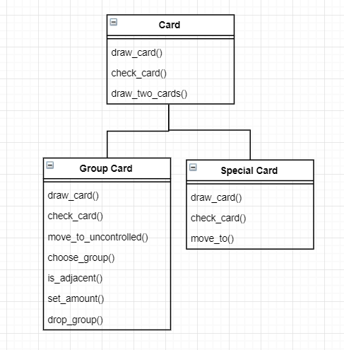

|  |  |  |
| --- | --- | --- |
| USE CASE #13 | Take special-power action | |
| Goal in Context | A special action will be executed depending on which Special Card the player has | |
| Scope & Level | Affects the user | |
| Preconditions | Player must have chosen to take a special-power action | |
| Success End Condition | Action was taken based on Special Card | |
| Failed End Condition | No action or wrong action was taken | |
| Primary Actors | User (Player) | |
| Secondary Actors | System | |
| Trigger | The “Special-Power Action” was chosen from menu | |
| DESCRIPTION | Step | Action |
| 1 | User chooses “Special Power Action” |
| 2 | User chooses which Special Card to use |
| 3 | Special Card’s special-power action is executed |
| 4 |  |
| 5 |  |
| 6 |  |
| 7 |  |
| 8 |  |
| 9 |  |
| 10 |  |
| 11 |  |
| 12 |  |
| EXTENSIONS | Step | Branching Action |
| 1a | N/A |
|  |  |
|  |  |
|  |  |
|  |  |
|  |  |
|  |  |
|  |  |
|  |  |
|  |  |
| SUB-VARIATIONS | Step | Branching Action |
| 1 | If Player does not have any Special cards: |
| 1.1 | System does not complete any Special-Power actions |
| 2 | If Player has Special Card with no action |
| 2.1 | System does not execute any special-power action |
|  |  |
|  |  |
|  |  |
|  |  |
|  |  |
|  |  |
| RELATED INFORMATION | Use Case #13 | |
| Priority: | Medium | |
| Performance | 12 hrs. | |
| Frequency | When user has a playable Special Card and decides to use its special-power action | |
| Channels to actors | N/A | |
| OPEN ISSUES | Menu must be finished beforehand | |
| Due Date | July 03, 2019 | |
| ...any other management information... | N/A | |
| Super ordinates | N/A | |
| Subordinates | N/A | |
| AUTHOR | Yosselin Velasco | |
| Create date | June 11, 2019 | |

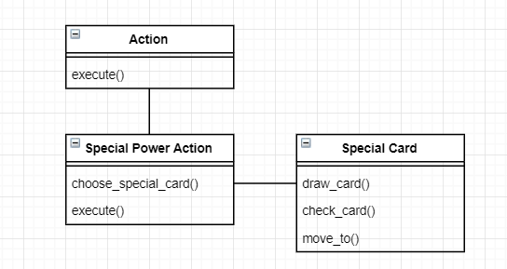

|  |  |  |
| --- | --- | --- |
| USE CASE #14 | Drop a group | |
| Goal in Context | Remove group from User’s Power Structure and return it to uncontrolled groups | |
| Scope & Level | Affects User | |
| Preconditions | User must have chosen to take a free action | |
| Success End Condition | A group has been removed from the user’s power structure and was returned to uncontrolled Groups | |
| Failed End Condition | Card dropped was not returned to uncontrolled Groups | |
| Primary Actors | User (Player) | |
| Secondary Actors | Groups, System | |
| Trigger | The “Drop a Group” option was chosen from menu | |
| DESCRIPTION | Step | Action |
| 1 | User chooses “Drop a Group” option |
| 2 | User decides which group to drop |
| 3 | System removes card from Player’s Power Structure |
| 4 | System adds card back into uncontrolled Groups |
| 5 |  |
| 6 |  |
| 7 |  |
| 8 |  |
| 9 |  |
| 10 |  |
| 11 |  |
| 12 |  |
| EXTENSIONS | Step | Branching Action |
| 2a | If Player chooses to drop a card with puppets: |
| 2a.1 | System will drop all its puppets as well |
| 2a.2 | Rejoin step 3 (for each puppet card) |
|  |  |
|  |  |
|  |  |
|  |  |
|  |  |
|  |  |
|  |  |
| SUB-VARIATIONS | Step | Branching Action |
| 1 | N/A |
|  |  |
|  |  |
|  |  |
|  |  |
|  |  |
|  |  |
|  |  |
|  |  |
|  |  |
| RELATED INFORMATION | Use Case #14 | |
| Priority: | High | |
| Performance | 5 hrs. | |
| Frequency | During any turn that may take a free action or action | |
| Channels to actors | N/A | |
| OPEN ISSUES | Menu must be finished beforehand; Use Case #8 must be finished | |
| Due Date | July 03, 2019 | |
| ...any other management information... | N/A | |
| Super ordinates | Use Case #8 | |
| Subordinates | N/A | |
| AUTHOR | Yosselin Velasco | |
| Create date | June 11, 2019 | |

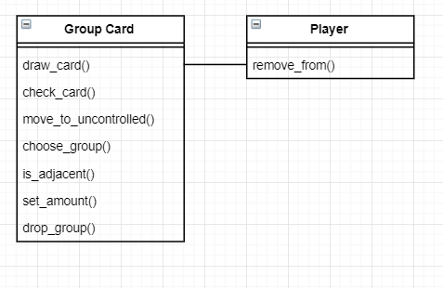

|  |  |  |
| --- | --- | --- |
| USE CASE #15 | Attack to destroy | |
| Goal in Context | Send a target group into the “dead pile” | |
| Scope & Level | Affects opponent any of playing user | |
| Preconditions | User must have chosen action of attack to destroy | |
| Success End Condition | Attack is successful and sends target group to “dead pile” | |
| Failed End Condition | Group is able to defend itself from attack | |
| Primary Actors | User (Player) | |
| Secondary Actors | System, Groups | |
| Trigger | The “Attack to Destroy” option was chosen from menu | |
| DESCRIPTION | Step | Action |
| 1 | User chooses “Attack to Destroy” |
| 2 | User must roll number* or less (*number = attacking Group’s Power – Defending Group’s Resistance) |
| 3 | User (attacker) rolls “Power minus Power” (defending Group defends with Power rather than Resistance) |
| 4 | System sends target Group to “dead pile” (its subordinate groups are not destroyed) |
| 5 | System adds subordinate Groups back to Uncontrolled Groups |
| 6 |  |
| 7 |  |
| 8 |  |
| 9 |  |
| 10 |  |
| 11 |  |
| 12 |  |
| EXTENSIONS | Step | Branching Action |
| 1a | If Special Card “Whispering Campaign” is used with attack on Group with no power: |
| 1a.1 | Rejoin step 2 |
| 1b | If attacking group has opposite alignment: |
| 1b.1 | Attack gets +4 bonus |
| 1b.2 | Rejoin step 2 |
|  |  |
|  |  |
|  |  |
|  |  |
|  |  |
| SUB-VARIATIONS | Step | Branching Action |
| 1 | If powerless Groups are organized where they control other Groups: |
| 1.1 | Attack may fail |
| 2 | If user rolls an 11 or 12: |
| 2.1 | Attack is automatic failure |
| 3 | If attacking group has identical alignment: |
| 3.1 | Attack gets -4 points |
| 4 | Group can be revived by Special card “Media Campaign” |
|  |  |
|  |  |
|  |  |
| RELATED INFORMATION | Use Case #15 | |
| Priority: | High | |
| Performance | 12 hrs. | |
| Frequency | Whenever user decides to attack | |
| Channels to actors | N/A | |
| OPEN ISSUES | Use Cases #2 and #18 must be done before; Menu must be finished beforehand | |
| Due Date | July 03, 2019 | |
| ...any other management information... | N/A | |
| Super ordinates | Use Case #2, Use Case #18 | |
| Subordinates | Use Case #17 | |
| AUTHOR | Yosselin Velasco | |
| Create date | June 11, 2019 | |

