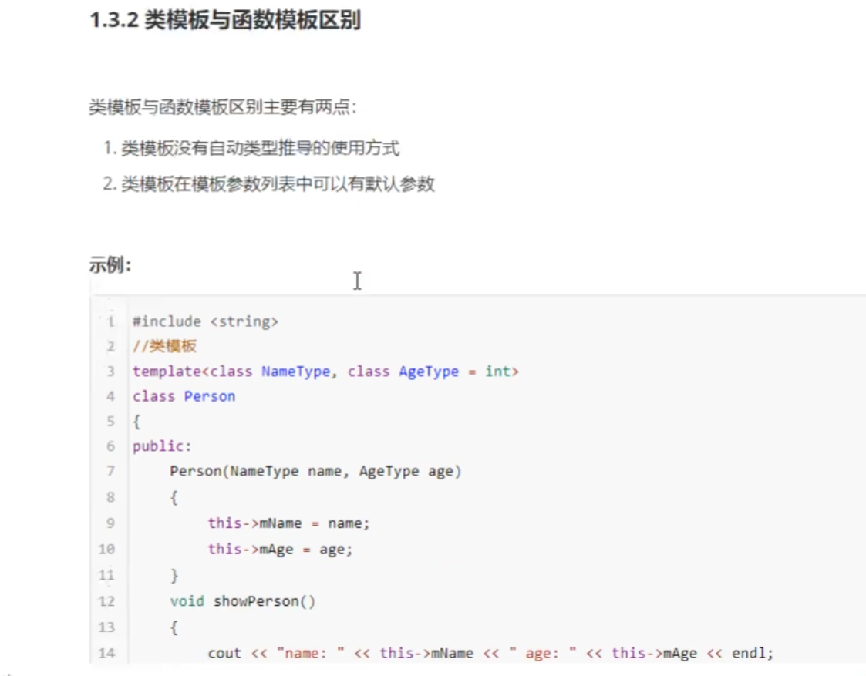
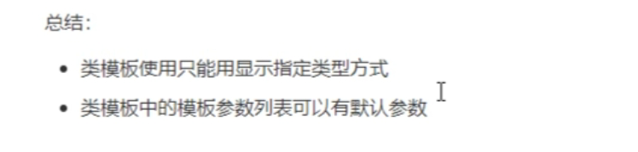
#include <iostream>
using namespace std;
#include <string>
template<class NameType,class AgeType = int >
class Person
{
public:
Person(NameType name, AgeType age)
{
this->m_Age = age;
this->m_Name = name;
}
void showPerson()
{
cout << "name:" << this->m_Name << "age:" << this->m_Age << endl;

}
NameType m_Name;
AgeType m_Age;
};
void test01()
{
Person<string, int>p1("孙悟空", 999);
p1.showPerson();

}

int main()
{
test01();
system("pause");
return 0;
}

