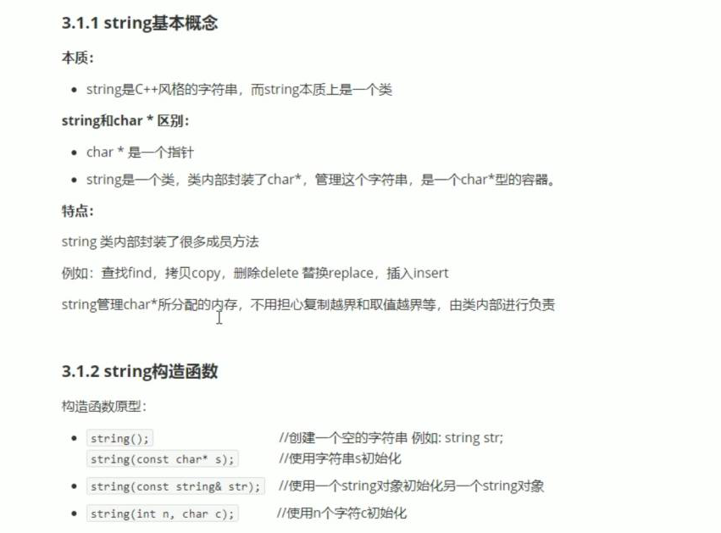
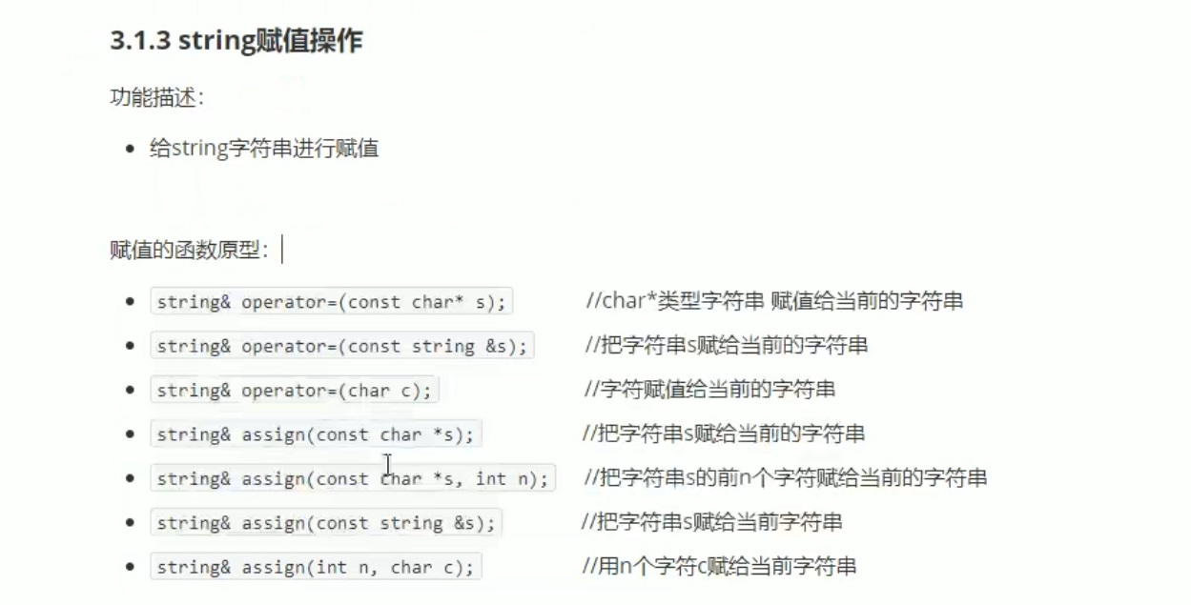
#include <iostream>
using namespace std;
#include <string>
void test01()
{
//string s1;
//const char* str = "hello world";
//string s2(str);
//cout << "s2= " << s2 << endl;
//string s3(10, 'a');
//cout << "s3= " << s3 << endl;
string str1;
str1 = "hello world";
cout << "str1 = " << str1 << endl;
string str2;
str2 = str1;
cout << "str2 = " << str2 << endl;
string str3;
str3.assign("hello world");
cout << "str3 = " << str3 << endl;
}

int main()
{
test01();
system("pause");
return 0;
}
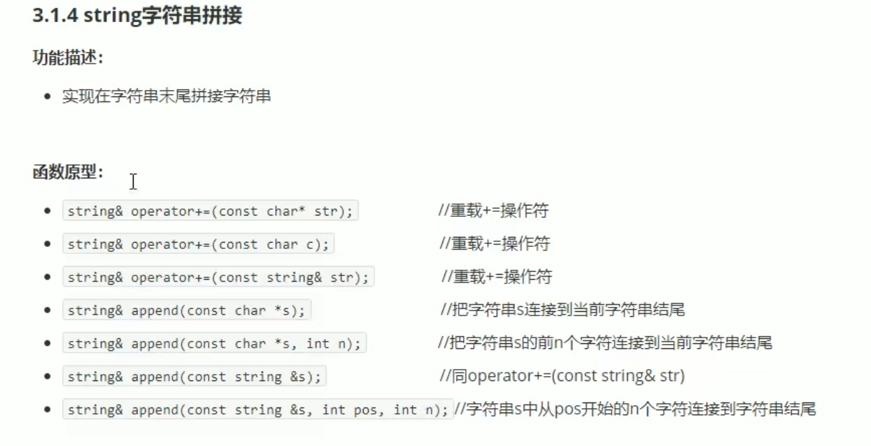

#include <iostream>
using namespace std;
#include <string>
void test01()
{
string str1 = "我";
str1 += "是骚远";
cout << "str1 = " << str1 << endl;
//string str2 = ":";
//str1 += str2;
//cout << "str2 = " << str2 << endl;
//string str3 = "蛇皮";
//str1 += str3;
//cout << "str1 = " << str1 << endl;
//
string str4 = "I";
str4.append(" love");
cout << "str4 = " << str4 << endl;
str4.append(" lovewarff",6);
cout << "str4 = " << str4 << endl;
str4.append(str1);
cout << "str4 = " << str4 << endl;
str4.append(str1, 0 ,4);//第二个是从几开始，第三个是截取几个字节
cout << "str4 = " << str4 << endl;
}
int main()
{
test01();
system("pause");
return 0;
}
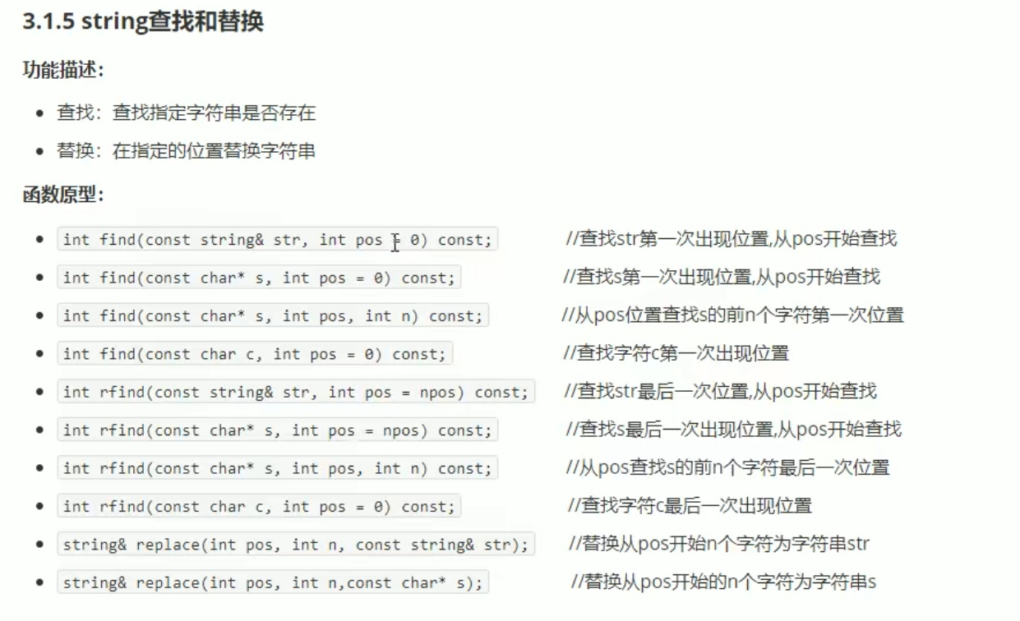
#include <iostream>
using namespace std;
#include <string>
void test01()
{
string str1 = "dawafaignadfa";
int pos = str1.find("fa");
if (pos == -1)
{
cout << "找不到这个字符串。" << endl;
}
else
{
cout << "找到这个字符串， pos = " << pos << endl;
}
//rfind和find 区别：rfind从右往左查，find从左往右查。
int pos1 = str1.rfind("fa");
cout << "pos1 = " << pos1 << endl;
}
void test02()
{
string str1 = "abcdefg";
str1.replace(1, 3, "1111");//从一号位置其3个字符替换为"1111";
cout << "str1 = " << str1 << endl;
}
int main()
{
test01();
test02();
system("pause");
return 0;
}
