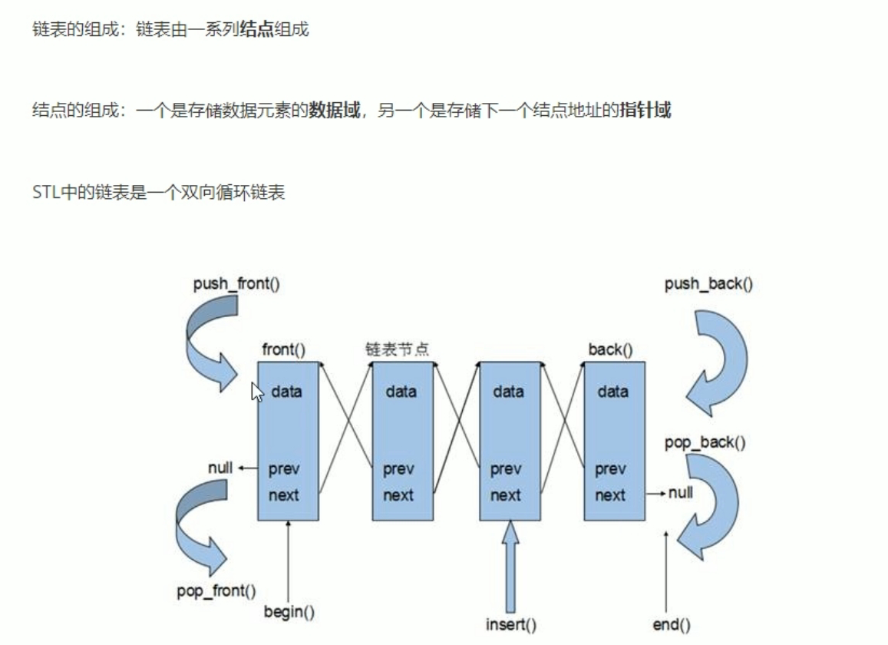

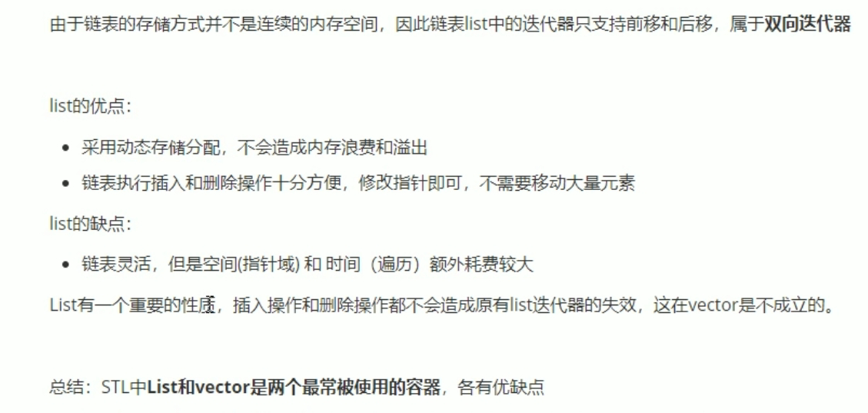

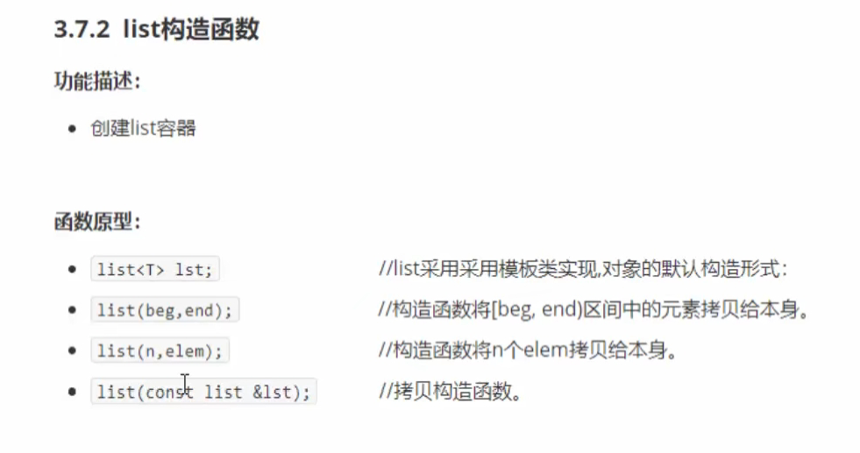

#include <iostream>

using namespace std;

#include <string>

#include <list>

void printList(const list<int>&L)

{

for (list<int>::const_iterator it =L.begin(); it != L.end(); it++)

{

cout << *it << " ";

}

cout << endl;

}

void test01()

{

list<int> L1;

L1.push_back(10);

L1.push_back(20);

L1.push_back(30);

L1.push_back(40);

L1.push_back(50);

printList(L1);

list<int>L2(L1.begin(), L1.end());

printList(L2);

list<int>L3(L2);

printList(L3);

list<int>L4(10,1000);

printList(L4);

}

int main()

{

test01();

system("pause");

return 0;

}

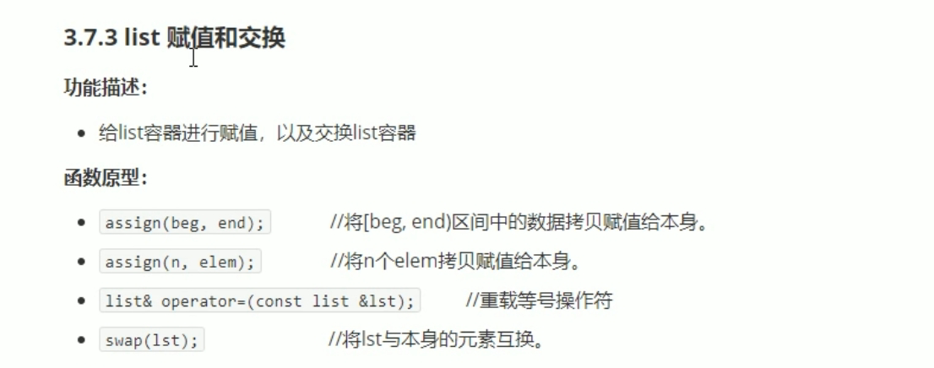

#include <iostream>

using namespace std;

#include <string>

#include <list>

void printList(const list<int>&L)

{

for (list<int>::const_iterator it =L.begin(); it != L.end(); it++)

{

cout << *it << " ";

}

cout << endl;

}

void test01()

{

list<int> L1;

L1.push_back(10);

L1.push_back(20);

L1.push_back(30);

L1.push_back(40);

L1.push_back(50);

printList(L1);

list<int>L2;

L2 = L1;

printList(L2);

list<int>L3;

L3.assign(L2.begin(), L2.end());

printList(L3);

list<int>L4;

L4.assign(9, 100);

printList(L4);

}

void test02()

{

list<int> L1;

L1.push_back(10);

L1.push_back(20);

L1.push_back(30);

L1.push_back(40);

L1.push_back(50);

list<int> L2;

L2.assign(7, 88);

cout << "交换前： " << endl;

printList(L1);

printList(L2);

L1.swap(L2);

cout << "交换后： " << endl;

printList(L1);

printList(L2);

}

int main()

{

test02();

system("pause");

return 0;

}

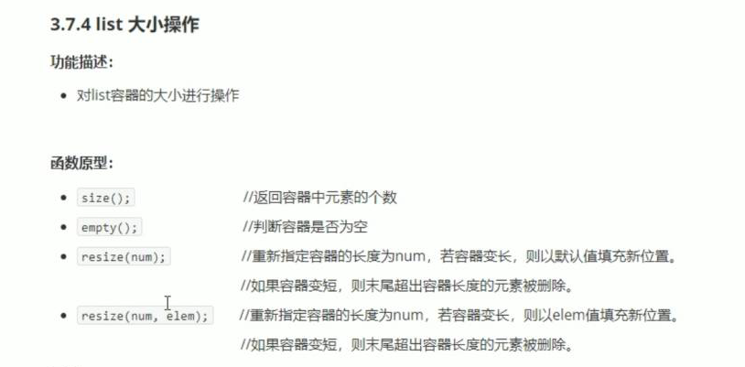





#include <iostream>

using namespace std;

#include <string>

#include<list>

#include<algorithm>

class Person

{

public:

Person(string name, int age, int height)

{

this->m_Name = name;

this->m_Age = age;

this->m_Height = height;

}

string m_Name;

int m_Age;

int m_Height;

};

bool comparePerson(Person &p1, Person &p2)

{

if (p1.m_Age == p2.m_Age)

{

return p1.m_Height > p2.m_Height;

}

else

{

return p1.m_Age < p2.m_Age;

}

return p1.m_Age < p2.m_Age;

}

void test01()

{

list<Person> L;

Person p1("刘备", 45, 200);

Person p2("张飞", 35, 170);

Person p3("关羽", 35, 180);

Person p4("黄忠", 60, 181);

Person p5("赵云", 35, 190);

Person p6("马超", 20, 185);

L.push_back(p1);

L.push_back(p2);

L.push_back(p3);

L.push_back(p4);

L.push_back(p5);

L.push_back(p6);

for (list<Person>::iterator it = L.begin(); it != L.end(); it++)

{

cout << "姓名是： " << (*it).m_Name << " 年龄是 ：" << (*it).m_Age << " 身高是：" << (*it).m_Height << endl;

}

cout << "---------------------------" << endl;

cout << "排序后：" << endl;

L.sort(comparePerson);

for (list<Person>::iterator it = L.begin(); it != L.end(); it++)

{

cout << "姓名是： " << (*it).m_Name << " 年龄是 ：" << (*it).m_Age << " 身高是：" << (*it).m_Height << endl;

}

}

int main()

{

test01();

system("pause");

return 0;

}