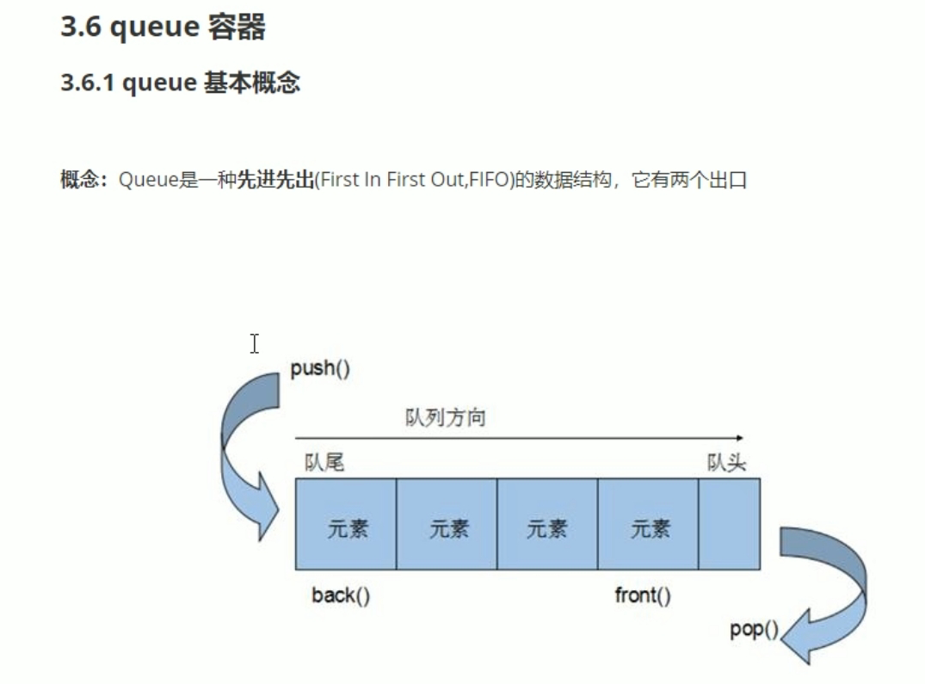

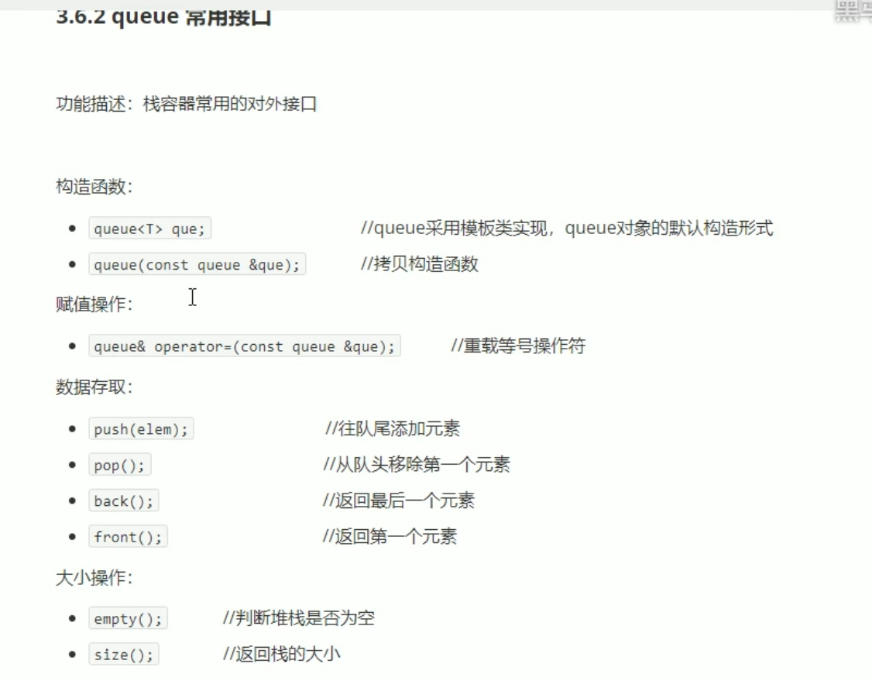

#include <iostream>

using namespace std;

#include <string>

#include <queue>

class Person

{

public:

Person(string name, int age)

{

this->m_Name = name;

this->m_Age = age;

}

string m_Name;

int m_Age;

};

void test01()

{

queue<Person>q;

Person p1("唐僧", 80);

Person p2("孙悟空", 2500);

Person p3("八戒", 30);

Person p4("沙僧", 100);

q.push(p1);

q.push(p2);

q.push(p3);

q.push(p4);

cout << "队列的大小：" << q.size() << endl;

while (!q.empty())

{

cout << "队头元素的姓名：" << q.front().m_Name << "年龄是 ：" << q.front().m_Age << endl;

cout << "队尾元素的姓名：" << q.back().m_Name << "年龄是 ：" << q.back().m_Age << endl;

q.pop();

}

cout << "队列的大小：" << q.size() << endl;

}

int main()

{

test01();

system("pause");

return 0;

}