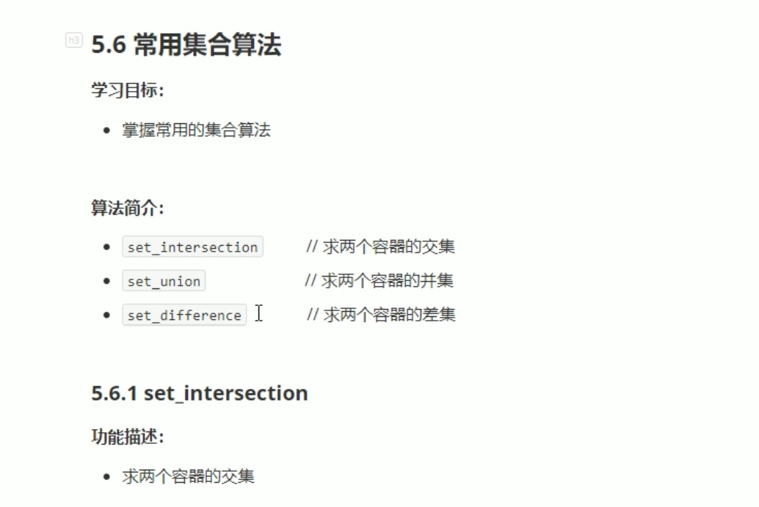

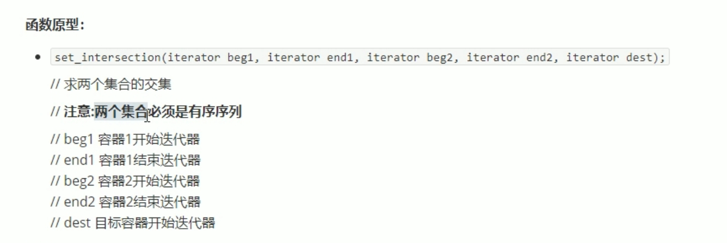

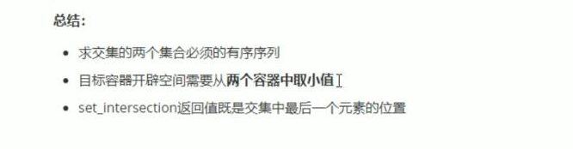

#include <iostream>

using namespace std;

#include <string>

#include <vector>

#include <algorithm>

void myPrint(int val)

{

cout << val << " ";

}

void test01()

{

vector<int> v1;

vector<int> v2;

for (int i = 0; i < 10; i++)

{

v1.push_back(i);

v2.push_back(i + 5);

}

vector<int>vTarget;

vTarget.resize(min(v1.size(),v2.size()));

vector<int>::iterator itEnd = set_intersection(v1.begin(), v1.end(), v2.begin(), v2.end(), vTarget.begin());

for_each(vTarget.begin(), itEnd, myPrint);

cout << endl;

}

int main()

{

test01();

system("pause");

return 0;

}

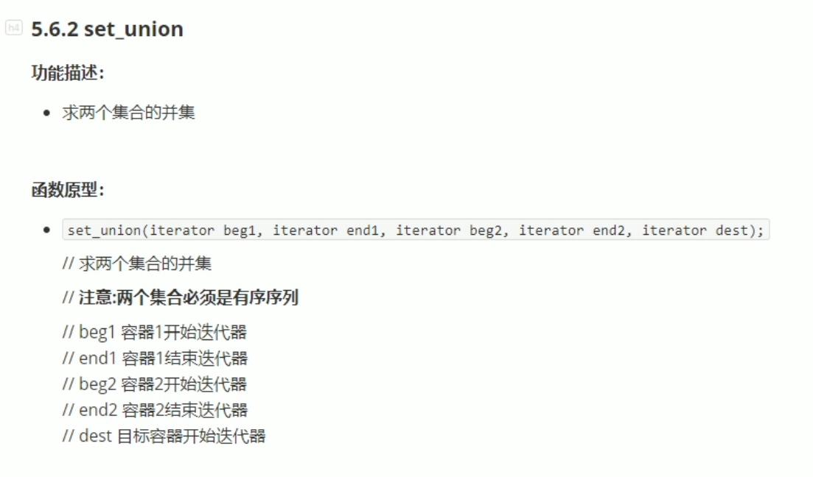

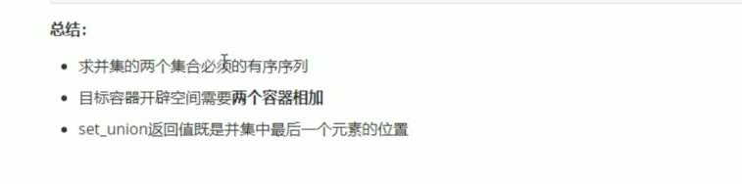

#include <iostream>

using namespace std;

#include <string>

#include <vector>

#include <algorithm>

void myPrint(int val)

{

cout << val << " ";

}

void test01()

{

vector<int> v1;

vector<int> v2;

for (int i = 0; i < 10; i++)

{

v1.push_back(i);

v2.push_back(i + 5);

}

vector<int>vTarget;

vTarget.resize(v1.size()+ v2.size());

vector<int>::iterator itEnd = set_union(v1.begin(), v1.end(), v2.begin(), v2.end(), vTarget.begin());

for_each(vTarget.begin(), itEnd, myPrint);//注意返回的迭代器itEnd。

cout << endl;

}

int main()

{

test01();

system("pause");

return 0;

}

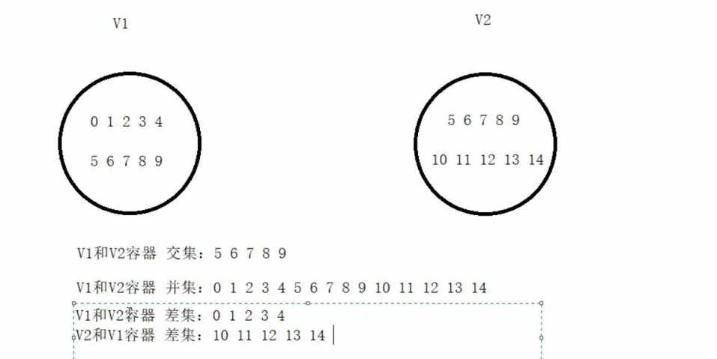

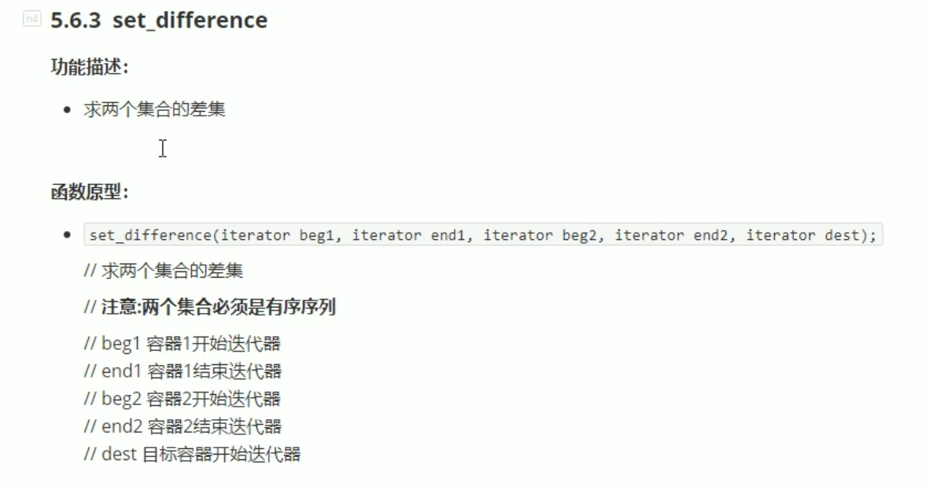

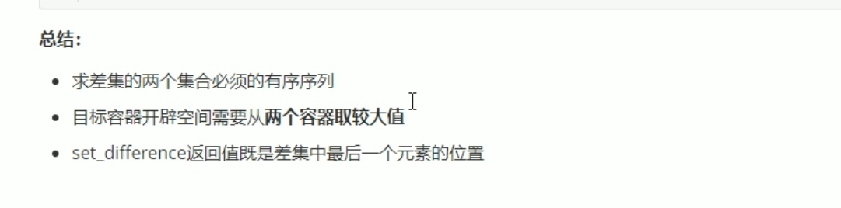

#include <iostream>

using namespace std;

#include <string>

#include <vector>

#include <algorithm>

void myPrint(int val)

{

cout << val << " ";

}

void test01()

{

vector<int> v1;

vector<int> v2;

for (int i = 0; i < 10; i++)

{

v1.push_back(i);

v2.push_back(i + 5);

}

vector<int>vTarget;

vTarget.resize(max(v1.size(), v2.size()));

cout << "v1和v2的差集是： " << endl;

vector<int>::iterator itEnd = set_difference(v1.begin(), v1.end(), v2.begin(), v2.end(), vTarget.begin());

for_each(vTarget.begin(), itEnd, myPrint);//注意返回的迭代器itEnd。

cout << endl;

}

int main()

{

test01();

system("pause");

return 0;

}