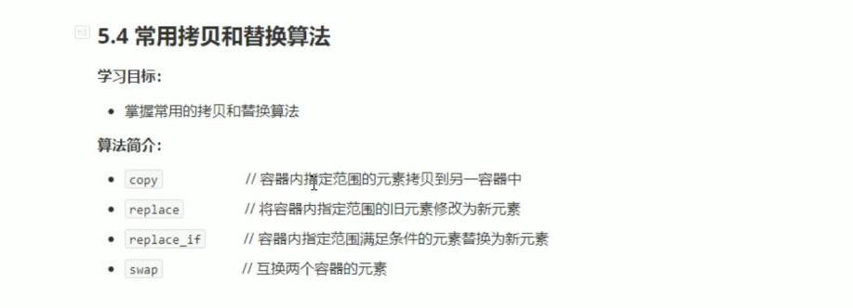

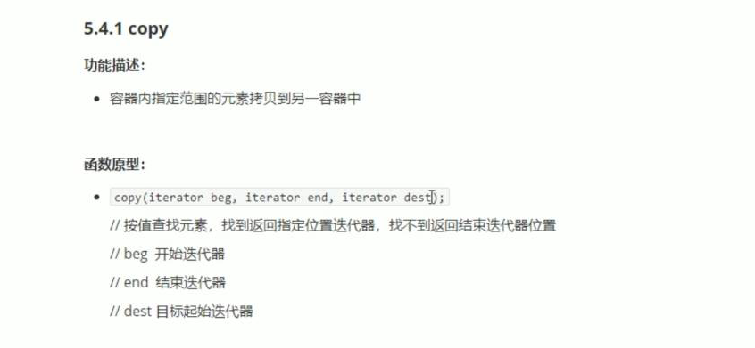



#include <iostream>

using namespace std;

#include <string>

#include<vector>

#include<algorithm>

void myPrint(int val)

{

cout << val << " ";

}

void test01()

{

vector<int> v1;

for (int i = 0; i < 10; i++)

{

v1.push_back(i);

}

vector<int> v2;

v2.resize(v1.size());

copy(v1.begin(), v1.end(), v2.begin());

for_each(v2.begin(), v2.end(), myPrint);

cout << endl;

}

int main()

{

test01();

system("pause");

return 0;

}

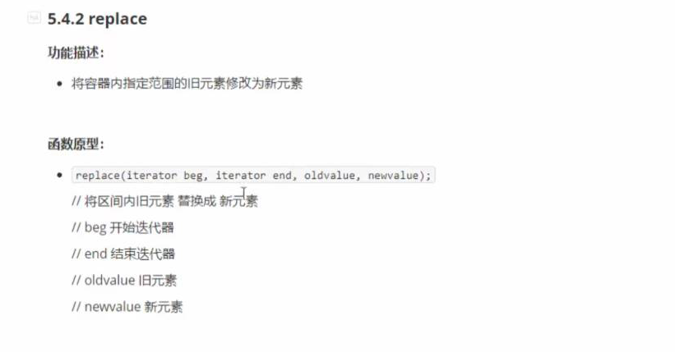

#include <iostream>

using namespace std;

#include <string>

#include<vector>

#include<algorithm>

void myPrint(int val)

{

cout << val << " ";

}

class MyPrint

{

public:

void operator()(int val)

{

cout << val << " ";

}

};

void test01()

{

vector<int> v;

v.push_back(10);

v.push_back(50);

v.push_back(30);

v.push_back(40);

v.push_back(50);

cout << "替换前： " << endl;

for_each(v.begin(), v.end(), MyPrint());

cout << endl;

replace(v.begin(), v.end(), 50, 1000);

cout << "替换后： " << endl;

for_each(v.begin(), v.end(), MyPrint());

cout << endl;

}

int main()

{

test01();

system("pause");

return 0;

}

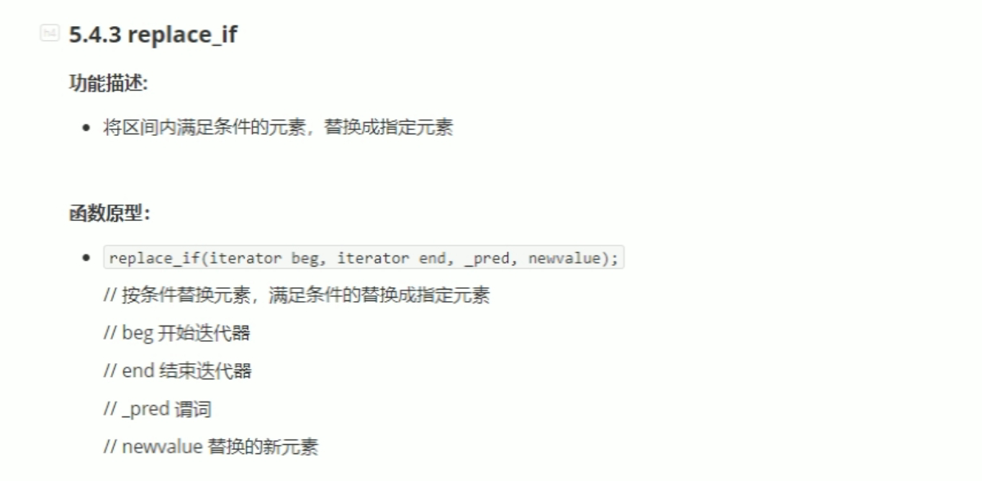#include <iostream>

using namespace std;

#include <string>

#include<vector>

#include<algorithm>

class MyPrint

{

public:

void operator()(int val)

{

cout << val << " ";

}

};

class Greater20

{

public:

bool operator()(int val)

{

return val > 20;

}

};

void test01()

{

vector<int> v;

v.push_back(10);

v.push_back(50);

v.push_back(30);

v.push_back(40);

v.push_back(50);

cout << "替换前： " << endl;

for_each(v.begin(), v.end(), MyPrint());

cout << endl;

replace_if(v.begin(), v.end(), Greater20(),2000);

cout << "替换后： " << endl;

for_each(v.begin(), v.end(), MyPrint());

cout << endl;

}

int main()

{

test01();

system("pause");

return 0;

}

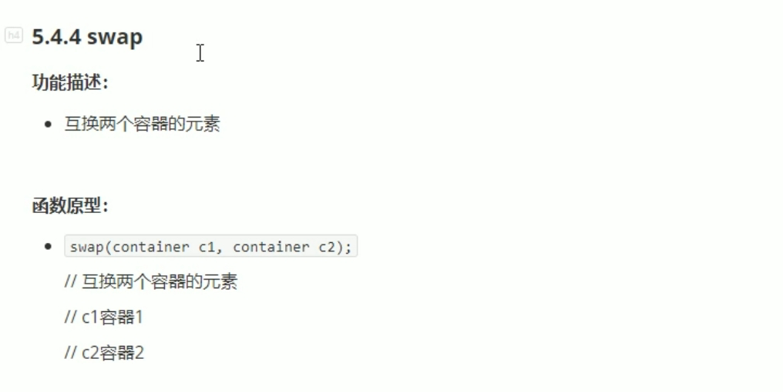

同种类型交换。

#include <iostream>

using namespace std;

#include <string>

#include <vector>

#include <algorithm>

void myPrint(int val)

{

cout << val << " ";

}

void test01()

{

vector<int> v1;

vector<int> v2;

for (int i = 0; i < 10; i++)

{

v1.push_back(i);

v2.push_back(i + 100);

}

cout << "交换前 ：" << endl;

for_each(v1.begin(), v1.end(), myPrint);

cout << endl;

for_each(v2.begin(), v2.end(), myPrint);

cout << endl;

cout << "----------------" << endl;

swap(v1, v2);

cout << "交换后 ：" << endl;

for_each(v1.begin(), v1.end(), myPrint);

cout << endl;

for_each(v2.begin(), v2.end(), myPrint);

cout << endl;

}

int main()

{

test01();

system("pause");

return 0;

}