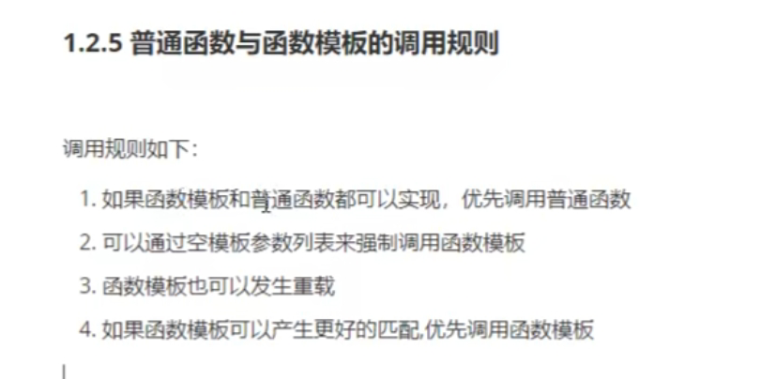



#include <iostream>

using namespace std;

#include <string>

void myPrint(int a, int b)

{

cout << "调用的普通函数" << endl;

}

template<class T>

void myPrint(T a, T b)

{

cout << "调用的函数模板" << endl;

}

template<class T>

void myPrint(T a, T b,T c)

{

cout << "调用的重载函数模板" << endl;

}

void test01()

{

int a = 10;

int b = 20;

myPrint(a, b);

myPrint<>(a, b);

myPrint(a, b,100);

char c1 = 'a';

char c2 = 'b';

myPrint(c1, c2);

}

int main()

{

test01();

system("pause");

return 0;

}