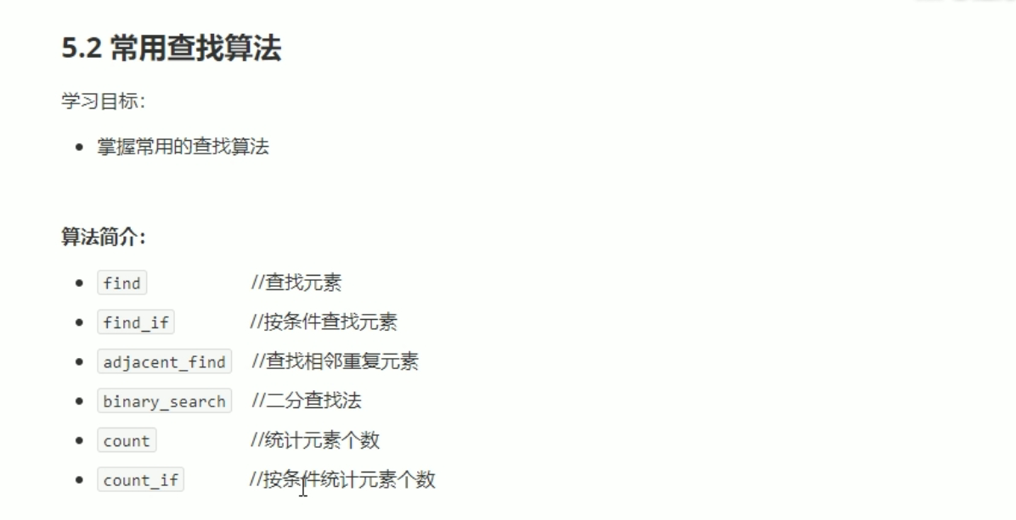

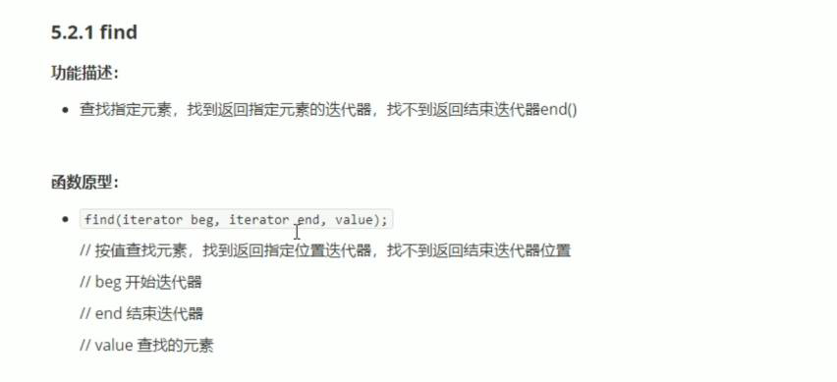

#include <iostream>

using namespace std;

#include <string>

#include<vector>

#include<algorithm>

void test01()

{

vector<int> v;

for (int i = 0; i < 10; i++)

{

v.push_back(i);

}

vector<int> ::iterator it= find(v.begin(), v.end(), 50);

if (it == v.end())

{

cout << "没有找到。" << endl;

}

else

{

cout << "找到了： " << *it << endl;

}

}

class Person

{

public:

Person(string name, int age)

{

this->m_Age = age;

this->m_Name = name;

}

//重载 == 底层find 不知道如何比较Person中的两个数据类型。

bool operator == (const Person &p)

{

if (this->m_Name == p.m_Name &&this->m_Age == p.m_Age)

{

return true;

}

else

{

return false;

}

}

string m_Name;

int m_Age;

};

void test02()

{

vector<Person> v;

Person p1("aaa", 10);

Person p2("bbb", 20);

Person p3("ccc", 30);

Person p4("ddd", 40);

Person p5("fff", 50);

v.push_back(p1);

v.push_back(p2);

v.push_back(p3);

v.push_back(p4);

v.push_back(p5);

vector<Person>::iterator it = find(v.begin(), v.end(), p2);

if (it == v.end())

{

cout << "没有找到。" << endl;

}

else

{

cout << "找到了：姓名 " << (*it).m_Name<<"年龄："<<(*it).m_Age<< endl;

}

}

int main()

{

test02();

system("pause");

return 0;

}

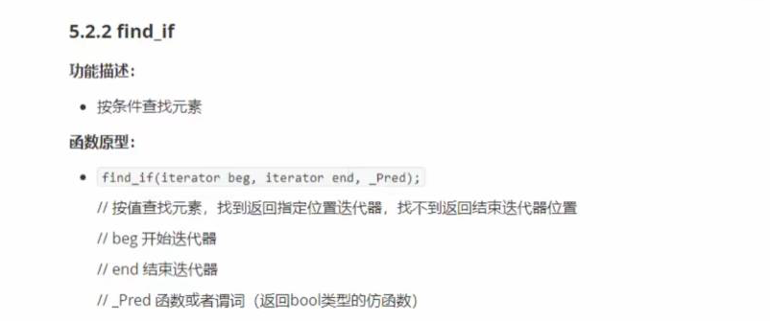

#include <iostream>

using namespace std;

#include <string>

#include<vector>

#include<algorithm>

class GreaterFive

{

public:

bool operator()(int val)

{

return val > 5;

}

};

void test01()

{

vector<int> v;

for (int i = 0; i < 10; i++)

{

v.push_back(i);

}

vector<int>::iterator it = find_if(v.begin(), v.end(), GreaterFive());

if (it == v.end())

{

cout << "没找到。" << endl;

}

else

{

cout << "找到大于5的数: " << *it << endl;

}

}

class Person

{

public:

Person(string name, int age)

{

this->m_Age = age;

this->m_Name = name;

}

string m_Name;

int m_Age;

};

class Greater20

{

public:

bool operator()(Person &p)

{

return p.m_Age > 20;

}

};

void test02()

{

vector<Person> v;

Person p1("aaa", 10);

Person p2("bbb", 20);

Person p3("ccc", 30);

Person p4("ddd", 40);

Person p5("fff", 50);

v.push_back(p1);

v.push_back(p2);

v.push_back(p3);

v.push_back(p4);

v.push_back(p5);

vector<Person>::iterator it = find_if(v.begin(), v.end(), Greater20());

if (it == v.end())

{

cout << "没找到。" << endl;

}

else

{

cout << "找到大于20的年龄的姓名： " << it->m_Name << endl;

}

}

int main()

{

test02();

system("pause");

return 0;

}

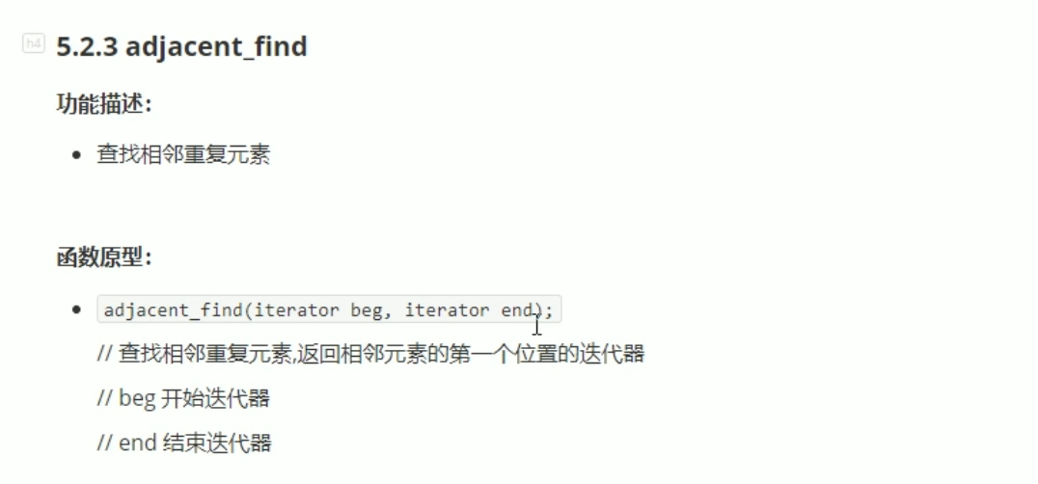

#include <iostream>

using namespace std;

#include <string>

#include <vector>

#include <algorithm>

void test01()

{

vector<int> v;

v.push_back(2);

v.push_back(0);

v.push_back(3);

v.push_back(3);

v.push_back(1);

v.push_back(9);

vector<int> ::iterator pos = adjacent_find(v.begin(), v.end());

if (pos == v.end())

{

cout << "未找到相邻重复元素。" << endl;

}

else

{

cout << "找到相邻重复元素。" << *pos << endl;

}

}

int main()

{

test01();

system("pause");

return 0;

}

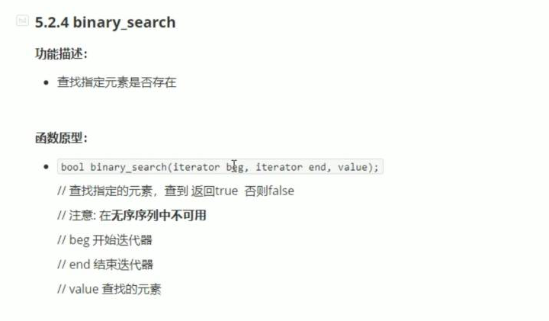

#include <iostream>

using namespace std;

#include <string>

#include <vector>

#include <algorithm>

void test01()

{

vector<int> v;

for (int i = 0; i < 10; i++)

{

v.push_back(i);

}

//容器下必须是有序的序列。如果无序，结果未知。

bool ret = binary_search(v.begin(), v.end(),5);

if (ret)

{

cout << "找到相邻重复元素。" << endl;

}

else

{

cout << "未找到相邻重复元素。" << endl;

}

}

int main()

{

test01();

system("pause");

return 0;

}

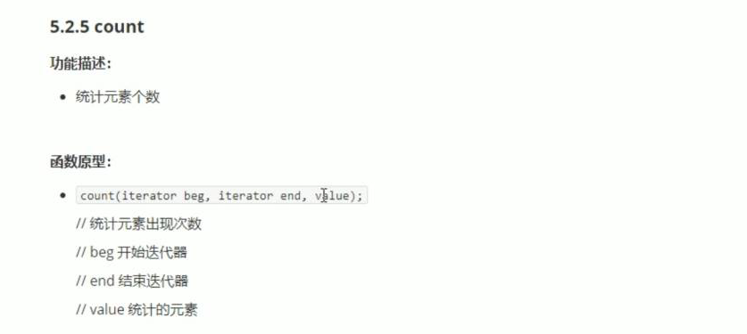

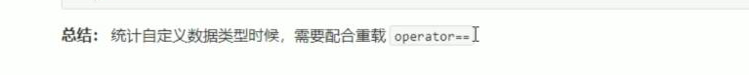

#include <iostream>

using namespace std;

#include <string>

#include <vector>

#include <algorithm>

void test01()

{

vector<int> v;

v.push_back(10);

v.push_back(50);

v.push_back(30);

v.push_back(40);

v.push_back(50);

int num = count(v.begin(), v.end(), 50);

cout << "50的个数为： " << num << endl;

}

class Person

{

public:

Person(string name, int age)

{

this->m_Age = age;

this->m_Name = name;

}

bool operator == ( const Person &p)

{

if (this->m_Age == p.m_Age)

{

return true;

}

else

{

return false;

}

}

string m_Name;

int m_Age;

};

void test02()

{

vector<Person> v;

Person p1("刘备", 30);

Person p2("关羽", 20);

Person p3("张飞", 20);

Person p4("赵云", 25);

Person p5("黄忠", 60);

v.push_back(p1);

v.push_back(p2);

v.push_back(p3);

v.push_back(p4);

v.push_back(p5);

Person p("诸葛亮", 20);

int num = count(v.begin(), v.end(),p);

cout << "和诸葛亮一样岁数的人： " << num << endl;

}

int main()

{

test02();

system("pause");

return 0;

}

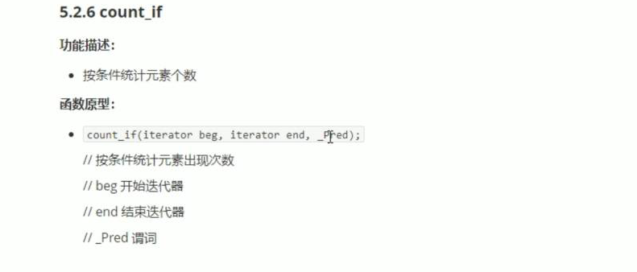

#include <iostream>

using namespace std;

#include <string>

#include <vector>

#include <algorithm>

class Greater20

{

public:

bool operator()(int val)

{

return val > 20;

}

};

void test01()

{

vector<int> v;

v.push_back(10);

v.push_back(50);

v.push_back(30);

v.push_back(40);

v.push_back(50);

int num = count_if(v.begin(), v.end(), Greater20());

cout << "大于20的个数为： " << num << endl;

}

class Person

{

public:

Person(string name, int age)

{

this->m_Age = age;

this->m_Name = name;

}

bool operator == ( const Person &p)

{

if (this->m_Age == p.m_Age)

{

return true;

}

else

{

return false;

}

}

string m_Name;

int m_Age;

};

class AgeGreater20

{

public:

bool operator()(const Person&p)

{

return p.m_Age > 20;

}

};

void test02()

{

vector<Person> v;

Person p1("刘备", 30);

Person p2("关羽", 20);

Person p3("张飞", 20);

Person p4("赵云", 25);

Person p5("黄忠", 60);

v.push_back(p1);

v.push_back(p2);

v.push_back(p3);

v.push_back(p4);

v.push_back(p5);

int num = count_if(v.begin(), v.end(), AgeGreater20());

cout << "年龄大于25的人数目： " << num << endl;

}

int main()

{

test02();

system("pause");

return 0;

}