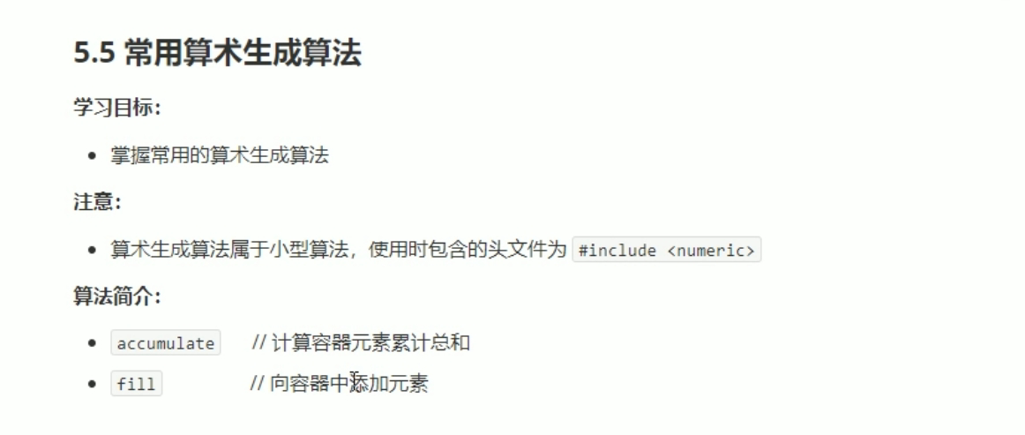

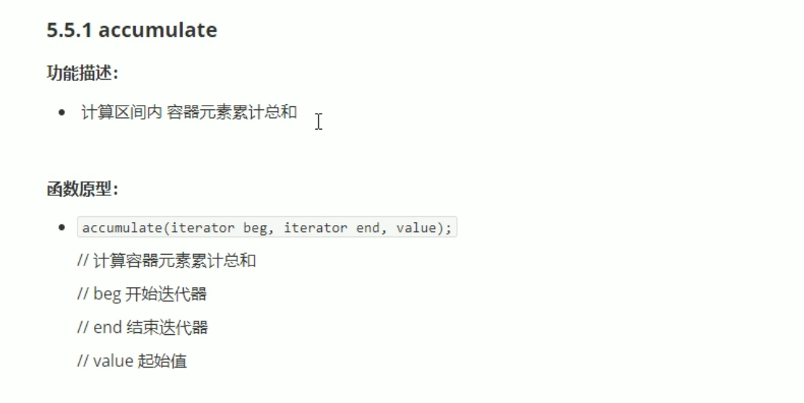

#include <iostream>

using namespace std;

#include <string>

#include <vector>

#include<numeric>

void myPrint(int val)

{

cout << val << " ";

}

void test01()

{

vector<int> v1;

vector<int> v2;

for (int i = 0; i <= 100; i++)

{

v1.push_back(i);

}

int total = accumulate(v1.begin(), v1.end(), 100);//起使累加值，总和加上 100

cout << "total = " << total << endl;

}

int main()

{

test01();

system("pause");

return 0;

}

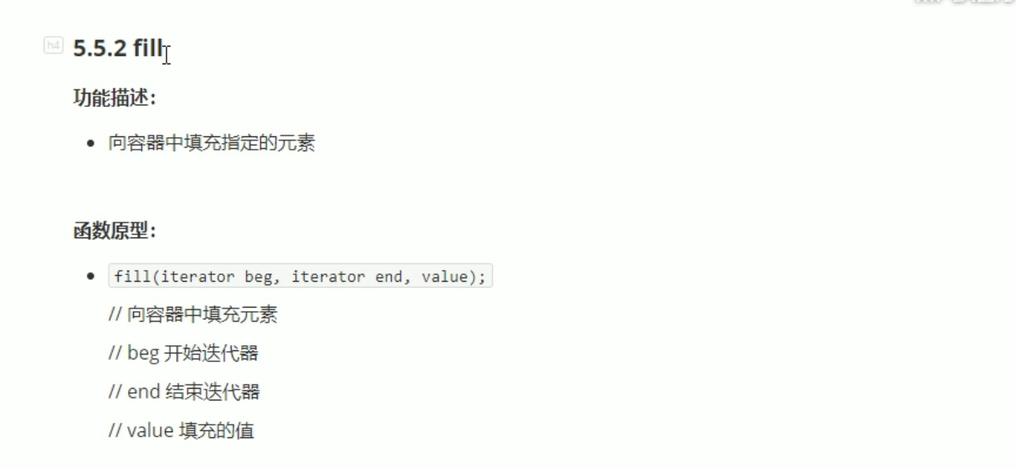

#include <iostream>

using namespace std;

#include <string>

#include <vector>

#include<numeric>

#include<algorithm>

void myPrint(int val)

{

cout << val << " ";

}

void test01()

{

vector<int> v1;

v1.resize(10);

cout << "填充前： " << endl;

for_each(v1.begin(), v1.end(), myPrint);

fill(v1.begin(), v1.end(), 100);//填充指定值100.

cout << endl;

cout << "填充后： " << endl;

for_each(v1.begin(), v1.end(), myPrint);

cout << endl;

}

int main()

{

test01();

system("pause");

return 0;

}