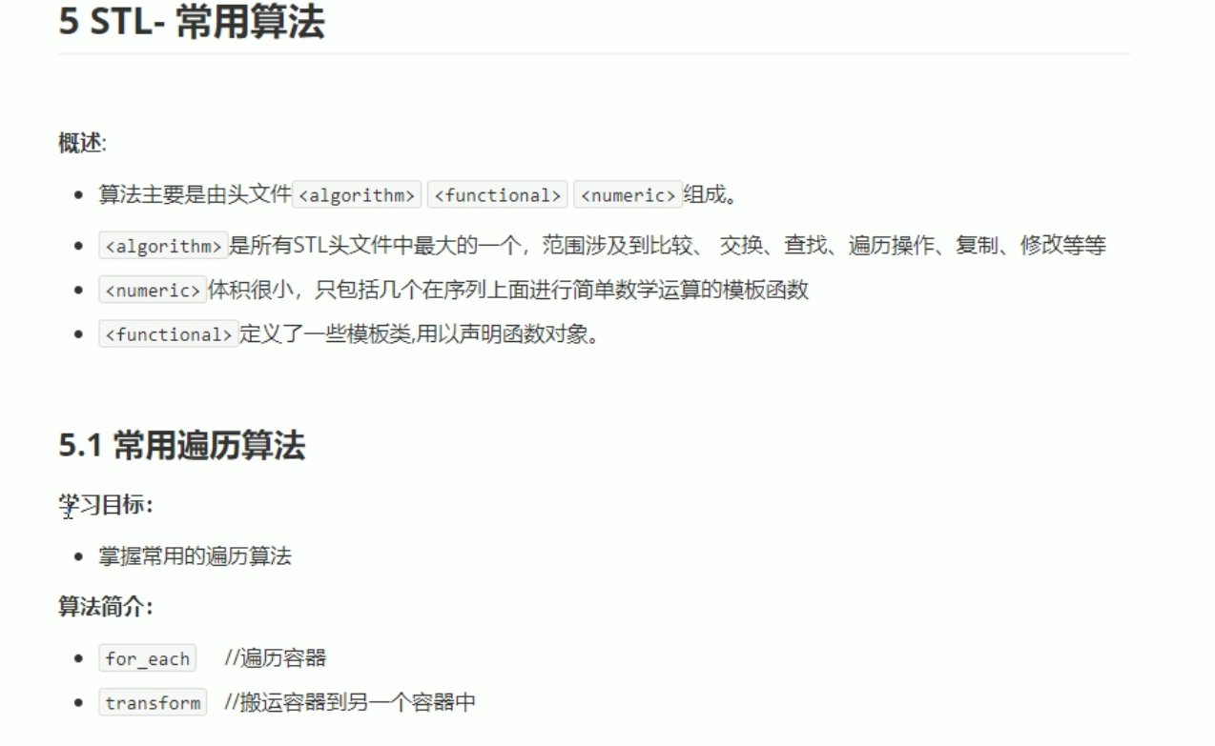

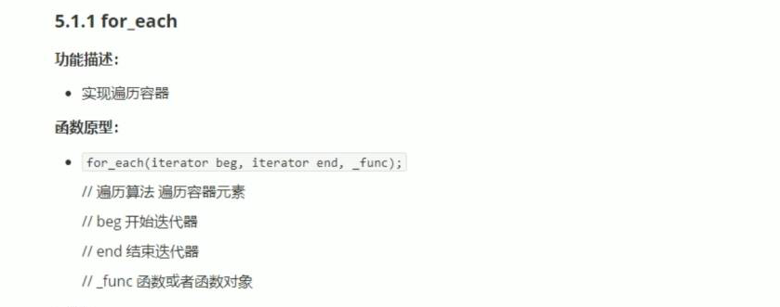

#include <iostream>

using namespace std;

#include <string>

#include <vector>

#include<algorithm>

void print01(int val)

{

cout << val << " ";

}

class print02

{

public:

void operator()(int val)

{

cout << val << " ";

}

};

void test01()

{

vector<int> v;

for (int i = 0; i < 10; i++)

{

v.push_back(i);

}

for_each(v.begin(), v.end(), print01);

cout << endl;

for_each(v.begin(), v.end(), print02());

cout << endl;

}

int main()

{

test01();

system("pause");

return 0;

}

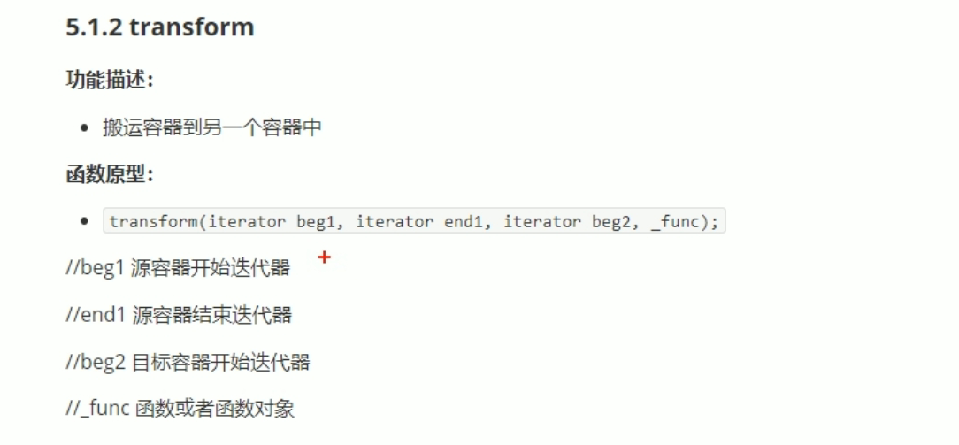

#include <iostream>

using namespace std;

#include <string>

#include <vector>

#include<algorithm>

#include<functional>

class TransForm

{

public:

int operator()(int v)

{

return v +1000;

}

};

class MyPrint

{

public:

void operator()(int val)

{

cout << val << " ";

}

};

void test01()

{

vector<int> v;

for (int i = 0; i < 10; i++)

{

v.push_back(i);

}

vector<int>vTarget;

vTarget.resize(v.size());//开辟空间

transform(v.begin(), v.end(), vTarget.begin(), TransForm());

for_each(vTarget.begin(), vTarget.end(), MyPrint());

cout << endl;

}

int main()

{

test01();

system("pause");

return 0;

}