**4. Purposes in medical field and advancements**   
  
**Research part**: Compared to MRI, fMRI gives the scientists a way to understand how the brain is working instead of how it has been designed. Nowadays, Brain scientist can draw a brain map briefly introduce all the parts in a human's brain is doing what kind of job.

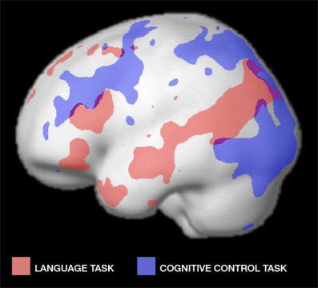

<https://www.sciencedaily.com/releases/2011/08/110830102554.htm>

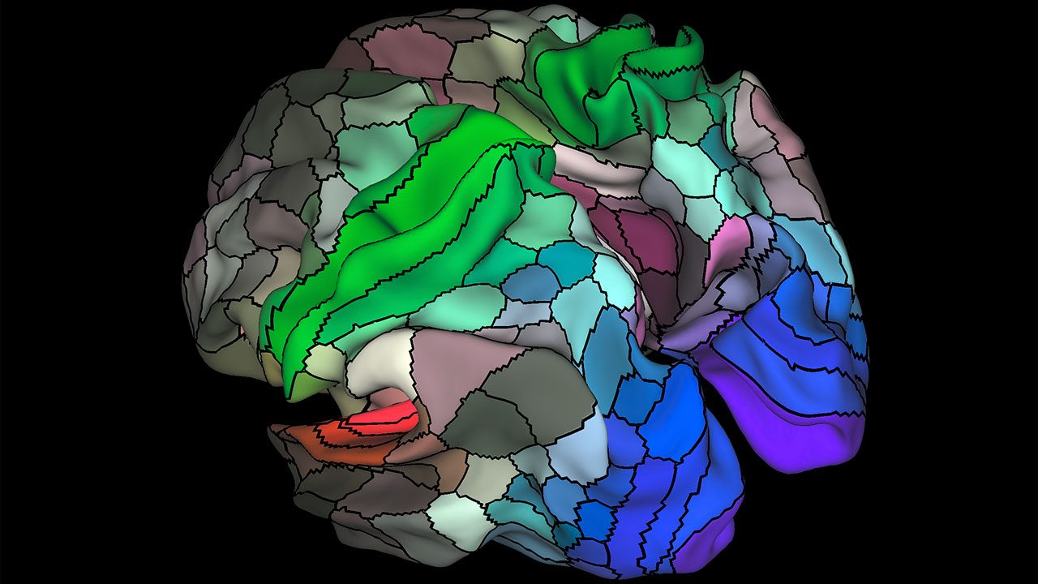

<http://www.sciencemag.org/news/2016/07/updated-human-brain-map-reveals-nearly-100-new-regions>

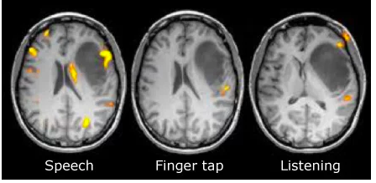

https://www.jameco.com/Jameco/workshop/HowItWorks/what-is-an-fmri-scan-and-how-does-it-work.html  
 **Medical field**:  Medical field:  It provided a functional way to assess patient’s brain, which is useful to plan for surgery and radiation therapy of the brain, and also can help to detect the effects of stroke and brain injury, or diseases such as Alzheimer's, which is useful in developing the future treatment program.  
 **https://www.radiologyinfo.org/en/info.cfm?**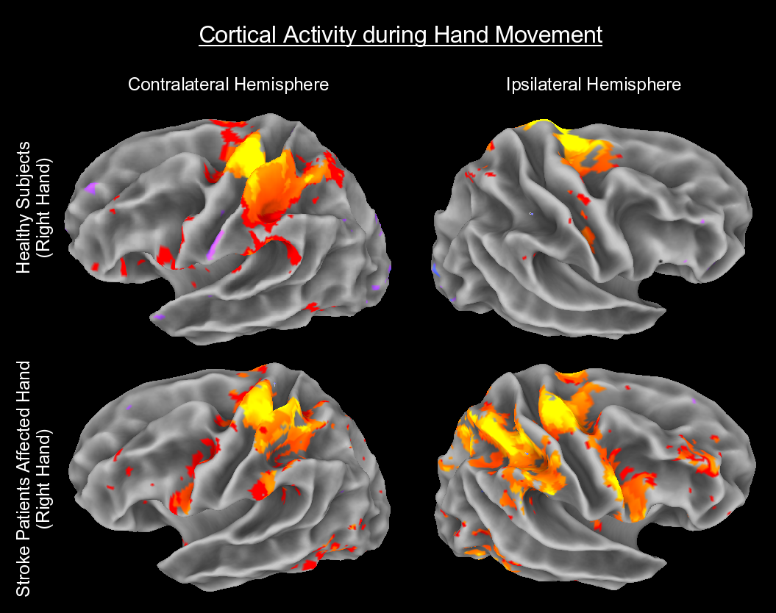

**A normal brain compared to a patient brain (with stroke), differences has been colored.**

**http://www.martinos.org/neurorecovery/technology.htm**

**Flaw and improvement:**In the research part, brain activity is continuously, but the whole fMRI progress will take 5 to 10 minutes, this will cause the research loss time effectiveness and make it is hard to control variable.

For example, when we are exposed to odors in the environment, we may instantly smell and recognize these odors. So if the scientist wants to study how the smell signal passed in the brain, they must constantly collect how the bold oxygen level is changing in a very short time period. However, the fMRI such long progress since it analyzes our brain by the slice to slice, this cause the result is not that accurate.

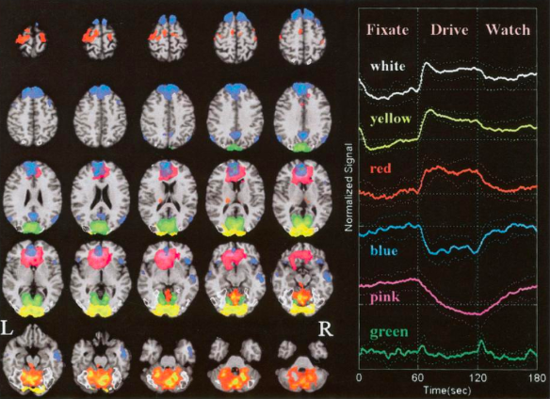

<https://psychology.stackexchange.com/questions/19505/visualization-of-ica-independent-component-analysis-results-to-the-brain-spati>

In the medical field, since the brain, medical science is not well developed yet, and the patients always have a noticeable individual difference, thus cause the information collected by fMRI is not that valuable and can not be used as reliable evidence when making treatment program.

<https://link.springer.com/protocol/10.1007%2F978-1-59745-520-6_12>

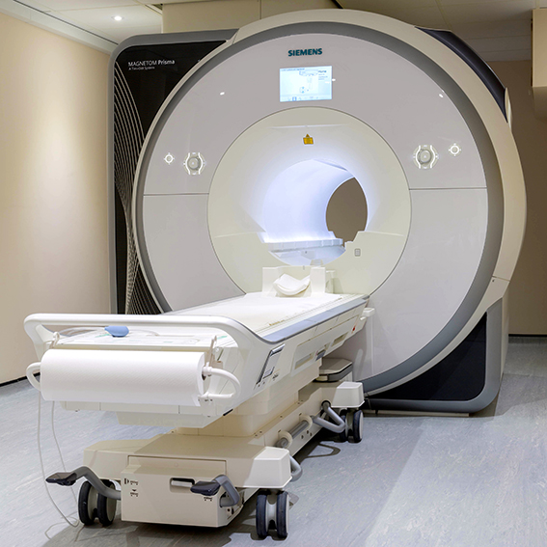<https://www.ndcn.ox.ac.uk/divisions/fmrib/what-is-fmri/introduction-to-fmri>

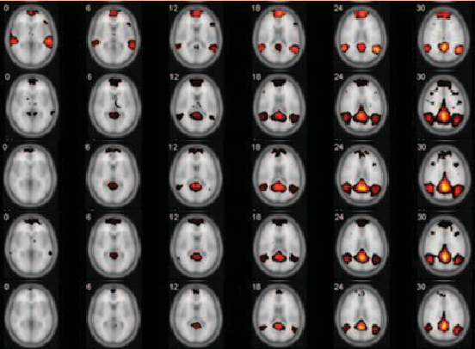

<https://www.semanticscholar.org/paper/Resting-state-fMRI-analysis-of-Alzheimer%27s-disease-Lee-Ye/2206c6202da5126d8e8ad14c33faba3874567888/figure/2>

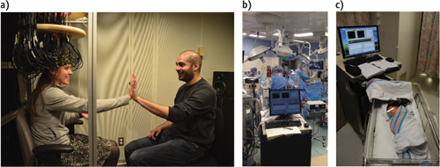

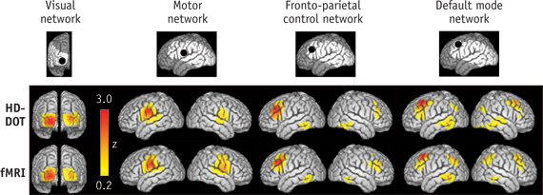

[Optical neuroimaging](https://www.bioopticsworld.com/articles/print/volume-7/issue-3/departments/biooptics-breakthroughs/neuroimaging-photoacoustics-photoacoustics-enables-high-res-functional-connectivity-imaging-of-the-mouse-brain.html) offers a portable, inexpensive, and noninvasive alternative that is radiation-free and compatible with implanted metal and electronic devices. Optical methods use [near-infrared spectroscopy (NIRS](https://www.bioopticsworld.com/articles/2014/06/portable-brain-mapping-device-uses-nir-spectroscopy-to-assess-ptsd.html)), a safe technique (employed in pulse oximeters) that measures light absorption at multiple

Neuronal activity in the brain results in a cascade of processes that locally increases cerebral blood flow and alters the relative concentrations of oxygenated (HbO) and deoxygenated (HbR) blood. This altered balance of HbO and HbR provides the blood-oxygen-level-dependent (BOLD) signal measured with fMRI.5Thus, the optical spectroscopy of blood by [NIRS](https://www.bioopticsworld.com/topics/near-infrared-spectroscopy.htm) provides a window into brain function similar to that offered by fMRI. Traditional functional NIRS (fNIRS) imaging uses sparse arrangements of NIR photon source-detector measurements that have significantly lower spatial resolution than fMRI. Recent developments in high-density diffuse optical tomography (HD-DOT), which uses multiple overlapping NIRS measurements, have provided dramatically improved resolution and brain sensitivity.6

<https://www.bioopticsworld.com/articles/print/volume-7/issue-4/features/high-density-diffuse-optical-tomography-imaging-distributed-function-and-networks-in-the-human-brain.html>

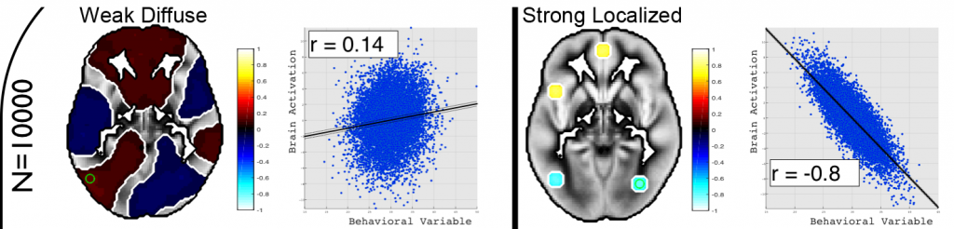

https://blogs.plos.org/neuro/2018/01/08/can-we-trust-statistics-in-fmri-studies/