>#Assigment 2

>#30613017 Yuan Gnegyao

>#Qusetion 1

>##a

>air <- read.csv("airfare.csv")

>pairs(~fare + pass + lead_share + lead_fare + low_share + low_fare,data = air)

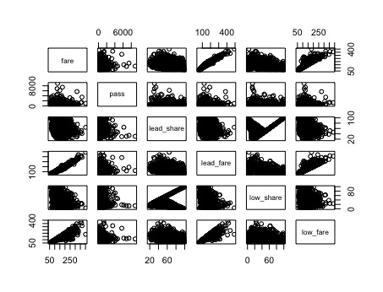

The distinct diagonal line shows there a linear relationship between lead airline and low airline, this probably because customers prefer lead airline when there exist lead airline(lead has market share), so the low share will decrease when lead airline increase.