PharmaDB Report

ISE305 Database Systems Project Term

Yağız Gürdamar

150190211

Description Of PharmaDB

Pharmadb is a database system that facilitates data entry for pharmacists. There are admin information, customer information, sales information and product information in the system. Through the console, the admin can add, delete or see any information they want. While doing these, it gives the privilege to operate on each column.

Functional Dependencies

med_ID -🡪 med_cat, name, descrip, price

phar_ID 🡪 fname, lname, gender, admin_mail, admin_pass, contact

cost_ID 🡪 fname, lname, gender, age, contact, cost_mail, cost_pass

sales_ID 🡪 phar_ID, cost_ID, med_ID, count, date, total_amount

Normalization Steps

When I set up my diagram, it was already in 2NF format because there was no multi value to add to the column. I also transferd the 2NF version to phpmyadmin because if I wanted to make the number of tables 3NF, the code I would write would be complicated and complex.



2NF table as you can see here. To make it 3NF, the following logic is valid. We can only access admin pass from admin mail, so mail and password can be in a separate table. Likewise for the password and mail in the costumer table. We can add cost_ID and phar_ID to them as foregin keys and create new tables.

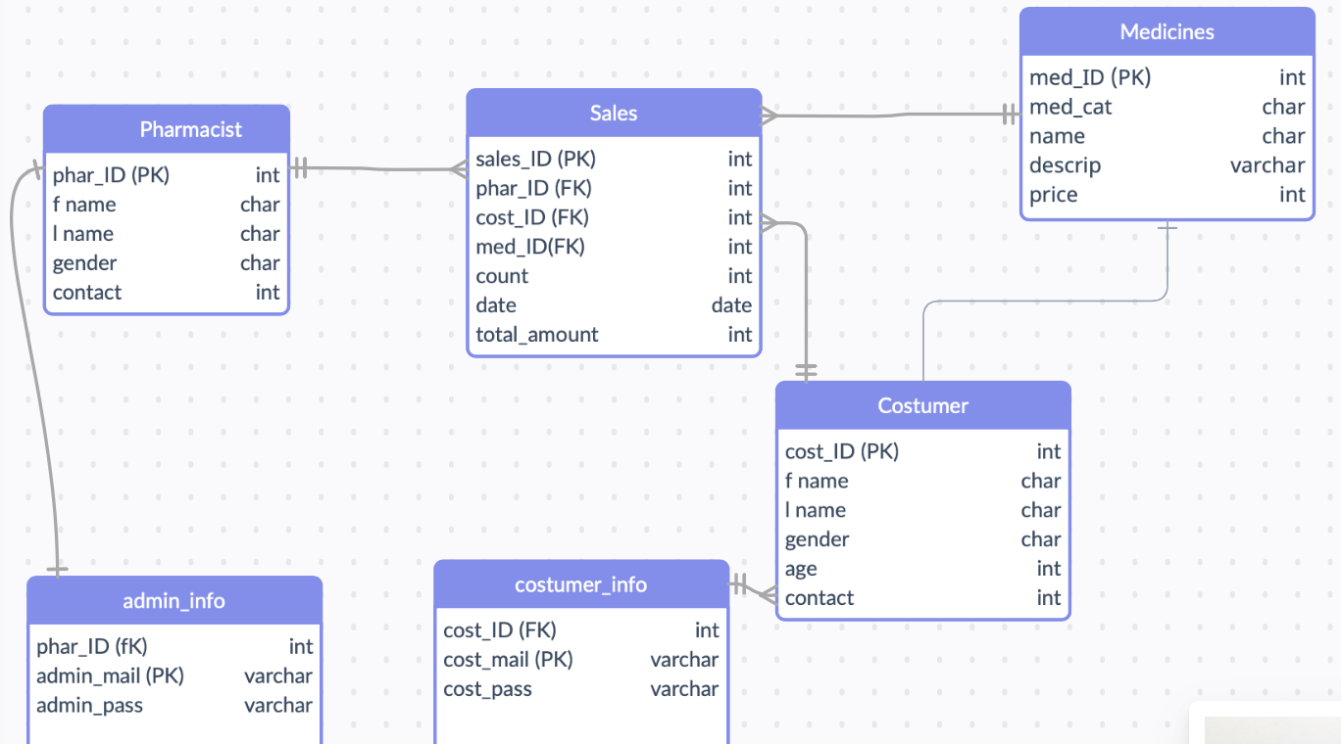

E-R Diagram

Sales

costumer

contains

pharmacist

medicines

Application Details

I chose the language that I used for the project according to the language I have the most command, and it was python. The application controlled via PyCharm was designed with object-oriented programming logic. I connected to Php Myadmin via mamp as a database and created my tables there. I connected my python code and my database with the mysql connector library. I have 4 main functions. One is the menu function and the others are the insert, update and delete functions. I used the try except commands to avoid any errors or to handle them if I do.