项目说明：
1.创建数据库fy_web
2.在Eclipse中创建动态Web项目fy_web
3.在Eclipse中发布和运行项目，会在数据库中自动创建表user
4.为了方便测试，手动在user表插入一条记录
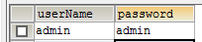

为了测试方便，可以通过SQL语句插入一些初始数据：
insert into category (cid, cname, pid)values(1,'简介',null);
insert into category (cid, cname, pid)values(2,'规划',null);
insert into category (cid, cname, pid)values(3,'机构',null);
insert into category (cid, cname, pid)values(4,'研创',null);
insert into category (cid, cname, pid)values(5,'成果',null);
insert into category (cid, cname, pid)values(6,'合作',null);
insert into category (cid, cname, pid)values(7,'交流',null);
insert into category (cid, cname, pid)values(8,'分类八',null);
insert into category (cid, cname, pid)values(9,'分类九',null);
insert into category (cid, cname, pid)values(101,'非遗资讯',null);
insert into category (cid, cname, pid)values(102,'学术交流',null);
insert into category (cid, cname, pid)values(103,'非遗聚焦',null);
insert into category (cid, cname, pid)values(104,'非遗讲坛',null);
insert into category (cid, cname, pid)values(105,'非遗传人',null);
insert into category (cid, cname, pid)values(106,'合作平台',null);
insert into category (cid, cname, pid)values(107,'分类七',null);
insert into category (cid, cname, pid)values(108,'分类八',null);
insert into category (cid, cname, pid)values(109,'分类九',null);

insert into user(userName, password)values('admin','admin');

5.启动项目后，进入登录页面进行测试：

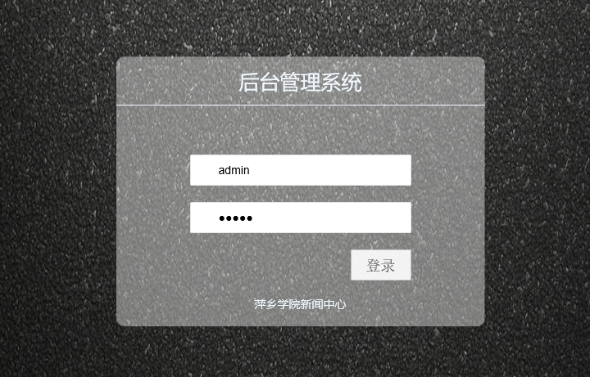
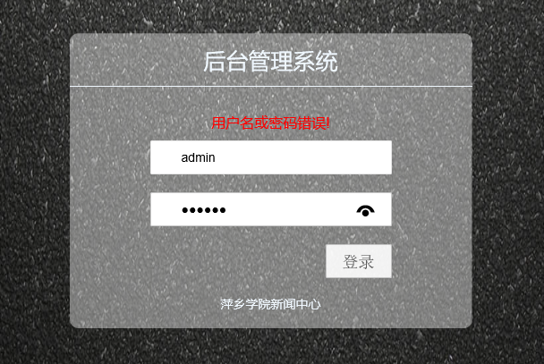
登录失败后进行后重新转到登录页面

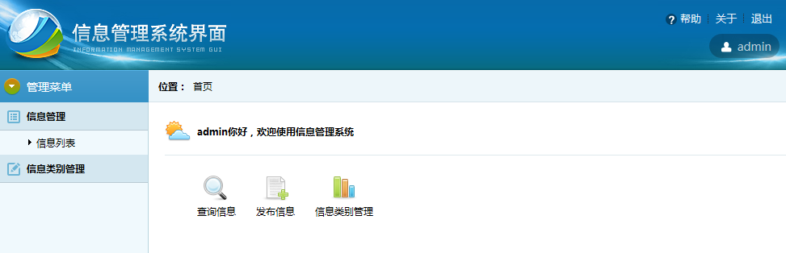
登录成功后进行后台管理主页面

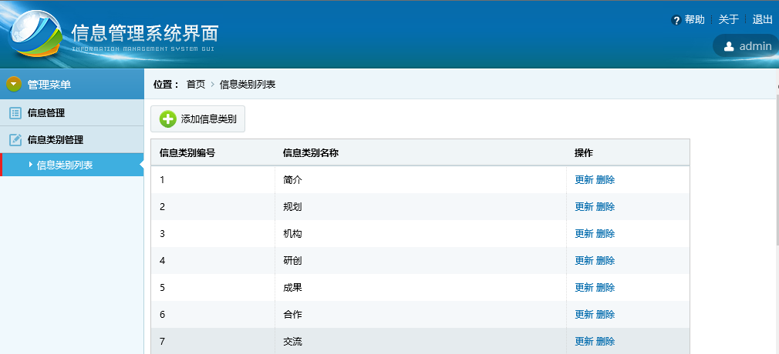
信息类别列表页面

