CDE1302 Mini Project: Autonomous UAV Exploration
Group Report
Lab group: [group / lab session] AY: [2026/27] Semester: [1] Demonstration date: [date]
Members: [Name, Matric No.]; [Name, Matric No.]; [Name, Matric No.]; [Name, Matric No.]
Source code: [GitHub repository link (the repo that holds the final code)]

1. Introduction and mission
The UAV must take off on a command from the ground laptop, search a bounded area for AprilTags at unknown positions, record each tag's ID, estimated position in the UAV's local frame, relative pose and timestamp, return to the start and land, with no manual input after takeoff. We describe one integrated system: a flight controller for stabilisation, a companion computer for tag detection and command execution, and a laptop program that plans the search, localises tags, logs events and checks safety. [One or two sentences on your result: tags found / total, mean localisation error, mission time.]

2. System architecture and data/control flow
[Hardware: state your final configuration, for example frame and camera mount, motors, props, battery, and any modifications with the reason for each.] The vehicle is a PX4 quadrotor (MicoAir743 v2 flight controller) with an optical-flow sensor (MTF-02P) for local position, and an ESP32-S3 companion with a camera that detects AprilTags (tag16h5 family) on board.
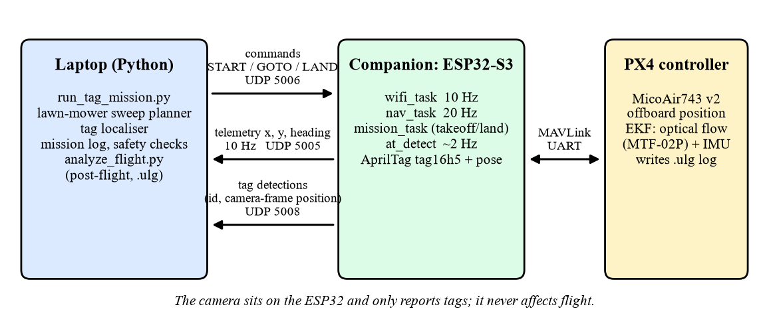
Figure 1. System architecture and data flow (drawn from the code: ports and rates as implemented).
Control flow: the laptop sends CMD_START; the ESP32 switches PX4 to offboard mode, arms and climbs to 0.5 m. The laptop then sends CMD_GOTO waypoints; the ESP32 streams position setpoints to PX4 at 50 Hz, and PX4's position controller flies the drone, so the flight speed is set by PX4 parameters, not by the laptop. Data flow: telemetry (local x, y, heading, navigation state) returns to the laptop at 10 Hz; tag detections (ID and camera-frame position) arrive separately on a second stream at about the camera processing rate. The camera path is read-only with respect to flight: detections never change the flight commands. PX4 records its own flight log (.ulg), which is used after the flight (Section 7).

3. Exploration and navigation strategy
The laptop flies a boundary-limited lawn-mower sweep. We chose it because the brief only requires staying inside the boundaries and allows waypoint navigation, and because a deterministic sweep is simple, predictable and easy to verify. The drone has no obstacle sensing in its current firmware (the time-of-flight avoidance stack is disabled), so the method does not rely on it.
- Planning: the search area (announced before the demonstration) is shrunk by an edge margin; lanes run along a configured axis (forward by default); the lane order and direction are chosen to minimise the flown distance including the return.
- Lane spacing: derived from the camera, as twice the sideways distance at which a floor tag can be seen (tilt, field of view, altitude, range limit, minimum viewing angle), reduced by a safety factor of 0.8. [Your final lane spacing and how you checked it with a real tag.]
- Execution: each waypoint is sent as CMD_GOTO and accepted within 0.25 m (the firmware arrival radius); a missed waypoint triggers a hold and continues; three consecutive misses end the search early.
- Return and landing: after the last lane the drone returns to the takeoff point and the landing command is sent. Landing is commanded, then a fixed wait follows, because telemetry has no touchdown signal.
- Safety: the program lands if telemetry is stale (3 s), if the drone leaves the search area by more than 0.5 m, on operator interrupt, or on any error. It stops searching early when the time limit is reached or when all expected tags are found (optional).
Alternatives considered: [the swarm stack's gap-based exploration (needs the time-of-flight sensors, disabled in our firmware), trajectory tracking with an uploaded minimum-snap path, a random walk. State why you did or did not use each.]

4. AprilTag detection and target localisation
Detection runs on the ESP32 (tag16h5 family). A detection is accepted only if it has at most one corrected bit error, a decision margin above 55 and a pose reprojection error below 0.5, which are the firmware's quality gates. For every accepted tag the ESP32 reports the tag's position in the camera frame (X right, Y down, Z forward). The laptop converts it to the UAV's local frame:
p_body = R_y(θ)·p_cam + t_cam, p_local = p_drone + R_z(ψ)·[p_body,x ; p_body,y]
where θ is the camera's nose-down tilt, t_cam is the lens offset from the drone body origin, p_drone is the drone position from telemetry interpolated to the frame time, and ψ is the heading. Repeated sightings of the same ID are fused by a weighted mean with weight 1/range², so nearer (more accurate) sightings count more. The tag's relative pose is recorded as the camera-frame translation: the detection stream does not carry the tag's rotation. Every sighting, accepted or not, is written to a log with all intermediate values.
Assumptions and error sources: [camera tilt and lens offset as measured on the assembled drone (state the values and how you measured them); the drone's roll and pitch are not in the telemetry and are ignored (Section 7 quantifies this from the flight log); detection latency; tags assumed on the floor.]

5. Important parameters and implementation decisions
All tunable values are in one configuration file (tag_mission.yaml), as the brief asks. Values marked * are assumptions that must be replaced by your measurements.
Parameter | Value | Basis
Search area (local frame) | [from examiner] | announced before the demo
Cruise altitude | 0.5 m | firmware constant CRUISE_ALT_M
Cruise speed (timeouts only) | [measured] m/s * | PX4 MPC_XY_VEL_MAX; measure from the .ulg
Lane spacing | [value] m * | camera swath x 0.8
Camera tilt / lens offset | [45°] / [x, y, z] mm * | measure on the drone
Camera field of view | 91° x 82° | firmware calibration
Max tag range / min viewing angle | [3 m] / [30°] * | test with a real tag
Waypoint arrival radius | 0.25 m | firmware
Safety limits | stale 3 s, fence +0.5 m | configuration

Key decisions: [list 3 to 5, each with the reason: for example the lawn-mower strategy; using the stock frame with a rigid camera mount; position-setpoint waypoints instead of trajectory upload; laptop-side localisation so the geometry can be changed without reflashing.]

6. Experimental results and performance observations
[Describe the test setup: area size, number and placement of tags, how true tag positions were measured (tape measure, reference marks), lighting, number of trials.]
Trial | Tags found / placed | Mean error (m) | Max error (m) | Mission time (s) | Notes
1 | [ ] | [ ] | [ ] | [ ] | [ ]
2 | [ ] | [ ] | [ ] | [ ] | [ ]
3 | [ ] | [ ] | [ ] | [ ] | [ ]

[Observations: detection reliability by range and angle, localisation error against range, how closely the drone returned to the start, measured flight speed against the configured value, any failures and what caused them. Report what happened, including failed trials.]
Software verification: the laptop code has automated tests, including full missions in a simulator and over real UDP sockets against a fake drone. These test the logic, not real-world accuracy, because the simulator uses the same camera geometry as the localiser. [Update the test count from the final run.]

7. AI-assisted flight-data analysis and visualisation
After each flight the PX4 .ulg log was downloaded and combined with the mission log by a Python script. It aligns the two clocks (PX4 time since boot against the laptop wall clock) by matching the drone path, then plots the full trajectory, the start and landing positions, and the estimated tag positions with their IDs, and tabulates path length, return error and localisation error against the measured tag positions.
[Figure 2. Flight overview from your real flight: trajectory, start, landing, tag IDs and positions (output of analyze_flight.py, flight_overview.png).]

The script also re-localises every sighting using the logged roll and pitch, to measure the error from ignoring tilt in flight. [Report the shift per tag from your flight.]

How AI was used, its limits, and how results were verified
[Tools and what each was used for (code, plots, analysis). Keep this factual and specific to your group.] Examples of AI errors that verification caught during development (replace or extend with your own):
- An AI assistant stated that the flight speed was set by a firmware constant; reading the code showed the constant is unused, and the speed is a PX4 parameter. It was caught by reading the source and the repository's own test guide, and the measured speed from the log now replaces the assumption. [Confirm with your log.]
- A first lane-spacing estimate treated any tag within camera range as detectable and suggested lanes 3 m apart; adding a minimum viewing angle (a floor tag seen edge-on will not decode) reduced it to about 1 m. [Confirm with a real tag test.]
Verification: unit tests on known geometry; synthetic logs in the PX4 log format; comparison of estimated against tape-measured tag positions; checking the flight-path plot against the observed flight. [Add what you actually did, and what remained unverified.]

8. Limitations, failure cases and possible improvements
- No obstacle avoidance (sensors disabled in the firmware); the sweep assumes a clear, bounded area.
- Localisation depends on the measured camera mount; the telemetry has no roll or pitch, and detection latency shifts the pose used. [Quantified error from your results.]
- Landing is a command plus a wait; no touchdown signal in telemetry. Auto-landing reliability: [describe what you observed.]
- Completion time is limited by the PX4 speed limit; raising it increases motion blur and pose lag. [What you tried.]
- The tag packet carries translation only, so the tag's orientation is not recorded.
Improvements: [for example adaptive search that revisits gaps, using tag height information, adding roll and pitch to the telemetry, speed tuning with detection latency compensation, automatic recovery.]

Appendix A. Team contributions and reproduction
Member | Contribution
[Name] | [e.g. airframe and camera mount, hardware assembly and tuning]
[Name] | [e.g. mission software, localisation, tests]
[Name] | [e.g. flight testing and data analysis]
[Name] | [e.g. report, verification, demonstration]

Run: python laptop/run_tag_mission.py --drone-id [ID] (dry run: --simulate; plan only: --plan-only). Analyse: python laptop/analyze_flight.py --ulg [file.ulg] --run [run folder]. Repository: [link]. Source code is excluded from the page limit; do not paste it here.

