**Part 3:**

*What is GitHub? When was it created? Why? By who? What similar platforms exist? Why would you use such a platform? (Answer between 5 and 10 lines)*

“GitHub is a code hosting platform for version control and collaboration. It lets you and others work together on projects from anywhere.” GitHub platform began develop on 1 Oct. 2007, founded on 8, Feb. 2008 by Tom Preston-Werner, Chris Wanstrath, and PJ Hyett. Bitbucket, SourceForge and GitLab, etc. Using there platforms could have collaboration work, code review and code management easier. And code will be saved on cloud, thus if your pc crashed, the code still safe in cloud.

**Part 4:**

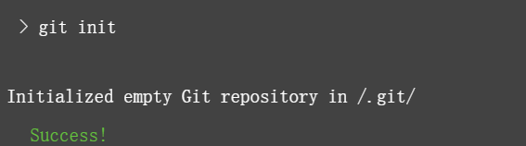

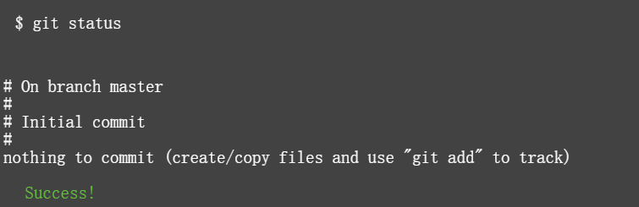 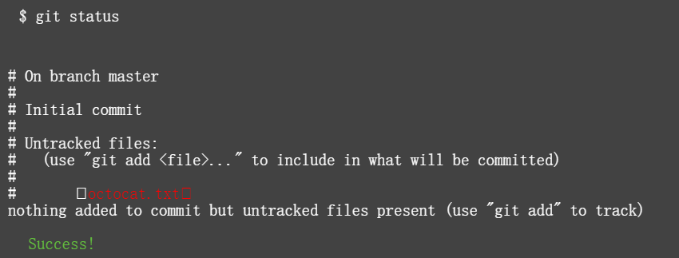 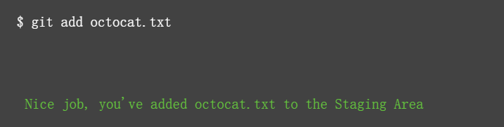 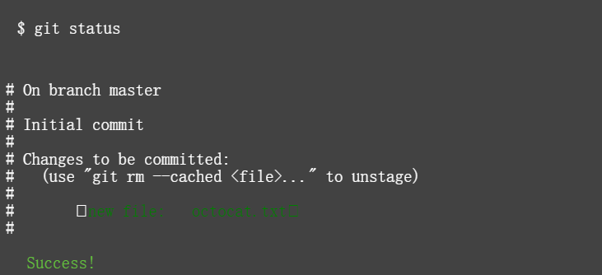 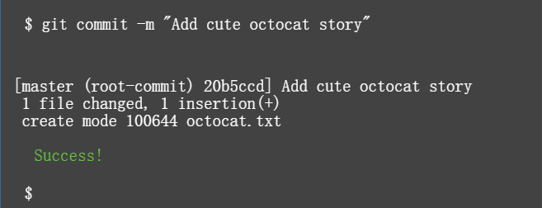 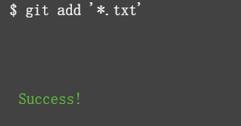 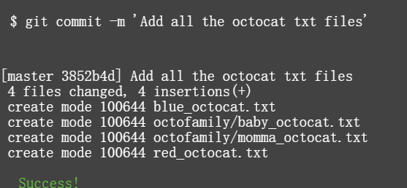 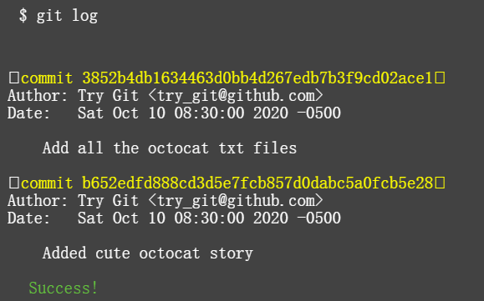 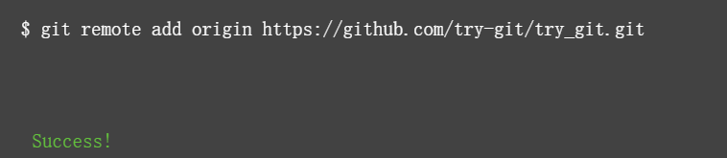 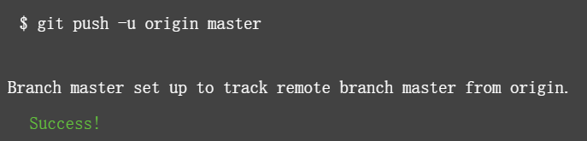 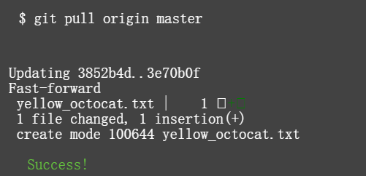 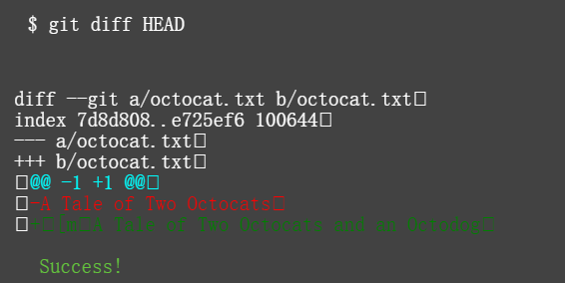 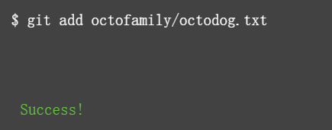 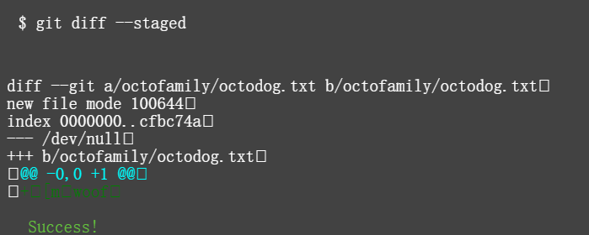 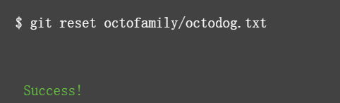 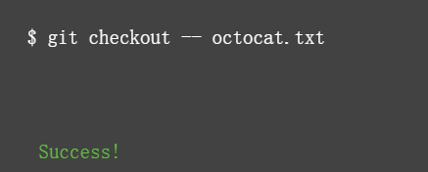 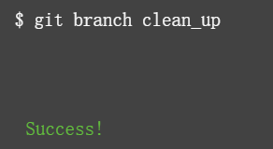 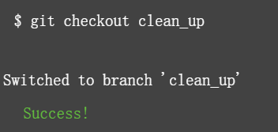 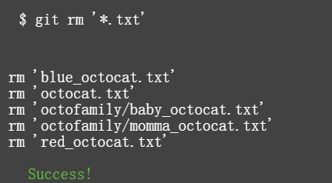 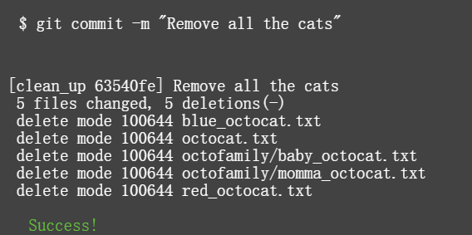 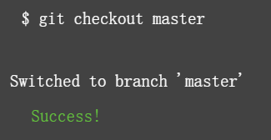 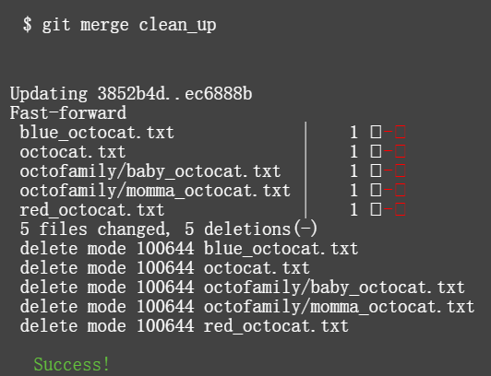 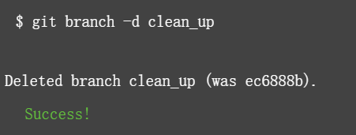 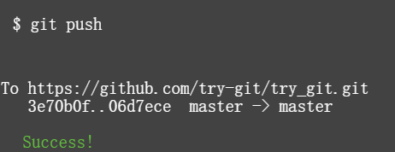

**Part 5:**

Define the following terms in the context of Git (2 lines maximum):

• Repository: A repository is usually used to organize a single project. Repositories can contain folders and files, images, videos, spreadsheets, and data sets – anything your project needs.

• Commit: On GitHub, saved changes are called commits. Each commit has an associated commit message, which is a description explaining why a particular change was made.

• Push: submit your work to github

• Branch: is different versions of a repository.

• Fork: A fork is a copy of a repository. Forking a repository allows you to freely experiment with changes without affecting the original project.

• Merge: merge branches into master for changes

• Clone: copy a repo provided by other developers into local environment.

• Pull: If someone else made changes to the master branch while you were working on your branch, you could pull in those updates.

• Pull request: Pull requests let you tell others about changes you've pushed to a repository on GitHub.

**Part 7:**

Go to <https://github.com/paceuniversity/courses>

Click into README.md

Click the pencil icon on the left

Editing my lastname, firstname date and time to the file.